EPS 100 (Stapleton) Name: _______________________________________
2015-2016 Final Exam Review

Physical Properties of Matter
Matching: Weight, Mass, Volume, Density,

1. Mass is the amount of stuff in an object

2. Volume describes the size of an object

3. Weight is the force of gravity pulling on an object

4. Density is a ratio of an object’s mass to its volume; a measure of the crowdedness of the particles in an object

The objects below are mostly empty space. The circle is the edge of each object. The dots inside represent all of each object’s mass. The empty space inside the objects has no air or mass of any kind.

5. Which object has the most weight? A 6. Which object has the least weight? D
7. Which object has the most volume? F 8. Which object has the least volume? E
9. Which object is most dense? C 10. Which object is least dense? B
11. Which object has the most mass? A 12. Which object has the least mass? D
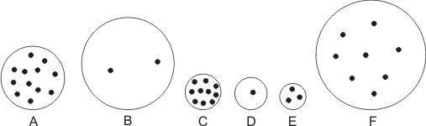
Air Pressure
13. What is the average value of air pressure that is all around us? (at sea level) 14.7psi

14. What causes the air pressure around us? The weight of the air that is stacked on top of us

15. a. In which direction do your ear drums stretch when you go to a higher elevation? outward

b. Why? As you ascend, the air pressure around you decreases. This means the air pressure inside your ears becomes stronger than the air pressure outside your ears.

Chemistry
16. Match these words with the descriptions below: Compound, Element, Atom

Atom: The basic unit of a chemical element; in a diagram of molecules and compounds, an atom is one of the circles with a letter symbol in it.

Element: One of many different types of chemical substance; each element has its own symbol of one or two letters; a type of atom.

Compound: Atoms of different elements, stuck together; in compounds, atoms may be connected by lines or they may be connected by opposite charges.

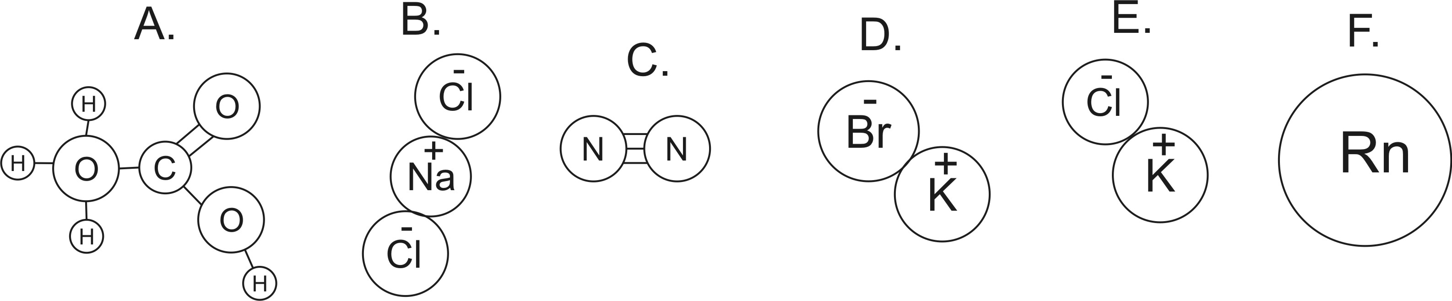

17. How many atoms are shown in the diagrams above? 17
18. How many elements are shown in the diagrams above? 9
19. Which lettered items are compounds? A, B, D, E

20-28. Matching:

A. Liquid B. Absolute Zero D. Temperature
E. Radiation F. Conduction G. Heat
I. Solid J. Gas K. Convection

20. __J___ This is the state of matter in which molecules (or individual atoms) are flying free, but they occasionally bump into one another.
21. __A___ This is the state of matter in which molecules (or individual atoms) are touching one another, but they are sliding, bumping, moving around and changing positions.
22. __I___ This is the state of matter in which molecules (or individual atoms) are locked in place, touching one another, and vibrating.
23. __F___ Heat transfer by touch
24. __G___ This is any transfer of energy from a warmer object to a colder object.
25. ___K__ Heat transfer by the movement of a warm fluid (liquid or gas).
26. The __D___ of a substance tells us the average kinetic energy of the particles (atoms and/or molecules) in that substance.
27. ___B__ This is the temperature at which all molecular motion stops.
28. __E___ Heat transfer without contact and without movement a “mass” of particles. The energy that we get from the sun is an example of this type of heat transfer.

Weather and Climate
When air rises…
29. What type of pressure does it encounter?
a. higher pressure b. lower pressure c. no change in pressure
30. What happens to air’s volume?
a. it increases b. it decreases c. it does not change
31. What happen to air’s temperature?
a. it increases b. it decreases c. it does not change
32. What is most likely to happen to water that is in the air?
a. evaporate b. condense
33. What type of weather is likely to be produced?
a. clear b. cloudy

34. Where are the Earth’s major deserts? Why are they in those locations?

The Earth’s major deserts are found in the Horse Latitudes, from 20-30 degrees latitude. This is a region of sinking air, and sinking air is dry.

35. Where are the Earth’s major rainforests? Why are they in those locations?

The Earth’s major rainforests are found at the equator. The air at the equator rises because it is hot. Rising air produces clouds.

36. The water on the east coast of a continent is usually a different temperature than the water on the west coast. Which coast has colder water? Why?
Ocean currents on the east coasts of continents come from the equator, so they are warm. Ocean currents on the west coasts of continents come from cold places near the poles.

37. In the diagram below, show where the rain shadow will form. Then show and/or explain why one side of the mountain is rainy and why the other side is dry.
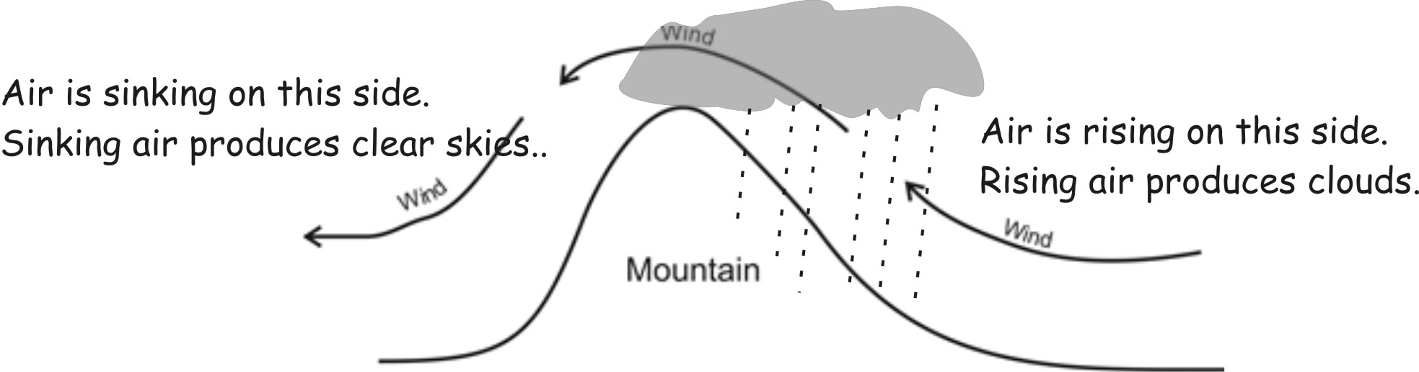

Plate Tectonics
On the map to the right, Light = Continental Crust Dark = Ocean Crust
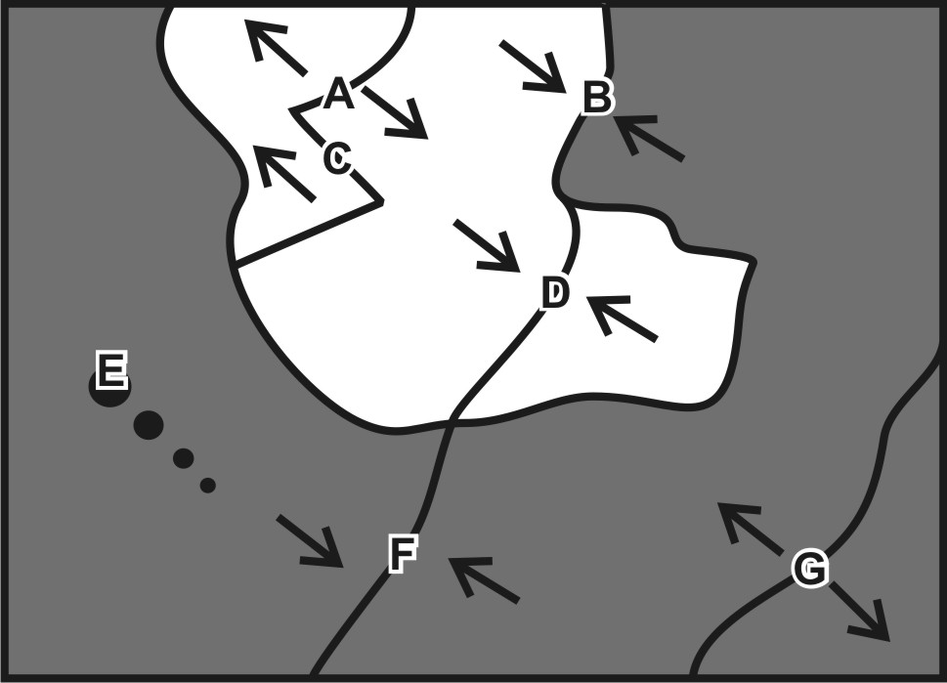
Each of the real-world locations below forms in an area that is similar to one of the lettered locations on the map. Match each real-world location to its corresponding map location.

38. A B C D E F G Hawaii
39. A B C D E F G East Africa
40. A B C D E F G Japan
41. A B C D E F G Mid-Atlantic Ridge
42. A B C D E F G Himalayas (Mt. Everest)
43. A B C D E F G Andes Mountains (South America)
44. A B C D E F G San Andreas Fault, California

45. Check all of the features that can be found in each locations?

 | Steep Volcanoes | Round Volcanoes | Ocean Trench | Earthquakes | New Ocean Crust Forming
Hawaii |  | x |  | x
East Africa |  |  |  | x | x
Japan | x |  | x | x
Mid-Atlantic Ridge |  |  |  | x | x
Himalayas (Mt. Everest) |  |  |  | x
Andes Mountains (South America) | x |  | x | x
San Andreas Fault (California) |  |  |  | x

Rock Dating:

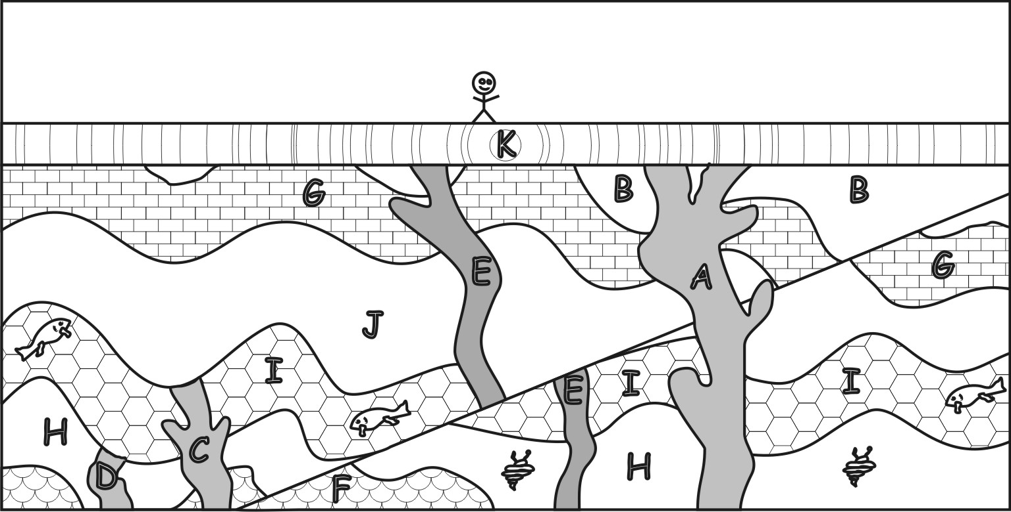
46. a. In the diagram on the right, which layer is older, Layer J or layer H? H

47. a. In the diagram on the right, which is older, magma tube A or magma tube E? E

48. Sample D contains 50 K-40 parent atoms and 220 Ar-40 daughter atoms.
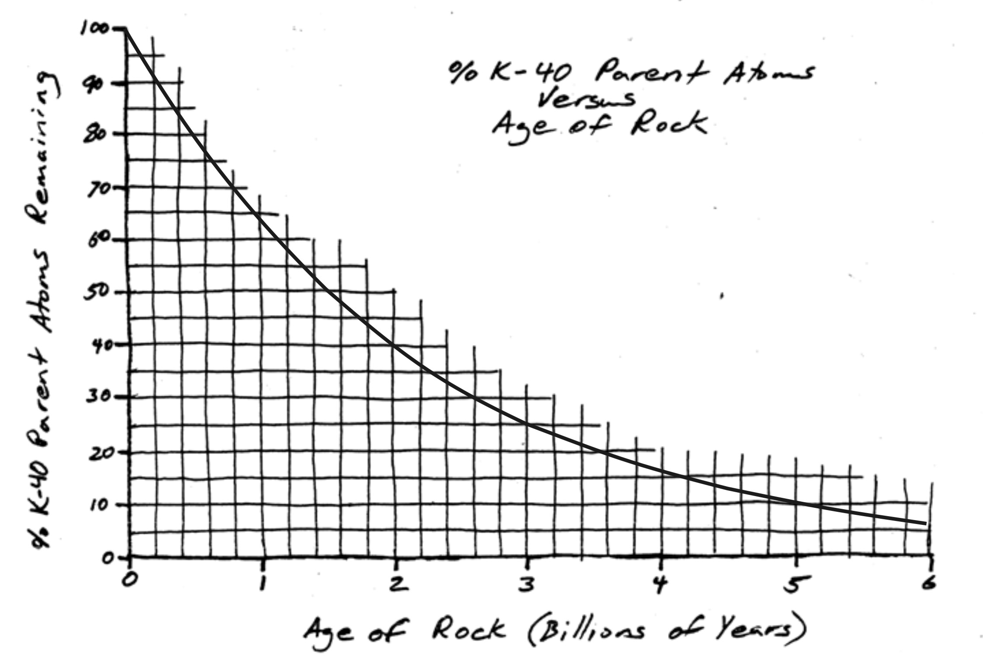
a. What percentage of those atoms are parent atoms?
50/270 = 18.5%

b. Use the graph to determine the approximate age of Sample D.
about 3.7 billion years

Solar System and Earth Formation

49. Before the solar system took shape, it was a slowly-rotating cloud of dust and “frozen gases,” called a __________Nebula__________.

50. As time passed, the size of the solar system decreased. What caused the solar system to shrink?
Gravity

51. Shrinking caused the solar system to spin rapidly and change its shape. What shape did it become?
disc

52. As the nebula got smaller, it heated up (especially in the center). What caused it to heat up?
Pressure (compression)

53. When the center of the solar system became hot enough, the sun formed. The sun gets its energy from a process called ___________nuclear fusion_________. In this process, ________hydrogen________ atoms are turned into __________helium________ atoms.

54. Some planets in the solar system are called terrestrial (rocky) planets. Others are called the gas giants. Where are each of these planet types located in the solar system? Gas giants are far from the sun. Terrestrial planets are close to the sun.
55. The planets are in stable orbits. They do not fly away from the sun, and they do not get pulled in to the sun.
a. What prevents the planets from flying away from the sun?gravity

b. What prevents the planets from being pulled in to the sun?momentum

56. Scientists think the Earth’s water came from ________________meteorites__________________.

57. Scientists think that the first oxygen was released into our atmosphere by _____blue-green algae (cyanobacteria)______.

58. The coal, oil, and natural gas that we burn today came from ______plants that died long ago_________.

Waves, Stars, Universe, and The Greenhouse Effect
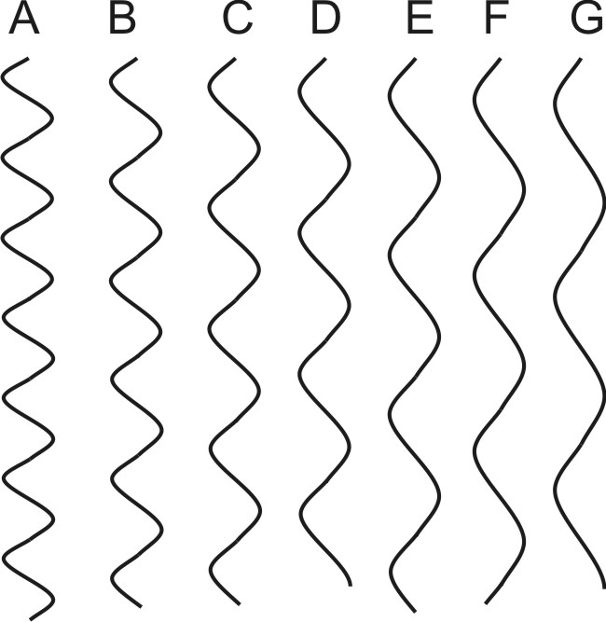
59. What color are the hottest stars? blue

60. What color are the coolest stars? red

61. Which wave on the right has the shortest wavelength? A

62. The people in the diagram below are looking at the same star. One person in the diagram below sees a blue-shift, and the other person sees a red-shift. Complete the drawing to show:
a. The direction of the star’s movement. Use an arrow.
b. The light waves leaving the star. Draw them with appropriate wavelengths.

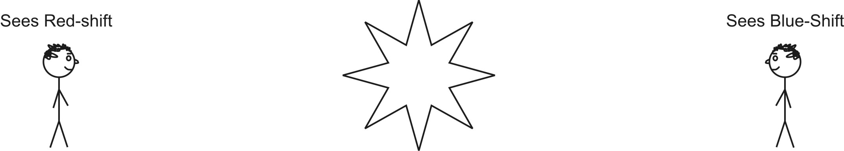

63. Circle the person who is observing the type of shift that we see when we look at distant galaxies.

64. Briefly describe two pieces of evidence that support the Big Bang theory.

- The universe is expanding (all galaxies have red shifts)

- We can see heat left over from the explosion (microwave radiation filling the universe)

High
A

B

Brightness
(brightness units)
C

D

Low
E

High Low
Temperature (º C)

65. In the diagram, which of the stars above is most similar to our present day sun? C

66. Which star in the diagram is coolest? E

67. List all of the stars that are main sequence stars. A, C, E

68. What do all main sequence stars have in common? They are fusing hydrogen into helium.

69. Which star is most likely a red giant?B

70. Which star is most likely a white dwarf?D

71. a. A very large star (many times bigger than our Sun) dies in an event called a supernova

72. Name one important greenhouse gas. Carbon Dioxide, Methane

73. Explain how those gases cause the Earth to heat up. They allow sunlight to enter the atmosphere, but they do not allow infrared radiation to leave the Earth.

Time of Day

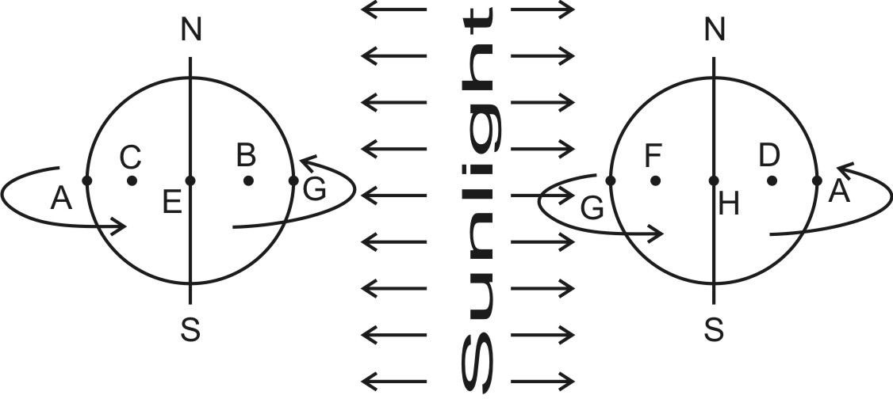
74. Correctly shade each of the Earths on the right.
75. In the diagrams on the right, what is the approximate time at letter A?
12AM 3AM 6AM 9AM 12PM 3PM
6PM 9PM
76. In the diagrams on the right, what is the approximate time at letter B?
12AM 3AM 6AM 9AM 12PM 3PM
6PM 9PM

Moon Phases

77. What is the difference between a waxing moon and a waning moon? Waxing means it’s growing. Waning means it’s shrinking.

78. By looking at the moon, how can you tell if it is waxing or waning? If the right side is lit up, it’s waxing. If the left side is lit up, it’s waning.

Seasons

79. Match the Earths on the right to the correct date. Dates: June 20th, December 20th, March 20th, September 22nd. B=June, A=September, C=December, D=March

80. Give two reasons why our weather is hotter during the summer than it is during the winter. We have more hours of daylight, and the sun’s rays are more direct.

Consider the diagram below. Approximately how many hours of daylight does someone living at letter A receive when the Earth is in…
81. Position 1? 0 9 12 15 24
82. Position 2? 0 9 12 15 24
83. Position 3? 0 9 12 15 24
