EPS 100 Stapleton Name: _______________________________
Practice Quiz: Physical Properties and Air Pressure

For multiple choice, CIRCLE the correct answer

Part I (Mass, Volume, Density, Weight) :

The objects below are mostly empty space. The circle is the edge of each object. The dots inside represent all of each object’s mass. The empty space inside the objects has no air or mass of any kind. All of the objects are in similar locations on the same planet.

1. Which object has the most mass? A B C D E F

2. Which object has the least mass? A B C D E F

3. Which object has the most volume? A B C D E F

4. Which object has the least volume? A B C D E F

5. Which object is most dense? A B C D E F

6. Which object is least dense? A B C D E F

7. Which object has the most weight? A B C D E F

8. Which object has the least weight? A B C D E F

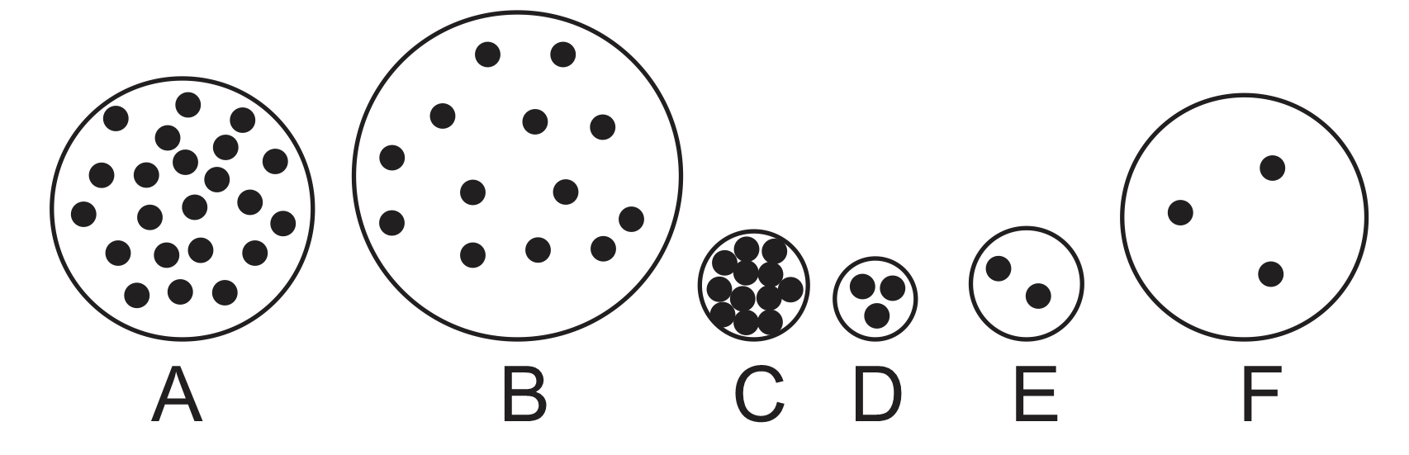

Part II (changes in mass, volume, density, and weight): For the following questions, tell whether each property increases, decreases, or stays the same. Choose the correct symbol, either +,-, or =.

9-12. An object’s size gets larger, but it has the same amount of stuff in it.

9. mass + - = 10. volume + - =

11. density + - = 12. weight + - =

13-16. The particles inside an object become more crowded, but the amount of stuff in the object doesn’t change.

13. mass + - = 14. volume + - =

15. density + - = 16. weight + - =

