EPS 100 Stapleton Name: _______________________________
26-27 Practice Test: Physical Properties and Pressure

Part I (Mass, Volume, Density, Weight) :

Briefly define each of these:

1. Mass:

2. Volume:

3. Density:

4. Weight:

The objects below are mostly empty space. The circle is the edge of each object. The dots inside represent all of each object’s mass. The empty space inside the objects has no air or mass of any kind. All of the objects are in similar locations on the same planet.

5. Which object has the most mass?

6. Which object has the least mass?

7. Which object has the most volume?
8. Which object has the least volume?

9. Which object is most dense?

10. Which object is least dense?

11. Which object has the most weight?
12. Which object has the least weight?

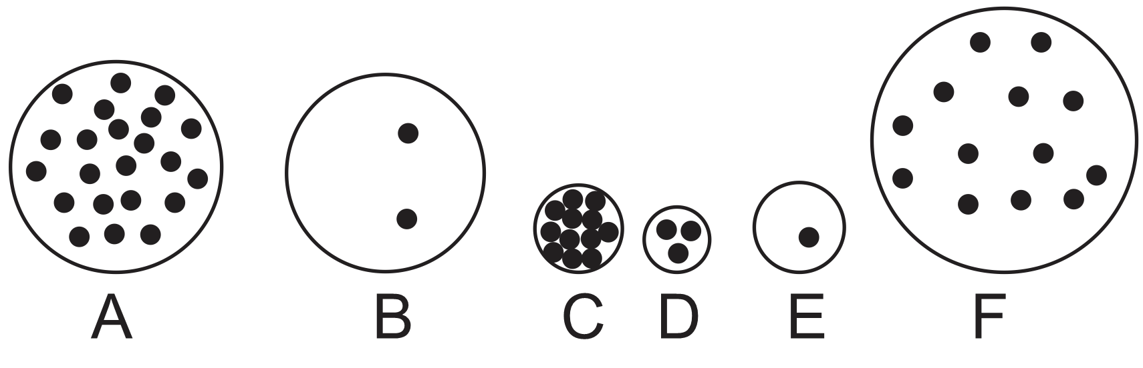

13. Explain how it is possible for your weight to get lighter without any change in your mass.

14. Which of these properties determines whether something will sink or float?
a. Mass b. Volume c. Density d. Weight

Part II (changes in mass, volume, density, and weight): For the following questions, tell whether each property increases, decreases, or stays the same. Choose the correct symbol, either +,-, or =.

15-18. An object’s size doesn’t change, but stuff is removed from it.

15. mass + - = 16. volume + - =

17. density + - = 18. weight + - =

19-22. The particles inside an object become more crowded, but the amount of stuff in the object doesn’t change.

19. mass + - = 20. volume + - =

21. density + - = 22. weight + - =

Part III: How heating and cooling can affect pressure, volume, and density
A sealed glass jar has air inside. The jar cannot change its size, and no air can enter or leave. What will happen when the jar and the air inside are heated up?
23. What will heating do to the motion of the air particles in the jar?

24. When the jar is heated, what will happen to the pressure inside the jar?

25. What is creating the pressure that is inside the jar?

A sealed plastic bag is partly filled with air. No air can enter or leave the bag. What if the bag of air is cooled down?
26. How does cooling affect the overall mass of the bag and its air? (increase, decrease, or no change)
27. How does cooling affect the overall volume of the bag and its air? (increase, decrease, or no change)
28. How does cooling affect the pressure inside the bag? (increase, decrease, or no change)
29. How does cooling affect the overall weight of the bag and its air? (increase, decrease, or no change)
30. How does cooling affect the overall density of the bag and its air? (increase, decrease, or no change)

Part IV: How compression and expansion can affect temperature
Consider the same sealed bag of air. No air can enter or leave the bag.
31. What will happen to the temperature of the bag if you squeeze the bag (but not hard enough to pop the bag)?

32. Explain why squeezing changes the temperature in this way.

33. What will happen to the temperature of the air in the bag if you release it after you have been squeezing it for a while?

More practice for parts 2-4:

Part II (changes in mass, volume, density, and weight): For the following questions, tell whether each property increases, decreases, or stays the same. Choose the correct symbol, either +,-, or =.

15-18. An object that was floating before is now sinking. The amount of stuff in it hasn’t changed.

15. mass + - = 16. volume + - =

17. density + - = 18. weight + - =

19-22. An object got smaller, and the particles inside the object became less crowded.

19. mass + - = 20. volume + - =

21. density + - = 22. weight + - =

Part III: How heating and cooling can affect pressure, volume, and density
A sealed glass jar has air inside. The jar cannot change its size, and no air can enter or leave. What will happen when the jar and the air inside are cooled down?
23. What will cooling do to the motion of the air particles in the jar?

24. When the jar is cooled, what will happen to the pressure inside the jar?

25. What is creating the pressure that is inside the jar?

A sealed plastic bag is partly filled with air. No air can enter or leave the bag. What if the bag of air is heated up?
26. How does heating affect the overall mass of the bag and its air? (increase, decrease, or no change)
27. How does heating affect the overall volume of the bag and its air? (increase, decrease, or no change)
28. How does heating affect the pressure inside the bag? (increase, decrease, or no change)
29. How does heating affect the overall weight of the bag and its air? (increase, decrease, or no change)
30. How does heating affect the overall density of the bag and its air? (increase, decrease, or no change)

Part IV: How compression and expansion can affect temperature
Mr. Stapleton compressed a bunch of air in his mouth. Then he released the air into the room.
31. What happened to the temperature of the compressed air when it was released from Mr. Stapleton’s mouth and allowed to spread out into the room?

32. When Mr. Stapleton first squeezed the air in his mouth, what did that do to its temperature?

33. Why did the air’s temperature change in this way when he squeezed it?

