Physics II Name: ___________________________
Notes: Pressure and Fluids
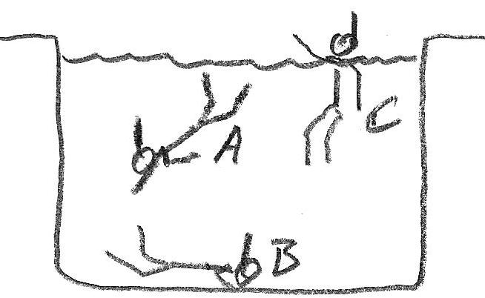
1. In the first picture on the right, which swimmer is experiencing the greatest water pressure?

2. In the second picture on the right, who is experiencing the greatest air pressure?
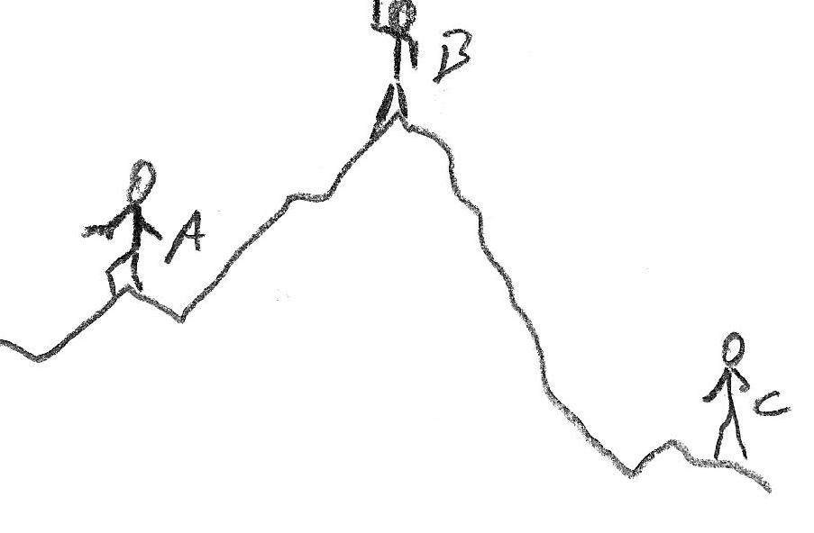

3. Whether you’re in air or water (or any other fluid), the origin of ambient pressure is the same. What creates the air pressure that we’re feeling right now?

Units, Conversions, etc.:

Pressure (P) =

1pa (pascal) = 1psi = 1 pound per square inch

1psi = _______ pa

Atmospheric Pressure (average, at sea level) = ___ psi ≈_____________pa

Density of liquid water = ρ_{water} = ____g/ml = ____ kg/m³

The symbol for density is ρ, which is referred to as "rho."

ρ =

4. According to sources, an average human has about 1.8m² (≈2,800 in²) of skin. What total force is

pushing against an average human’s skin? _______ N _________ lbs

5. Why doesn’t this force crush us?

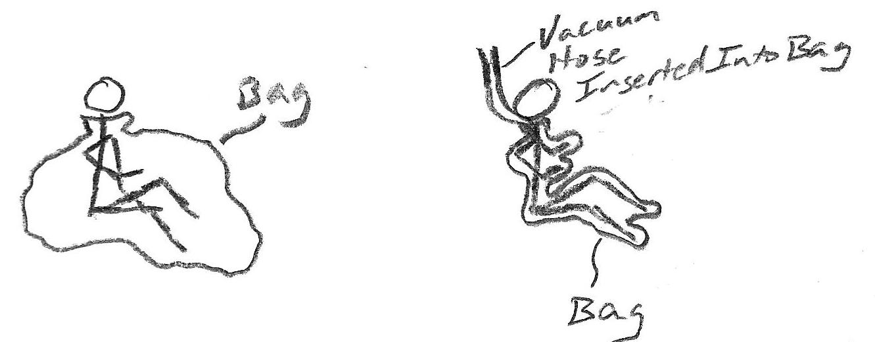

6. The two people on the right are inside trash bags. One has a vacuum hose inserted in the bag. The other does not. Use arrows to show how the sensation of vacuum packing is caused by air pressure pushing inward from the outside of the bag.

7. Explain how a suction cup works.
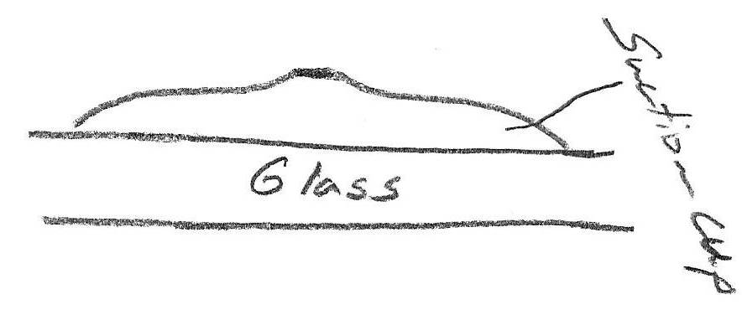

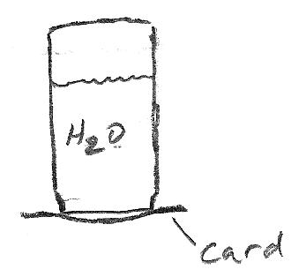
8. What happens if you fill a jar with water, cover it with a laminated card, and then turn the jar upside down? Explain why.

9. Calculate the weight of the 3m water column that is positioned directly above the box on the right. Then calculate the pressure on the box's top surface.
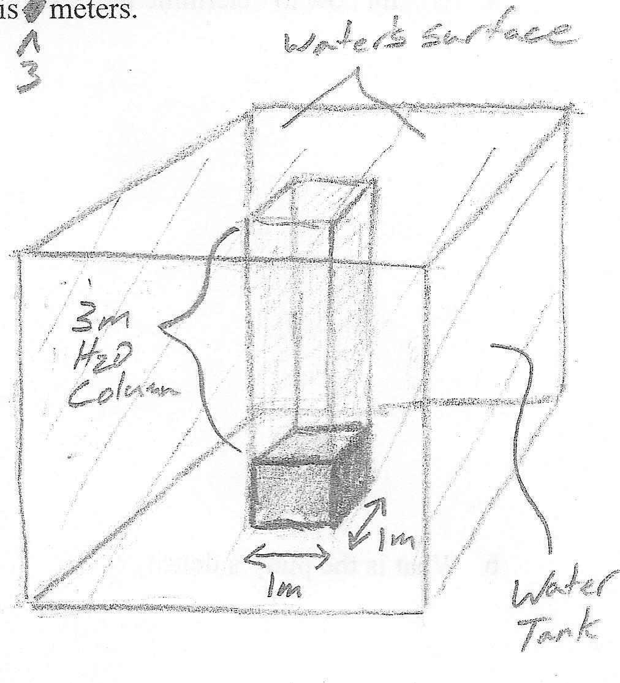

10. More generally, the pressure exerted on a surface of area A at a depth of h below the surface of a liquid of density ρ is P = . This formula should yield the same answer to #9.

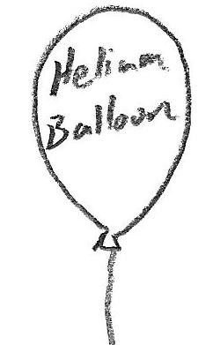
11. A helium balloon floats upward. Show how it “knows” which way to go.

12. Calculate the downward force acting on the cube (below, right).
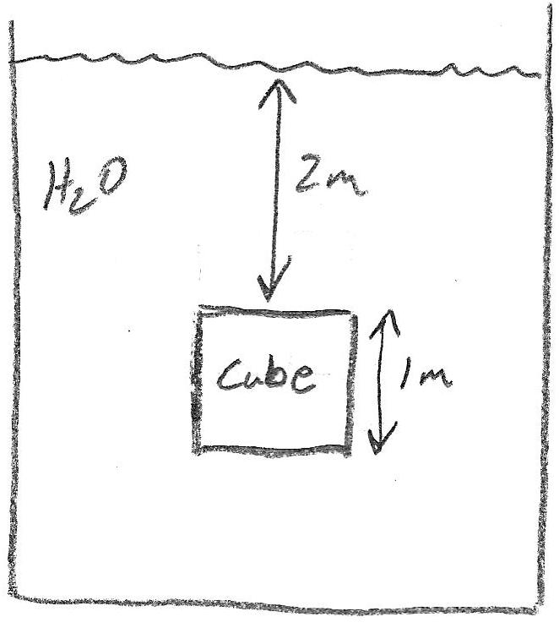

13. Calculate the upward force acting on the cube on the right.

14. What is the net force of pressure (the buoyant force) acting on the box on the right?

15. Calculate the mass and weight of the water displaced by the cube.

Archimedes' Principle: the buoyant force on an object =

16. If an object is either positively buoyant (floating) or neutrally buoyant (same density as fluid), the object

has a mass that is ___________________ the mass of the water it displaces.

17. If an object is negatively buoyant (sinking), the object has a mass that is ___________________ the mass of the water it displaces.

