Physics II Name: ____________________________
More Pressure Problems

1kg = 2.2lbs 1inHg = 3386pa 1in = 2.54cm

1. Why don't suction cups work in space?

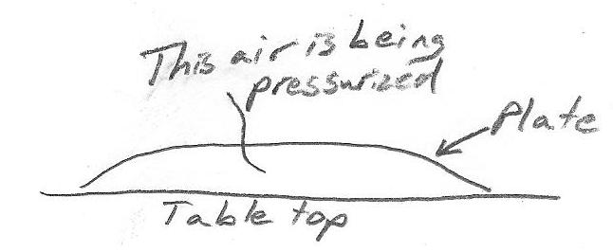
2. A circular suction cup has a radius of 3inches. The suction cup is stuck to a vertical glass window. Assuming that all of the air is evacuated from beneath the suction cup, how many pounds of force are pushing the suction cup against the window?

3. The upside-down plate on the right has a mass of 0.3kg and a radius of 9cm. How much air pressure must build up under the plate in order to lift the entire plate upward? [Assume that the entire plate moves straight up.]

4. If we have a hovercraft with three circular "pressure pads," contributing a total "air cushion" surface area of 2m², how much air pressure (gauge pressure) will be required from our vacuum cleaner in order to lift the 40kg hovercraft, plus an 80kg passenger? Answer in psi.

5. Your water comes from a nearby water tower. The upper surface of the water in the tower is 250 feet higher than the end of your garden hose. If there is no pressure reducing apparatus between the tower and your garden hose, what is your hose's water pressure?

6. You tape a tube inside the neck of a balloon, so that it extends from the balloon. Then you inflate the balloon to 2psi (gauge pressure) and insert the tube into some water. How deep will you have to insert the end of the tube so that the balloon cannot blow a bubble into the water?

7. A tire gauge indicates that a 2-liter plastic bottle has been pressurized to 50psi. If this pressurization caused the bottle's mass to increase by 5g, what is the molar mass of the gas inside the bottle (in g/mol)? Assume that the bottle's volume and temperature remain constant at 2 liters and 20°C, respectively.

8*. The molar mass of helium is 4g/mol.
a. What is the density of helium at a pressure of 15.7psi?
b. Suppose a spherical, latex, helium-filled balloon is inflated to a gauge pressure of 1psi. The balloon's diameter is 10 inches. If the mass of the latex comprising the balloon is 1g, what net force is acting on the balloon at an atmospheric pressure of 14.7psi and a temperature of 21°C?
c. At this pressure and temperature, how many of these balloons would it take to lift a 150 lb high school student?

9. Suppose you drop a mannequin into a completely full bathtub. 20 liters of water spill out of the tub, and the mannequin floats there with the water brimming. Then you get a large, flat board, and you pretend to carefully drown the mannequin. You manage to completely submerge the mannequin without wetting your board, but the tub loses 30 more liters of water. What is the mannequin's density?

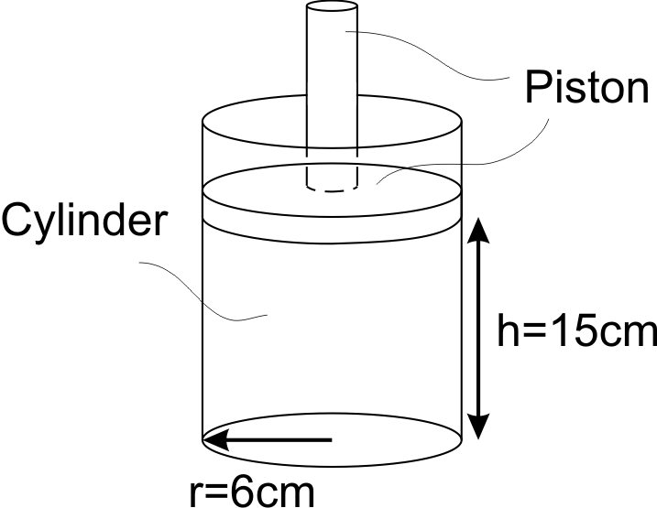
10. An earthling weighs itself. It weights 200lbs. Then it swims to the bottom of a deep pool and finds a 40lb rock that is resting on an accurate and fully-operational waterproof scale. The earthling grabs the rock and uses it as an anchor, floating above it during a brief moment of relaxation. The waterproof balance reads 30lb at this time. What is the earthling's volume in liters?

11. A piston protrudes from a sealed, air-filled cylinder, as shown. The piston is stuck. It will only move upward if the air pushes it 300 pounds of force. If the cylinder air is at an original temperature and pressure of 101,350 and 21°C, to what temperature must the air be heated in order to move the piston? [Assume that the sizes and shape of the piston and cylinder do not change.]

12**. A cylindrical jar has a radius of 5cm, and a height of 20cm. The jar is filled to 80% capacity with water. Next, a laminated card is placed over the jar's mouth, and the jar is turned upside-down. To everyone's amazement, the water stays in the jar. In this inverted state of equilibrium, how far is the water's top surface from the bottom (now the top) of the jar? Assume that the thickness of the jar is negligible, and that the ambient air pressure is 101,350pa.
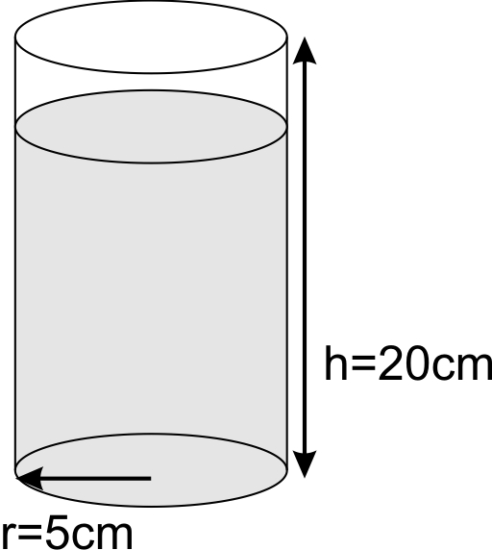
13. Suppose that, as your car sits in its parking spot, the areas of contact between its tires and the ground are rectangular in shape and equal in size. Each of the rectangles is 9 inches in one dimension, because that is the width of the tires. If your car weighs 3,000 lbs, and the pressure in your tires is 32psi, what is the other dimension of those rectangular areas of contact?

14. Suppose you have a helmet that fits the contours of your head perfectly. The helmet is extremely hard and rigid, and light. However, it has absolutely no padding. Even so, the helmet should still protect your head from a sudden hammer blow. Why?

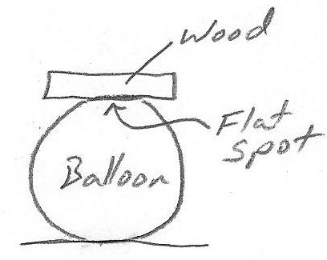
15. Suppose you inflate a standard rubber balloon and you balance a flat piece of wood on it. The wood has a mass of 0.4kg. The wood flattens a little area on the top of the balloon. You trace around the area of contact between the wood and the balloon, and you determine it to be a circle approximately 5cm in radius. What can you deduce about the air pressure inside the balloon?

16***. Suppose you're making a spherical balloon using plastic grocery bags. The bags have a mass/area ratio of 19.5g/m^2. Your balloon is heated by 20 candles with a mass of 0.7g each. The candles heat your balloon air to an average temperature of 200F. To create a structure to hold your candles, you have used 6 drinking straws, at a mass of 0.5g each. The ambient air has a pressure of 30inHg, and a temperature of 70F. Create a graph of liftable payload mass (in grams) vs. balloon radius. The graph should span radii of 0m-1m. Ignore other mass-contributing components, such as tape.

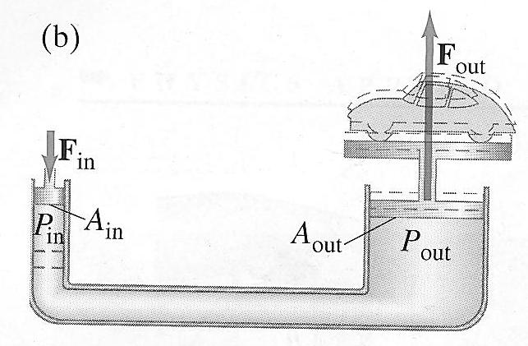
Pascal's Principle (see textbook around p. 280): pressure applied to any part of a confined fluid is transferred to every other part of the fluid – or – a pressure increase in any part of a confined fluid is transferred to every other part of the fluid. Since P=F/A, F_{in}/A_{in} = F_{out}/A_{out}

17. The diagram on the right (stolen from the textbook) shows a hydraulic lift. The radius of the "in" piston is 4cm. The radius of the "out" piston is 2m. The entire apparatus is sealed, so that an increase of pressure in one location creates an equal increase in pressure throughout the fluid. How much mass must be placed on the "in" piston in order to lift a 1000kg weight that is sitting on the "out" piston? [Ignore the masses of the pistons themselves.]

18. Timmy has a stomp rocket. He steps on the bladder of the stomp rocket with a downward force of 50N. The surface area of Timmy's foot is 100cm². The radius of the tube that ejects the rocket is 0.5cm. As Timmy stomps downward, what force does the air pressure in the toy transfer to the rocket?

* = may be difficult
** = probably a little more difficult
*** = quite lengthy

