Physics II Name: _______________________________
Drag, Mass, and Rocket Stability

Purpose: Explore how an understanding of Center of Mass, Center of Pressure can reduce the drag on a rocket.

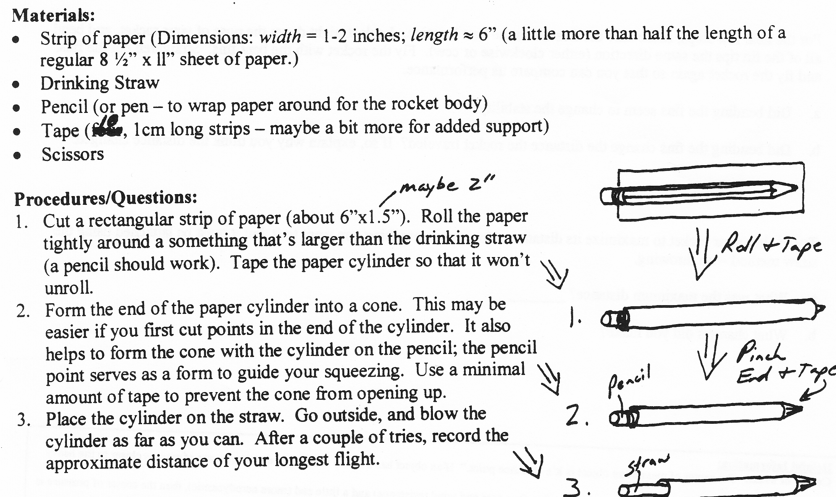

4. Your rocket isn’t much of a rocket yet. But it’s time to begin testing. First, find your rocket’s “center of mass” (CM). Do this by balancing your rocket on something thin – a pencil should work. The point along the length of your rocket where the rocket balances is its center of mass.

a. Sketch your rocket, and label its center of mass with “CM”:
b. Fly your rocket, and describe its flight.

5. Shift your rocket’s center of mass by adding a paper clip to the back. Find the new center of mass, fly your rocket, and observe its flight.

a. Sketch your rocket (paper clip in back) and label its center of mass:
b. Fly your rocket, and describe its flight.

6. Shift your rocket’s center of mass by adding a paper clip to the front. Find the new center of mass, fly your rocket, and observe its flight.

a. Sketch your rocket (paper clip in front) and show the location of its CM:
b. Fly your rocket, and describe its flight.

7. Based on your observations, where should a rocket’s center of mass be located in order to make the rocket as stable as possible?

8. Remove the paper clip and prepare find your rocket’s “center of pressure.” To do this, poke a needle through your rocket’s body, as shown on the right. Wiggle your needle a little so that the rocket can rotate freely. Now hold on the needle and move the rocket through a wind. You can run with it, blow on it, or swing it in circles. If the rocket doesn’t swing in the wind, you’ve found its center of pressure. If swings so that it’s parallel to the direction of the wind, you haven’t. Remove and re-insert your needle until it is “balanced” in a wind. Sketch your rocket and indicate its CP.
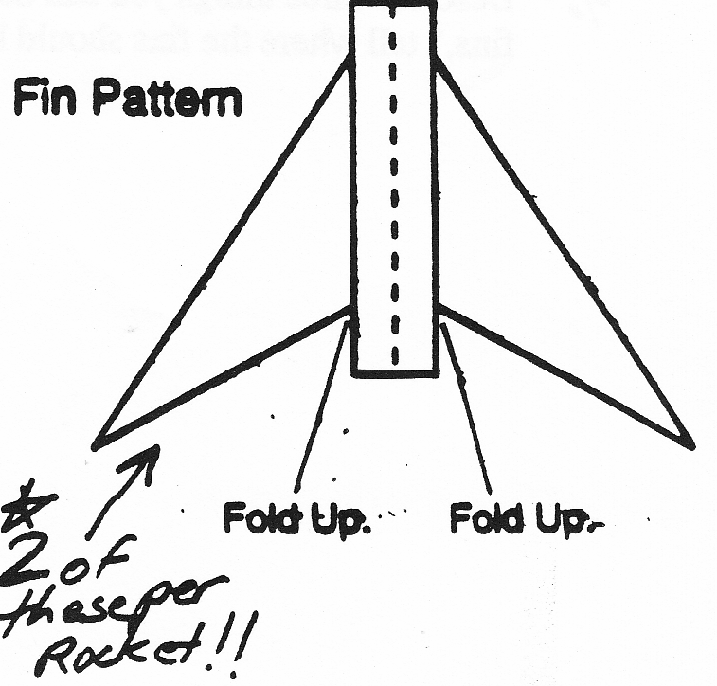
9. Cut out two fin pair templates and attach them to make a 4-finned rocket. Build the two rockets shown below, fly them, and locate their centers of pressure. Mark each CP.
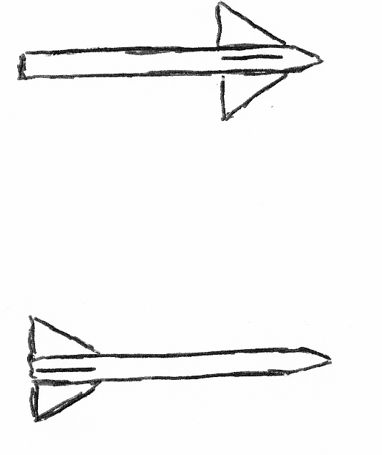

10. Based on your observations of those rockets’ flights, where should the CP be located in order to make your rocket fly as straight as possible?

11. Build the best paper rocket that you can.
a. Sketch it.
b. On your diagram, show where its CM and CP are (or should be) located.
c. Fly it, and see how far it goes.

12. Now try to minimize drag. Cut away portions of the fins, little by little, to see if you can reduce drag and make your rocket go farther. Keep going until your rocket is no longer stable in flight.

- Were you able to increase distance?
- Once your fins are too small for stable flight, what can you do to them (without adding new material) to regain stability? Try it. Why is this sort of solution a “tradeoff?”

- You should have discovered by now that, for stable forward flight, a rocket’s CM should be in front of its CP. Why is that? Attach extra paper for your answer.

- Explain why a well-designed weathervane always points into the wind (answer on attached paper).

Physics II Name: _____________________
Unit II: Projectiles and Drag
Baseball Drag

Useful Formulas/Info:

F_{d} = ½ ρ C_{d} A v²

F_{d} = Force of drag on an object (air friction) (Units = N)
ρ = “rho” = Density of surrounding fluid (air’s density ≈ 1.22kg/m³)
C_{d} = Drag coefficient of the object (specific to object in question; a measure of aerodynamics)
A = Cross-sectional area of the object that is exposed to surrounding moving fluid (m²)
V = Velocity of the object, relative to surrounding fluid (m/s)

F=ma

Terminal Velocity: velocity at which the force of drag on a falling object balances the force of gravity, so that there is no net force on the object – and no acceleration.

Problems (Solutions to 1-4 on Back):

1. A baseball has a C_{d} of about 0.3, and a cross-sectional area of about 0.0043m². If the density of air is 1.22kg/m³, what is the force of drag acting on a baseball that is traveling at 30m/s?
2. What is the terminal velocity of this baseball?
3. Suppose the same baseball has a mass of 0.125kg. It is thrown with an initial horizontal velocity of 40m/s.
- Approximate the horizontal velocity of that baseball after 0.45 seconds (about the time it would take to travel from the pitcher’s mound to home plate).
- Why is this only an approximation?

Excel Problems:

4. Using Excel, set up a spreadsheet to perform the calculation from the previous question. Then…
- Alter your spreadsheet to come up with a more accurate calculation of final horizontal velocity. Do this by recalculating the baseball’s velocity for every 0.05 second interval. For example, use v_{o} to calculate drag, and use that drag to determine the ball’s deceleration and thus the ball’s new velocity after decelerating for 0.05 seconds. Then use that new velocity to calculate the new force of drag. Use that new force of drag to get the new deceleration, and apply that deceleration for the next 0.05 seconds (total time of 0.1 seconds)… Keep doing this until you get to t=0.45 seconds. What final velocity do you get for t=0.45s?
- Now do the same thing, but perform the calculations in 0.01 second increments. What is your new approximation of the final horizontal velocity of the baseball?

More on Back ↓

Trajectory of A Projectile, Accounting For Drag

5. Suppose a baseball has been launched with a given initial speed and launch angle. Create a spreadsheet to calculate the position of a launched baseball throughout its flight, taking drag into account. See if you can recreate what I’ve done below [only the first few moments are shown].

One problem that you will encounter is that drag should always slow down a moving object. This creates trouble when you’re trying to put in a formula for Y drag. On the way up, drag is directed downward. But on the way down, it’s directed upward. To deal with this, you can use an “If” formula for drag. In a cell, start to type “=if(” and you will be told how to set up the if/then statement. I set up my Y drag formula so that it was negative whenever the previous velocity

Make a graph of the baseball’s trajectory (x position versus y position) for its entire flight.

Baseball Drag Coefficient (Cd) | 0.3
Cross-Sectional Area (m^2) | 0.0043
Density of Air (kg/m^3) | 1.22
Mass of baseball (kg) | 0.125
Initial Velocity (m/s) | 50
Launch Angle  (degrees) | 45
Current Y  velocity (m/s) | Current X  velocity (m/s) | Y drag (N) | X Drag (N) | t | Y position  (m) | X position  (m)
35.35533906 | 35.35533906 | -0.983625 | -0.983625 | 0 | 0 | 0
33.58843906 | 34.56843906 | -0.88776739 | -0.94032738 | 0.1 | 3.447189 | 3.496189
31.89822515 | 33.81617715 | -0.80066821 | -0.89984678 | 0.2 | 6.721522 | 6.838462
30.27769058 | 33.09629973 | -0.72138156 | -0.86194276 | 0.3 | 9.830318 | 10.03687
28.72058533 | 32.40674552 | -0.64909179 | -0.82640014 | 0.4 | 12.78023 | 13.10061
27.2213119 | 31.74562541 | -0.58309276 | -0.79302581 | 0.5 | 15.57733 | 16.03809

Solutions to Front:

1. 0.78 N
2. 39.4 m/s
3. a. 35.47

b. It’s an approximation because it assumes that the force of drag remains constant for the whole 0.45seconds. In reality, the force of drag decreases as soon as the force of drag causes the ball to decelerate.

4. a. 35.88 m/s
b. 35.92 m/s

Physics II Name: ____________________
Problems Relating to Drag and Trajectory

COMPLETE THESE WITHOUT USING YOUR EXCEL SPREADSHEET.

Sphere characteristics:
- Diameter = 37 cm
- Mass = 0.15 kg
- C_{d} = 0.4

Launch Information:
- The sphere is launched at an angle of 60° above horizontal.
- The sphere launcher is 35% efficient.
- The work put into the sphere launcher is 120 joules.
- The sphere leaves the launcher at time zero (t=0s).
- The initial position of the projectile is x = 0m, y = 0m.

Other Info:
- Density of ambient air = 1.22 kg/m³

A sphere has been launched. Use the information above to calculate the following:

1. What is the sphere’s initial speed?
2. What is the sphere’s initial v_{x}?
3. What is the sphere’s initial v_{y}?
4. What force of drag is initially acting on the sphere in the x dimension?
5. What force of drag is initially acting on the sphere in the y dimension?
6. What is the sphere’s initial x acceleration?
7. What is the sphere’s initial y acceleration?

If you calculate the following changes over a whole 1 second interval (without breaking time down into smaller calculation intervals)…

8. What is the sphere’s new v_{x}, after 1 second?
9. What is the sphere’s new v_{y}, after 1 second?
10. What is the sphere’s new x position, after 1 second?
11. What is the sphere’s new y position, after 1 second?

Physics II Name: ____________________
Test Review Problems – Projectiles and Drag

Section I: to be completed without an Excel spreadsheet

#1-11. A very non-aerodynamic object has been launched. Use the information below to answer questions 1-11.

Sphere characteristics:
- Diameter = 12 cm
- Mass = 5 kg
- C_{d} = 0.7

Launch Information:
- The sphere is launched at an angle of 70° above horizontal.
- The sphere launcher is 40% efficient.
- The work put into the sphere launcher is 30,000 joules.
- The sphere leaves the launcher at time zero (t=0s).
- The initial position of the projectile is x = 0m, y = 0m.

Other Info:
- Density of ambient air = 1.22 kg/m³

1. What is the sphere’s initial speed?
2. What is the sphere’s initial v_{x}?
3. What is the sphere’s initial v_{y}?
4. What force of drag is initially acting on the sphere in the x dimension?
5. What force of drag is initially acting on the sphere in the y dimension?
6. What is the sphere’s initial x acceleration?
7. What is the sphere’s initial y acceleration?

If you calculate the following changes over a whole 1 second (I mean it this time ☺!) interval…

8. What is the sphere’s new v_{x}, after 1 second?
9. What is the sphere’s new v_{y}, after 1 second?
10. What is the sphere’s new x position, after 1 second?
11. What is the sphere’s new y position, after 1 second?

12. If you tape a rock to one end of a meter stick, and then you toss the meter stick off of a tall building, the rock end will hit the ground first. Explain why this will happen without using the terms CP or CM.
13. Define “center of pressure,” as it relates to objects in moving air.
14. Suppose you are given a typical sheet of 8.5” x 11” copier paper, and you are challenged to make the paper fall as fast as possible (after being dropped). You are allowed to use only your bare hands and 2 inches of Scotch tape. Describe what you should do to the paper, and explain why you should do it.
15. An object is hanging from a string in a constant 35 m/s wind. Its wind-exposed cross-sectional area is 0.01m². The string’s deviation from vertical is 60°. If the object’s mass is 0.1kg, what is its Cd? Assume that the string has negligible surface area and mass.

16. Your speedometer has stopped working, so you have suspended a baseball and a protractor outside your car window. The baseball hangs from a string of negligible surface area and mass. The baseball’s Cd is 0.3. Its mass is 0.125kg, and its wind-exposed cross-sectional area is 0.0043m². If the speed limit is 60mph (26.8m/s), how will you know when you’re speeding?

Section II: Use Excel to solve these problems

17. How dangerous is it to shoot bullets straight up into the air? Among perfect spheres of identical, uniform density, how does terminal velocity vary with the sphere diameter? In other words, as the diameter of the sphere increases (but the density remains constant), how does the sphere’s terminal velocity change? Answer this question for lead spheres. Assume that the density of lead is 11.35 g/cm³, and the Cd of a spherical lead pellet is 0.5. Create a graph of terminal velocity versus sphere diameter for lead spheres. Express velocity in mph (1m/s = 2.23693629mph). Your range of sphere diameters should go from 0m to 0.2m. [FYI, some of the smallest lead shot (#9 shot, which is used for quail) has a diameter of 2.03mm. 00 Buck shot (“double ought” buck shot) has a diameter of 8.4mm. Large Cannonballs are about 20cm in diameter, but they’re generally iron, not lead.]

18-19. Answer the following questions using the same spreadsheet that you used to determine the Cd of a light projectile:

18. A rocket has a cross sectional area of 0.009m², and a mass of 0.17kg. After reaching its apogee at a height of 110m, the rocket falls to the ground. The fall time is 5 seconds. What is the rocket’s Cd?

19. Two identical boys throw two identical spheres from the same cliff. The spheres’ initial speeds are identical. The only non-identical feature of the projectile launches is that one boy throws his sphere at an angle 60 degrees above horizontal, while the other releases his sphere at an angle 60 degrees below horizontal. The release points are 200m above a canyon floor below. What are the two speeds of the projectiles at the moment of impact on the canyon floor? Sphere Cd = 0.35. Sphere Mass = 0.1kg. Sphere cross-sectional area = 0.004m.

Optional Extra Credit: Submit the following for extra credit or to replace one missing assignment.

Extra credit (2% or replace missing assignment): In Excel, use a spreadsheet to determine the period of a pendulum with a string of known length, a bob of known mass, and an original displacement angle (relative to vertical) of θ. This must work for any value of θ between 0° and 90°. Ignore the effects of air resistance. Submit spreadsheet as proof of solution. For 1% more, include the effects of air resistance on the bob. Assume that the bob is spherical with a known diameter and a Cd of 0.5.

Extra Credit (2% or replace missing assignment): In Excel, use Newton’s law of gravitation (g = G[(m₁m₂)/r²]) determine the period of a satellite orbiting 200km above the earth’s surface. Assume that the orbit is circular. Ignore any air resistance. Submit spreadsheet as proof of solution.

Physics II
Potato Gun Problems

The picture below shows a theoretical potato cannon. When the firing valve is opened, air will flow into the barrel from the pressure chamber. The pressure chamber is so large that the pressure drop from this expansion is negligible. The pressure gauge mounted on the chamber accurately reads “25psi.”

Pressure
Chamber
(Pressure = 25 psi)
Barrel (inner radius =1.5cm)
Potato (5g)
Firing
Valve

1. If the pressure gauge reads “25psi,” what is the actual pressure inside the pressure chamber?

2. What is the gauge pressure in pascals (pa)?

3. Upon firing, what area of the potato is exposed to the chamber pressure?

4. What force is applied to the potato as it begins to exit the barrel?

5. Assuming that this pressure (from previous question) is applied to the potato on its entire trip down the barrel, how much work is done on the potato as it exits the barrel?

6. If we assume 100% efficiency, how much kinetic energy will the potato have as it exits the barrel?

7. What should be the velocity of a 5g potato if it has the kinetic energy you calculated in the previous question?

8. List some reasons why, in reality, the potato’s muzzle velocity will not be nearly as high as the velocity you just calculated.

Physics II
More Potato Gun Practice

A potato is launched from one of the class potato guns. The barrel length is 3.05m, the barrel has an inner radius of 0.0075m, and the potato “bullet” has a mass of 0.005kg. The pressure chamber is filled with 3Liters (0.003m³) of air at air a gauge pressure of 44psi. [The data used in these questions were collected in class last year.]

1. What is the gauge pressure in pascals (pa)?

2. What force is applied to the potato as it begins to move?

3. Assuming that this pressure (from previous question) is applied to the potato on its entire trip down the barrel, how much work is done on the potato on its trip through the barrel?

4. Assuming the amount of work from the previous question, and 100% efficiency, what velocity should the potato have as it leaves the barrel? Answer in m/s and mph.

5. Suppose the potato leaves the barrel and immediately passes through photogates that are 0.1m apart. It passes between the photogates over a time of 0.0006 seconds. What is the potato’s actual muzzle velocity? Answer in m/s and mph.

6. Using the data above, what is the efficiency of the potato launch?

7. What was the actual pressure in the tank above, in pa?

8. Using PV=nRT, calculate the new pressure of the air in the tank if it were to immediately expand into a volume of 5liters? Assume that n, R, and T remain constant. Be sure to use the actual pressure for this, and not the gauge pressure.

9. As you know, T does not remain constant. It decreases when air expands rapidly. This means PV is not actually constant, so the answer above is wrong. Pressure change resulting in a temperature change is an adiabatic process [as opposed to an isothermal process, where temperature remains constant]. Would you expect this consideration to cause your previous answer to be higher or lower than the real answer? Why?

10. Normally, when n, R, and T remain constant, PV = constant, so P₁V₁ = P₂V₂. According to several sources, for an adiabatic change in air pressure, P₁V₁^{1.4} = P₂V₂^{1.4}. Use this formula to recalculate your previous answer {where V₁ = 3L; V₂ = 5L). Be sure to use the actual pressure for this, and not the gauge pressure.

11. When the potato begins to move down the launcher’s barrel, the volume of the pressurized air in the tank is at a minimum. As the potato moves down the barrel, the volume increases, because the air expands into the barrel. What is the final total volume of pressurized air, just before the potato chunk leaves the end of the barrel?

12. Using the change in volume from the previous question, and the adiabatic formula, P₁V₁^{1.4} = P₂V₂^{1.4}, calculate the pressure pushing the potato just before it exits the barrel.

13. Calculate an “average force” with which the tank pressure pushes on the potato by averaging the initial pressure (as it first starts to move) and the final pressure (from previous question).

14. Use your “average force” from the previous question to recalculate the work done on the potato as it moves down the barrel.

15. Use the “work done on the potato” that you just calculated to recalculate the efficiency of the launch. [You already calculated it once, in #5.]

16. If you assume that all of the inefficiency (from #15) is due to friction from the potato rubbing against the barrel, what is the force of friction that acts on the potato as it travels down the barrel? Based on your calculated force of friction, does this assumption seem reasonable?

Physics II
Pressure Odds and Ends -- Answers

Bernoulli’s Principle – Things to Try

- Blow over a sheet of paper.
- Blow between two balloons.
- Use a straw to keep a ping-pong ball in the air.
- Use vacuum exhaust (blowing air) and a funnel to pick up a balloon.
- Blow a quarter into a cup.
- If you put one end of a hose in a bag of air, and you swirl the free end around in the open air, what should happen? Is that Bernoulli’s Principle?

Questions:

Bernoulli’s Principle

7. If all other things are equal, which has lower pressure, faster moving fluid or slower moving fluid? Faster fluid

Equation of Continuity

8. As water flows down a stream of varying width, where will the current be fastest? Slowest? Assume even depth. The narrowest part of the stream will have the fastest current. The widest part will have the slowest current.
9. If the current is the same speed in all parts of the second stream (and the water is, in fact, moving), what does that tell you?

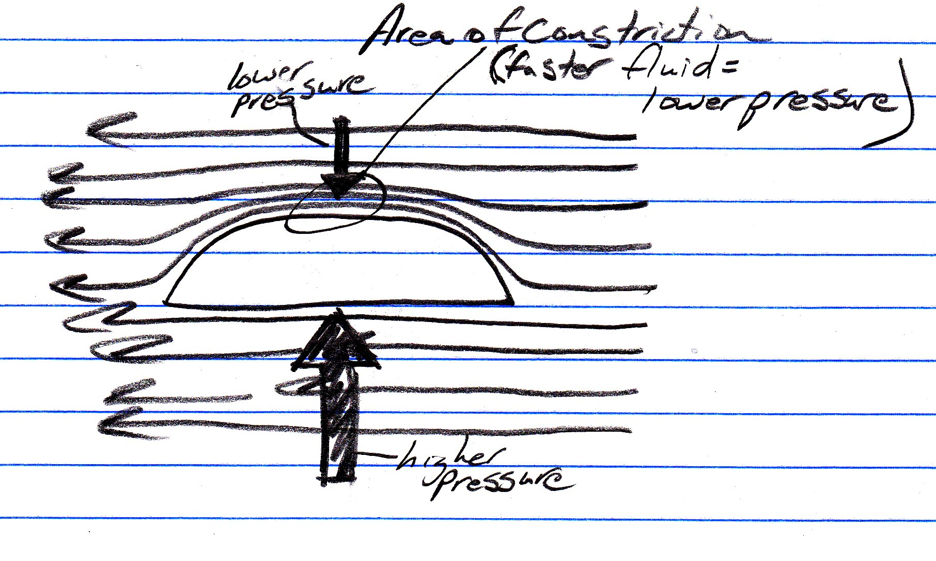
Bernoulli + Equation of Continuity

10. Use a diagram to show how air flowing past a Frisbee™ gets constricted. Explain why this helps a Frisbee ™ stay aloft.

The shape of the disc causes the passing air to travel as shown in the diagram. Air hitting the lip of this disc gets deflected upward, causing the streamlines above the disc to get compressed together. According to the equation of continuity, when the cross-section of flowing fluid decreases, that fluid must speed up. This increased speed means (according to Bernoulli’s equation) that there must be a drop in pressure. The big arrows in the diagram represent the higher pressure of the slower-moving air below and the lower pressure of the faster moving air above. The net force resulting from these two pressures in upward.

Magnus Effect
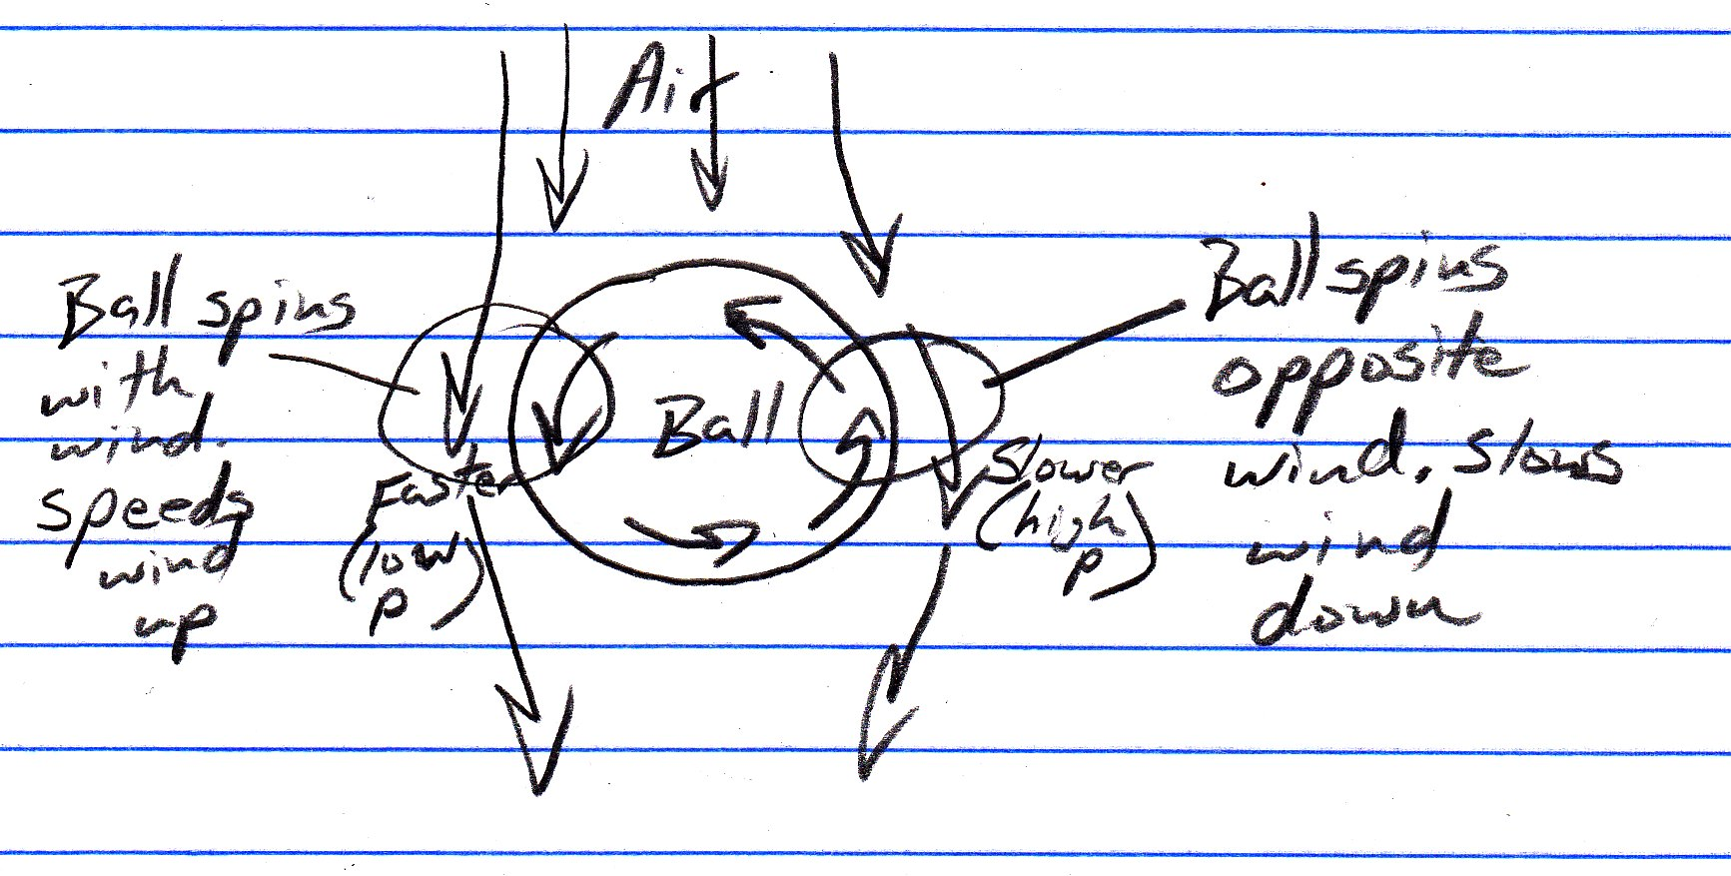
11. Use a diagram to help explain why a curveball curves the way it does.

The diagram is a top view of a ball. Air is shown to be moving “downward” past the ball, so the ball can be understood to be moving upward on this sheet of paper.

The left side of the ball is spinning in the same direction that the wind is moving (downward on this page), so that side of the ball will give the already moving air an extra push. It will speed up the air.

The right side of the ball is spinning counter to the air movement, so it will slow the air down a bit.

Faster air has lower pressure, so there is lower pressure on the left side of the ball. The ball will therefore be pushed to the left.

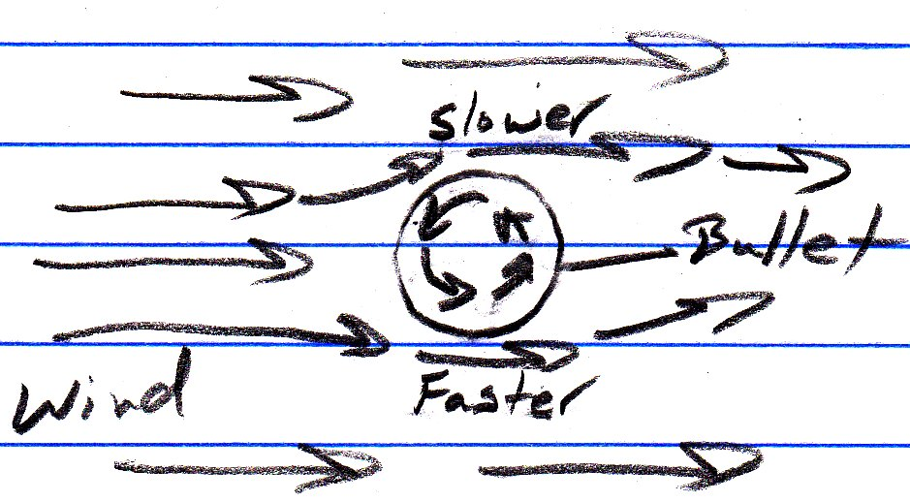
12. You shoot a rifle at a distant target. The “rifling” in your barrel causes the bullet to spin counter-clockwise (from your perspective, watching it travel away). There is a left-to-right wind (again, from your perspective as you watch the bullet travel away). Assuming that you’ve accounted for the slowing of your bullet due to air resistance, the drop due to gravity, and the rightward push of the wind, your bullet will still not hit its expected target. You haven’t accounted for the Magnus Effect. Will your bullet’s impact point be above, below, to the left, or to the right of the point where you expected it to hit?

This is the same as the curve ball question, except that the air is moving left to right in the picture. Also, in the case of the curve ball, the ball was moving and the air was still, but that doesn’t really make a difference.

In this case, the air below the bullet gets sped up by its interaction with the surface of the bullet (which spins to the right on its bottom), so there is lower pressure below the bullet. This will cause the bullet to undergo extra downward drift.

Also To Do:

13. Measure the max air pressure output of both air sources.
a. black “air source” b. big, round, manila air source
Water Rocket Project
Guidelines/Restrictions:
- Rockets must be propelled only by compressed air (90 psi gauge pressure) and tap water.
- • Rockets must be compatible with class launcher (or your own launcher)
    - o Nozzles must be compatible with 2-liter bottle caps.
    - o Fins, etc. must not interfere with launcher "jaws."
- Rockets must be "made from scratch." Aside from basic construction materials (glue, tape...), parts must not be used for their intended purposes.
- • Items that are allowed:
    - o multi-stage rockets [I've never seen a successful one.]
    - o rockets with very large (spliced together) compression chambers [very difficult to do].
    - o parachutes

4th Quarter Grading (percentages approximate):
- (30% of quarter grade) Time aloft -- Cutoff for an "A" (93%) is 14 seconds. 20 seconds for an A+. 40 seconds for 100%. Extra credit for top 3 groups.
- (20%) Excel Rocket Flight Simulator Spreadsheet.
- (20%) Document your design process -- In a PowerPoint Presentation or a video, document your design process. Show the evolution that led to your final rocket design. Explain the changes that you made along the way, as well as why you made them. Share your discoveries and unanswered questions. Show your parachute ejection mechanism in detail. -- Keep it simple!! Use a digital camera (the class one or your own) take pictures of all of your modifications and rocket iterations.

Ft = Δmv. Ft is called "impulse." Impulse is the product of a force and the time over which the force is applied. When a force is applied to an object over a period of time, that object accelerates or decelerates. Thus the object's momentum changes. Impulse is equal to the change in the object's momentum.
By rearranging Ft = Δmv, we can get F= Δmv/t, or F = (Δm/t) (v). This final form is useful for rocket thrust. In a rocket, tiny particles are accelerated and ejected from the rocket. An "action" force accelerates those particles away from the rocket, and a "reaction" force accelerates the rocket in the other direction. In this final form of the impulse equation [F = (Δm/t) (ve)], Δm represents the mass ejected from the rocket per unit of time, and v represents the velocity at which that mass is moving as it leaves the object. The more mass leaving per second, and the faster the mass is moving as it leaves, the greater the thrust generated. In the case of a water rocket, Δm/t is the mass of water being lost by the rocket per unit of time (in kg/s). The exit velocity (ve) is the velocity (in m/s) at which water is exiting the rocket.

We have Fthrust = (Δm/t) * ve.
Calculating Water's Exit Velocity:
We can find ve using Bernoulli's equation (P1 + 1/2 ρv1² + ρgh1 = P2 + 1/2 ρv2² + ρgh2). Remember that Bernoulli's equation applies to the pressure exerted on two different cross-sections of a liquid, which are represented by the left and right sides of Bernoulli's equation. These could be two points along a pipe, or one could be the surface of the water in a water rocket while the other is the surface of the water coming out of the water rocket’s nozzle.
First, let's assume that P1 is the gauge pressure of the pressurized air in a rocket. If that's the case, we can simply leave out P2 and use this gauge pressure for P1. [Here's why we can do this: If we used actual pressures, on the left side of the equation, we would have P1 = Pgauge + Patmospheric , and on the right side of the equation, we would have P2 = Patmospheric. "Patmospheric" values would be on both sides of the equation, so they would cancel one another out. We would be left with only Pgauge on the left side of the equation.] With P2 gone, our equation now looks like (P1 + 1/2 ρv1² + ρgh1 = 1/2 ρv2² + ρgh2).
Second, let's assume that the hole through which water is leaving is fairly small relative to the overall volume of water. In other words, there's enough of a constriction so that all of the water doesn't go whooshing out instantly. If this is the case, the velocity of the water leaving through the hole is much higher than the velocity of the surface of the water inside the rocket. In fact, that difference is so large that we will assume here that the water's upper surface has zero velocity. Setting v1 = 0 allows us to get rid of some more of Bernoulli's equation. So now we have (P1 + ρgh1 = 1/2 ρv2² + ρgh2).
Third, a portion of Bernoulli's equation is concerned with pressure generated by the height of a column of fluid. In the case of our water rockets, the height of the water column in the rocket is very small, so it generates very little pressure. Furthermore, the pressure in the rocket is very high, causing the effects of this gravity-generated pressure to be even more negligable. So, let's leave out anything having to do with h1 or h2. This gives us our final useful formula, P1 = 1/2 ρv2², or Pgauge = 1/2 ρve², where ve is the exit velocity of the fluid in the rocket and ρ is the density of that fluid.
We can rearrange this to get ve = (2Pgauge/ρwater)^{1/2}.
Now we have two equations: one for thrust [Fthrust = (Δm/t) * ve] and one for exit velocity [ve = (2Pgauge/ρwater)^{1/2}]. These can be combined and simplified.
Calculating Rate of Mass Loss (Δm/t):
In order to calculate the thrust of a water rocket, we need to find a new way to write Δm/t, which can be thought of as mass of water ejected per unit of time. More precisely, we want to know how many kilograms of water are exiting the rocket each second. Since the rocket nozzle is a circle, we can visualize the water exiting the rocket as a cylinder. If we know how big that cylinder is and how fast it is shooting out of the nozzle, we can get an idea of how much mass is being lost every second.
In fact, we can easily calculate the cylinder's cross-sectional area. We can also easily calculate the speed with which the cylinder of water moves (using the ve equation). The exit velocity of the cylinder of water, in meters per second, tells us the length of cylinder that exits the rocket per unit of time. If we know this length, and we also know the cross-sectional area of the cylinder, then we can calculate the volume of the cylinder that exits per unit of time. The formula for the volume of a cylinder is V= meters of length * area, so the volume of water exiting per second is: V/t = (meters of length/t) * area. The water's exit velocity, ve tells us the meter of water that exit per second, so the volume of water exiting per second is V/t = ve*A. The volume of water leaving the rocket per unit of time is a "change in volume," so this equation can be written as ΔV/t = ve *A.
Now we know the volume of water leaving the rocket per unit of time, but what we really want to know is the mass of water leaving the rocket per unit of time. Density = m/V, so m=ρV. Therefore, if we take the equation from the previous paragraph (for volume of water leaving the rocket per unit of time), and we multipy this volume by the density of water, we get expressions for the mass of water lost per unit of time. ρ(ΔV/t) = Δm/t = ρ*ve*A. In summary, rate of mass loss = Δm/t = ρ*ve*A
Final Simplification of Water Rocket Thrust:
Finally, we can substitute Δm/t = ρ*ve*A into the thrust equation Fthrust = (Δm/t) * ve. This gives us Fthrust = (ρ*ve*A)*ve = ρ *ve²*A.
From the previous page, ve = (2Pgauge/ρ)^{1/2}, so ve² = 2Pgauge/ρ. Thus, Fthrust = ρ *ve²*A = ρ*(2Pgauge/ρ)*A = 2PgaugeA.
So, for an air pressure-powered water rocket, Fthrust = 2PA, where P = gauge pressure.
Water Rockets Provide 2X More "Kick" Than Potato Guns:
Note that water rocket thrust is twice as powerful as the thrust provided by a potato chunk that is being shot from a potato gun. In the case of a potato gun, the force of thrust is only PA.
The seeming contradiction stems from the fact that the potato accelerates from zero, finally achieving a maximum velocity as it leaves its barrel. The stream of water of a rocket, however, shoots from the rocket at a constant exit velocity, seemingly bypassing the act of acceleration. The potato's average velocity is half of its exit velocity, whereas the water's average velocity is equal to its exit velocity.
This means the water provides twice as much thrust, but it also means that the water leaves the rocket twice as fast. In each case, for equal ejected masses ejected by equal pressures, Ft = Δmv is the same. The water provides a stronger force for a shorter time. The potato provides a weaker force for a longer time. In both cases, the change in momentum provided by these forces is the same.
A water rocket has been constructed using a 20-liter water cooler bottle for its compression chamber. The bottle has a mouth with an inner radius of 0.03 m. In preparation for the rocket’s launch, the air in the rocket is pressurized to a gauge pressure of 40psi. Before pressurization, 60% of the bottle's volume was filled with water. The mass of the empty rocket (everything except water and added air) is 2.3 kg. The additional air added to the bottle during “inflation” adds another 0.04kg to the total mass of the rocket.
- What is the initial exit velocity of the water that spews from this 20-liter bottle?
- What is the initial rate at which mass is lost (in kg/s) from this bottle?
- What initial thrust is produced by this expulsion of water?
- What is the initial mass of water in the rocket?
- What is the initial volume of air in the rocket?
- What is the initial total mass of the rocket?
- What is the initial total weight of the rocket?
- What is the initial net force acting on the rocket?
- What is the initial acceleration of the rocket?

At these rates, after 0.01 seconds have elapsed…
- …what is the new volume of air in the rocket?
- …assuming that P1V1^{1.4} = P2V2^{1.4}, what is the new air pressure inside the bottle?

A water rocket has been constructed using a 2-liter water bottle for its compression chamber. The bottle has a mouth with an inner radius of 0.01 m. In preparation for the rocket’s launch, the air in the rocket is pressurized to a gauge pressure of 90psi. Before pressurization, 40% of the bottle's volume was filled with water. The mass of the empty rocket (everything except water and added air) is 0.15 kg. The additional air added to the bottle during “inflation” adds another 0.008kg to the total mass of the rocket.
- What is the initial exit velocity of the water that spews from this 20-liter bottle?
- What is the initial rate at which mass is lost (in kg/s) from this bottle?
- What initial thrust is produced by this expulsion of water?
- What is the initial mass of water in the rocket?
- What is the initial volume of air in the rocket?
- What is the initial total mass of the rocket?
- What is the initial total weight of the rocket?
- What is the initial net force acting on the rocket?
- What is the initial acceleration of the rocket?

At these rates, after 0.01 seconds have elapsed…
- …what is the new volume of air in the rocket?
- …assuming that P1V1^{1.4} = P2V2^{1.4}, what is the new air pressure inside the bottle?

