Physics II Name: _____________________________
Cloud Formation

Candle In A Jar:

1. The diagrams below are incomplete. By drawing on any or all of the diagrams, show what happens when you place a burning candle in a dish of water, and then you cover the candle with a jar.

2. Add notes to explain why what you drew is happening.

Kinetic Molecular Theory: attributes macroscopic characteristics and behavior of matter to the microscopic motions of molecules.

Molecules are locked in place and touching, but they’re vibrating.
Molecules are touching, but they’re moving around, slithering across one another
Molecules are not generally touching. They’re flying around and occasionally colliding.
Solid
Liquid
Gas

3. Explain why sweating cools us off. Or explain why rubbing alcohol makes our skin feel cold.

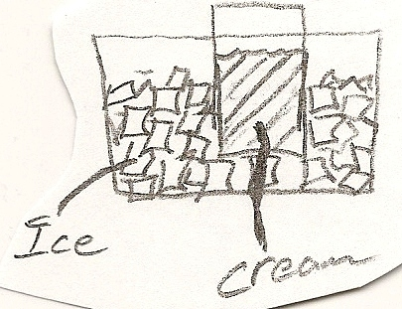
4. The picture on the right shows some delicious cream and some ice. The temperature of the ice is almost exactly 0 degrees Celsius. It’s not cold enough to freeze the cream. Explain where to add the salt and why it makes the ice cream freeze.

Temperature Change Due To Compression/Decompression

The three pictures on the right show a moving molecule and a teeny, tiny ping pong paddle. In the first picture, the paddle is moving toward the molecule. In the second, the paddle is held perfectly stationary. In the third, the paddle is allowed to be pushed downward by the collision with the molecule.
A
B
C
5. In which situation will the molecule speed up the most after being hit by the paddle?
6. In which situation will the molecule slow down after hitting the paddle?
after being hit by the paddle?
7. In which situation will the molecule’s speed remain approximately the same after hitting the paddle?

The three pictures on the right show “boxes” which have teeny, tiny ping pong paddles for walls. Inside the boxes, molecules are bouncing around. In box A, the walls are moving in. In Box B, the walls are held perfectly stationary. In Box C, they are allowed to be pushed out by the molecules.
A
B
C

8. In which “box” will the walls behavior cause the molecules to speed up?
9. In which “box” will the walls behavior cause the molecules to slow down?
10. In which “box” will the walls behavior not affect the molecules’ speeds?

11. Rapidly squeezing air causes its temperature to ______________________________, because…

12. When air is allowed to rapidly expand, its temperature ______________________________, because…

Isothermal Compression/Expansion: temperature is kept constant, as heat is allowed to flow into or out of the system. Slow compression or decompression is an isothermal process, because heat can be transferred into or out of the system. Compression/decompression of small bodies is often isothermal for the same reason. For an isothermal system, PV = constant.

Adiabatic Compression/Expansion: no heat enters or exits the system, resulting in a temperature change as work is done on or done by the system. Compression/decompression that is rapid, or that occurs in large bodies of gas, is adiabatic, because heat cannot be thoroughly transferred before the process has ended. For an adiabatic system, PV^{γ} = constant. For air, γ = 1.4.

Putting it All Together – Cloud Formation
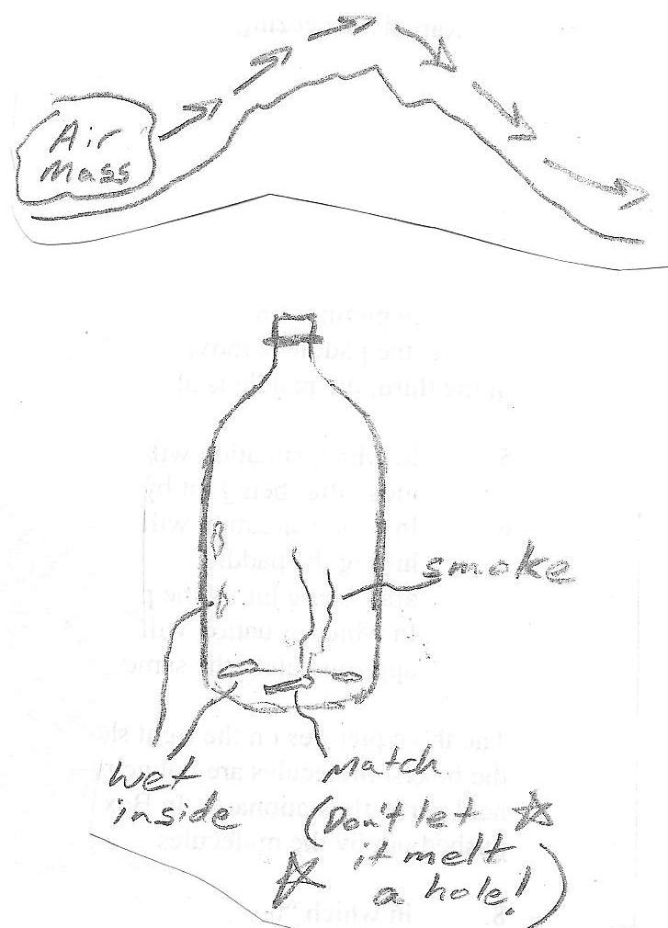
“Cloud In a Bottle” Activity:
- Get some matches, and a clear plastic bottle with a cap.
- Get the inside of the bottle wet by doing the following. Put water in the bottle and shake it around. Then pour out the water.
- Light a match and get it burning well. Drop it in the bottle while it’s burning, and quickly shake the bottle to put it out. Cap the bottle tightly before the smoke escapes.
- Now squeeze the bottle as hard as you can for one second.
- Stop squeezing and let the bottle expand for one second.
- Squeeze again for another second, with all of your might. But don’t jump on the bottle. This should be a steady squeeze.
- Release your squeeze.
- Squeeze again….
- Keep repeating this until you see a cloud forming and disappearing. Pay close attention to when the cloud is appearing and when it is disappearing.

Cloud in a Bottle Questions: Circle the correct word or phrase, in parentheses.

When you squeeze the bottle….
13. The air is (being compressed, expanding)
14. That change is causing the air’s temperature to (increase, decrease).
15. That temperature change is causing water molecules in the bottle to (evaporate, condense).
16. Tiny droplets of water in the air are (appearing, disappearing)

When you release…
17. The air is (being compressed, expanding)
18. That change is causing the air’s temperature to (increase, decrease).
19. That temperature change is causing water molecules in the bottle to (evaporate, condense).
20. Tiny droplets of water in the air are (appearing, disappearing)

21. Suppose you’re a weatherman. You notice that a large high pressure center is moving into your area. Should you forecast that the weather will be clear or cloudy?

22. High pressure = (clear skies, cloudy skies)
23. Low pressure = (clear skies, cloudy skies)

Suppose some air is passing over a mountain range, as shown on the right.

What happens to a mass of air as it rises up the west side of the mountains?
24. As the air rises, it will encounter (higher pressure, lower pressure)
25. This pressure change will cause the air to (expand, be compressed)
26. This change in the air’s volume will cause the air to (cool down, heat up)
27. This change in the air’s temperature, will cause water molecules in the air to (evaporate, condense)
28. Tiny droplets of water in the air are (appearing, disappearing)
29. This area of rising air is (cloudy, clear)

What happens to a mass of air as it sinks down the east side of the mountains?
30. As the air sinks, it will encounter (higher pressure, lower pressure)
31. This pressure change will cause the air to (expand, be compressed)
32. This change in the air’s volume will cause the air to (cool down, heat up)
33. This change in the air’s temperature, will cause water molecules in the air to (evaporate, condense)
34. Tiny droplets of water in the air are (appearing, disappearing)
35. This area of rising air is (cloudy, clear)

36. Rising air = (clear skies, cloudy skies)
37. Sinking air = (clear skies, cloudy skies)

