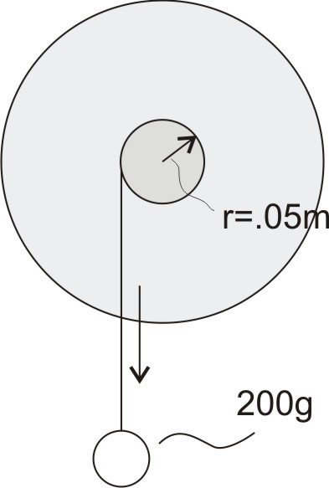
Physics II Name: ________________________________________

Test: Rotational Motion

Suppose you have a disc with a smaller disc attached at its center. A string is wrapped around the outside edge of the smaller disc, and a 200g mass is attached to the end of the string. The mass of the string is negligible. When the mass is released, the mass drops, the string to unwinds, and the disc rotates. Starting from rest, the mass falls 0.7m in 10 seconds. The radius of the smaller disc is 0.05m.

1. What is the linear acceleration (m/s²) of the mass as it drops?
2. What is the tension (approximate or actual) in the string as the mass is dropping (in Newtons)?
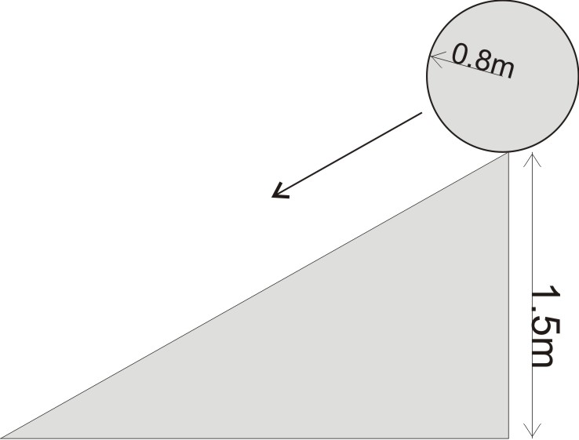
3. How much torque does the string apply to the disc?
4. What is the angular acceleration (α) of the disc?
5. What is the disc’s moment of inertia (I)?

A second disc is allowed to roll down a ramp. The ramp’s vertical drop is 1.5m, and the disc’s velocity at the bottom of the ramp is 5m/s. The disc’s radius is 0.08m.

6. What is this second disc’s moment of inertia?
7. What is this second disc’s rotational kinetic energy when it reaches the bottom of the ramp?

The diagram below shows a penny smearing machine. An operator turns the big crank while feeding a penny into the space where the smearing wheel meets the smearing plate. The big crank turns sprocket A, which turns sprocket B via the chain. Radii are listed in the table.

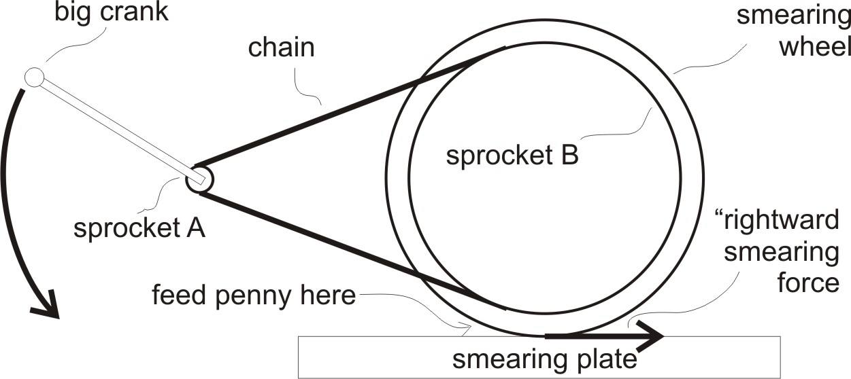
Big Crank length | 0.3m
Sprocket A radius | 0.02m
Sprocket B radius | 0.8m
Smearing Wheel Radius | 0.83m

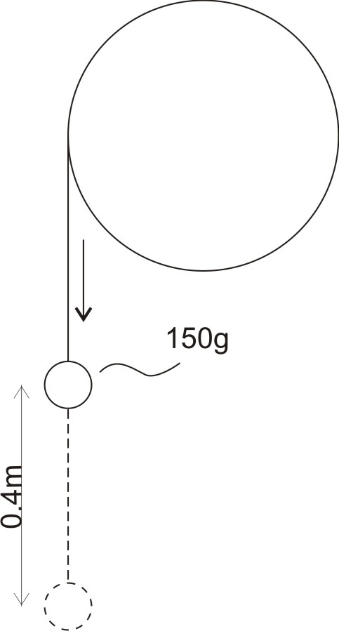
8. The smearing wheel applies a force to the penny that pushes it to the right. What is the magnitude of this rightward force when an operator applies a 40N force to the big crank. ?
9. How far will a point on the outside edge of the smearing wheel move during each rotation of the big crank?
10. If an operator turns the big crank at a rate of one revolution every 1.8 seconds, how fast is the outside edge of the smearing wheel moving (in m/s)?

String is wrapped around a pulley. A 150g mass is suspended from the string, held at rest, and then allowed to fall 0.4m. The mass falls the 0.4m in 2 seconds.

11. What is the mass’ linear acceleration during its fall?
12. What is the mass' kinetic energy at the bottom of its 0.4m fall?
13. What is the pulley’s kinetic energy when the mass reaches the bottom of its 0.4m fall?

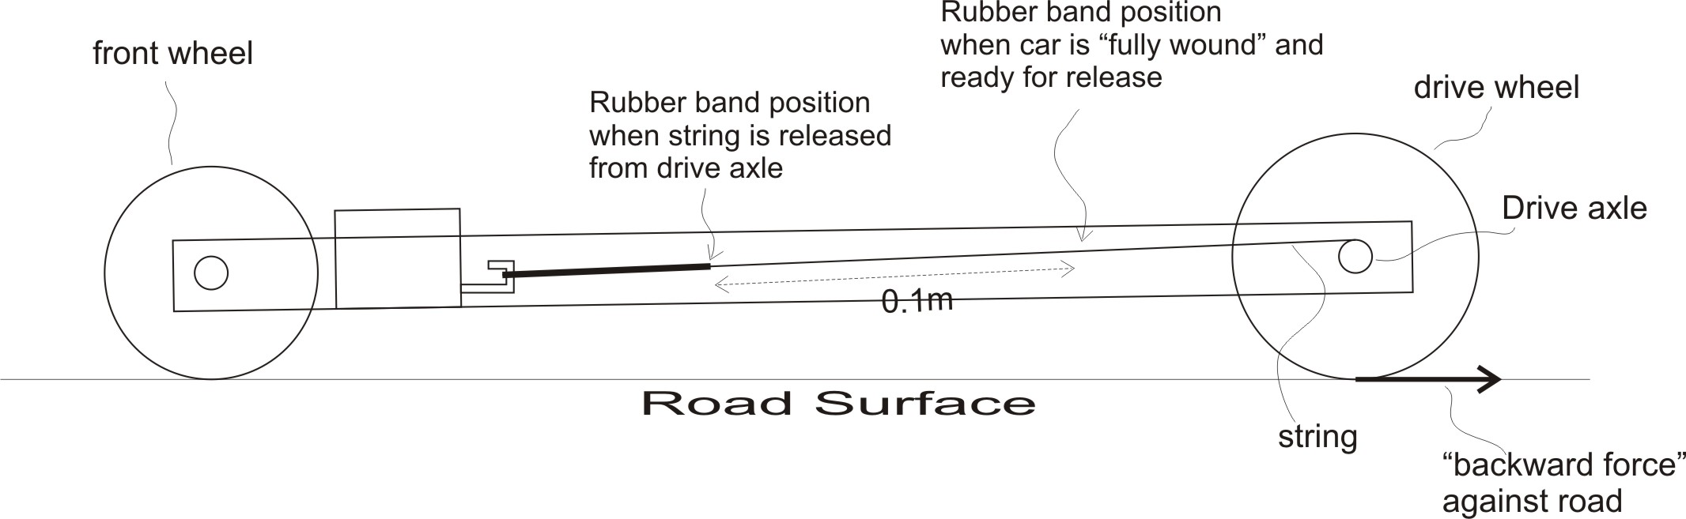
Diagram and Table Support #14-22.
Length of string wrapped around axle (m) | 0.1
Force of rubber band at moment when string is released from drive axle (N) | 4
Force of rubber band when string is fully wound (N) | 12
Total car mass (kg) | 0.2
Drive Wheel Radius (m) | 0.03
Front Wheel Radius (m) | 0.02
Drive wheel and axle Moment of Inertia (kgm^2) | 0.00006
Front wheel and axle Moment of Inertia (kgm^2) | 0.00004
Drive Axle Radius (m) | 0.003

14. What is the average force applied by the rubber band as it pulls string from the car’s drive axle?
15. What is the distance over which that force is applied?
16. How potential energy is stored in the rubber band when the string is fully wound (assuming 100% efficiency).
17. What initial backward force do the car’s drive wheels apply to the road?
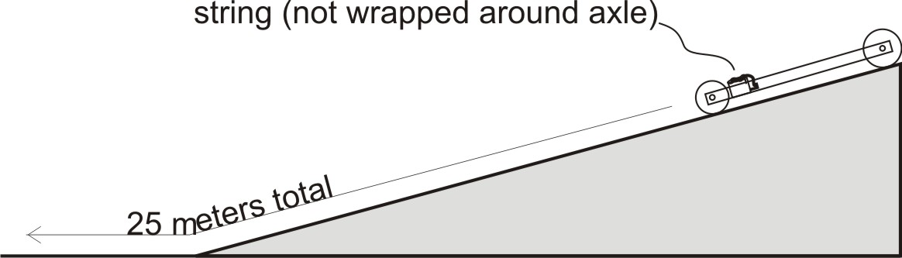
18. Suppose the car is released at the top of a ramp. The string is not wound, so the car is powered only by gravity. The car travels down the ramp and rolls out onto a level surface. During its descent, the car's center of gravity drops 0.6m vertically. After rolling a total linear distance of 25m, the car comes to a stop. What is the net force of friction that is opposing the car’s motion? [Assume that this force of friction is the same on the ramp and the level floor.]
19. The car is fully wound and released from rest on a level surface. How far will the car travel before its string unwinds?
20. If the car is fully wound in the beginning, what is the car’s approximate total kinetic energy at the moment the string unwinds?
21. What is the car’s velocity at the moment that all of the string is unwound?
22. What is the total distance that this car will travel before coming to a stop?

