Physics 200 Name: _________________________________
Midterm Exam Topics/Scope
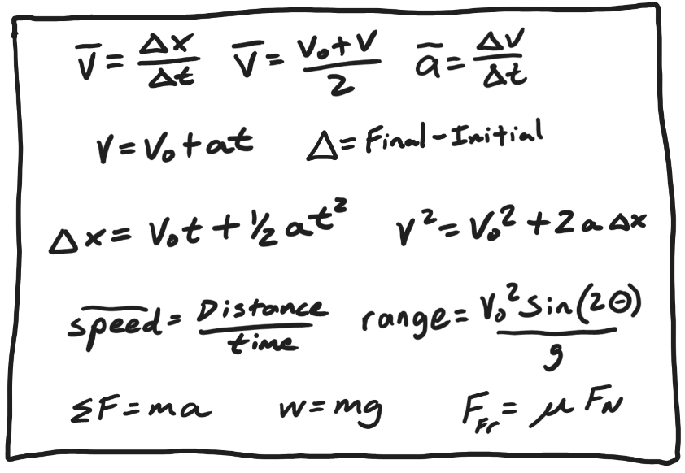
Formulas: Be able to apply any of these formulas. **You will not need the drag formula.**

Part 1: Multiple Choice and Short Answer

Basic Vocabulary, Symbols, Definitions:
- Identify vectors or scalars.
- Definitions of basic kinematics terms
- Describe the 5 basic types of forces
- Interpret symbols/notation used in kinematics equations.
- Know the symbol for net force and be able to distinguish it from normal force.
- Know conversions from N to lbs, kg to lbs, feet to m, and m/s to mph.
- Weight
  - Know what it is.
  - Be able to explain situations where something seems to be weightless but isn’t.
  - Be able to explain situations where something seems to have weight but is, in fact, weightless.
  - Know the value of g and how to use it in equations.

Types of motion and graphing:
- Be able to describe the motion of an object with any of the “9 types of motion” (+,-,or zero velocity and +,-,or zero acceleration.) Generally, describe direction and whether the object is speeding up or slowing down.
- Match graphs showing the same motion depicted with different quantities (position, velocity, or acceleration -- vs time).
- Given a scenario matching the behavior of an object to a timeline, create a graph of the object’s acceleration vs. time.
- For any stage in a water rocket’s flight, sketch graphs of position, velocity, and acceleration – versus time.

Projectile Motion: On a diagram showing the path of a projectile where one of the projectile’s velocity vectors is shown at one point, draw the vectors V, Vx, and Vy at multiple points along the path (including at least one at the apogee).

Part 2: Problems There are currently 10 problems, corresponding to the numbers below. #9 isn’t actually a problem.

- 1) Find velocity and speed of an object in a situation where they are not the same.
- 1-D kinematics “find everything” problems
  - 2) A problem in the x dimension
  - 3) A “free-fall” problem in the y dimension
- Projectile Motion Problems:
  - 4) Find “everything” in an asymmetric projectile problem.
  - 5) In a symmetric projectile problem where something is launched horizontally, find $∆t$ and one of these variables when the other two are provided: $v_{0}, ∆y, ∆x$
- 1-D Force Problems:
  - Based on information provided – and on your calculations, draw (or complete) a diagram showing all of the individual forces and net force acting on an object. [You will need to utilize the two different ways of finding net force.] There will be two of these…
    - 6) A scenario involving either an object hanging from a rope or an object on an elevator floor, accelerating upward or downward.
    - 7) A water rocket in some stage of flight.
- 8) Problem with 1-D Forces AND Kinematics. Either use kinematics to find acceleration and acceleration to find force – or – use forces to find acceleration and acceleration to find some other motion quantity. This problem may happen in the x or y dimension, and it may include any combination of the 5 types of force.
- 9) 3rd Law Pairs: This one isn’t really a problem – identify the 3rd law “reaction” forces for all of the forces acting on the object in the previous problem
- 10) 2-D forces problem – similar to one of two problems from the Unit 3 test -- either problem 1 (box sliding down incline) or problem 2 (box dragged by a rope at an angle)

