Semester Exam Name: ____________________________
Physics 200 (25-26) Practice Exam

Multiple Choice, Matching, and Short Answer

1. Circle all of the quantities that are scalars.
Distance Acceleration Displacement Velocity Force Speed

2. This tells us how far something has moved, and it also tells us the direction of that movement.
Position Displacement Velocity Speed Acceleration Distance

3. This tells us how fast something is moving, but it does not tell us the direction of its movement.
Position Displacement Velocity Speed Acceleration Distance

4. This tells us how the velocity of an object changes over time.
Position Displacement Velocity Speed Acceleration Distance

#5-9 Answer Choices: A. Drag B. Tension C. Weight D. Normal Force E. Friction

5. A B C D E Resistance between two surfaces sliding across one another

6. A B C D E A force exerted perpendicularly outward by a surface

7. A B C D E The pulling force in a rope, cable, or chain

8. A B C D E The force of a planet’s gravity acting on a smaller object.

9. A B C D E Resistance acting on an object moving through a fluid

10. Average Velocity: $v_{0}$ $v$ $\overline{v}$ $y$ $∆x$ $a$ $∆t$ $∆v$

11. Change in Position: $v_{0}$ $v$ $\overline{v}$ $y$ $∆x$ $a$ $∆t$ $∆v$

12. Final Velocity: $v_{0}$ $v$ $\overline{v}$ $y$ $∆x$ $a$ $∆t$ $∆v$

13. Initial Velocity: $v_{0}$ $v$ $\overline{v}$ $y$ $∆x$ $a$ $∆t$ $∆v$

Fill in the blanks…

14. 1N = ________________ pounds 15. 1kg = _________________ pounds

16. 1 foot = _________________ meters 17. 1 m/s = _________________ mph

18. Write the symbol for Net Force:

19. Write the abbreviation for Normal Force.

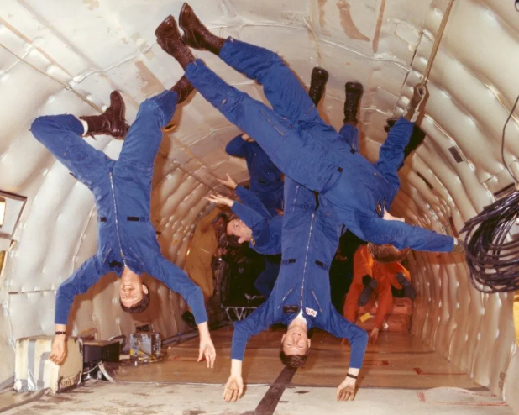
20. These astronauts are training in an airplane nicknamed the “Vomit Comet,” which allows them to experience zero g’s by flying in a parabolic flight path. Are the astronauts weightless? Explain how you know.

21. Describe what something could be doing if it has positive velocity and negative acceleration

22. Describe what something could be doing if it has zero velocity and positive acceleration.

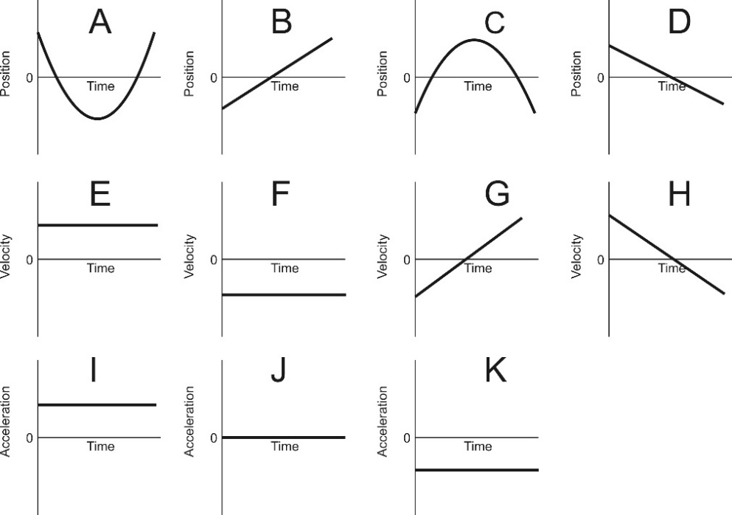
23. Which velocity graph represents the same motion as position graph D?
E F G H
24. Which acceleration graph represents the same motion as position graph B?
I J K
25. Which position graph represents the same motion as acceleration graph K?
A B C D

26. In the space below, sketch a graph of a squirrel’s acceleration based on the following information.
- t=0s: begins to fall
- t=2s: comes to rest on ground at base of tree
- t=2-3s: sits, dazed and motionless.
- t=3-7s: climbs up tree at a constant rate o 2m/s.
- t=7-8s: stops for 1 second to sniff
- t=8-10s: runs up tree, speeding up the entire time

27-28. Draw sets of position, velocity, and acceleration graphs for the water rocket flight stages described below. To keep things simple, assume that accelerations are constant.
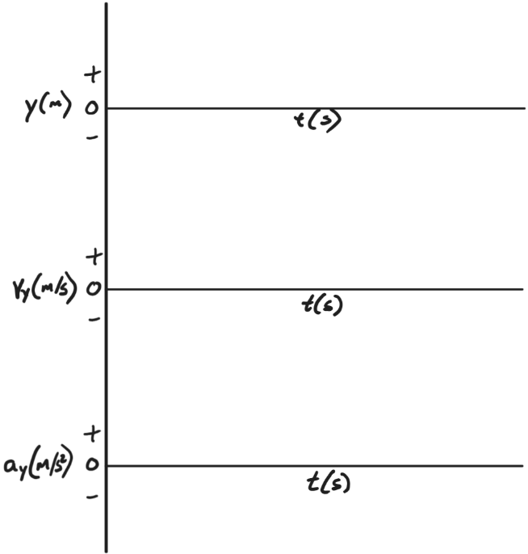
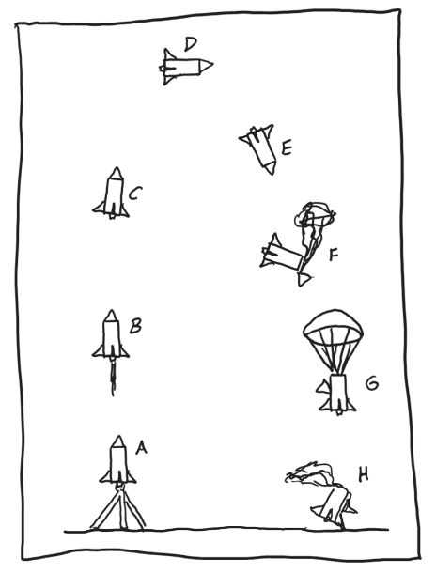
28. Stage G: the rocket is falling at terminal velocity.

29. Stage H: the rocket is still traveling downward, but it is slowing down because of contact with the ground.

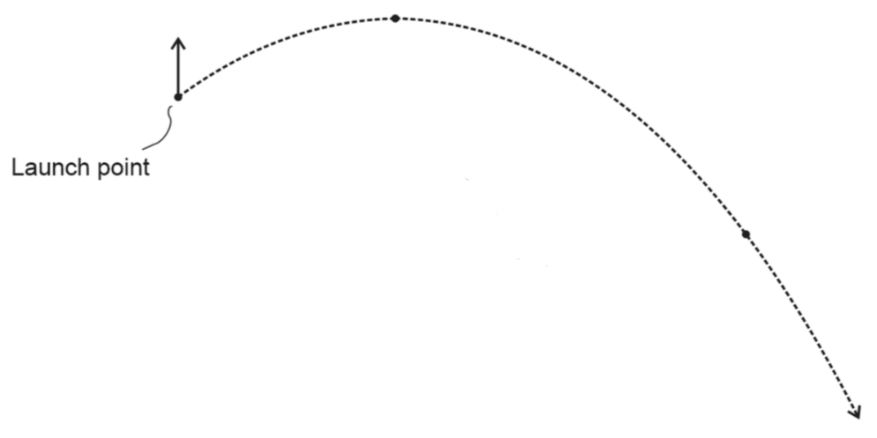
30. Drawing velocity vectors: For each projectile path, one velocity vector is given for one of the points (circular dots)…
- Correctly label the given vector with its name.
- Draw and label the other velocity vectors for that point.
- Draw and label all velocity vectors at the rest of the points indicated by circular dots.
- For every circular dot, include the net velocity vector (v), as well as any other component vector (e.g. v_{x} and/or v_{y} that exists at that point.
- For every vector drawn along the same projectile path, make sure that the vector directions are correct and that their lengths are in correct proportion to one another.

Problems (mostly): ****Include correct units with all answers. Also include correct signs or directions for all answers that are vectors. For possible partial credit, clearly show useful starting formulas and intermediate answers.****

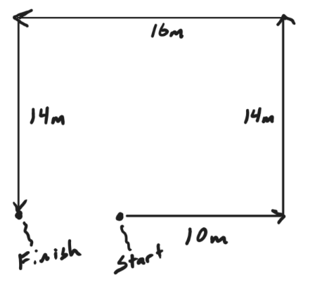
1. Over a 9 second time period, an object travels 10m rightward, then 14m upward, then 16m leftward, and then 14m downward. ** Make sure that you provide complete answers.**
a. What is the object’s average speed for the entire trip?

b. What is the object’s average velocity for the entire trip?

2. A deer is running rightward at 5m/s. After running 20m further to the right, the deer’s velocity is now 12m/s. Find everything in the box -- even the givens.
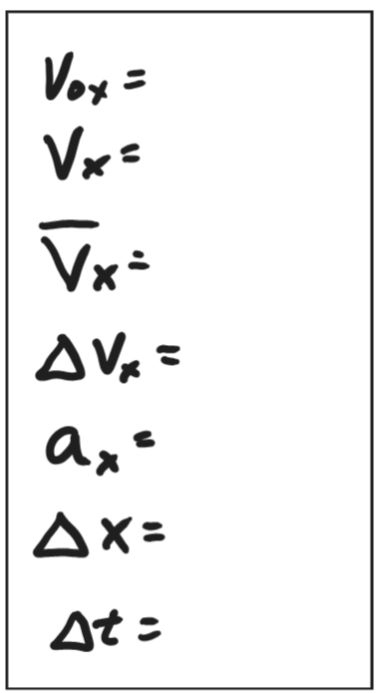

3. A child tosses a ball directly upward with a velocity of 12m/s. One second later, the ball is caught. Find everything in the box -- even the givens.
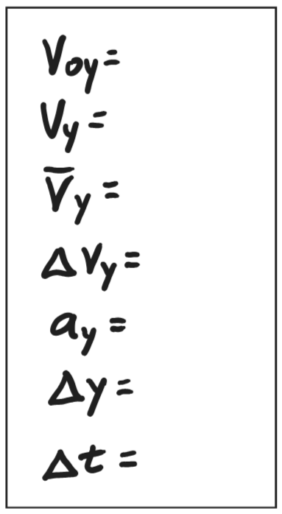

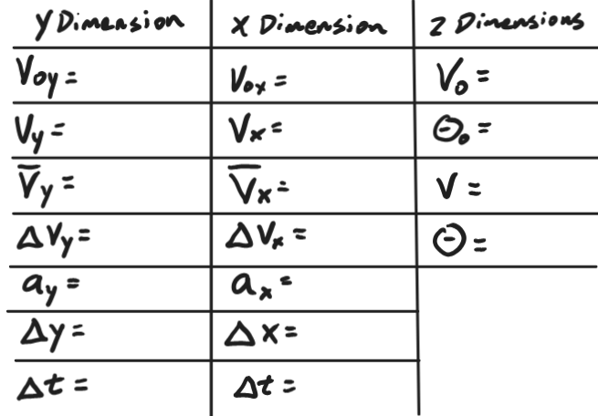
4. You are about to launch a projectile at a 67° angle above horizontal. You know that its initial velocity will be 6.8m/s, and it will hit its target after traveling a y displacement of -1.67 meters.
Fill out the entire answer table. You will even get some credit for the givens.

5. You launch a projectile horizontally (in the positive X direction) from a table top. The initial velocity is 5m/s and the launch point is 1.4 m above the floor.

a. How long is the projectile in the air?

b. How far, horizontally, does the projectile travel before hitting the floor??

6a. Clarise is climbing up a rope. The tension in the rope is 800N, and Clarise’s mass is 60kg…
- Use arrows to show the directions of every individual force – and the net force -- acting on Clarise.
- Label each individual force with a correct name.
- Label each force with its magnitude and correct units.

6b. What is Clarise’s acceleration?

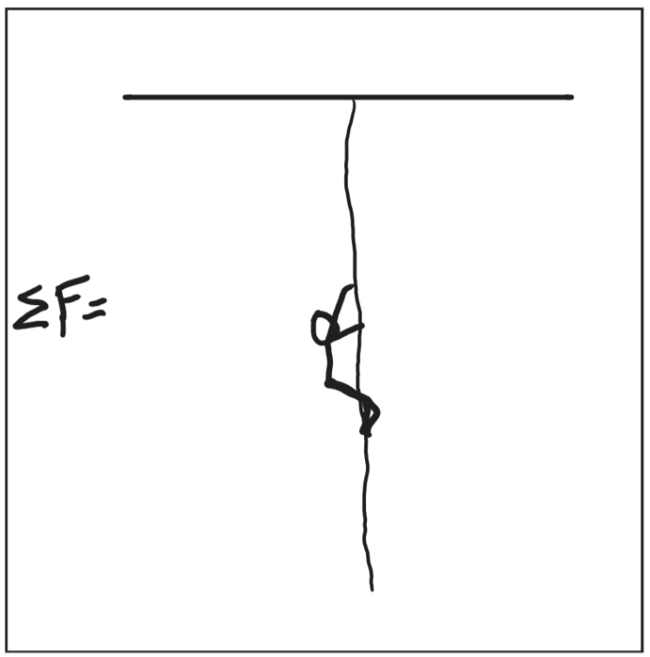

7. A rocket is falling from the sky at a velocity of -15m/s and it is accelerating upward at a rate of 1.5m/s². It is experiencing a drag force of 2N.

- Draw the rocket.
- Use arrows to show the directions of every individual force – and the net force -- acting on the rocket.
- Label each individual force with a correct name.
- Label each force with its magnitude and correct units.

Bonus: Will be here

8. During thrust, a water rocket accelerates from rest to 55m/s over a height vertical distance of 2.4m. During this time, the rocket’s average mass is 0.38kg, and the average thrust is 230N. This problem takes place in real air.

a. What is the rocket’s weight? _______________

b. What is the rocket’s acceleration? _______________

c. What force of drag is acting on the rocket? _______________

9. In the previous problem, there are three individual forces acting on the rocket. Briefly describe each force and its 3rd Law counterpart force.
Force acting on Rocket | 3rd Law “Reaction” Force

10. Only one of these will be on the actual test.

