Find Everything Motion Review Problem #2:

An object undergoes motion during time interval 1, which leads directly to time interval 2. The object’s acceleration is constant during each interval, but its accelerations during the two intervals are different.

- Find the missing values for each interval.
- Propose a real-life scenario that could have accounted for this scenario. Sketch a diagram to explain your scenario

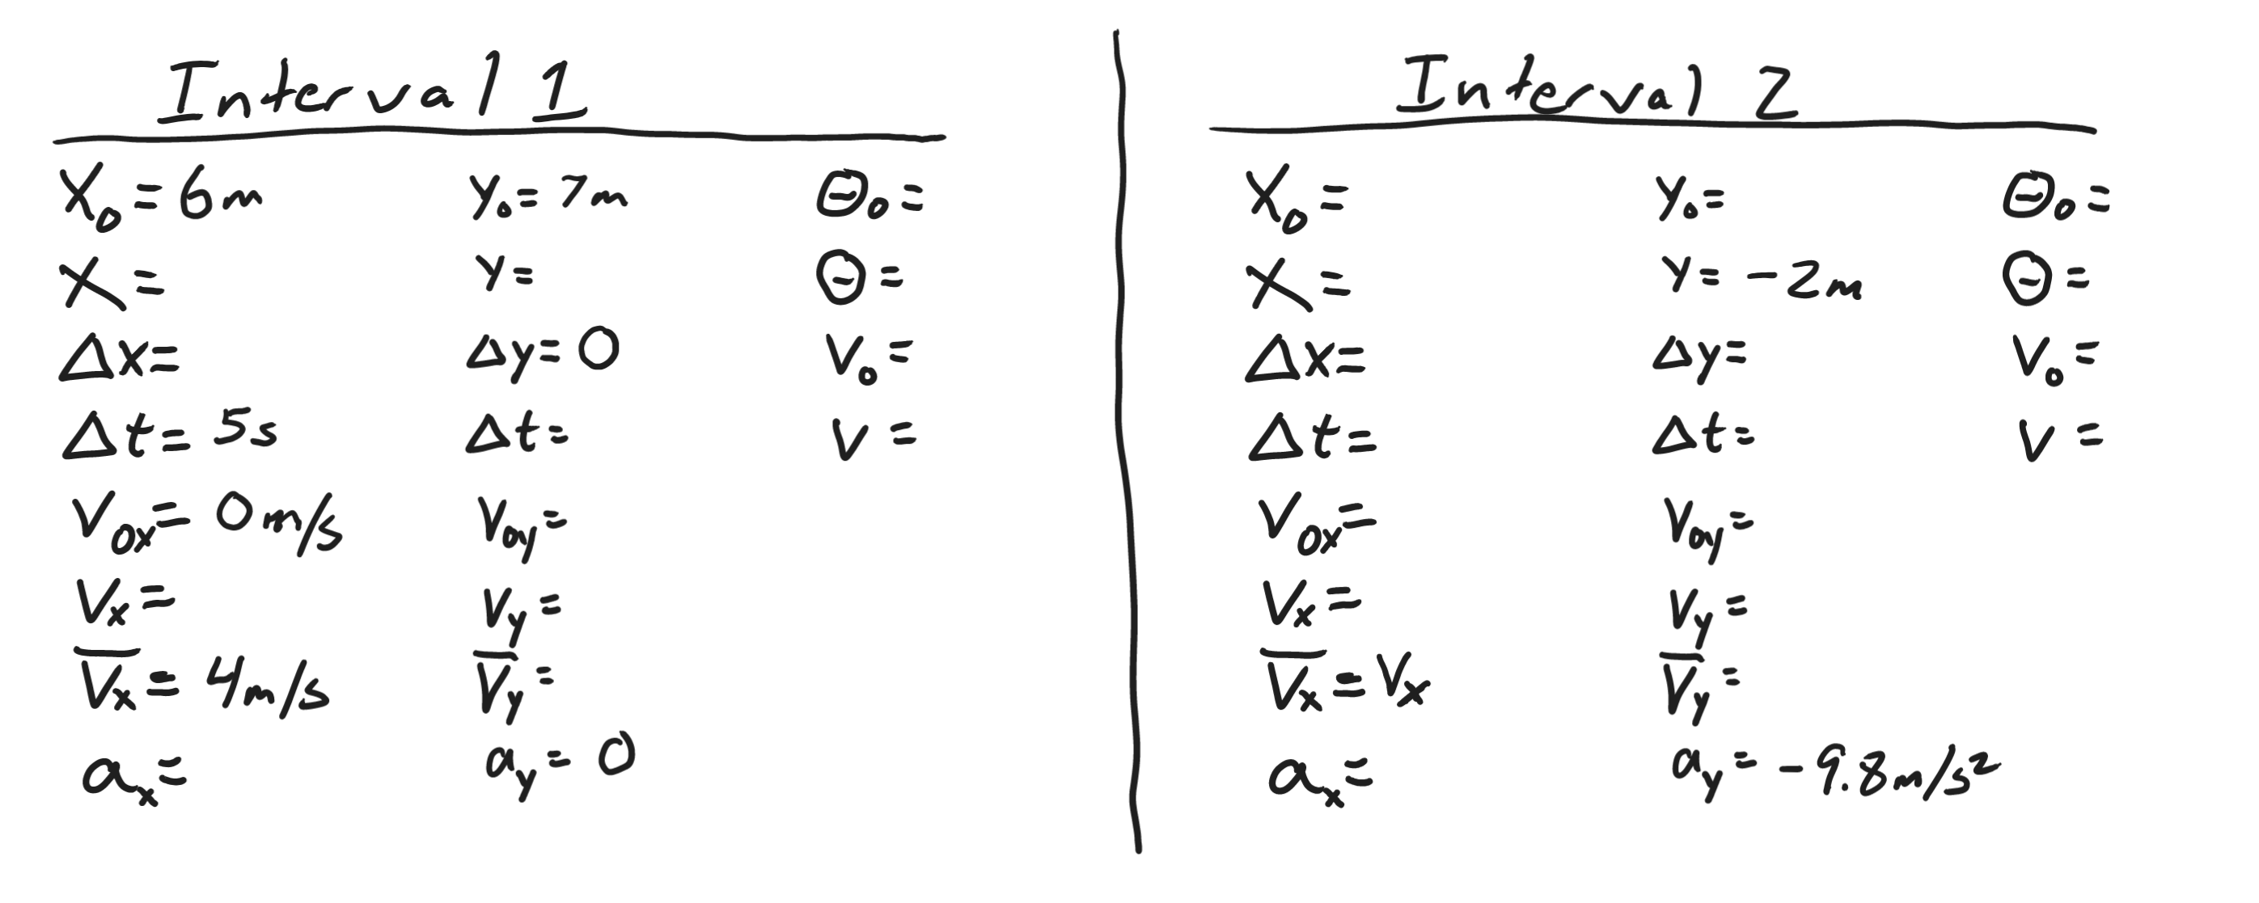

Formulas:
