Physics 200
Semester 1 Formulas, 2017-2018

d=rt [zero acceleration]
Formulas:

$$∆x=x-x_{0}$$

$$v_{x Ave.}=\frac{∆x}{∆t}$$

$$a=\frac{∆v}{∆t}$$

$$∆x=\frac{1}{2}\left(v_{x0 }+v_{x}\right)t$$

$$v_{x}=v_{x0 }+at$$

$$∆x=v_{x0 }t+ \frac{1}{2}at^{2}$$

$${v_{x}}^{2}= {v_{0x}}^{2}+2a(∆x)$$

$${∑F=F}_{NET}=ma$$

$$w=mg$$

$$F_{f}=µF_{N}$$

$$g=9.8\frac{m}{s^{2}}$$

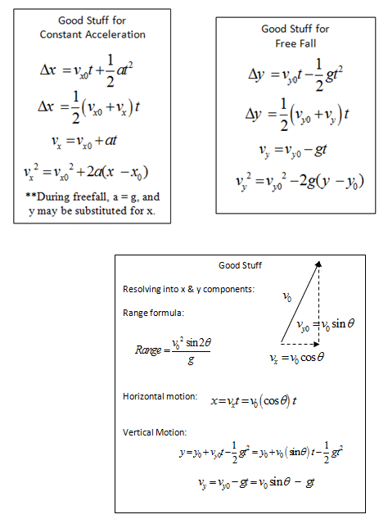

a_{centripetal} = v²/r F_{centripetal} = mv²/r G = 6.67x10⁻¹¹Nm²/kg²

$F_{gravity}=G\left(\frac{M_{1}m_{1}}{r^{2}}\right)$ $\frac{T_{A}^{2}}{T_{B}^{2 }}=\frac{r_{A}^{3}}{r_{B}^{3 }}$ Circumference = 2πr w=mg

W=Fd $P=\frac{W}{t}$ W_{net} = ΔKE $KE=\frac{1}{2 }mv^{2}$ ΔPE = mgh

KE_{initial} +PE_{initial} = KE_{final} + PE_{final} KE_{initial} +PE_{initial} + W_{nc} = KE_{final} + PE_{final}

PE_{spring} =$\frac{1}{2}kx^{2}$ F_{spring} = kx

