Physics 200: Name: ________________________________
Graphical Energy Conservation Practice:

1. A car drives up a hill from position 0(bottom of hill) to position 1 (half way up) to position 2 (top of the hill). Its speed is constant the entire time. The car’s KE₀ and PE₀ are shown.
- Draw the remaining energy bars in a sensible manner.
- Add notes to each non conservative work (W_{NC}) and other energy (OE), indicating the type of energy or what sort of work is being done.
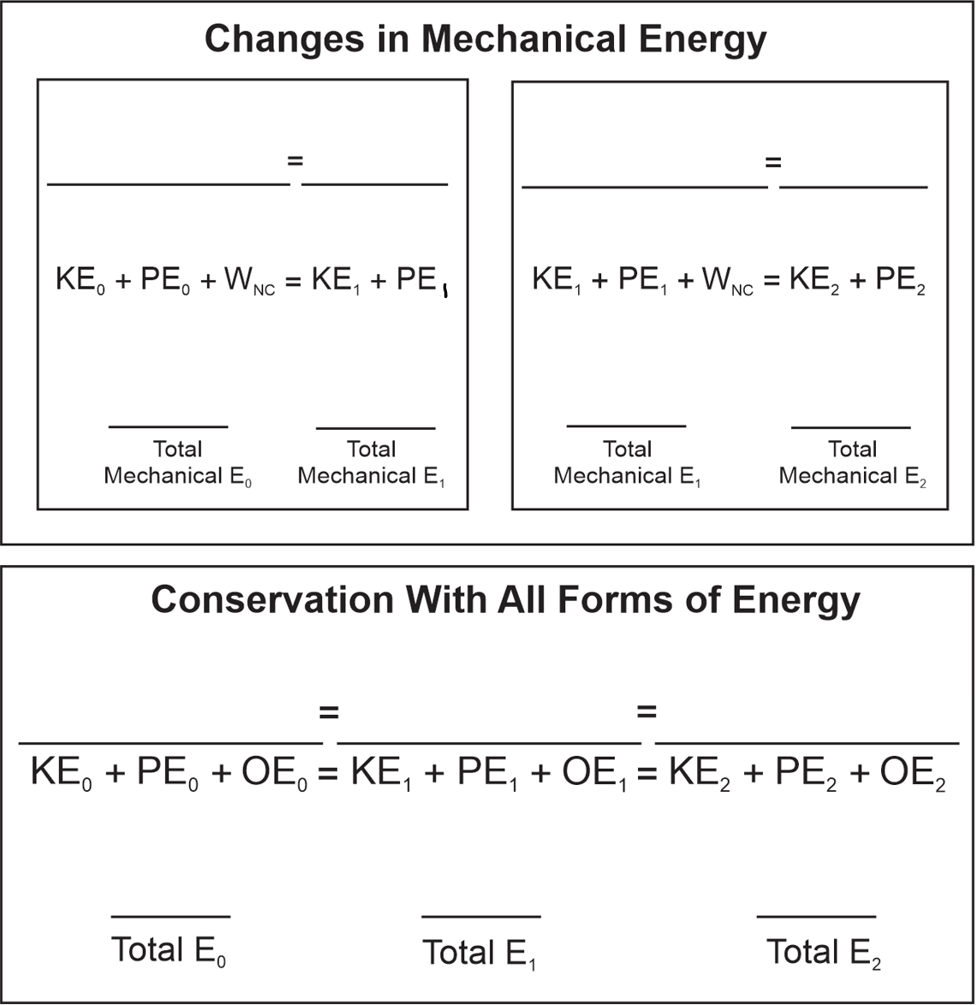
2. A car drives down a hill from position 0 (top) to position 1 (half way down) to position 2 (bottom of the hill). Its speed is constant the entire time. The car’s KE₀ and PE₀ are shown.
- Draw the remaining energy bars in a sensible manner.
- Add notes to each non conservative work (W_{NC}) and other energy (OE), indicating the type of energy or what sort of work is being done.

