Physics 200 Name: _________________________________
More Work/Energy Test Practice

1. Write the standard units and some equivalent units for work, energy, and power.

2. If you are giving energy to an object, explain how you can accomplish the task with a variety of forces and a variety of powers.

3. Starting from rest, a 500kg box is pushed across a frictionless, horizontal surface for a distance of 16m with a constant net force of 500N. The push continues for another 24m, but over that 24m the force diminishes at a constant rate, finally reaching zero N. What is the box’s final velocity?

4. A machine on a 3m tall table uses 1,500W to accelerate a 0.02kg hard candy horizontally from rest. If the machine is 40% efficient, how fast does the candy move after 2 seconds?

5. A rock climber, starting from rest at ground level, climbs up a wall and falls off. 30 seconds after the start of the climb, the rock climber is falling at a rate of 4m/s, and their height is 8m above the ground. How high did they go before falling?

6. Someone drops a spring weighing 1N from a height of 1m. The spring bounces, hitting the ground three times. When it hits the ground the third time, the spring comes to rest. Sketch a graph showing how all of the types of energy change over time during this event. Use a different color (or pattern) line for each type of energy.

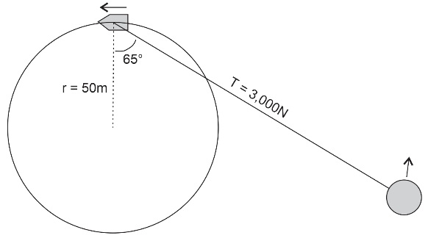
7. Give three examples of OE turning to mechanical energy, and give three examples of mechanical energy turning to OE. Use different types of OE in your examples.

8. A boat traveling in a circle is pulling an innertube, as shown in the picture on the right. Based on the information in the diagram, how much work does the boat do on the rope as the boat makes one complete circle?

Energy conservation problems.
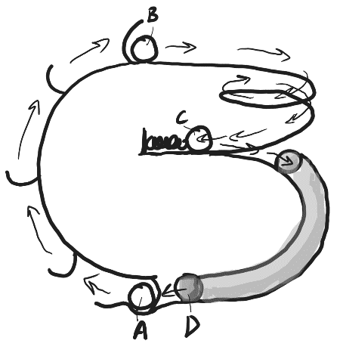
9. There’s a guy who likes to make what he refers to as “marblevators.” In the marblevator on the right, the 0.02kg marble is motionless when it is picked up at point A. The marble is dumped out at point B and rolls along the track until it hits the spring compressing the spring and becoming momentarily motionless at point C. Then the marble is bounced back by the spring, entering the tube. The marble exits the tube at point D and then rolls into a small divot at point A, where it is picked up again by the elevator. The only time the marble experiences kinetic friction is when it is in the tube.

a. Fill in the table with the correct values.

Position | Height (m) | Speed (m/s) | PE_{spring} (J) | PE_{Gravitational} (J) | KE (J) | Total Mechanical Energy
A | 0 | 0
B | 0.2 | 0.12
C | 0.13
D | 0.01 | .02

b. If the tube section of the marble run is 0.18m long, what average force of kinetic friction does the marble experience while it is in the tube?

c. When is positive work done on the marble? How much work is done?

d. If the machine releases marbles at a rate of one marble every 5 seconds, how much power is consumed by the elevator doing the work you identified in the previous question?

d. A typical AA battery offers 10,000J of energy. Given the power consumption that you calculated in the previous question, how long can the elevator keep up its marble lifting if it is powered by a single AA battery?

e. How long would the battery last if the elevator were only 30% efficient?

