Physics 200 (Stapleton) Name: _______________________________
Work and Energy Notes

Work is the application of a force over a distance. W=Fd. The “distance” is the distance through which the force acts. Technically, the “force” in the equation is only the component of force in the direction of movement. The dot product notation is a reminder of this.

Work units = N•m = Joules (J). [J is also the primary unit we use for energy.]

1. A child pulls a wagon 4m to the right, applying a constant rightward force of 10N. How much work is done?

2. Another child pulls a wagon using a rope. The tension in the rope is 20N, and the rope makes a 45° angle with horizontal. If the child applies this force constantly as the wagon travels 6m, how much work is done?

Power is the rate of work. $P=\frac{W}{t}$ . The units for power that we will use are Watts. 1 Watt = 1J/s. 1horsepower = 746W

3. A 60kg student climbs 12m up a vertical rock wall in 50 seconds. The student’s speed is constant.

a. Approximately how much work did the student do?

b. What was the student’s average power output, in Watts?

c. How long would the climb have taken if the student’s power output had been 1 horsepower?

Energy: Work can be thought of as equivalent to energy. When work is done on an object, the object gains energy. When work is done by an object, the object loses energy.

The Work-Energy Theorem states that W_{net} = ΔKE. [Note that if you are lifted at a constant rate, no net work is done on you; constant rate means no net force.]

The abbreviation KE stands for Kinetic Energy, which is energy of motion. The formula for Kinetic Energy is… $KE=\frac{1}{2 }mv^{2}$, where m = mass and v = velocity.
Energy units are the same as Work units. 1 Joule is derived from the amount of energy required to raise 1kg of water by 1°C. 1calorie = 4.184 Joules. 1 “food calorie” = 1kcal = 1,000 calories = 4,184 Joules. The “calories” used to describe nutrition values are actually kilocalories.

4. When a 0.5kg water rocket is launching, it experiences an average net force of 400N for a distance of 1m. By how much does the rocket’s KE change during this time period?

5. Assuming that the rocket started from rest, use the KE formula to find the rocket’s velocity after accelerating for that one meter.

6. A 2kg package is sliding across a surface with a velocity of 3m/s. The force of friction acting on the package is 1N. How far will the package slide before it stops?

Potential Energy: Potential energy is stored energy. PE can have many forms, including gravitational energy, spring energy, and chemical energy.
PE_{gravitational} : Work done against gravity results in a change in an object’s gravitational potential energy. The minimal possible** work done in the process of lifting an object to a certain height equals the force of gravity multiplied by that height. For objects that are being lifted, this means ΔPE = mgh, where h is the height through which something is lifted. Any object which is already situated at some height can be thought of as having stored gravitational potential energy equal to mgh.

PE_{gravitational} = mgh

Energy Conservation: Unless there is friction, or an external input of energy, the total amount of mechanical energy in a closed system remains constant. KE_{initial} +PE_{initial} = KE_{final} + PE_{final}. The total mechanical energy remains constant, so energy is said to be conserved. This is one form of the Law of Conservation of Energy. [PE_{grav} and KE are mechanical energy; heat is not.]

7. A 3kg watermelon is dropped from a height of 100m. What is its potential energy at its release point (100m)?

8. What is the watermelon’s potential energy when it has fallen to an altitude of 25m?

9. What is the watermelon’s KE when its altitude is 25m?

10. What is the watermelon’s velocity when its altitude is 25m?

Addition or Subtraction of Energy to/from a system: Sometimes work is done on a system. When this happens, energy is either added or removed. Sometimes work takes away energy. In either case, this work is said to be done by “non-conservative forces,” and is labeled W_{nc}. Friction is an example of something that does work to remove energy from a system. In this case, KE_{initial} +PE_{initial} + W_{nc} = KE_{final} + PE_{final}. When there is friction, W_{nc} is a negative number, because friction opposes motion. When something adds energy, W_{nc} is a positive number. In the case of friction, the energy is not really lost, but rather it gets turned into thermal energy. Still, the equation above apples to mechanical energy, not thermal energy.

11. A 20kg child sits at rest at the top of a slide which is 5m long and 3m high. As the child slides down the slide, the child experiences a constant 5N force of friction.

a. What is the child’s total energy at the top of the slide? What form of energy does the child have?

b. How much work is done by friction?

c. How much PE and KE does the child have at the bottom of the slide?

d. What is the child’s speed upon reaching the bottom of the slide?

Work and Energy Practice Problems:

1. A stick pushes a 170g hockey puck with a constant force of 100N over a distance of 0.4m and a time of 0.1 seconds.
a. How much work is done on the puck?
b. How much power does the stick use while it is pushing the puck?
c. Assuming that the puck starts from rest, what is its speed after being pushed by the stick?

2. A dad pulls his daughter in a sled. He drags the sled using a long rope, which is essentially horizontal, maintaining a constant tension of 100N.
a. How much work does the dad do if he pulls his daughter for one mile?
b. A Snickers Bar contains about 260,000 calories of energy. Assuming that the dad’s body is 30% efficient (makes use of only 30% of its energy intake), how many Snickers bars must he eat to replace the energy lost by dragging his daughter around?

3. A 5kg bowling ball is hanging by a cable from the ceiling of a train. The cable makes a 70° angle with the ceiling. During a certain time interval, the train travels 30m.
a. What is the horizontal component of the tension in the cable?
b. How much net work is done on the ball during this time interval?
c. If the velocity of the train and ball were both 10m/s at the beginning of this time interval, what are their velocities at the end of the time interval?

4. Suppose it takes 100J of energy to smash an apple. What horsepower is required to smash 5 apples in 1 seconds?

5. According to Wikipedia, a Ferrari 458 has a mass of 1,565kg, and the car’s maximum acceleration takes it from 0-100km/h (≈27.8m/s) in 3.0 seconds. The tires, which are racing slicks, have a µ_{s} = 0.9 and µ_{k} = 0.6.

a. How much work does the car’s motor do as the car accelerates from 0-100km/h?
b. How much power, in Watts, is required in order to achieve this acceleration?
c. Convert that power to horsepower.
d. If, after reaching 100km/h, the driver stops accelerating and applies the maximum braking force without skidding, how far will the car travel before coming to a stop?
f. How far will the car travel before stopping if the driver brakes too hard, the tires lock, and the car skids to stop?

6. The diagram below shows the path followed by a 200kg car on a roller coaster. Between points A and B, the car is pulled up a slope in the absence of friction. Starting from rest at point A, the car is pulled up the incline by an average force of 1,120N force along 70m of track. By the time it reaches point B, the car’s speed has slowed to 0m/s. At point B, the car begins to accelerate frictionlessly down the slope to C and across a horizontal section to point D. Between points D and E, a constant 500N braking force is applied, but this is not enough to keep the cart from flying off the precipice at point E. Complete the table, below.

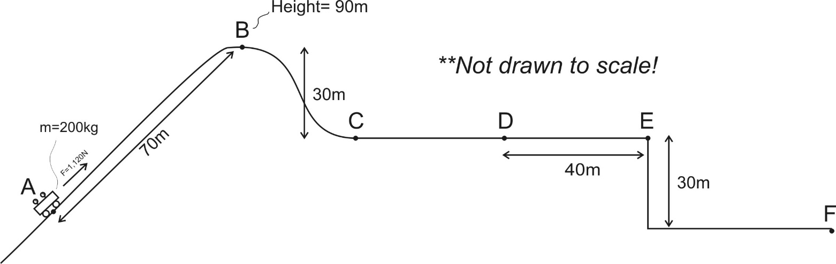

Location | Height (m) | Velocity (m/s) | Potential Energy (J) | Kinetic Energy (J) | Total Energy (J)
A |  | 0
B | 90m | 0
C
D
E
F

Practice Quiz: Work and Energy

Formulas and Info:

W=Fd $P=\frac{W}{t}$ W_{net} = ΔKE $KE=\frac{1}{2 }mv^{2}$ ΔPE = mgh

KE_{initial} +PE_{initial} = KE_{final} + PE_{final} KE_{initial} +PE_{initial} + W_{nc} = KE_{final} + PE_{final}

1horsepower = 746W 1 Calorie = 4.184 Joules. 1kcal = 1 food calorie = 4,184 Joules

1. A 10kg wagon is initially at rest at a height of 0m. A goat pulls the wagon a distance of 4m along an incline, over a time of 6 seconds. The goat applies a constant force of 70N parallel to the incline. At the end of this 6 second time period, the wagon’s speed is 3m/s, and the wagon is 1.5m higher than when it was at rest.

a. How much work was done on the wagon by the goat?
b. How much power did the goat contribute to the wagon?
c. What is the wagon’s final KE?
d. What was the wagon’s final PE?
e. How much work was done by friction?
f. What was the force of friction?

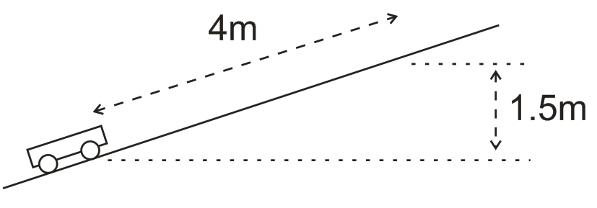

g. How much work would have been done on the wagon by the goat if the goat had pulled the wagon horizontally while applying a force in a direction 25° above horizontal? Assume that the distance (4m) and the magnitude (70N) of the applied force were the same.
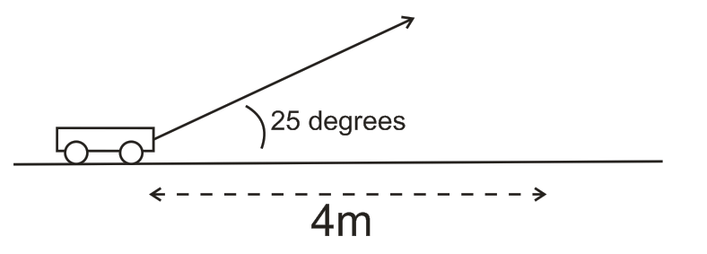

2. Starting from rest, a 15kg child climbs up a ladder to the top of a slide and stops there. The child sits at the top for a moment and then slides down the slide without friction. Upon reaching the level portion at the bottom of the slide, the child encounters friction and eventually comes to rest 15m later. The vertical height of the slide is 3m, but the ladder is 4m long. The length of the slide surface is 7m. The child climbs the ladder at a constant speed of is 0.5m/s.

a. What are the child’s PE and KE when he is sitting at the top of the slide?

b. As the child climbs the ladder, what average force does the ladder exert on the child (parallel to the ladder)?

c. How much KE does the child have at the bottom of the slide, just before he/she slides onto the level surface?

d. What is the force of friction on the level surface at the bottom of the slide?

e. If there are 2.91 food calories in one Pez candy, and if the child is 25% efficient at converting Pez energy to mechanical energy, how many climbs up the slide equal the usable energy in one Pez?

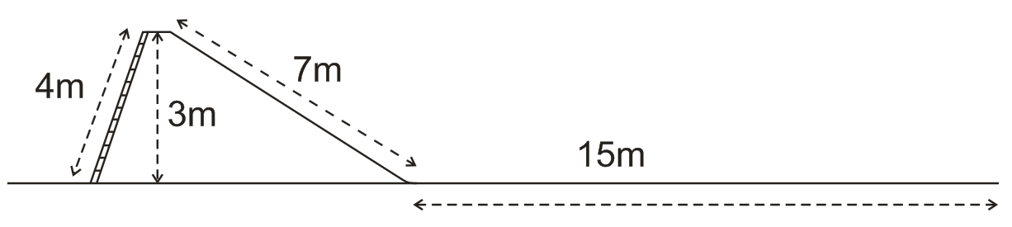

Notes: Springs + Odds and Ends

Springs Notes:

1. We will be solving problems with two kinds of springs, _____________________ springs and _______________________ springs.

2. The spring constant (or “stiffness constant”) tells us how much force is exerted by a stretched or

compressed spring. It is represented by the letter _____, and its units are __________.

3. The force exerted by a spring with a stiffness constant k that is stretched or compressed a distance of x is…

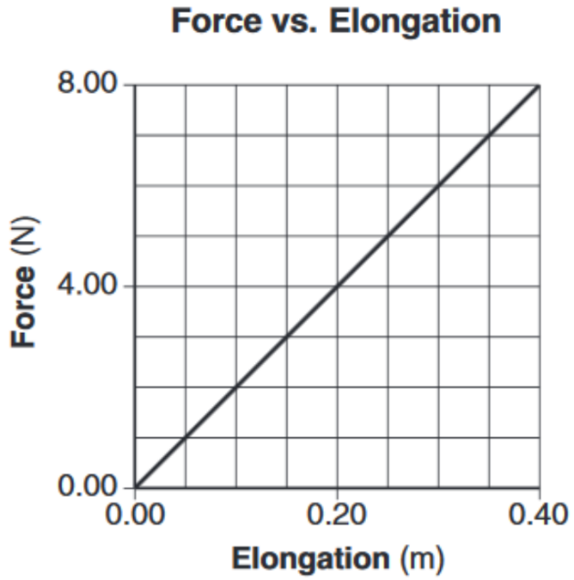

The force that must be applied to the spring to stretch it a distance x equals…

4. What is the spring constant of the spring represented by the graph on the right?

5. How much work must be done to stretch the spring from 0m of elongation to 0.4m of elongation?

6. How much work must be done to stretch or compress a spring with a spring constant of k through a distance x?

7. How much energy is stored in a spring with a spring constant of k that is stretched or compressed a distance x?

Other Forms of Energy (other than mechanical energy):

8. Law of Conservation of Energy with other energy forms (OE): KE_{i} + PE_{i} + OE_{i} = KE_{f} + PE_{f} + OE_{f}

9. List some other (non-mechanical) forms of energy

10. If you drop a tennis ball on a level surface and let it bounce until it comes to rest, what types of non-conservative work and other energy might be involved in this process?

W_{nc} :

OE_{f} :

Electrical Energy Units:

11. The so-called power company sells us energy, not power. The unit that they use for the energy that they sell is the kiloWatt-hour (kWh).

Describe a kiloWatt-hour:

How many joules equals one kiloWatt-hour?

12. Green Mountain Power sells some of their energy at a rate of $0.169/kWh. At this rate, how much does it cost to leave a 10W LED lightbulb turned on for an entire week?

Efficiency: Ratio of output energy to input energy, usually expressed as a percentage.

% Efficiency =

13. Starting from rest, a 10kg ‘possum climbs 5m up a tree and stops at that point, using 1000J of energy in the process. How efficient was this event?

More Work and Energy Practice Problems

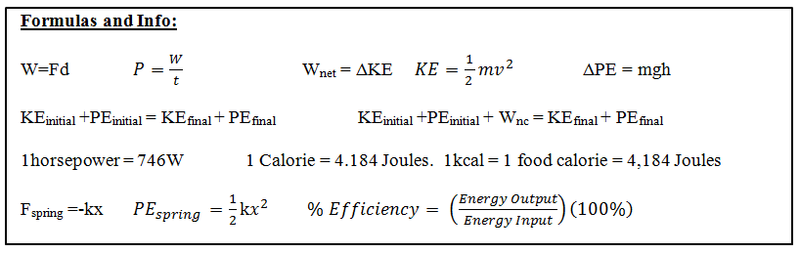

Part 1: Springs

1. Consider an ideal compression spring with k=300N/m. How much force is required to compress the spring a distance of 5cm?

2. How much energy is stored in the spring above when it is compressed 5cm.

3. An ideal extension spring of negligible mass is hanging from a ceiling. One end of the spring is attached to the ceiling, and the other end is pointing downward. A 50g object is added to the bottom of the unstretched spring and the object is then released. The object stretches the spring downward, bobs around for a while, and comes to rest with the spring stretched 20cm beyond its original length.
a. How much energy is stored in the spring after the object comes to rest?
b. What is the spring’s k?
c. Now the 50g object is attached to the end of the spring, raised upward nearer the ceiling, and released. The object falls to a low point and then bounces back up. When the object is at its low point, the spring is stretched 80cm beyond its original length. How far did the object fall before bouncing back upward?

4. A water rocket’s water thrust phase lasts for 0.05 seconds. During this time, the rocket travels upward 0.85m with an average thrust of 400N.
a. How much work is done by the rocket during the water thrust phase?
b. What is the average power output of the rocket during this phase, in Watts? In horsepower?

5. Gravity does work on a falling human. Describe the conditions under which gravity does work on a falling 50kg human at a rate of 1 horsepower.

6. Mt. Everest is 8,848m above sea level, and an average waffle offers about 82,000 calories. Considering only the vertical travel that must take place, how many waffles must a 150 pound human eat in order to climb from sea level to the top of Mt. Everest? Assume that the human’s conversion of waffle energy to mechanical energy is 30%.

7. A 200hp sports car has a mass of 1,600kg. The car accelerates using all 200hp for 6 seconds. Then the driver releases the accelerator and hits the brakes, skidding to a stop. The car’s µ_{s} = 0.8 and it’s µ_{k} = 0.5.
a. What is the car’s speed after 6 seconds?
b. How far does the car skid?

8. Is a car’s stopping distance directly proportional to its velocity or is it directly proportional to its kinetic energy? Why?

9. The frictionless roller coaster in the diagram below has a mass of 500 kg. The coaster is pulled up to point 1 where it is released from rest. Assuming that total energy is conserved, complete the empty elements in the chart below.

Position | Height (m) | Total Energy (J) | Potential Energy (J) | Kinetic Energy (J) | Velocity (m/s)
1 | 35.0 |  |  |  | 0
2 | 0.0
3 | 28.0
4 | 15.0
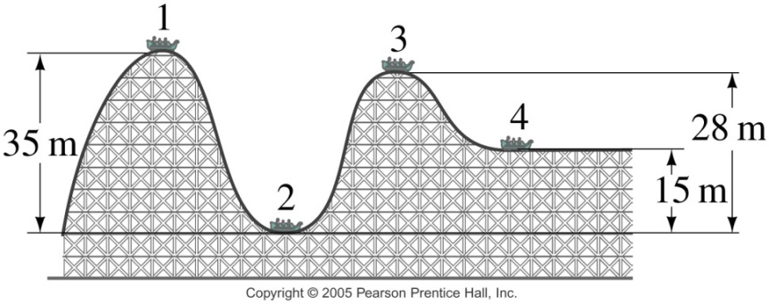

10. A 20kg child slides down a 7m long slide which is inclined to horizontal at a 37° angle.

a. What is the child’s KE at the end of the slide?

b. What is the child’s velocity at the end of the slide?

11. A child creates a homemade bow with the force curve shown on the right. The graph shows how the force applied to the bow string changes as the child pulls it back to the full draw distance of 0.5m.

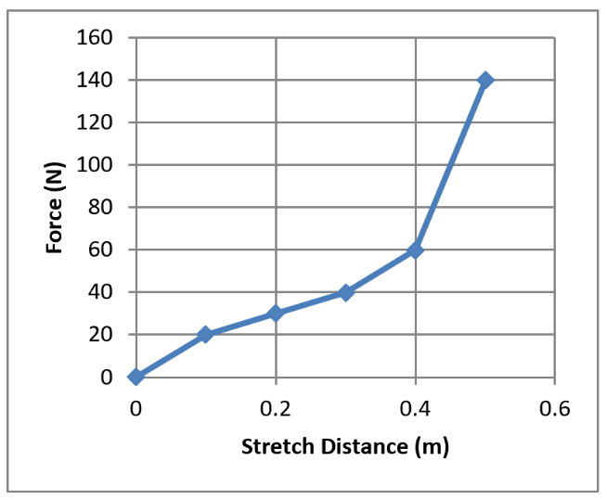
a. How much work is done in drawing the bow?

b. If the bow is 60% efficient, how much energy will the arrow have when it leaves bow?

c. If the child wants to shoot an arrow with a velocity of 30m/s, what arrow mass should be used?

Chapter 7 Test 2015-2016

I. MULTIPLE CHOICE – Assume g = 10 m/s² for the multiple choice questions.

1. A greased pig has a choice of three frictionless slides along which to slide to the ground. On which slide will the pig have the greatest velocity at the bottom.
A. Slide A B. Slide B C. Slide C
D. The pig’s velocity will be the same at the bottom of all three slides.

2. A man pulls a sled along a rough horizontal surface by applying a constant force F at an angle θ above the horizontal. In pulling the sled a horizontal distance d, the work done by the man is:
A. Fd B. Fd cos θ C. Fd sin θ D. Fd/cos θ E. Fd/sin θ

3. Power is
A. joules per second.
B. work per unit of time.
C. the rate at which work is done.
D. all of the above.

4. The amount of work (done by an external force) required to stop a moving object is equal to the:
A. velocity of the object.
B. mass of the object times its acceleration.
C. kinetic energy of the object.
D. mass of the object times its velocity.
E. square of the velocity of the object.

5. A woman lifts a barbell 2.0 m in 3.0 s. If she now lifts the same barbell the same distance in 6.0 s, the work done by her is:
A. four times as great
B. two times as great
C. the same
D. half as great
E. one-fourth as great

6. A woman lifts a barbell 2.0 m in 3.0 s. If she now lifts the same barbell the same distance in 6.0 s, the power of this lift is:
A. one-fourth as great
B. half as great
C. the same
D. two times as great
E. four times as great
7. A 2.0 kg ball is raised to a height of 3.0 m above the ground and then released. (Assume that U = 0 at ground level.) After the ball hits the ground, bounces a few times and then comes to rest, which statement is true? [U=PE, K=KE, and OE= Other Energy] ** The answer to this question is incorrect in the scan of solutions **
A. U = 0 J, K = 0 J and OE = 0 J
B. U = 60 J, K = 0 J and OE = 60 J
C. U = 0, K = 0 and OE = 60 J
D. U = 0 J, K = 60 J and OE = 0

8. [Same conventions as #7]. A simple pendulum with a string length of 0.60 m and a mass of 2.0 kg swings back and forth. At the lowest point in the swing,
A. U is a maximum and K is a minimum.
B. U is a minimum and K is a minimum.
C. U is a maximum and K is a maximum.
D. U is a minimum and K is a maximum.

9. The potential energy of a box on a shelf, relative to the floor, is a measure of
A. the work done putting the box on the shelf from the floor.
B. the weight of the box times the distance above the floor.
C. the energy the box has because of its position above the floor.
D. all of these.

10. What does the area under a force versus position (F vs. x) graph represent?
A. work
B. kinetic energy
C. power
D. potential energy

11. A truck weighs twice as much as a car, and is moving at twice the speed of the car. Which statement is true about the truck's kinetic energy compared to that of the car?
A. All that can be said is that the truck has more kinetic energy.
B. The truck has 8 times the kinetic energy of the car.
C. The truck has 4 times the kinetic energy of the car.
D. The truck has twice the kinetic energy of the car.

12. A body of mass 2.0 kg is launched upwards with a velocity 20 m/s. It momentarily comes to rest after attaining a height of 18 m. How much energy is lost due to air friction?
A. 20 J
B. 40 J
C. 60 J
D. 80 J

13. A planet of constant mass orbits the Sun in an elliptical orbit. What happens to the planet's kinetic energy?
A. It remains constant.
B. It increases continually.
C. It decreases continually.
D. It increases when the planet approaches the Sun, and decreases when it moves farther away.

14. An acorn falls from a tree. What can be said about the acorn’s kinetic energy K and its potential energy U?
A. K increases and U decreases.
B. K decreases and U decreases.
C. K increases and U increases.
D. K decreases and U increases.

15. A 8000-N car is traveling at 10 m/s along a horizontal road when the brakes are applied. The car skids to a stop in 4.0 s. How much kinetic energy does the car lose in this time?
A. 5.0 x 10³ J
B. 6.0 x 10⁶ J
C. 4.0 x 10⁴ J
D. 2.0 x 10⁵ J
E. 8.0 x 10⁵ J

16. A 3-kg object is moving at 9 m/s. A 4-N force is applied in the direction of motion and then removed after the object has traveled an additional 5 m. The work done by this force is:
A. 20 J
B. 18 J
C. 15 J
D. 12 J
E. 27 J

II. PROBLEMS - For full credit, your starting equation(s) must be clearly shown before substituting in numbers. Circle your answer and have the correct number of significant figures. Assume g = 9.80 m/s² for these problems. All work must be done on a separate sheet of paper.

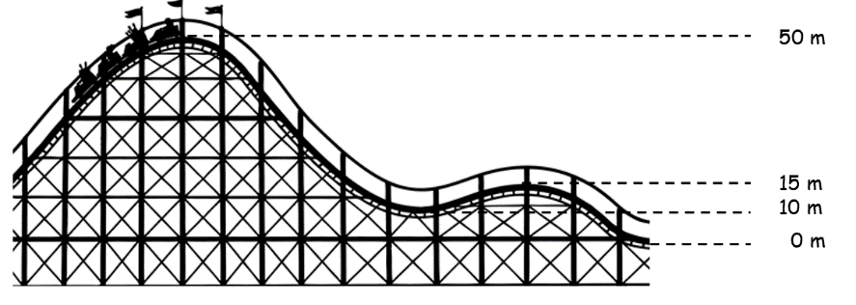
1. Roller Coaster

At the top of the roller coaster (h = 50.0 m), v_{i} = 10.00 m/s. Find the velocity of the roller coaster when h = 15.0 m.

2. Find the velocity of a 1.50-kg the pendulum at its lowest point in the swing given a difference of 0.220 m between the highest point and the lowest point of the swing.
0.220 m
1.50 kg
0.940 m

3. A 4.50 x 10⁵-kg subway train is brought to a stop from a speed of 0.500 m/s in 0.660 m by a large spring bumper at the end of its track. What is the force constant k of the spring?

4. A large household air conditioner may consume 25.0 kW of power. What is the cost of operating this air conditioner 8.00 h per day for one month (30.0 days) if the cost of electricity is $0.150 per kW⋅h?

5. An alkaline D-cell battery contains 20.8 watt-hours of energy. How high could this energy lift a 62.0 kg person above the ground?

6. A 7.00-kg block from a height of 3.00 m slides down a track starting from rest where the coefficient of friction between the block and the track is 0.280. The track is inclined at an angle of 55.0º. What is the speed of the block at the bottom of the track?

7. Starting at rest, a 5.00-kg block slides 7.00 m down a frictionless ramp. The ramp makes a 30.0º angle with the horizontal. The block then slides along a horizontal frictionless surface until it strikes a spring with a spring constant k = 3250 N/m attached to a rigid wall.

30.0º
5.00 kg
7.00 m
3250 N/m

A. What is the speed of the block on the horizontal surface?

B. After the block strikes the spring, how far the spring is compressed from its equilibrium position at maximum compression?

Bungee Jumper Problems

1. Starting from rest, a 0.25kg bungee-jumping object falls 2m vertically before beginning to stretch its bungee. If the graph on the right shows the forces that are necessary to hold the bungee stretched at a variety of distances, how far will the falling object stretch the bungee before the object comes to rest? Assume that the object does not hit any other object (e.g. the floor). Solve the problem graphically, using the graph space below.
2. Starting from rest, a 0.5kg bungee-jumping object falls 1.5m vertically before beginning to stretch its bungee. If the graph on the right shows the forces that are necessary to hold the bungee stretched at a variety of distances, how far will the falling object stretch the bungee before the object comes to rest? Assume that the object does not hit any other object (e.g. the floor). Solve the problem graphically, using the graph space below.

“4-Minute Drill” Provide the formula or answer…
- Work
- Work done pulling at an angle Θ, relative to direction of motion
- Power
- 1kWh, in Joules
- Spring force
- Gravitational Potential Energy
- Spring Potential Energy
- Kinetic Energy
- Work-Energy Theorem
- Law of Conservation of Energy (no friction, no outside forces)
- Law of Conservation of Energy (with friction or outside forces)
- % Efficiency

Energy Conservation Drill Provide the formula or answer…
- Change in speed of an object with mass m after falling a distance h
- Change in speed of an object with mass m after flying upward a distance h
- Stopping distance of a car with mass m, speed v, and braking force F_{Fr}, on a level surface.
- Compression distance x of a spring with constant k after stopping an object with mass m and speed v
- Work done by friction when an object of mass m slides down a hill at a constant speed, descending a height of h in the process
- Speed of an object with mass m just after being launched directly upward from rest by a spring, if the spring has a constant k and was compressed a distance x
- Height gained by the object in the previous question, before returning to Earth
- Net work done on a car of mass m that starts from rest, drives up a hill of height h, and stops.
- Net work done by the car in the previous question.

