Physics 200 (Stapleton) Name: _______________________________
Practice Quiz: Work and Energy

Formulas and Info:

W=Fd $P=\frac{W}{t}$ W_{net} = ΔKE $KE=\frac{1}{2 }mv^{2}$ ΔPE = mgh

KE_{initial} +PE_{initial} = KE_{final} + PE_{final} KE_{initial} +PE_{initial} + W_{nc} = KE_{final} + PE_{final}

1horsepower = 746W 1 Calorie = 4.184 Joules. 1kcal = 1 food calorie = 4,184 Joules

1. A 10kg wagon is initially at rest at a height of 0m. A goat pulls the wagon a distance of 4m along an incline, over a time of 6 seconds. The goat applies a constant force of 70N parallel to the incline. At the end of this 6 second time period, the wagon’s speed is 3m/s, and the wagon is 1.5m higher than when it was at rest.

a. How much work was done on the wagon by the goat?
b. How much power did the goat contribute to the wagon?
c. What is the wagon’s final KE?
d. What was the wagon’s final PE?
e. How much work was done by friction?
f. What was the force of friction?

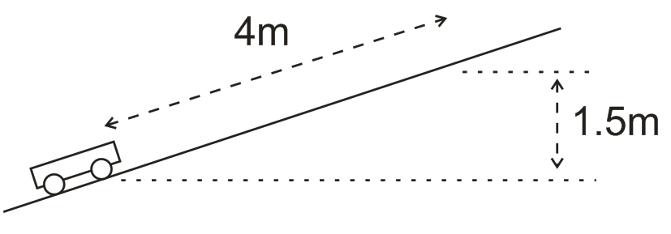

g. How much work would have been done on the wagon by the goat if the goat had pulled the wagon horizontally while applying a force in a direction 25° above horizontal? Assume that the distance (4m) and the magnitude (70N) of the applied force were the same.
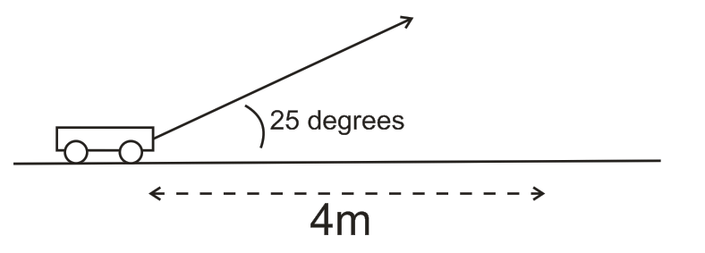
2. Starting from rest, a 15kg child climbs up a ladder to the top of a slide and stops there. The child sits at the top for a moment and then slides down the slide without friction. Upon reaching the level portion at the bottom of the slide, the child encounters friction and eventually comes to rest 15m later. The vertical height of the slide is 3m, but the ladder is 4m long. The length of the slide surface is 7m. The child climbs the ladder at a constant speed of is 0.5m/s.

a. What are the child’s PE and KE when he is sitting at the top of the slide?
b. As the child climbs the ladder, what average force does the ladder exert on the child (parallel to the ladder)?
c. How much KE does the child have at the bottom of the slide, just before he/she slides onto the level surface?
d. What is the force of friction on the level surface at the bottom of the slide?
e. If there are 2.91 food calories in one Pez candy, and if the child is 25% efficient at converting Pez energy to mechanical energy, how many climbs up the slide equal the usuable energy in one Pez?

