Physics 200 Name: _________________________________
Bone Cube on Bone Hill, With WD-40 and Springs

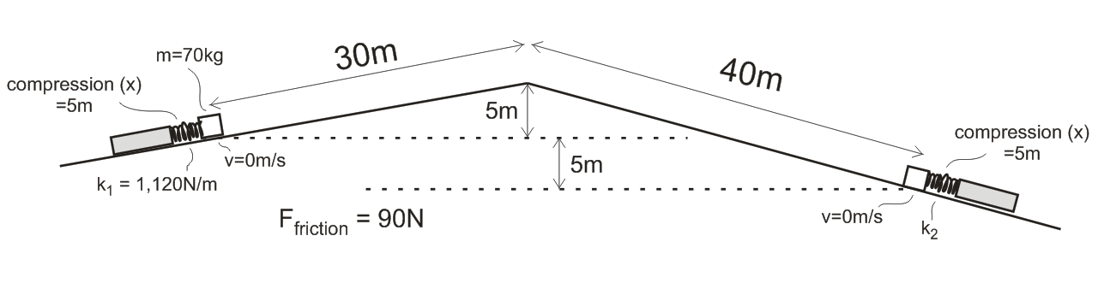
A 70kg cube of processed bone is propelled by a first spring (left spring, above; k₁ = 1,120N/m). The bone slides up and down the hill of processed bone on a film of WD-40, experiencing a constant frictional force of 90N. The bone comes to rest as it compresses a second spring (spring constant = k₂). Each spring is compressed 5m (x=5m). The spring on the left is compressed 5m before it launches the bone. The spring on the right is compressed by the moving bone, reaching the full 5m compression at the moment that the bone comes to rest. Use the distances in the diagram above to find the following…

1. Find the speed of the bone at the top of the hill.

2. Find k₂.

Physics 200 Name: _________________________________
Bone Cube on Bone Hill, With WD-40 and Springs

A 70kg cube of processed bone is propelled by a first spring (left spring, above; k₁ = 1,120N/m). The bone slides up and down the hill of processed bone on a film of WD-40, experiencing a constant frictional force of 90N. The bone comes to rest as it compresses a second spring (spring constant = k₂). Each spring is compressed 5m (x=5m). The spring on the left is compressed 5m before it launches the bone. The spring on the right is compressed by the moving bone, reaching the full 5m compression at the moment that the bone comes to rest. Use the distances in the diagram above to find the following…

1. Find the speed of the bone at the top of the hill.

2. Find k₂.

