Physics 200 Name: _____________________________________
Work and Energy
Elastic Bungee Jumping

Summary:

You will be given a bungee. Later on, after you have analyzed your bungee, you will predict the fall distance of a mass dropped from ceiling height.

In the first part of this process, you will be calculating the work done in stretching the bungee to different lengths. You will hang the bungee from the classroom ceiling and measure the distance of the bottom of the bungee from the floor. Then you will attach a weight and measure/record the new distance from the floor. You will continue doing this with heavier and heavier weights until the bungee is close the floor. From the table of weights and distances from the floor, you will be able to calculate the work done in stretching the bungee. Each time a weight is added, the bungee is stretched and work is done. The work for this “interval” is equal to the average force for that interval multiplied by the distance the bungee was stretched. By totaling the work done in multiple intervals, you can determine the total work done on the bungee. In the case of the bungee jumper, this work will be done by the jumper. The bungee will gain the energy while the jumper loses it.

In the second part of this process, you will be determining the PE_{grav.} that is lost by the jumper as it falls from its starting position. You will determine the total PE lost at each height between the starting position and the floor.

In the third part of this process, you will find the height where the jumper stops. This is the point where the PE_{grav} lost by the jumper is equal to the work done on the bungee (work done on the bungee = PE_{bungee}). This can be done by plotting the two data sets on graph of PE vs Distance fallen. One set of data will be the work done on the bungee. The other is the PE lost by the jumper. The two curves intersect where the jumper stops (when all of its original PE has been transferred to the bungee).

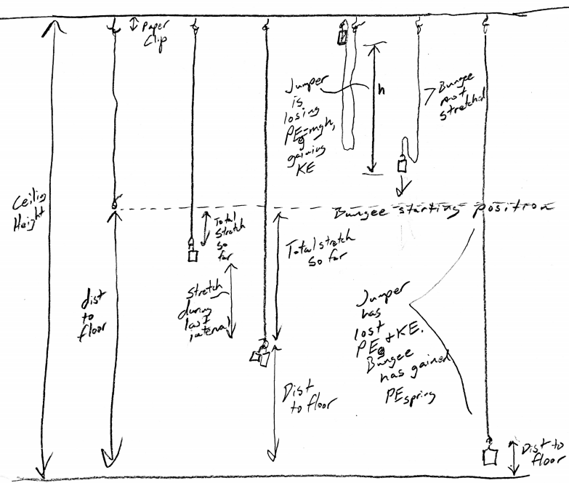

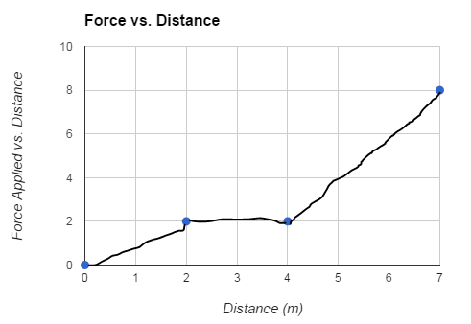
Practice Problem:

When work is done by a varying force, total work can be calculated by breaking the work distance into short intervals and calculating the work for each interval. For each interval, work is determined by multiplying the interval distance by the average force applied during the interval.

Calculate the total work done according to the graph on the right.

Total Work = ________

Bungee Jump Graphs:

** No practice jumps are allowed. You can hang masses on your bungee, but you cannot drop them!

Use a spreadsheet to create the following graphs. Save your spreadsheet and your graphs so that you can use them later and change your data if necessary.

1. Create a graph of bungee stretching force vs. stretch distance.

3. Now prepare to predict how far a 200g bungee jumper will fall when dropped from ceiling height. You will be attaching a 200g mass to the end of your bungee and holding the top of the mass’ stem at ceiling height. You will release the mass and record the minimum distance between the bottom of the mass and the floor. It is this distance from the floor that you must try to anticipate.

4. Create a graph of PE (J) versus Distance Fallen (m). Plot two kinds of PE on your graph. One set of PE data will reflect the PE that the falling 200g mass loses as it falls. The other PE data set will reflect the PE that is stored in the bungee as the 200g mass falls.

5. The falling object is losing PE. Initially, this energy is turning into KE, but as the bungee starts to stretch the object gives its energy to the bungee by doing work on the bungee. When the bungee has stored as much energy as the falling object has lost, the object should be out of KE. It should come to a stop.

Use your graph of PE vs. Distance Fallen to determine how far the object will fall before it stops.

Predicted Distance fallen to stopping point = ________m

Based on your predicted fall distance, predict the distance from the floor at which the bottom of the falling object will stop falling.

Predicted Distance to floor at low point = _______ m

Ceiling Height (m)
Mass of "jumper" (kg)
Paper Clip Length (m)

Weights Hanging Motionless
Bungee Position | Distance between lowest point of bungee and floor (m) | Hanging mass hooked on to bungee (kg) | Total stretch up to this point -- current distance of the bottom end of the bungee from starting position (m) | Weight of Hanging Mass (N) | Average force exerted during previous interval (N) | Distance stretched during previous interval (m) | Work done by gravity during previous interval (J) | Total work done stretching Bungee -- sum of all intervals up to the current interval (J)
1 (starting position)
2
3
4
5
6
7
8
9
10

The Jump
Bungee Position | Bungee Distance from the floor (m) | Distance Fallen (m) | Work Done by falling object stretching bungee (J) | PE lost by falling object (J)
1 (starting position)
2
3
4
5
6
7
8
9
10

