Physics 200 (Stapleton) Name: _______________________________
Waves and Simple Harmonic Motion

The motion of a simple harmonic oscillator can be described using either a sine or cosine function. The rate at which the objects moves can be described using either the sine or cosine of the angle, in radians, that is swept through by an imagined radially rotating arm. The oscillator itself (e.g. mass on a spring, vibrating string…) does not actually have to rotate.

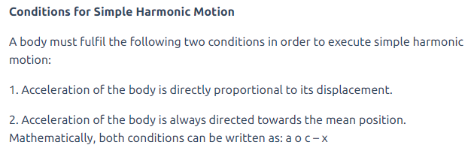

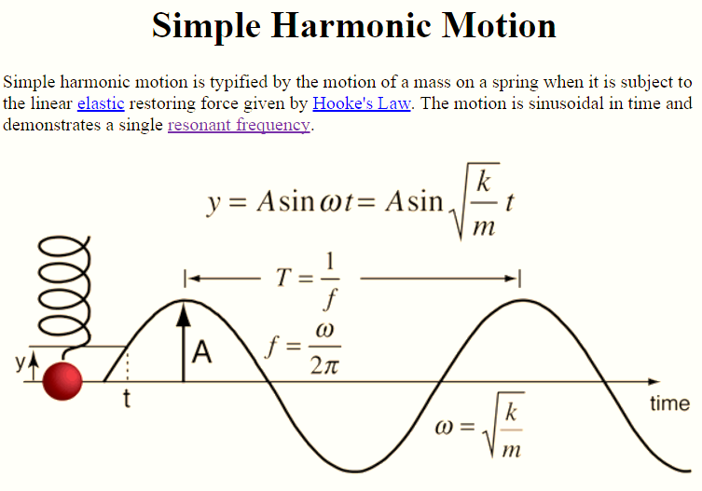
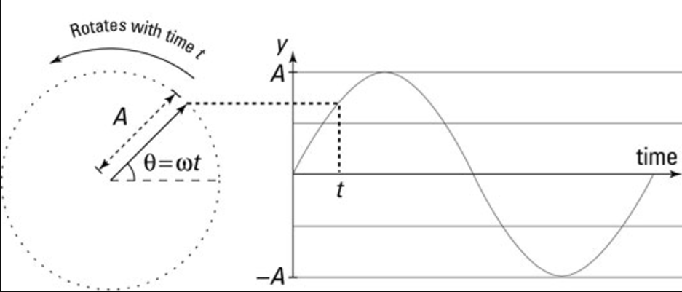

General equation for a sine wave:

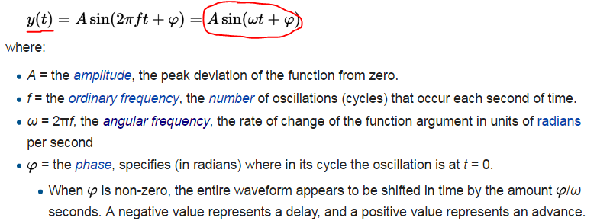

Questions:
1. For an oscillating mass (m) attached to a spring with spring constant (k), the angular frequency can be determined by $ω= \sqrt{\frac{k}{m}}$. A guitar string’s frequency is determined string length, tension, and mass. To which component of this equation does each of these string characteristics correspond?

Mass:

Tension:

Length:

2. Use the formulas on the previous page to write an equation for angular frequency ($ω)$ in terms of frequency.

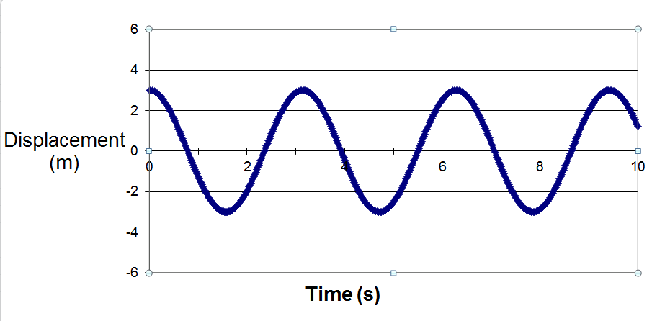
3. Find the following for the wave on the right.

f =

T =

A =

ω =

