Physics 200 (Stapleton) Name: _______________________________
Waves and Simple Harmonic Motion

Conditions for Simple Harmonic Motion:
- The oscillating object must always experience a restoring force that is directly proportional to its distance from rest position.
- Other conditions are often mentioned, but if the one above is met, the others will also be met.

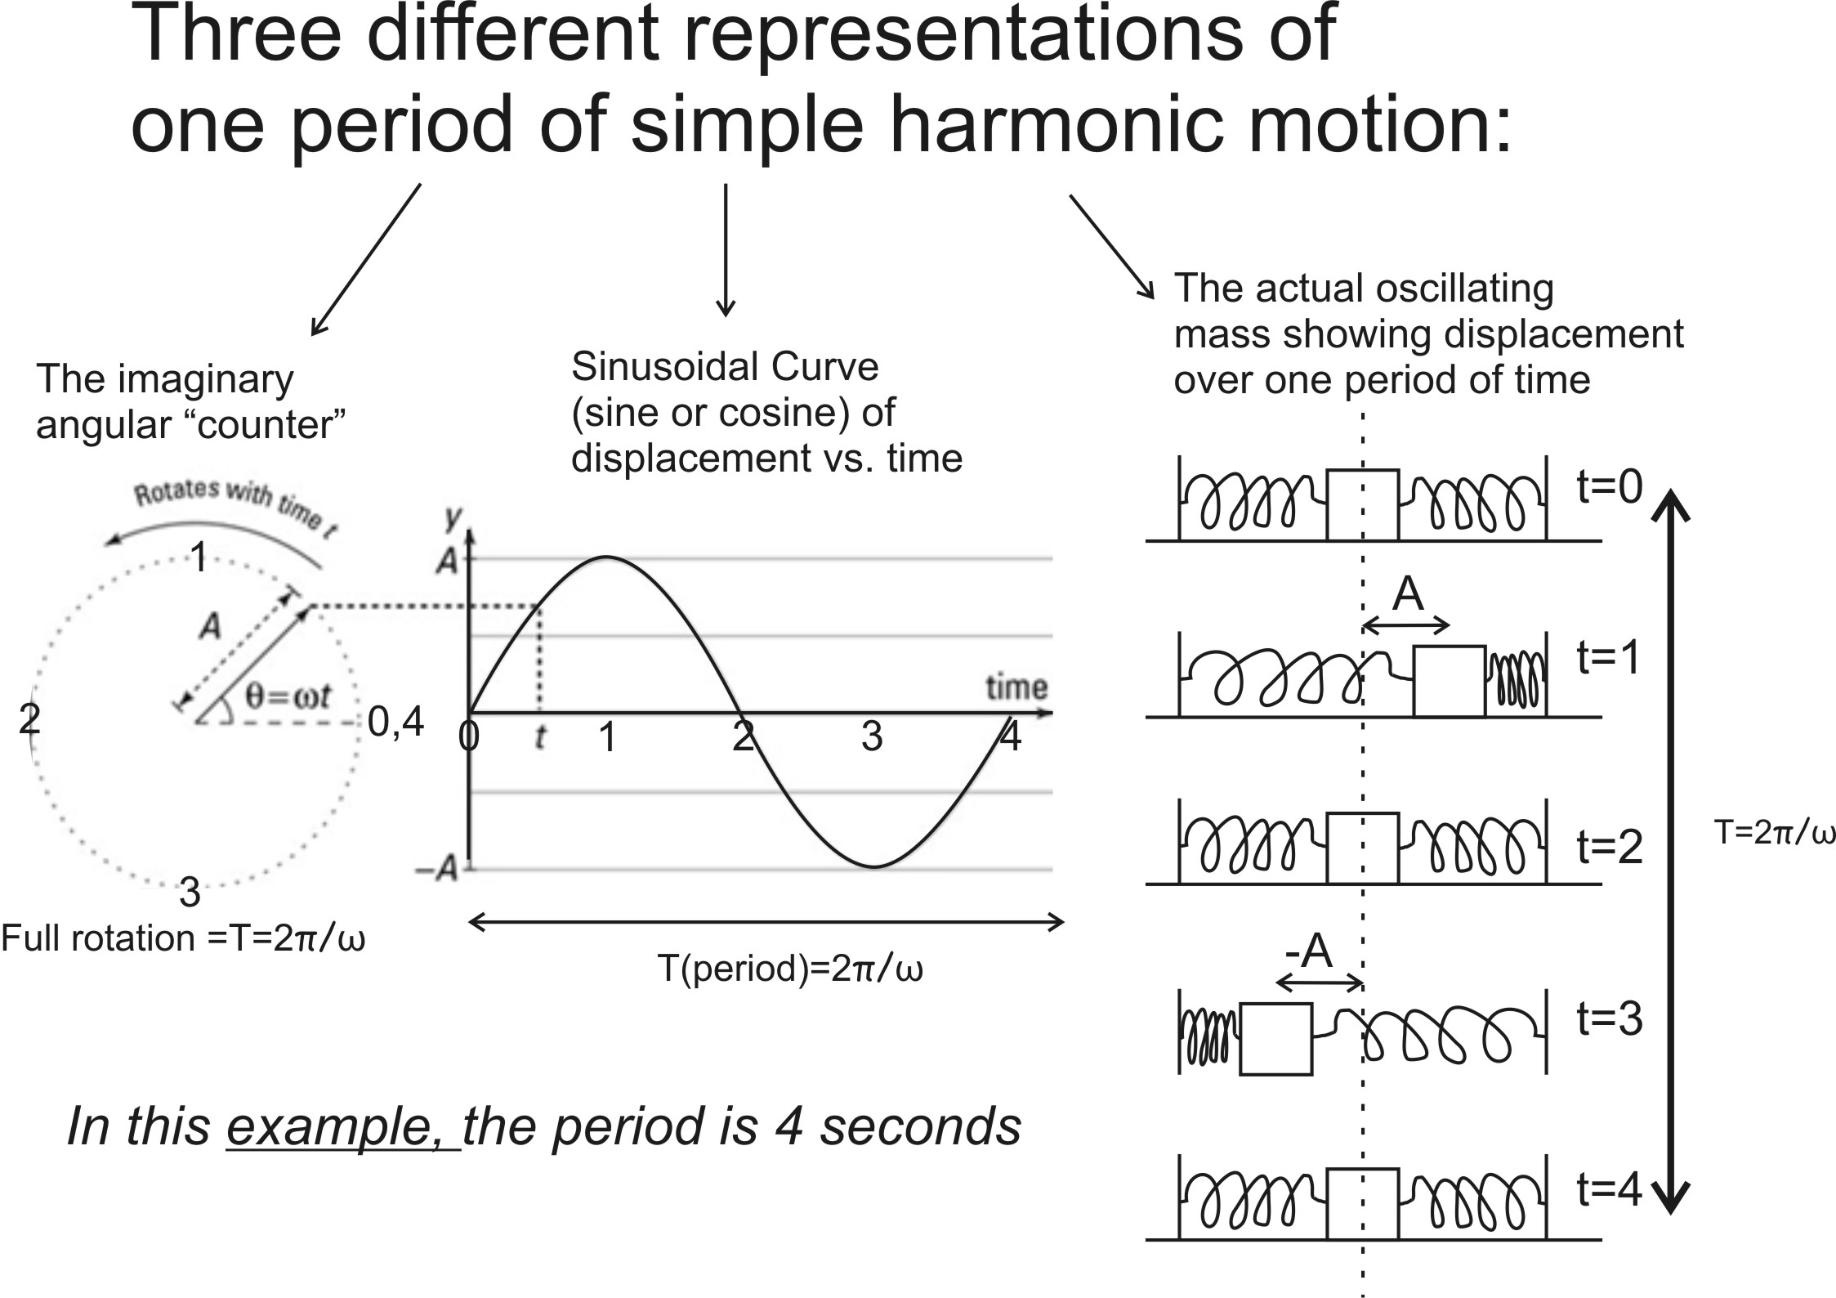
The angular frequency (ω) is the number of radians that the imaginary counter sweeps through each second. One full wavelength on the center curve, above, represents 2π radians (a full circle) of sweeping by the counter. An angular frequency of 2π rad/sec would mean an ordinary frequency of 1 Hz.

1. What is the ordinary frequency (f) of the wave, above?

2. Write and equation for angular frequency ($ω)$ in terms of ordinary frequency (f).

3. What is the angular frequency (ω) of the wave above?

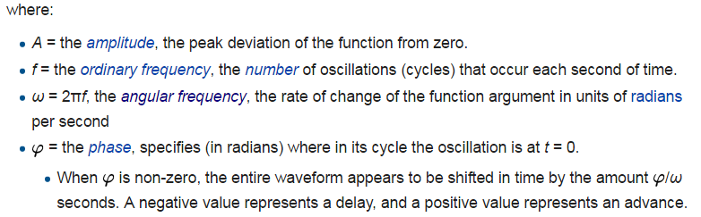
Equations for a sinusoidal wave:

Y(t) = Asin(ωt+ϕ)
Y(t) = Acos(ωt+ϕ)

1. Incidentally, for an oscillating mass (m) attached to a spring with spring constant (k), the angular frequency can be determined by $ω= \sqrt{\frac{k}{m}}$. A guitar string’s frequency can be understood using this formula.

a. Do you think an oscillating guitar string meets the condition for simple harmonic motion?

b. In the context of a guitar string, you can change the angular frequency (ω) by changing k or m or both. What could you do to alter the string’s k?

c. What could you do to alter its m?

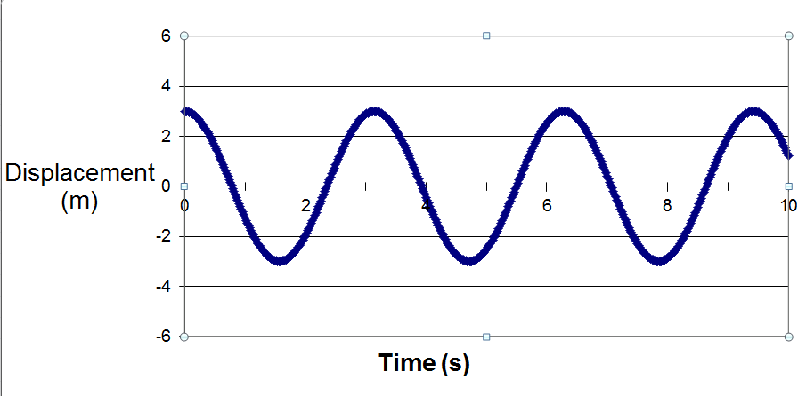
3. Find the following for the waves on the right.

f =

T =

A =

ω =

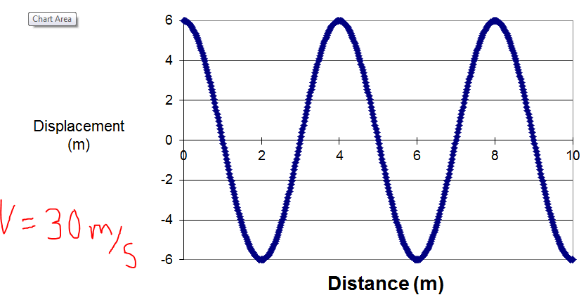
4. The waves on the right are traveling at 30m/s. Find…

λ =

f =

T =

A =

ω =

