Physics 200 (Stapleton) Name: ___________________________
Practice Test: Chapter 16-17– Waves and Sound (2016-2017)

I. Matching (Select the correct SI unit for each wave parameter).
A. seconds

B. meters per second

C. radians per second

D. meters

E. Hertz
1. period

2. angular frequency

3. amplitude

4. wavelength x frequency

5. frequency

6. wavelength

7. speed of sound

II. Multiple Choice (Choose the one best answer for each question.)
8. Which sound has the fastest speed in air at 0.0 ºC?
A. 220 Hz tuning fork B. 440 Hz tuning C. It is the same for both

9. Which sound has the largest wavelength in air at 0.0 ºC?
A. 220 Hz tuning fork B. 440 Hz tuning C. It is the same for both

10. Which sound has the largest frequency in air at 0.0 ºC?
A. 220 Hz tuning fork B. 440 Hz tuning C. It is the same for both

11. As the temperature of the air decreases, the speed of sound
A. increases B. decreases C. stays the same

12. How many beats/sec are heard when two tuning forks of 512 Hz and 508 Hz are sounded simultaneously?
A. 1 Hz B. 2 Hz C. 4 Hz D. 510 Hz E. 1020 Hz

13. How many wavelengths will fit inside a tube with one closed when you have resonance at the fundamental frequency?
A. 1/4 B. 1/2 C. 3/4 D. 1 E. 5/4

14. When shaking a string at one end that is attached to a post at the other end with just the right frequency to form a standing wave, the parts of the string that have maximum movement are called
A. fundamentals B. harmonics C. nodes D. antinodes

15. Transverse waves have a disturbance that is
A. in the same direction as the motion of the wave.
B. perpendicular to the direction of motion of the wave.
C. counterclockwise to the direction of the wave.
D. clockwise to the direction of the wave.

16. Sound waves are an example of a longitudinal wave.
A. True B. False C. Unable to determine

17. Water waves are an example of a longitudinal wave.
A. True B. False C. Unable to determine

18. When two waves are added together, you can get
A. constructive interference.
B. destructive interference.
C. standing waves.
D. All of the above.

19. A sound source moving away from you (compared to the same sound source at rest) will have
A. a higher pitch
B. a lower speed of sound
C. a lower frequency
D. a smaller wavelength
E. the same frequency

20. As the frequency of a tone increases,
A. the speed of sound increases.
B. the speed of sound decreases.
C. the frequency decreases.
D. the wavelength increases.
E. the wavelength decreases.

III. Problems:

1. At 35.0 ºC, how much time will elapse between the firing of a gun and return of its echo from a cliff that is 2.60 km away?

2. Find the length of an organ pipe closed at one end that produces a fundamental frequency of 262 Hz (i.e. middle C) when the air temperature is 24.0ºC.

3. A military sea mine is detonated at the surface of the water and the sound of the blast travels both through the air and the water. A Navy Seal swims right on the surface 1.60 km away from the blast. The sound travels through the sea water at 1540 m/s. The air temperature is 20.0 ºC. How much sooner will the Navy Seal hear the blast through the water than he does through the air?

4. Calculate the speed of sound on a day when a 963 Hz frequency has a wavelength of 0.351 m.

5. What is the wavelength of a water wave that has a frequency of 0.200 Hz and a speed of 3.00 m/s?

6. The human range for hearing is commonly given as 20 to 20,000 Hz (though there is considerable variation between individuals, especially at high frequencies). At 22.0 ºC, what is the wavelength range for human hearing?

7. An ambulance approaches a pedestrian standing on the side of a hot desert road at 108 km/hr. If the ambulance’s siren produces a steady tone of 675 Hz, what frequency will the observer hear? The air temperature is 42.0 ºC.

8. Given v = 90.0 m/s, find (2 points each)
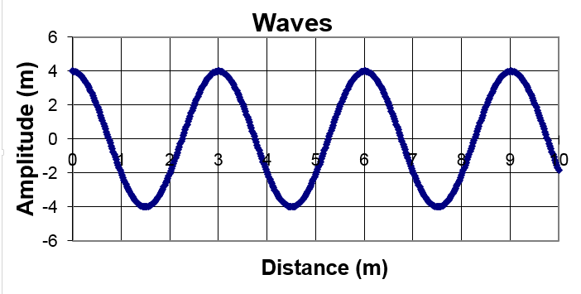
A. λ
B. f
C. T
D. A
E. ω

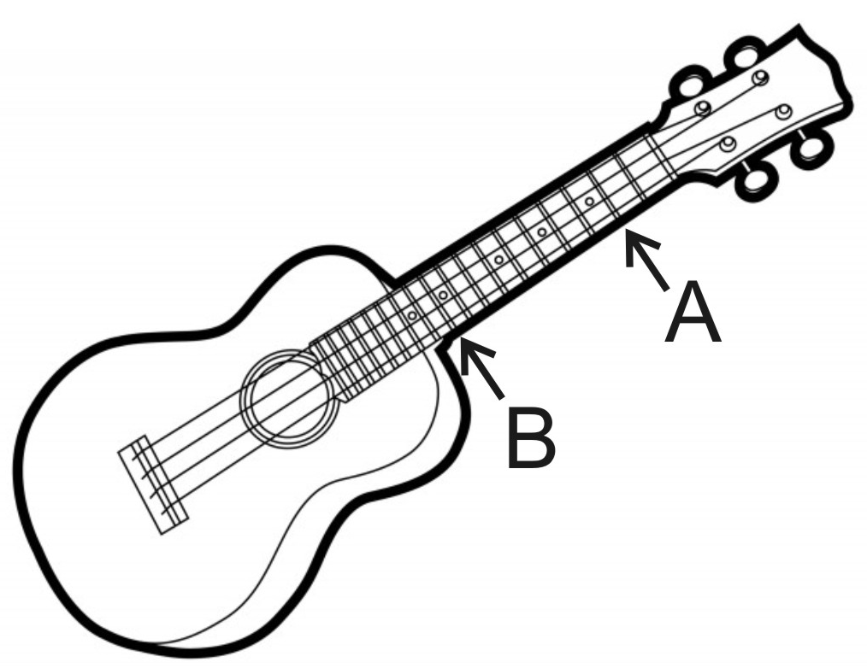
9. On a cold November morning, a student listened to a passing stock car and hears a Doppler shift. The student recreated the shift by playing two notes on the ukulele to the right (by plucking a string while pressing the string against each of the indictated frets). The air temperature was 0°C.

a. To recreate the Doppler shift she heard, in which order did the student play the two notes, indicated on the right?

b. What was the velocity of the passing car?

