**Unit 11 Handout, Part 1 Name: _____________________**

**Part 1: Wave Terminology and Standing Waves**

Show these parts of a transverse wave: crest, trough, wavelength, amplitude

Wavelength Symbol: ___________________

Frequency:

Frequency Symbol: ______ Units: _______ Frequency Formula:

Wave speed Formula: v =

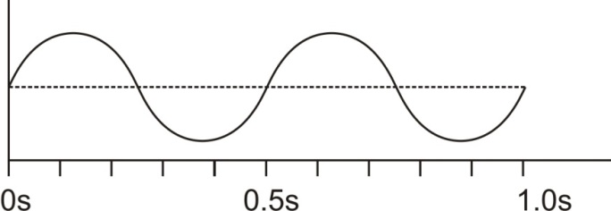

Calculate the frequency of the series of waves on the right.

Assuming that λ=10m for the waves on the right, what is the wave speed?

Transverse and Longitudinal Waves

A. A transverse wave (a.k.a. shear wave, sinusoidal wave) is a disturbance ______________________ to the direction of propagation.

B. A longitudinal wave (or compressional wave) is a disturbance ______________________ to the direction of propagation.

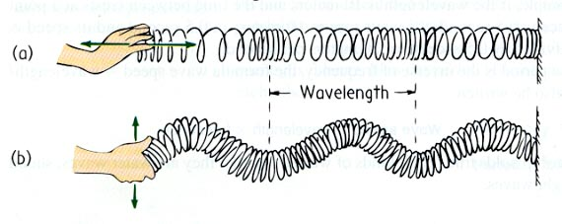Types and parts of waves:

Identify the two different types of waves on the right.

Parts of a longitudinal wave: compression, rarefaction, wavelength



What determines the amplitude of a longitudinal wave?

Formation of a sound wave (longitudinal wave, a.k.a. compression wave)

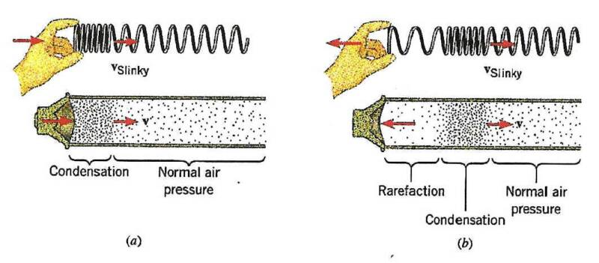

Which of the series of waves on the right shows the greatest amplitude?

Period (T) is the duration of one wave. What is the period of Wave C?

What is the relationship between period (T) and frequency (f)?

What is the frequency of wave C?

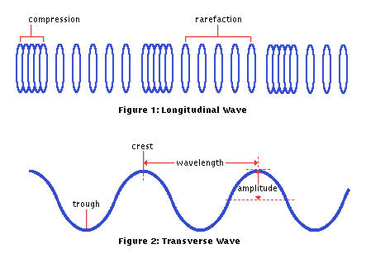

Sound waves are longitudinal, but they can be represented as transverse waves:

**Wave Interference:**

2. When two or more waves arrive at the same point, the resulting wave is the _________ of the individual waves. This is a phenomenon called ____________________. If the disturbance corresponds to a force, then the forces add. Whatever the disturbance, the resulting wave is a simple addition of the disturbances of the individual waves. That is, their amplitudes add.

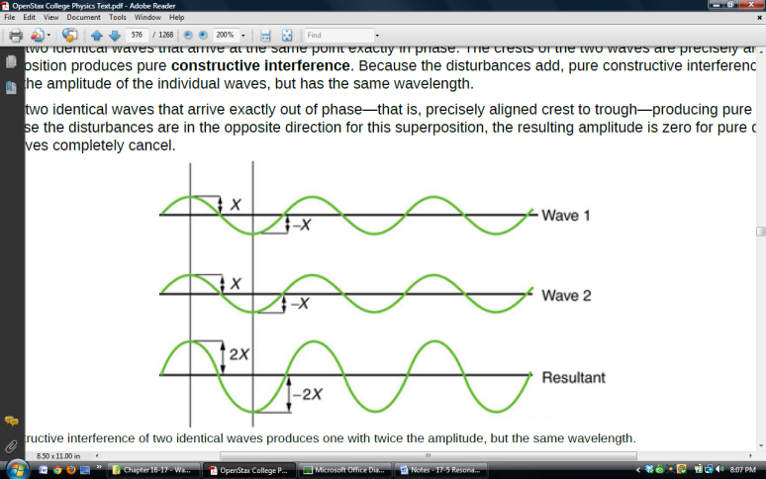

Pure ______________ Interference

Pure ______________ Interference

3. In the diagram below, two waves pass through each other moving in opposite directions, and their disturbances add as they go by. Since the two waves have the same ___________________ and ___________________, then they alternate between constructive and destructive interference. The resultant looks like a wave standing in place. This is called a ____________________________.

Beats:

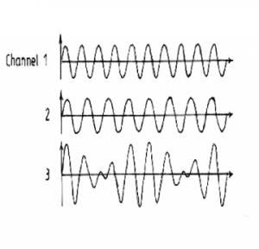Wave Interference can cause “**beats**”. When two waves have slightly different frequencies, their interference alternates between constructive and destructive. The diagram below shows transverse representations of two sound waves (channels 1 and 2) and their resultant sound (channel 3).

* In the diagram, label the channel with the highest frequency (1 or 2).
* Then label regions of constructive and destructive interference. Channel 3 is the “sum” of channels 1 and 2.
* Label the “beats” that will be heard

**Beat frequency =difference in frequencies of two notes that are played together**

Example: What is the beat frequency when 220Hz and 216Hz are played at the same time? _______

**Standing Waves:**

What are the rules for drawing standing waves?

1.

2. If an end is free to move, it is a(n) _________________. If an end is fixed, it is a(n) __________________.

Draw a vibrating string with the combinations of nodes and antinodes below. Label the free and fixed ends.

* 3 nodes, 2 antinodes
* 4 nodes, 4 antinodes
* 2 nodes, 3 antinodes

**Standing Sound Waves in a Tube**

Wavelengths and Harmonics in a tube **open at one end** (e.g. an organ pipe)

1. How are waves in an organ pipe different than waves on a string?

2. The diagram above represents the organ pipe waves as transverse waves. In reality, they are longitudinal. What is really happening to air molecules at the antinodes?

3. At the nodes, what are the air molecules doing?

4. For the fundamental, explain why there is a node at the left end and an antinode at the right?

5. Draw the fundamental for a pipe that is closed at both ends. How much of a wavelength does the pipe length represent?

6. For each harmonic above, write an equation for wavelength in terms of tube length.

7. Label any harmonics according to the order of the harmonic (i.e. 1st harmonic, 2nd harmonic, 3rd harmonic…). The lowest frequency harmonic is the **1st harmonic (a.k.a fundamental)**. The **nth harmonic** has a wavelength that is equal to the fundamental wavelength/n.

8. Label the harmonics using the term “overtone,” rather than the term harmonic.

Notes – 17.1-17.3 Sound

2. Vibrations of an object result in compressions (_______________ pressure regions) and rarefactions (_______________ pressure regions) that move out as _____________ pressure waves.

3. Sound, like all waves, travels at a certain speed and has the properties of frequency and wavelength. The perception of frequency is called _______________.

4. The relationship of the speed of sound, its frequency, and wavelength is the same as for all waves:

5. The speed of sound in a medium is determined by a combination of the medium’s _________________ (or compressibility in gases) and its __________________. The more rigid (or less compressible) the medium, the _________________ the speed of sound. (This observation is analogous to the fact that the frequency of a simple harmonic motion is directly proportional to the stiffness of the oscillating object.) The greater the density of a medium, the _________________ the speed of sound. (This observation is analogous to the fact that the frequency of a simple harmonic motion is inversely proportional to the mass of the oscillating object.) The speed of sound in air is low, because air is compressible. Because liquids and solids are relatively rigid and very difficult to compress, the speed of sound in such media is generally greater than in gases.

6. The speed of sound in air is given by:

Practice – 17.1-17.3 Sound

1. When poked by a spear, an operatic soprano lets out a 1200-Hz shriek. What is its wavelength if the speed of sound is 345 m/s?

2. What frequency sound has a 0.10-m wavelength when the speed of sound is 340 m/s?

3. Calculate the speed of sound on a day when a 1500 Hz frequency has a wavelength of 0.221 m.

4. A. What is the speed of sound in a medium where a 100-kHz frequency produces a 5.96-cm wavelength?

B. Which substance in Table 17.1 (found in Section 17.2) is this likely to be?

5. Air temperature in the Sahara Desert can reach 56.0ºC (about 134ºF). What is the speed of sound in air at that temperature?

6. A sonar echo returns to a submarine 1.20 s after being emitted. What is the distance to the object creating the echo? (Assume that the submarine is in the ocean, not in fresh water.)

7. If a submarine’s sonar can measure echo times with a precision of 0.0100 s, what is the smallest difference in distances it can detect? (Assume that the submarine is in the ocean, not in fresh water.)

8. A physicist at a fireworks display times the lag between seeing an explosion and hearing its sound, and finds it to be 0.400 s. How far away is the explosion if air temperature is 24.0ºC and if you neglect the time taken for light to reach the physicist?

9. Suppose a bat uses sound echoes to locate its insect prey, 3.00 m away. Calculate the echo times for temperatures of 5.00ºC and 35.0ºC.

**Answers**:

1. 0.288 m 2. 3400 Hz 3. 332 m/s

4. A. 5.96 x 103 m/s B. steel 5. 364 m/s 6. 924 m

7. 7.70 m 8. 138 m 9. 0.0179 s (5 oC) , 0.0171 s (35 oC)

Practice – 16.10 & 17.5 Superposition, Interference and Resonance

1. A “showy” custom-built car has two brass horns that are supposed to produce the same frequency but actually emit 263.8 and 264.5 Hz. What beat frequency is produced?

2. A piano tuner hears a beat every 2.00 s when listening to a 264.0-Hz tuning fork and a single piano string. What are the two possible frequencies of the string?

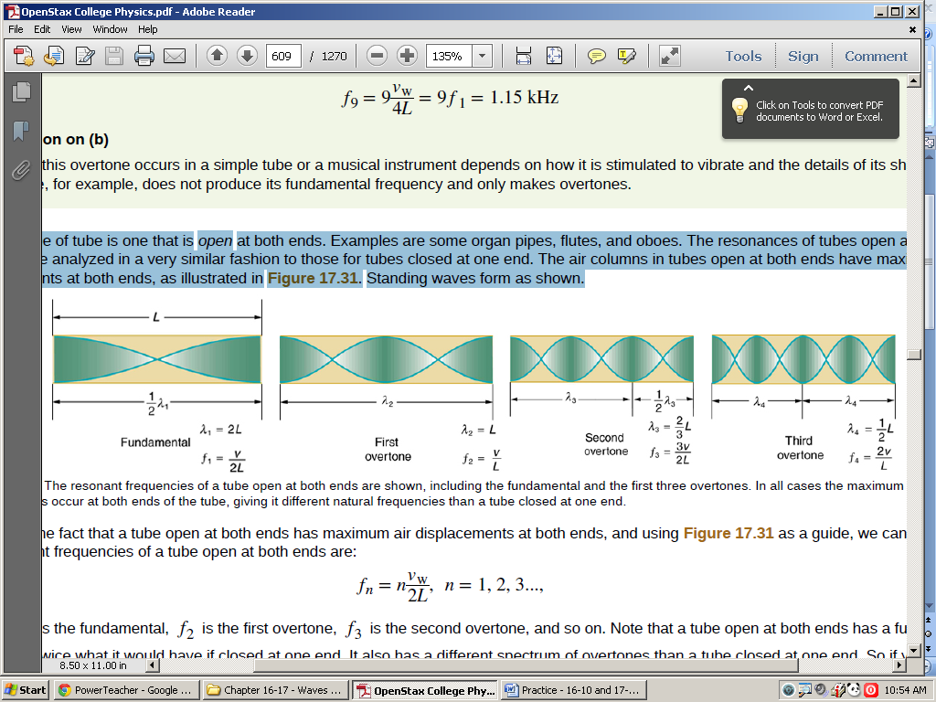3. Another type of tube is one that is open at both ends. Examples are some organ pipes, flutes, and oboes. The resonances of tubes open at both ends can be analyzed in a very similar fashion to those for tubes closed at one end. The air columns in tubes open at both ends have maximum air displacements at both ends. A standing wave occurs at resonance.

A. What is the fundamental frequency of a 0.672-m-long tube, open at both ends, on a day when the speed of sound is 344 m/s?

B. What is the frequency of its second harmonic?

4. How long must a flute be in order to have a fundamental frequency of 262 Hz (this frequency corresponds to middle C on the evenly tempered chromatic scale) on a day when air temperature is 20.0ºC? It is open at both ends.

5. A. Find the length of an organ pipe closed at one end that produces a fundamental frequency of 256 Hz when air temperature is 18.0ºC.

B. What is its fundamental frequency at 25.0ºC?

6. Students in a physics lab are asked to find the length of an air column in a tube closed at one end that has a fundamental frequency of 256 Hz. They hold the tube vertically and fill it with water to the top, then lower the water while a 256-Hz tuning fork is rung and listen for the first resonance.

A. What is the air temperature if this first resonance occurs for a length of 0.336 m?

B. At what length will they observe the second resonance (first overtone)?

**Answers**:

1. 0.7 Hz 2. 263.5 Hz, 264.5 Hz 3. A. 256 Hz B. 512 Hz 4. 0.655 m

5. A. 0.334 m B. 259 Hz 6. A. 21.5 oC B. 1.01 m

**Resonance Lab**

**Purpose:** To measure the speed of sound using a tuning fork and resonating tube.

**Setup:**



1 ruler 1 meter stick

1 large graduated cylinder 1 thermometer

1 white PVC pipe 1 512 Hz tuning fork $v=fλ$

**Procedure:**

1. Measure the air temperature. Record this in the data table.

2. Calculate the speed of sound. Record this in the data table.

**512 Hz First harmonic (n = 1)**

3. Fill your graduated cylinder almost, but not quite, full of water with the white PVC pipe inside the cylinder. *NOTE: Do not overflow the water.*

4. Strike your 512 Hz tuning fork on one of the green rubber striking blocks. Hold it over the PVC pipe and slowly lift the pipe out of the water until your hear the pipe’s first harmonic resonating with the tuning fork. Hold the pipe here, and…

5. Measure the length (L) of the PVC pipe that is above water level with the meter stick. Record this measurement in meters in the data table. *Note: Be sure to measure from the level of the water, not from the top of the graduated cylinder.*

6. Now calculate the wavelength of the sound waves when the first harmonic was produced by the 512 Hz tuning fork. Record this in the data table.

7. Next calculate the experimental speed of sound using the formula v = f where  is the wavelength calculated above in 6 above and f is the frequency of the tuning fork in Hz. Record this in the data table.

8. Finally, calculate the % error in your measurement of the speed of sound compare to the calculated speed of sound. Use the formula % error = 100% . Record this in the data table. Remember that % error can be either + or – !

**512 Hz Third Harmonic (n = 3)**

1. Strike your 512 Hz tuning fork on one of the green rubber striking blocks. Hold it over the PVC pipe and slowly lift the pipe out of the water past the first harmonic until you hear the next resonance. This is the third harmonic. Repeat steps 5-8 above. Record your results in the second column of the data table.

**Another First Harmonic (n = 1)**

2. Get a tuning fork with another frequency that is not 512 Hz. Record its frequency at the top of the third column in the table below. Repeat steps 6-9 above. Record your results in the third column of the data table.

**Data Tables:**

|  |  |
| --- | --- |
| T = room temp | oC |
| vactual (calculated from equation) | m/s |

|  |  |  |  |
| --- | --- | --- | --- |
|  | f = 512 Hz  1st harmonic  n = 1 | f = 512 Hz  3rd harmonic  n = 3 | f = ____ Hz  1st harmonic  n = 1 |
| Lobserved |  |  |  |
| ● |  |  |  |
| Vobserved |  |  |  |
| % error = 100% $×\frac{(\operatorname{observed}{-}actual)}{actual}$ |  |  |  |

**Some Questions:**

**Choose one of these answers for each of the questions below.**

A. increase B. decrease C. stay the same

Use the equations we have used in class to help you answer these questions. Suppose you have a tuning fork with an adjustable frequency…

_____1.If you decrease a tuning fork’s frequency, what happens to its sounds’ wavelength in air at a given temperature (i.e. at a given speed of sound)?

_____2. If you decrease a tuning fork’s frequency, what happens to the speed of its sound waves?

_____3. If you were to repeat this experiment with a tuning fork having a lower frequency, how would your measured values of L change?

_____4. If you were to decrease the temperature of the air, what would happen to the speed of the sound waves made by any tuning fork?

_____5. If you were to decrease the temperature of the air, what would happen to the wavelengths of the sound waves made by any tuning fork?

6. How do we know that the first resonant frequency that you hear is the fundamental? You can explain with a picture.

7. As you pull the pipe from the water, you first hear the first harmonic. Next you hear the 3rd harmonic. Why did you not hear a 2nd harmonic? You can use a drawing to explain.

Notes – 17.4 Doppler Effect

1. The Doppler effect (or Doppler shift) is named after the Austrian physicist Christian Doppler who proposed it in 1842. It is the change in frequency of a wave for an observer moving relative to the source of the wave. It is commonly heard when a vehicle sounding a siren or horn approaches, passes, and recedes from an observer.

2. The sound that is heard shifts from a ________________ frequency to a ________________ frequency.

3. This effect is due to motion of either the ________________ or the ________________.

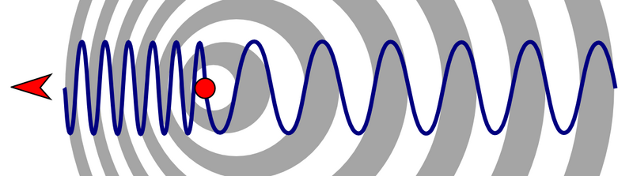

4. Equation: fo = fs

fo : frequency heard by the observer

fs : frequency of the sound source

v : velocity of sound (which is a function of the medium and temperature)

vo : velocity of the observer

vs : velocity of the sound source

Name: ___________________________

**Practice 17.4 - Doppler Effect**

**Equations:**

v = 331.3  331.3 + 0.606 T m/s fo = fs

1. Suppose a train that has a 150-Hz horn is moving at 35.0 m/s in still air on a day when the speed of sound is 340 m/s.

A. What frequencies are observed by a stationary person at the side of the tracks as the train approaches and after it passes?

B. What frequency is observed by the train’s engineer traveling on the train?

2. What frequency is received by a mouse just before being dispatched by a hawk flying at it at 25.0 m/s and emitting a screech of frequency 3500 Hz? Take the speed of sound to be 331 m/s.

3. A car passes through an intersection at 1.00 x 102 km/hr. If the air temperature is 20.0 oC and the frequency of the car's horn is 3.00 x 102 Hz, what change in frequency would a stationary observer notice as the car passes? **Note:** f = ftowards - faway

4. Two police cars pass each other, both moving at 80.0 km/hr. The air temperature is 25.0 oC. If each car sounds its siren with a frequency 4.00 x 102 Hz, what change in frequency will be heard by each policeman as the cars pass?

5. A sound meter at a race track records the frequency of the exhaust of an approaching race car to 6.00 x 102 Hz. The actual frequency is known to be 5.30 x 102 Hz. The air temperature is 20.0 oC. How fast is the car going?

6. A sound meter records the exhaust frequency of a receding race car to be 4.00 x 102 Hz. The actual frequency is 4.50 x 102 Hz. If the air temperature is 15.0 oC, how fast is the car going?

**Solutions:** 1. A. 167 Hz, 136 Hz B. 150 Hz 2. 3.79 x 103 Hz 3. 48.9 Hz 4. 103 Hz 5. 40.0 m/s 6. 42.5 m/s

**Making and Modeling Waves**

Waves are often made by objects that oscillate, and objects tend to oscillate in a predictable way. One type of oscillation is called **Simple Harmonic Motion** (or Simple Harmonic Oscillation). Some examples of objects that oscillate in this way are:

Pendulums (with small displacements), Instrument strings, Masses bouncing on springs, Vibrating rulers (that have just been bent and released)…

To model these waves, a modified sine curve is often used. One form of the **Wave Equation** looks like this…

**y = A cos(t + ) + y0 or y = A sin(t + ) + y0**

Sketch a graph of y = cos(t), where t = time.

** =**

** =**

**y0 =**

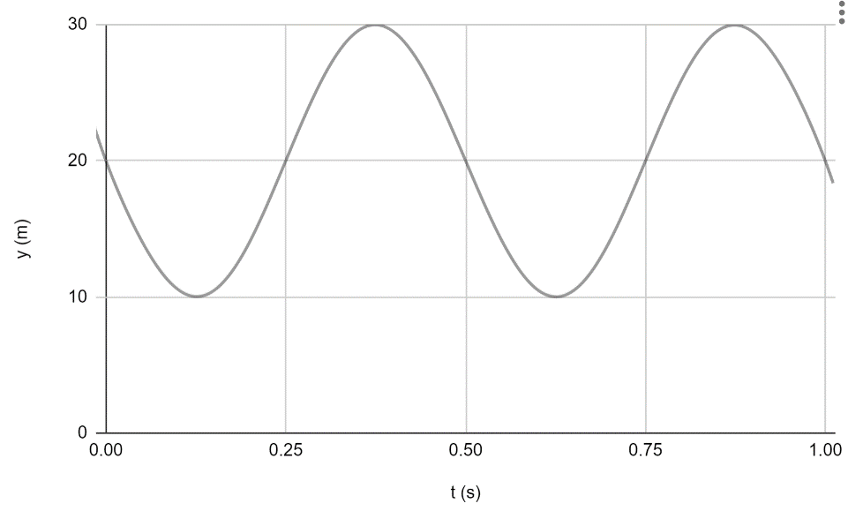Write an equation for the graph on the right, in the form

y = A cos(t + ) + y0

**Physics 200 (Stapleton) Name: ___________________________**

**2019-2020 Test: Chapter 16-17– Waves and Sound**

**I. Matching (Select the correct SI unit for each wave parameter).**

A. seconds

B. Hertz

C. meters

D. meters per second

1. ____ frequency

2. ____ T

3. ____ wavelength x frequency

4. ____ **λ**

5. ____ amplitude

**II. Multiple Choice (Choose the one best answer for each question.)**

6. For sound traveling through air at 0.0°C, which of the following changes as the sound travels farther from the source?

A. Wavelength B. Period C. Amplitude D. Velocity E. None of these

7. The pictures on the right show sound waves produced by a moving object. In which case is the object is moving the **fastest?**

8. The two sets of waves on the right interact to produce beats. How many beats can you identify during the time span shown on the graph?

a. 0 b. 1 c. 2 d. 3 e. 4

9. As the temperature of air increases, the speed of sound in that air…

A. increases B. decreases C. stays the same

10. A beat frequency of 6Hz is heard when a 600Hz tuning fork and a ____ tuning fork are struck at the same time.

A. 6Hz B. 100 Hz C. 594 Hz D. 660 Hz E. 3600 Hz

11. For a tube of length L that is open on both ends, the wavelength of the fundamental is?

A. 1/4L B. 1/2L C. L D. 2L E. 4L

12. The parts of a standing wave that have no movement are called

A. fundamentals B. harmonics C. nodes D. antinodes

13. Longitudinal waves have a disturbance that is

A. parallel to the motion of the wave.

B. perpendicular to the direction of motion of the wave.

C. counterclockwise to the direction of the wave.

D. clockwise to the direction of the wave.

14. A sound wave is an example of a transverse wave.

A. True B. False

15. A child picks up one end of a garden hose that is stretched out, lying horizontally on the ground. The child jerks the hose directly upward and then directly downward, causing a ____________ wave to travel along the length of the hose.

A. Transverse B. Longitudinal

16. How many of the following phenomena can occur when two waves are added together?

Phenomena: Silence; Beats; Increased Volume

A. 0 B. 1 C. 2 D. 3

17. A sound source moving toward you (compared to the same sound source at rest) will have

A. a lower pitch

B. a lower speed of sound

C. a lower frequency

D. a shorter wavelength

E. the same frequency

18. A tone is produced by a computer. As the frequency of the tone is decreased,

A. the speed of the sound increases.

B. the speed of the sound decreases.

C. the sound wave’s period increases.

D. the sound wave’s period decreases.

E. the sound’s wavelength decreases.

19. A vibrating string has a standing wave pattern with exactly 3 nodes and 2 antinodes. If the length of the string is L, what is the wavelength of the standing wave pattern?

a. 1/2L b. L C. 2/3 D. 3/2L E. 2L

**III. Problems** f=1/T $v=fλ$ v= 331.3 + 0.606 T or

1. A bat finds a moth by sending a sound pulse through the air and listening for the echo. If the distance between the moth and the bat is 15m, how long after it makes a sound does the bat hear its echo? (Assume that the speed of sound is 340m/s)

2. The eruption of the island of Krakatoa in 1883 was extremely loud. In fact, the sound was reportedly heard about 3.8 hours later at distant locations on the Earth. Assuming a constant air temperature of 28°C, how far would the sound have traveled in 3.8 hours? Answer in kilometers (1km = 103m).

3. Calculate the speed of sound on a day when sound with a frequency of 440Hz frequency has a wavelength of 0.79 m.

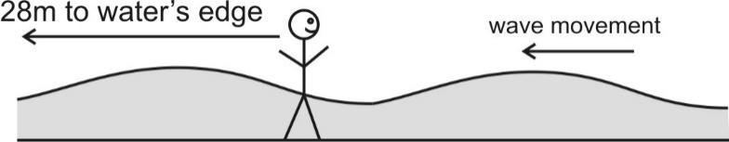4. You’re standing motionless in the waves at the beach. You are 28m from the water’s edge. A wave crest hits you every 5 seconds. After the waves pass you, it takes them 7 seconds to travel to the water’s edge. Find…

1. The frequency of the waves.
2. The speed of the waves.

c. The wavelength of the waves

5. The velocity of a standing sound wave in a pipe is 300m/s. The pipe is closed on both ends. If the pipe length is 0.63m, what is its fundamental frequency?

6. An overheated bicyclist traveling at a rate of 15m/s approaches a stationary ice cream truck that is playing *Pop Goes The Weasel.* When the ice cream truck loudspeaker plays a note with a frequency of 600Hz, what frequency is heard by the approaching bicyclist? Assume that the speed of sound is 340m/s.

7. Given that the velocity of the wave shown on the right is 120 m/s, find each of the following.

V = 120 m/s

A.   

B. f  

C. T  

D. A  

8. Write a wave equation for the wave on the right, in the form

**y = A cos(t + ) + y0**