Physics 200 Name: _________________________________
Notes: String Instrument Scales

You will be expected to play a song. This will probably be easier if you have some way of remembering which notes are part of a minor key or major key (because your song will be in one type of key or the other).

1. On a piano keyboard, the keys get higher in pitch as you travel to the _____________ (left or right?).

2. Each key on a piano keyboard, whether it is black or white, is separated from the next key by exactly one

_______________ step.

3. On a piano keyboard, the white keys are the notes (A, B, C, D,E, F, and G) and the black keys are called sharps (#) or flats(♭). The black key adjacent and to the right of an A is an A __________. The black key adjacent and to the left of an A is an A____________.

4. Label 13 consecutive piano keys with their note names. For the darkened keys, give either the sharp name or the flat name.

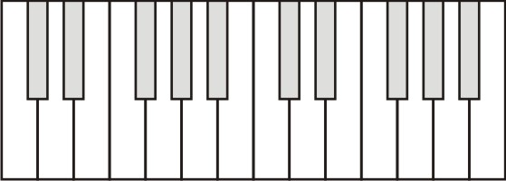

5. If you play all of these notes, from low to high, you are playing what is called a

_____________________________________________

11. The only major key scale that can be played without using any black keys is the _______ Major scale.

12. All major key scales have the following pattern of whole and half steps: __________________________

13. Show the keys of a 1-octave C major scale. Number the notes 1-7.

14. Show the keys of a 1-octave (8 note) A major scale. Number the notes 1-7.

15. The only minor key scale that can be played without using any black keys is the _______ Major scale.

16. All minor key scales have the following pattern of whole and half steps: __________________________

17. Show the keys of a 1-octave (8 note) A minor scale. Number the notes 1-7.

18. Show the keys of a 1-octave C minor scale. Number the notes 1-7.

Playing major keys on String Instruments:

17. String instruments don’t have white and black keys, but many do have frets. Each space between frets is a half-step. Unlike a piano, the precise frequency at any fret varies according to the string mass, string tension, etc. So, your instrument can have an open string frequency corresponding to an A, A#, D♭, or whatever. Thus we will be marking notes in a more flexible way. The notes of the scale will be 1-7, and an 8 octave scale will go from 1 up to the next 1. On the half of the instrument above the string, write the notes of a major scale, starting with 1 at the nut. Then write the minor scale notes below the string.

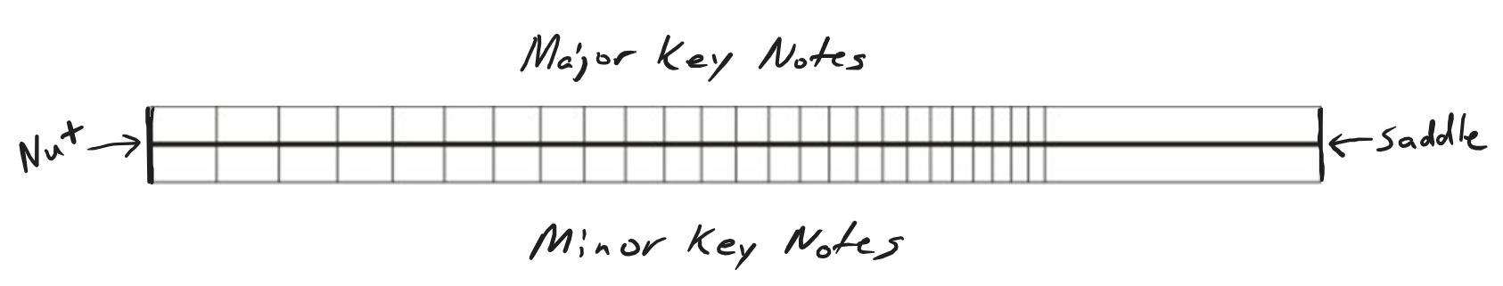

18. The first note of a scale is called the “tonic.” There’s no reason why the tonic has to be your open string note. On the diagram below, place your number 1 in a different location and then write the rest of your notes.

