Physics 200 (Stapleton) Name: ___________________________

Notes – Waves, Standing Waves, Division of The Octave, and Fret Calculations

Show these parts of a transverse wave: crest, trough, wavelength, amplitude
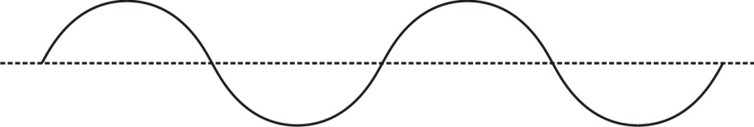
Wavelength Symbol: ___________________

Frequency:

Frequency Symbol: ______ Units: _______ Frequency Formula:

Wave speed Formula: v =

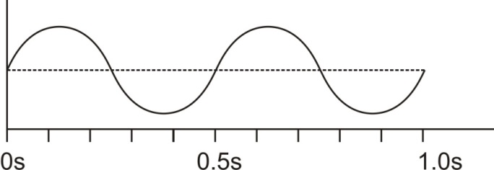
Calculate the frequency of the series of waves on the right.

Assuming that λ=10m for the waves on the right, what is the wave speed?

2. When two or more waves arrive at the same point, the resulting wave is the _________ of the individual waves. This is a phenomenon called ____________________. If the disturbance corresponds to a force, then the forces add. Whatever the disturbance, the resulting wave is a simple addition of the disturbances of the individual waves. That is, their amplitudes add.

Pure ______________ Interference
Pure ______________ Interference

3. In the diagram below, two waves pass through each other moving in opposite directions, and their disturbances add as they go by. Since the two waves have the same ___________________ and ___________________, then they alternate between constructive and destructive interference. The resultant looks like a wave standing in place. This is called a ____________________________.

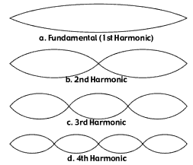
Standing Waves in Vibrating Strings fixed at both ends (e.g. a guitar string)

A plucked string seems to be simply vibrating back and forth, perpendicularly to the length of the string. In actuality, the vibration can be understood as a set of complex interactions between waves that are traveling parallel to the string length, interfering with one another as they reflect back and forth, and producing standing wave patterns.

The vibrations of a string actually comprise several different standing wave patterns superimposed over one another. The loudest wave pattern is the fundamental (a.k.a. 1st harmonic). All of these wave patterns are called harmonics, and they only occur at integer multiples of the fundamental frequency. For example, if the fundamental frequency is 10Hz, the 2nd harmonic would have a frequency of 20Hz; the 3rd harmonic would be 30Hz; the 4th harmonic = 40Hz. For wavelength, this relationship is inverted. The wavelength of the 2nd harmonic is ½ the fundamental wavelength. The 3rd harmonic’s wavelength is 1/3 the fundamental wavelength

4. For the figure on the top right, give the wavelength for each harmonic, in terms of the vibrating string length.

Fundamental Wavelength = ___________ string length

2nd harmonic Wavelength = ___________ string length

3rd Harmonic Wavelength = ___________ string length

4th Harmonic Wavelength = ___________ string length
12 TET (12 Tone Equal Temperament) Division of the Octave

Note  Name | half steps  up from starting note | Frequency (Hz) | Ratio: Current frequency / Previous frequency | Ratio of wavelength to starting note wavelength
A | 0 | 440 | NA | 1
A# (or B♭) | 1 | 466 | 1.059 | 0.944
B | 2 | 494 | 1.059 | 0.891
C | 3 | 523 | 1.059 | 0.841
C# (or D♭) | 4 | 554 | 1.059 | 0.794
D | 5 | 587 | 1.059 | 0.749
D# (or E♭) | 6 | 622 | 1.059 | 0.707
E | 7 | 659 | 1.059 | 0.667
F | 8 | 698 | 1.059 | 0.630
F# (or G♭) | 9 | 740 | 1.059 | 0.595
G | 10 | 784 | 1.059 | 0.561
G# (or A♭) | 11 | 831 | 1.059 | 0.530
A | 12 | 880 | 1.059 | 0.5
A# (or B♭) | 13 | 932 | 1.059 | 0.472
B | 14 | 988 | 1.059 | 0.445
C | 15 | 1047 | 1.059 | 0.420
C# (or D♭) | 16 | 1109 | 1.059 | 0.397
D | 17 | 1175 | 1.059 | 0.375
D# (or E♭) | 18 | 1245 | 1.059 | 0.354
E | 19 | 1319 | 1.059 | 0.334
F | 20 | 1397 | 1.059 | 0.315
F# (or G♭) | 21 | 1480 | 1.059 | 0.297
G | 22 | 1568 | 1.059 | 0.281
G# (or A♭) | 23 | 1661 | 1.059 | 0.265
A | 24 | 1760 | 1.059 | 0.25
1. When musicians play a 1-octave scale, they play ________ notes. When we hear the musical notes at the bottom and top of a 1-octave scale, our ears perceive those notes as being the same notes, even though one sounds “higher” and one sounds “lower.”

2. When two notes are separated by an octave, the higher note has a frequency that is

___________________ the frequency of the
lower note.

For example, a musical note with a frequency of 110Hz is an A. If we start singing at that pitch and move gradually upward, we will reach the next A when we get to ______Hz. The next A after that will be heard at _______Hz.

3. In an 8 note, one octave scale, not every note on the instrument gets played. The music that most of us listen to actually divides each

octave into ________ “equal” parts. Each of these equal parts is called a

_________________________ or a

_________________________. The musical system that divides an octave in this way is called

__________________________________________________________________________________. This is the system that applies to most of the music that you have heard (probably).

4. A one octave jump in pitch represents a ______________________________ of sound wave frequency.
5. A two octave increase in pitch represents a 2⁽ ⁾ increase in frequency.
6. A three octave increase in pitch represents a 2⁽ ⁾ increase in frequency.
7. A four octave increase in pitch represents a 2⁽ ⁾ increase in frequency.
8. A 1/12 octave increase in pitch (in other words, a half step) represents a 2⁽ ⁾ increase in frequency. In other words, to raise the pitch of a sound by a half step its frequency must be multiplied by 2^{(1/12)} ≈1.0595.
9. To raise pitch by n half steps, one must multiply the current frequency by 2⁽ ⁾.

10. 2^{(1/12)} ≈1.0595

String Instruments:

11. The frequency of sound produced by a string is affected by the string’s _________________,

____________________, ___________________ and other characteristics.

12. The vibrating portion of a string extends from an instrument’s ________________ to its

_______________.

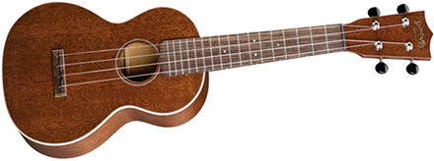
13. Label the nut, bridge, body, neck, frets, saddle, and tuners on the string instrument to the right.

14. The purpose of frets is to allow the musician to precisely control _______________________________

____________________________________________________________________________________

15. The purpose of the body is to ___________________________________________________________

_____________________________________________________________________________________

16. The purpose of the bridge is to ____________________________________________________________

_____________________________________________________________________________________

_____________________________________________________________________________________

17. The purpose of the saddle is to ____________________________________________________________

_____________________________________________________________________________________

18. The purpose of the tuners is to ____________________________________________________________

_____________________________________________________________________________________

Fret Placement:
When a string is plucked or bowed, many types of waves travel along it, producing a variety of standing waves. The dominant (loudest) standing wave is called the fundamental. There are also other harmonics (a.k.a. overtones), which have higher frequencies and pitch.

19. Suppose an instrument string is 50cm long, and when the open string is plucked, its frequency is 400hz.

- For purposes of tuning, we care about the fundamental vibration of the string. On the diagram to the right, label the position of the bridge and the nut. In this case, how many wavelengths does the vibrating string represent?

- What is the full wavelength of the waves that are traveling down the string?

- What is the relationship between string length and the wavelength of the string’s fundamental standing wave?

- What is the speed of those waves? Note: This speed is constant for a given string as long as the string’s tension remains constant.

- The first fret (closest to the nut) on a finger board needs to correspond to a note that is one half-step higher than the open string. What is the frequency of a note one half step higher than the 400hz open string?

- In order to produce that note, what wavelength must the string have? [hint: you know the string’s wave speed]

- How long must the vibrating portion of the string be in order to produce that wavelength?

- How far from the nut should the first fret be located? In other words, by what distance must you shorten your string in order to raise your instrument’s pitch by one half step?

Fret Distance Calculations for Your Instrument

Your chosen scale length -- distance from bridge to nut (cm)
Distance from bridge to nut (cm)
Wavelength of open string Fundamental (cm)
Frequency of Open String (hz)  "open string" means the entire string oscillates. For calculations, we will assume that your open string produces an A at 440Hz | 440
Speed of wave (inches/s) – constant for all calculations below

Assuming that the wave speed for each of your strings remains constant at a given tension…

half steps  above open string | hz | wavelength | Vibrating string  length (cm) | Distance of fret from nut (cm)
0 | 440
1
2
3
4
5
6
7
8
9
10
11
12

