Physics 200 (Stapleton) Name: ______________________
Notes: Waves and Sound, Part 1

1. Give some examples of waves.

2 . Transverse and Longitudinal Waves
A. A transverse wave (a.k.a. shear wave, sinusoidal wave) is a disturbance ______________________ to the direction of propagation.

B. A longitudinal wave (or compressional wave) is a disturbance ______________________ to the direction of propagation.

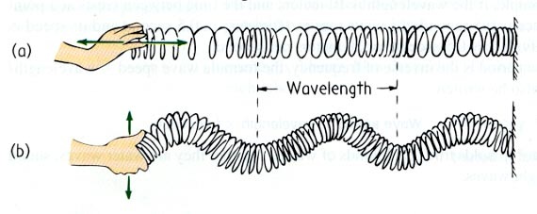
Types and parts of waves:

Identify the two different types of waves on the right.

Parts of a transverse wave: crest, trough, wavelength, amplitude

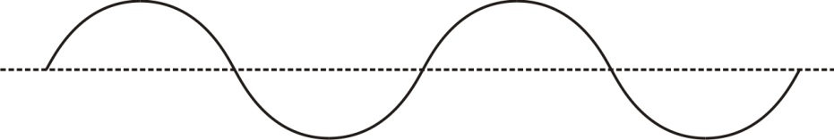

Parts of a longitudinal wave: compression, rarefaction, wavelength

What determines the amplitude of a longitudinal wave?
Fomation of a sound wave (compression wave)
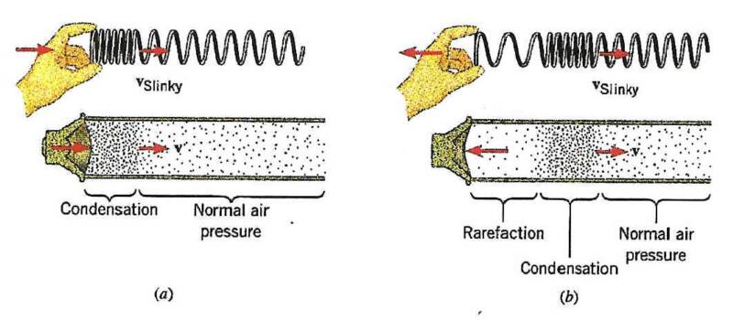

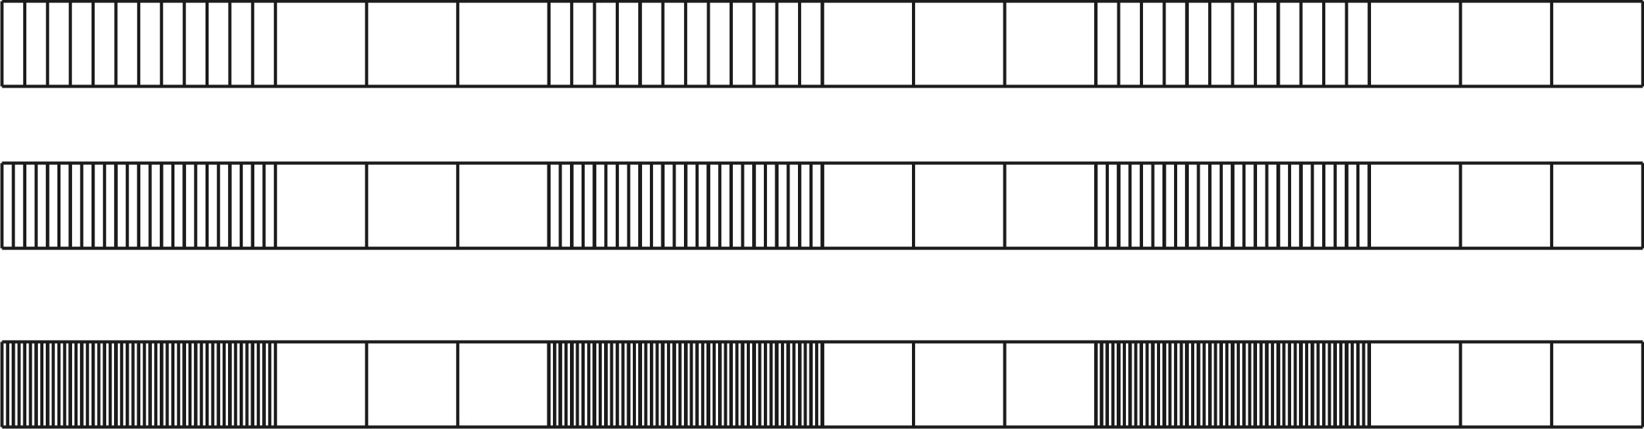
Which of the series of waves on the right shows the greatest amplitude?

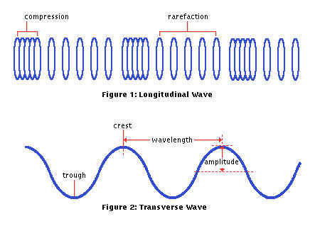
Sound waves are longitudinal, but they can be represented as transverse waves:

Period, Frequency, and Wave Speed

Period:

Frequency:

Wave speed: v =

What is the period of the waves below? _________

Calculate the frequency of those waves. f = ___

If the wave below has a wavelength of 10m, what is its wave speed?

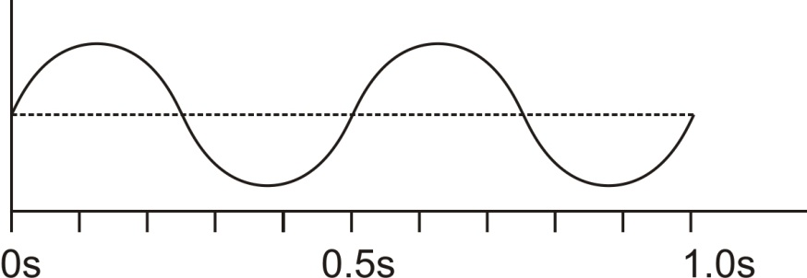

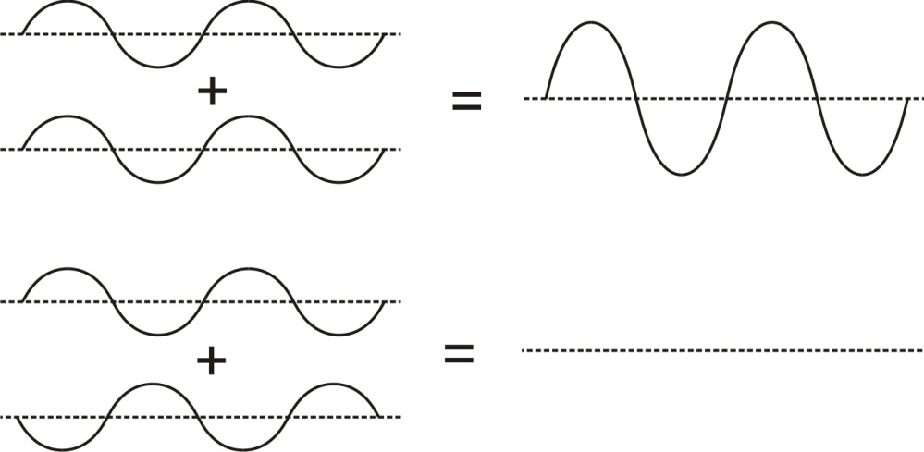
Wave Interference: When two waves overlap one another, their oscillations can add to one another, or they can diminish one another. Label the examples of interference on the right.

Wave Interference can cause “beats”. When two waves have slightly different frequencies, their interference alternates between constructive and destructive. The diagram below shows transverse representations of two sound waves (channels 1 and 2) and their resultant sound (channel 3).

- In the diagram, label the channel with the highest frequency (1 or 2).
- Then label regions of constructive and destructive interference. Channel 3 is the “sum” of channels 1 and 2.
- Label the “beats” that will be heard
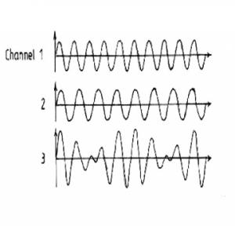

Beat frequency =difference in frequencies of two notes that are played together
Example: What is the beat frequency when 220Hz and 216Hz are played at the same time? _______

