Physics 200 (Stapleton) Name: _____________________ School
Test Review – Work and Energy

Formulas and Info:

W=Fd $P=\frac{W}{t}$ W_{net} = ΔKE $KE=\frac{1}{2 }mv^{2}$ ΔPE = mgh

KE_{initial} +PE_{initial} = KE_{final} + PE_{final} KE_{initial} +PE_{initial} + W_{nc} = KE_{final} + PE_{final}

1horsepower = 746W 1 Calorie = 4.184 Joules. 1kcal = 1 food calorie = 4,184 Joules

F_{spring} =-kx ${PE}_{spring} =\frac{1}{2}kx^{2}$ $\% Efficiency= \left(\frac{Energy Output}{Energy Input}\right)\left(100\%\right)$

1. A child and her sled have a total mass of 15kg. The child sits at rest at the top of a frictionless sledding run which is 40m long. Starting from rest, the child lets gravity pull her down the hill. The force of friction acting on her sled is constant and her velocity at the bottom of the hill is 10m/s.

a. What was her vertical drop, in meters?

b. What was the downhill (parallel) component of her and her sled’s weight?

2. A stranded motorist pushes a frictionless 1,400kg car with a constant force of 200N.

a. If the motorist converts food calories to car pushing power with 35% efficiency, how far will the car have traveled when the motorist has burned 1 falafel patty’s worth of energy (57kcalories)?

b. What speed will the car have at that point?

3. Suppose a 30% efficient car burns one gallon of gas in 1 hour. If a gallon of gas contains 1.2x10⁸J of energy, how much average power does the car generate? Answer in both Watts and horsepower.

4. A teenager pushes a lawn mower by applying a force of 100N at a 35°, relative to horizontal. How much work does the teenager do in the process of pushing the mower once across a 20m wide horizontal lawn?

5. During a race, a 1,050kg top fuel dragster produces an average of 4,200hp.

a. What speed should such a dragster have after accelerating for 3.7 seconds?

b. If a dragster uses 5 gallons of nitromethane during 3.7 seconds of acceleration, and one gallon of nitromethane contains 5.03x10⁷J of energy, what is the dragster’s efficiency?

6. Two alpacas skid to a stop with identical coefficients of kinetic friction. Before applying their brakes, one alpaca is traveling three times faster than the other alpaca. How many times farther does the faster alpaca skid?

7. A bicyclist and his bicycle have a total mass of 85kg. The bicyclist rides up a hill at a constant speed of 4m/s, gaining 30m in elevation over a distance of 300m. Energy is conserved (no friction).

a. If the hill has a constant slope, what force is the bicyclist applying over those 300m?

b. What velocity would the bicyclist have had at the end of 300m if he had applied the same constant force on level ground, with an initial speed of 4m/s?

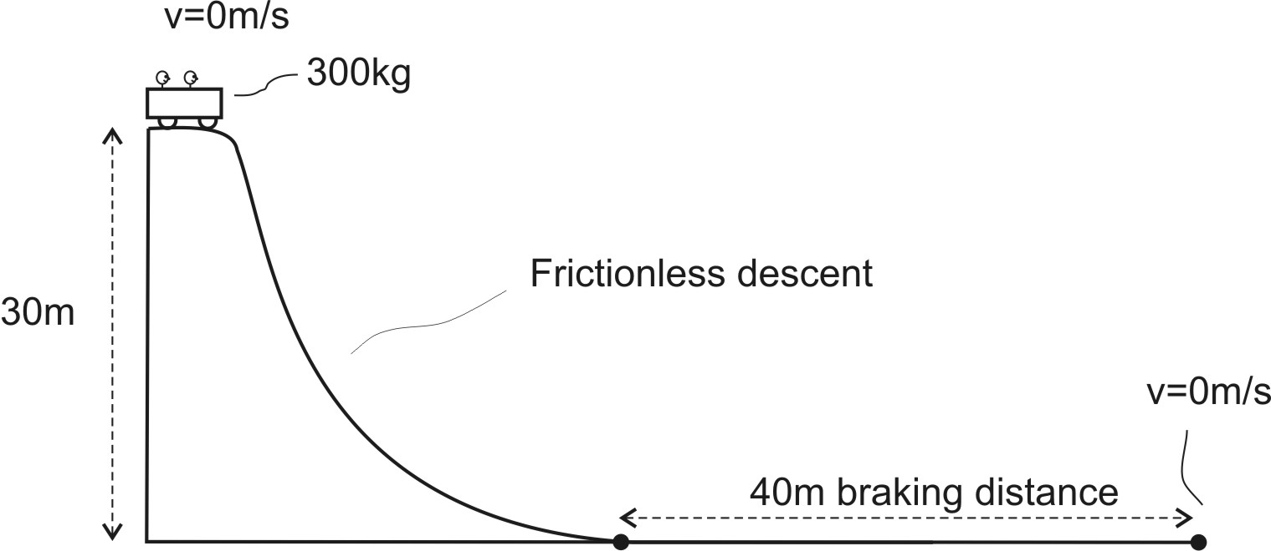
8. The roller coaster in the diagram drops 30m in height and then immediately applies a constant braking force for 40 meters, slowing to a stop at the end of the 40 meters. How much braking force is applied?

9. The graph on the right shows bungee tension vs. stretch distance. The bungee’s mass is negligible.

a. On the provided PE vs Stretch graph, sketch the relationship between work done on the bungee and the distance the bungee is stretched.
b. Suppose a 200g object is attached to the end of the bungee and dropped. The object falls 1m before beginning to stretch the bungee. On the PE vs Distance stretched graph, show the PE that has been lost by the object as it falls and stretches the bungee. In other words, the object PE that you plot at 0m of stretch distance should be the PE that the object has lost after falling one meter, because the object has already fallen 1m when it begins to stretch the bungee. When the stretch distance is 0.5m, the object will have fallen 1.5m. A stretch distance of 1m corresponds to the object having fallen 2m…
c. Use your PE graph to determine far will the bungee stretch before the object comes to rest.

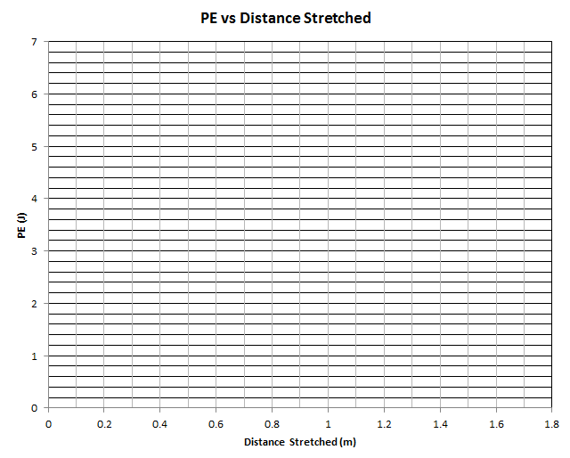
d. Suppose the bungee is used to accelerate a 20kg curling stone. One end of the bungee is hooked to the stone, and the other end is held stationary. The bungee is then stretched 1.6m, and the stone is released. As the bungee returns to its rest position, it accelerates the curling stone. If the bungee is 60% efficient, what is the stone’s speed when the bungee has returned to its resting length?

10. An ideal, 100% efficient extension spring of negligible mass is hanging from a ceiling. A 0.1kg object is added to the bottom of the spring, held at the point where the spring is just about to stretch, and is then released. The object falls to a low point and then bounces back up.

a. If the spring stretched 0.3m when the object reached its low point, how much energy was stored in the spring at that time?

b. What is the spring’s k?

11. Suppose the water exiting a water rocket generates a constant force of 500N during a 0.05s time period. What happens to the rocket’s power output during that time? Does it increase, decrease, or stay the same – or is it impossible to tell? Explain your reasoning.

