Physics 200 (Stapleton) Name: _________________________________
Spring Car Problems, Part 3

How fast does a car need to go in order to jump a 1m gap on the classroom ramp?

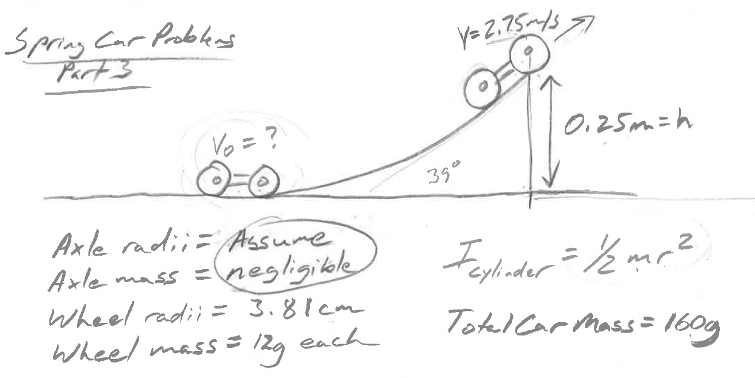

A rubber band-powered car accelerates on a runway leading up to a ramp. Acceleration ends when it reaches the ramp and begins to coast up the ramp without friction. The car slows down (due to gravity) as it climbs the 0.25m tall ramp, reaching a velocity of 2.75m/s at the moment that it leaves the ramp. Given the 39° angle of the ramp, this is just enough velocity for the car to travel 1m horizontally before returning to an elevation even with the base of the ramp.

This particular car has plywood wheels that are 3.81cm (1.5”) in radius. Each wheel is a plywood disc with a mass of 12g. For purposes of calculating moments of inertia, ignore the car’s axles and bearings; consider the rotating parts of the car to be limited to the four disk-shaped wheels. The total mass of the car, including the wheels, is 160g.

In order to maintain a speed of 2.75m/s at the top of the ramp, what velocity does this car need to attain before ascending the ramp?

