Physics 200 (Stapleton) Name: _________________________________
Spring Car Problems, Part 2

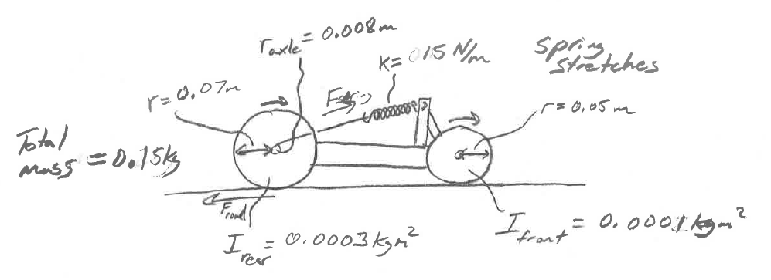
A 0.15kg car is powered by a spring with a spring constant of k=15N/m. To store energy in the car, a thin string is attached to the spring, and the spring is wound around the car’s rear axle. As the car’s rear axle is turned to wind up the car, the spring is stretched a distance of 0.25m. When the car is placed on a surface and released, the spring returns to its normal position, pulling the string and unwinding it from the axle. As the string unwinds, torque is exerted against the axle, and that wheel and axle torque transmits force to the road. The car is 50% efficient.

Rear axle radius = 0.008m. Rear Wheel radius = 0.07m. Rear wheel and axle moment of inertia = 0.0003kgm²
Front Wheel radius = 0.05m. Front wheel and axle moment of inertia = 0.0001kgm²
Total car mass = 0.15kg. The spring is stretched 0.25m.

1. What force does the spring exert on the string when it is fully wound (stretched 0.25m)?
2. What maximum torque does the spring create in the rear axle?
3. What maximum backward force does the rear wheel exert against the road (assuming no slipping)?
4. How much PE is stored in the spring?
5. Assuming that the car is 50% efficient, what is the car’s energy output?
6. If the car’s total KE is equal to the energy output you just calculated, what is the car’s velocity?
7. How many rotations does the rear axle make while the string unwinds?
8. How far does the car travel while the string unwinds?

