Physics 200 Name: _________________________
Rotational Motion: Spring Car Problems, Part 1

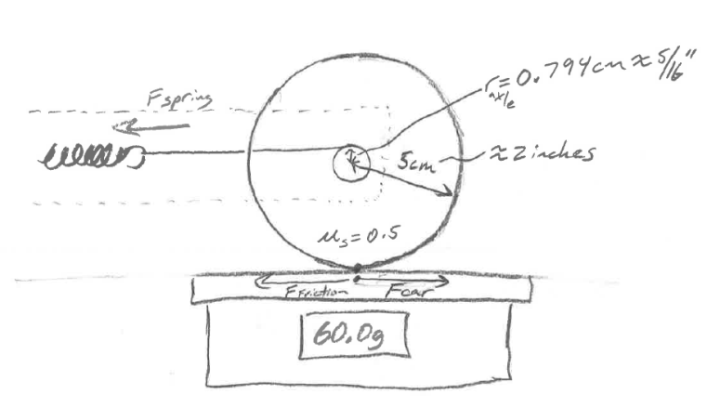
1. A car’s rear wheel has a radius of 5cm. The wheel is attached to an axle with a radius of 0.794cm. The wheel and the axle are glued so that they turn together. The rear wheel of the car is resting on a balance, which reads 60.0g. The coefficient of static friction between the wheel and the surface of the balance is 0.5. A spring is creating a torque in the wheel and axle by pulling a string that is wrapped around the axle.

a. As the wheel begins to push horizontally against the balance surface, what is the maximum force of friction that the surface can exert against the wheel?

b. What is the maximum wheel torque that can be achieved without causing the wheel to slip against the balance surface?

c. What is the maximum force of tension that the spring can create in the string without causing the wheel to slip?

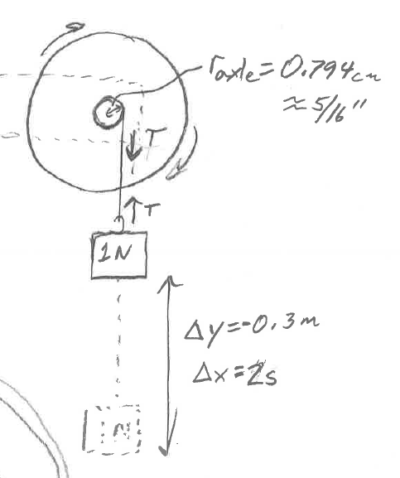
2. The frame of a car is clamped to a table, so that the car’s back wheels and axle extend from the table edge. A string is attached to and wrapped around the axle, and a 1N weight is attached to the other end of the string. With the wheel and axle at rest, the weight is released, causing the wheel, the axle, and the weight to accelerate. Starting with zero velocity, the weight falls 0.3m in a time of 2 seconds. Accordingly, the wheel and axle spin faster and faster during this time period.

a. What is the linear acceleration of the weight as it falls?

Δt=2s

b. What is the tension in the string as the weight falls?

c. What is the moment of inertia (I) of the wheel and axle?

