Physics 200 Name: ___________________________
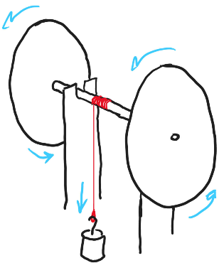
Rubber Band Car Wheel & Axle Problems

Wheel radius (m) | 0.08
Mass of falling weight (kg) | 0.2
Distance descended by weight (m) | 0.8
Descent time (s) | 2.7
Distance risen by weight before stopping (m) | 0.6
Number of wheel and axle rotations during descent | 24
The rear wheel and axle assembly of a rubber band car was supported horizontally by a frame (see diagram). A string was tied to the axle, and a weight was tied to the other end of the string. The string was carefully wound around the axle (with no overlaps) so that the weight was hanging just below the axle. The weight and wheel and axle were held at rest and then released, allowing the weight to fall and causing the wheels and axle to turn. This continued as the weight accelerated downward. When the weight reached its low point, the momentum of the wheel and axle caused the string to wind back up on the axle. This caused the weight to rise again, but it did not rise all the way to its starting point. Data for this event are provided in the table.

1. Calculate the angular displacement (in radians) of the wheels and axle during the time that the weight was falling.

2. Calculate the axle radius.

3. What was the angular acceleration of the wheel and axle during the weight’s descent?

4. Calculate the linear acceleration of the falling mass during its descent.

5. Calculate the string tension during the weight’s descent.

6. Find the maximum angular speed of the wheel and axle (assuming that its acceleration was constant).

Wheel radius (m) | 0.08
Mass of falling weight (kg) | 0.2
Distance descended by weight (m) | 0.8
Descent time (s) | 2.7
Distance risen by weight before stopping (m) | 0.6
Number of wheel and axle rotations during descent | 24
7. Find the maximum speed of a point on the edge of one of the wheels.

10. What was the total angular displacement of the wheels and axle during the round trip down and back up?

8. Find the total distance (entire time) traveled by a point on the edge of one of the wheels.

9. Find the non-conservative work done on the system between the time when the weight started to descend and the time when the weight stopped ascending.

11. What was the average torque due to friction that acted on the wheel and axle during its round trip down and up?

12. What was the torque applied by the string during the weight’s descent?

13. What was the net torque acting on the axle during the weight’s descent?

14. Find the moment of inertia of the wheel and axle.

