Physics 200 (Stapleton) Name: ______________________

Chapter 9-10 Test Review #2

**Part I. Multiple Choice**

1. With the same non-zero clockwise torque applied, if an object’s angular acceleration is increasing, its moment of inertia must be

A. increasing. B. decreasing. C. staying the same.

2. A rubber band car is powered by a rubber band pulling tangent to the axle. Increasing the wheel diameter

A. increases the torque B. decreases the torque C. has no effect on the torque

3. The units of rotational inertia are

A. kg m2 B. rad C. rad/s D. rad/s2 E. kg m2s-1

4. The units of angular momentum are

A. kg m2 B. rad C. rad/s D. rad/s2 E. kg m2s-1

5. A wheel with a radius of 0.500 m rolls for a distance of 6π meters. Through what angle has the a point on the wheel rotated?

A. 3.14 radians B. 6 radians C. 18.8 radians D. 37.7 radians



6. In an effort to tighten a bolt to a torque of 2.5 N.m, a force **F** is applied as shown in the figure below. If the distance from the end of the wrench to the center of the bolt is 25.0 cm, what force must be applied at the end of the wrench?

A. 1N B. 2.5N C. 5.00 N D. 10NE. 25N

7. If a wheel turning at a constant rate completes exactly 20 revolutions in 10.0 s, its angular speed is:

A. 0.314 rad/s B. 0.628 rad/s C. 12.6 rad/s D. 6.28 rad/s E. 31.4 rad/s

8. A child initially standing at the center freely spinning merry-go-round moves to the edge. Which one of the following statements is necessarily true concerning this event and why?

A. The angular speed of the system increases because the moment of inertia of the system has decreased.

B. The angular speed of the system decreases because the moment of inertia of the system has decreased.

C. The angular speed of the system increases because the moment of inertia of the system has increased.

D. The angular speed of the system decreases because the moment of inertia of the system has increased.

E. The angular speed of the system remains the same because the net torque on the merry-go-round is zero.

9. In order to increase the torque created by F2 below, the fulcrum should be moved

F2

F1

A. closer to F1 B. closer to F2

10. A comet orbiting the Sun can be considered an isolated system with no outside forces or torques acting on it. As the comet moves closer to the sun in its highly elliptical orbit, what happens to its angular momentum?

a. It increases b. It decreases c. It stays the same

11. As a comet moves closer to the sun in its highly elliptical orbit, what happens to its rotational inertia?

a. It increases b. It decreases c. It stays the same

12. As a comet’s position in its orbital path changes, its moment of inertia doubles due to the change in position. What happens to its kinetic energy as its moment of inertia doubles?

a. multiplied by 0.5x b. No change c. multiplied by 2x d. multiplied by 4x

13. Which of the following determine(s) the speed of a rolling object as it reaches the bottom of a smooth hill? Select all that apply. [Assume that all objects will actually roll without slipping.]

a. Object radius b. Object mass c. Object Shape (distribution of mass)

14. A disk initially rolls along the flat ground at a constant speed without slipping. A second disk has the same mass and rolls at the same translational speed of the first disk – but the second disk has 2x the radius of the first disk. Compared to the first disk, the second disk…

A. has 1/2 as much angular speed and less kinetic energy

B. has 1/4 as much angular speed and less kinetic energy

C. has 1/2 as much angular speed and the same amount of kinetic energy

D. has 1/4 as much angular speed and the same amount of kinetic energy

15. What happens when a gymnast flipping in a frictionless space opens up from a tucked position?

A. His moment of inertia decreases causing him to speed up.

B. His angular momentum decreases.

C. The torque that he exerts increases his moment of inertia.

D. His angular momentum increases.

E. His moment of inertia increases causing him to slow down.

16. A 3 kilogram rotating mass has a rotational radius of 1m and a moment of inertia of 3kg.m2. What shape could it be?

A. Thin hoop

B. Sphere

C. Disk

17. If a mechanic applies a force (F) at an acute angle θ, relative to the length of a wrench, torque generated equals

A. rFsinθ B. rFcosθ c. rFtan θ d. rF

**Part II. Problems:**

1. A car accelerates from rest to 3m/s in a time of 1.5 second. The car’s wheels have radii of 0.04m.

a. How fast do the wheels accelerate, in rad/s2?

b. Through how many radians do the wheels rotate during this 1.5s?

c. What is the angular velocity of the wheels at the end of the 1.5s, in rpm?

2. A car’s wheels are rotating at a rate of 3 revolutions per second. If the wheels slow down at a rate of 3rad/s2…

a. How much time does it take the car to come to a stop?

b. How many revolutions do the wheels make before coming to a stop?

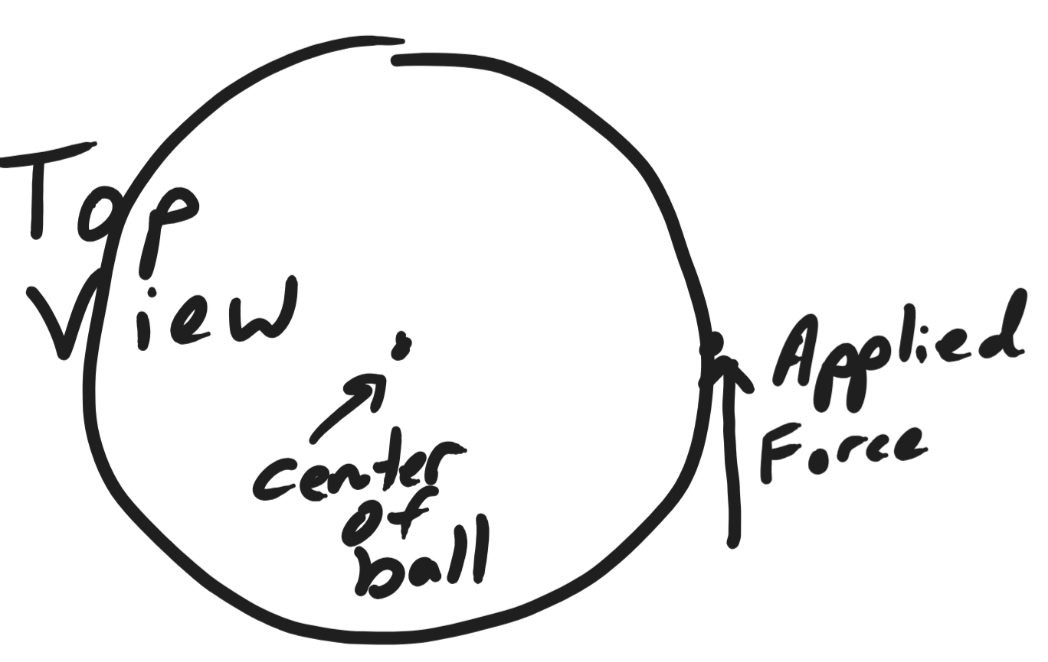

3. In an attempt to spin a basketball (initially at rest), a child places a ball on the tip of his finger and applies a force of 3N tangent to its surface. The basketball has a mass of 0.65kg and a radius of 0.12m. [Ihollow sphere = 2/3 mr2]

a. How much torque is exerted on the basketball by the child?

b. Assuming zero friction, what is the angular acceleration of the basketball?

c. If the child were able to maintain this acceleration for one minute, what angular velocity would the basketball have, in revolutions per second?

4. A woman coasts (somehow) on unicycle, traveling horizontally off the edge of a cliff. From a bystander’s perspective, her velocity as she leaves the cliff is 6m/s to the right. The unicycle wheel has a mass of 1.5kg and a radius of 23cm. For purposes of calculating moment of inertia, the wheel may be considered a thin hoop (I=mr2). The woman and the unicycle remain vertical until, a few moments after leaving the cliff, she stops the wheel’s rotation (relative to the rest of the unicycle). As she stops the wheel, she and her unicycle begin to rotate together, achieving a final rate of 10rpm.

a. What is the wheel’s angular velocity at the moment she leaves the cliff?

b. What is the wheel’s angular momentum at the moment the woman leaves the cliff?

c. From the bystander’s perspective, in which direction does the unicyclist begin to rotate after stopping the wheel?

d. What is the overall moment of inertia of the unicyclist/unicycle?

5. A visitor to a game arcade wants to roll a Skeeball with enough speed so that it will have a velocity of 3m/s when it reaches the top of its ramp. The ball has a radius of 4cm and a mass of 160g. It is a solid sphere, so I=2/5 mr2. The height of the ramp is 0.3m. What speed (translational speed) must the ski ball have when it reaches the bottom of the ramp, in order to have a velocity of 3m/s at the top of the ramp?

6. A 200N force and a 300N force are applied to the beam on the right in the locations indicated. Where should the fulcrum be placed in order to balance the 500N beam?

