Unit 8 Packet (Physics 200): Rotational Motion Name: ___________
τorque Notes

I. τorque

A. The rotational equivalent of force is _____________. Its symbol is _______.

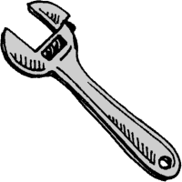
F
r

B. Torque = lever arm (r) x perpendicular force (F).

C. When θ = 90º,

When θ = 0º,

Torque is a maximum when θ = ___________.

II. Rotational Equilibrium

A. In rotational equilibrium,
In other words, the clockwise torques = the counterclockwise torques

B. Examples of rotational equilibrium:
2.0 m
100 N
2.0 m
?
1.

2.0 m
100 N
4.0 m
?
2.

?
4.0 m
600 N
800 N
3.

4. Find the force needed to hold the 5.0-meter beam that weighs 500 N level.
F

5. Find the force needed to hold the same beam level with the addition of a hanging weight.
100 N
2.0 m
F

Torque Practice

I. Find the force, F, needed to keep the bar level. The bar has a weight of 100. N. The location of the center of mass is designated by the downward arrow and the W.

F
W=100. N
2.00 m
2.00 m
A)

F
W=100. N
1.00 m
3.00 m
B)

F
W=100. N
1.00 m
3.00 m
C)

II. Find the location of the fulcrum so that the bar balances. In case A), assume the bar has negligible mass. In cases B) and C), the location of the center of mass is again designated by the downward arrow and the W.
6.00 m
450.0 N
300.0 N
A)

W=100. N
5.00 m
200.0 N
400.0 N
5.00 m
B)

W=100. N
3.00 m
400.0 N
300.0 N
2.00 m
4.00 m
1.00 m
200.0 N

C)

III. Find the force, F, needed to balance the bar. In cases A) and C), assume the bars have negligible mass. In case B), the location of the center of mass is again designated by the downward arrow and the W.
F
300. N
1.00 m
3.00 m
A)

W=50.0 N
300.0 N
F
3.00 m
1.00 m
3.00 m
1.00 m
B)

150.0 N
F
250.0 N
100.0 N
0.500 m
0.300 m
0.100 m
0.100 m
C)

Solutions:
I. A. 50.0 N B. 25.0 N C. 75.0 N
II. A. 2.40 m from left edge B. 1.43 m right of center C. 1.20 m left of center
III. A. 100 N B. 213 N C. 250 N

Notes – 10.1 Angular Acceleration

1. What is the definition of angular speed ω? What are the units of ω?

2. How are velocity and angular speed related?

3. What is the definition of angular acceleration α? What are the units of α?

4. Suppose a teenager puts her bicycle on its back and starts the rear wheel spinning from rest to a final angular velocity of 250 rpm in 5.00 s.
A. Calculate the angular acceleration in rad/s². Show your work.

B. If she now slams on the brakes, causing an angular acceleration of –87.3 rad/s², how long does it take the wheel to stop? Show your work.

5. How are tangential acceleration and angular acceleration related?

6. Distinguish between tangential acceleration (a_{t}) and centripetal acceleration (a_{c})?

7. A powerful motorcycle can accelerate from 0 to 30.0 m/s (about 108 km/h) in 4.20 s. What is the angular acceleration of its 0.320-m-radius wheels? Show your work.
Practice – 10.1 Angular Acceleration

1. At its peak, a tornado is 60.0 m in diameter and carries 500 km/h winds. What is its angular velocity in revolutions per second?

2. An ultracentrifuge accelerates from rest to 100,000 rpm in 2.00 min.
A. What is its angular acceleration in rad/s²?

B. What is the tangential acceleration of a point 9.50 cm from the axis of rotation?

C. What is the radial acceleration in m/s² and multiples of g of this point at full rpm?

3. A drum rotates around its central axis at an angular velocity of 12.60 rad/s. If the drum then slows at a constant rate of 4.20 rad/s²,
A. How much time does it take to come to a stop?
[Note: ω_{f} = ω₀ + αt ]

B. Through what angle does it rotate before coming to a stop?
[Note: θ_{f} – θ₀ = ω₀t + ½ αt² ]

4. Starting from rest, a disk rotates about its central axis with constant angular acceleration. In 5.0 s, it rotates 25 rad. During that time, what is the magnitude of the angular acceleration? [Note: θ_{f} – θ₀ = ω₀t + ½ αt² ]

Answers:
1. 0.737 rev/s 2A. 87.3 rad/s² 2B. 8.29 m/s² 2C. 1.04 x 10⁷ m/s², 1.06 x 10⁶ g
3A. 3.00 s 3B. 18.9 rad 4. 2.0 rad/
Notes – 10.2 Kinematics of Rotation

1. Fill in the table below for the translational and rotation kinematic equations.
Translational (linear) | Rotational
∆x = v∆t (or v=∆x/∆t)
v = v₀ + at
∆x = v₀t + ½at²
v² = v₀² + 2a(∆x)

2. A deep-sea fisherman hooks a big fish that swims away from the boat pulling the fishing line from his fishing reel. The whole system is initially at rest and the fishing line unwinds from the reel at a radius of 4.50 cm from its axis of rotation. The reel is given an angular acceleration of 110 rad/s² for 2.00 s.
A. What is the final angular velocity of the reel? Show your work.

B. At what speed is fishing line leaving the reel after 2.00 s elapses? Show your work.

C. How many revolutions does the reel make? Show your work.

D. How many meters of fishing line come off the reel in this time? Show your work.

Practice – 10.2 Kinematics of Rotation

1. A spinning fishing reel has an initial angular velocity is ω₀ = 220 rad/s. If the fisherman applies a brake to the spinning reel, achieving an angular acceleration of –300 rad/s², how long does it take the reel to come to a stop?

2. Large freight trains accelerate very slowly. Suppose one such train accelerates from rest, giving its 0.350-m-radius wheels an angular acceleration of 0.250 rad/s².
A. After the wheels have made 200 revolutions (assume no slippage), how far has the train moved down the track?

B. After the wheels have made 200 revolutions (assume no slippage), what are the final angular velocity of the wheels and the linear velocity of the train?

Answers:
1. 0.733 s 2. A. 440 m B. 25.1 rad/s, 8.77 m/s
Notes – 10.3 Dynamics of Rotational Motion: Rotational Inertia
1. Rotational Inertia (a.k.a. moment of inertia) is a rotational version of _____________. Whereas mass and ordinary inertia cause resistance to linear acceleration, an object’s moment of inertia describes its resistance to _____________________________. The rotational inertia of an object depends both on its mass and the distance of that mass from the object’s axis of rotation. As an example, consider a door. If the door’s mass is increased, it will have a __________________(higher,lower) resistance to rotational acceleration, and its moment of inertia will be _________________ (higher,lower). If the door’s mass is shifted “inward,” so that it is closer to its axis of rotation, the door will have a __________________ (higher,lower) resistance to rotational acceleration, and its moment of inertia will be _________________ (higher,lower).

2. Starting with Newton’s 2nd Law, derive an expression for torque t in terms of mass m, lever arm r and angular acceleration α (and introduce I – “Rotational Inertia” or “moment of inertia”)

3. Compare Newton’s second law for linear motion and rotational motion.

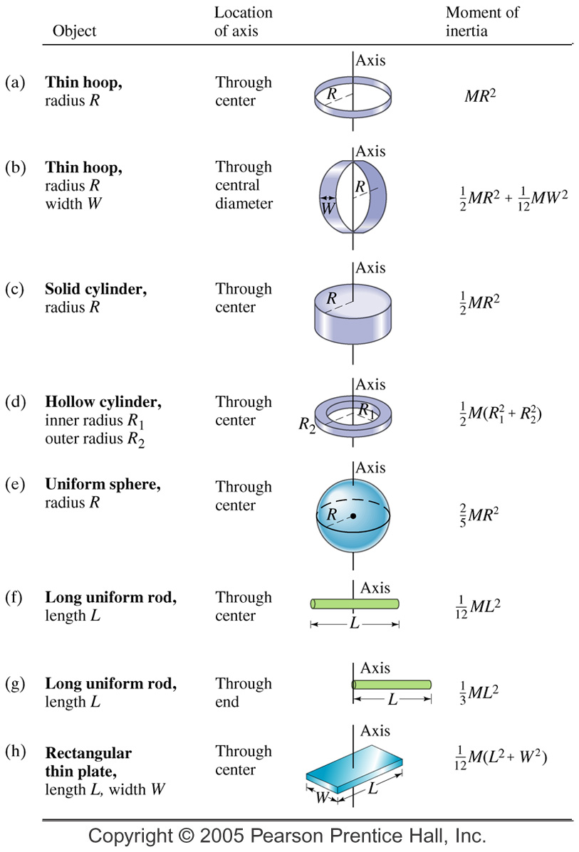

4. The two definitions of torque:

5. Rotational Inertia (I) of Various Objects

A. A single point mass:

B. Multiple point masses:

C. Other shapes – see chart
Practice 10.3: Rotational Dynamics

3. Calculate the rotational inertia of a solid sphere of mass M = 5.0 kg and a radius of R = 0.25 m.

4. Calculate the rotational inertia of a solid cylinder of mass M = 2.0 kg and a radius of R = 0.075 m about its central axis.

5. Suppose you exert a force of 180 N tangential to a 0.280-m-radius 75.0-kg grindstone (a solid disk).
A. What torque is exerted?

B. What is the angular acceleration assuming negligible opposing friction?

C. What is the angular acceleration if there is an opposing frictional force of 20.0 N exerted 1.50 cm from the axis?

Answers:
1. 0.733 s 2. A. 440 m B. 25.1 rad/s, 8.77 m/s 3. 0.13 kg m² 4. 5.6 x 10⁻³ kg m²
5. A. 50.4 N.m B. 17.1 rad/s² C. 17.0 rad/s²
Notes – 10.4 Rotational Kinetic Energy

1. Starting with the linear (or tangential) kinetic energy formula, derive a formula for the rotational kinetic energy of a single mass m, with a velocity v, revolving around an axis at a radius r. The formula should be in terms of I and ω.

2. Calculate the final speed of a solid cylinder that rolls down a 2.00-m-high incline. The cylinder starts from rest, has a mass of 0.750 kg, and has a radius of 4.00 cm.

4. Calculate the final speed of a hoop of the same radius (4cm) that is allowed to roll down an incline of the same height (2m)

5. Compare the speeds of thin hoops and solid cylinders, in general, after rolling down ramps (assuming the objects’ radii and the ramp heights are identical, and that there is no friction).

Practice – 10.4 Rotational Kinetic Energy

1. What is the final velocity of a 1.00 kg hoop starting from rest that rolls without slipping down a hill 5.00 meters high?

2. What is the final velocity of a 1.0 kg solid disk/cylinder starting from rest that rolls without slipping down a hill 5.00 meters high?

3. Calculate the rotational kinetic energy of Earth on its axis. Assume the Earth is a uniform solid sphere of mass M = 5.97 x 10²⁴ kg and a radius R = 6371 km.

4. What is the rotational kinetic energy of Earth in its orbit around the Sun? M = 5.97 x 10²⁴ kg and R = 150 million kilometers.

5. A ball with an initial velocity of 8.00 m/s rolls up a hill without slipping. Treating the ball as a spherical shell, calculate the vertical height it reaches.

Answers:
1. 7.00 m/s 2. 8.08 m/s 3. 2.56 x 10²⁹ J 4. 2.66 x 10³³ J 5. 5.44 m
Notes – 10.5 Angular Momentum and Its Conservation

1. Write the equation for linear momentum.

2. Write the equation for angular momentum.

3. State the Law of Conservation of Angular Momentum in words.

4. Write the equation for the Conservation of Momentum.

6. Suppose an ice skater is spinning at 0.800 rev/ s with her arms extended. She has a moment of inertia of 2.34 kg⋅m² with her arms extended and a moment of inertia equal to 0.363 kg⋅m² with her arms close to her body. (These moments of inertia are based on reasonable assumptions about a 60.0-kg skater.)
A. What is her initial angular velocity, in rad/s?

B. What is her initial angular momentum?

C. What is her final angular velocity?

B. What is her rotational kinetic energy before and after she does this? Why does her KE_{R} change?
Practice – 10.5 Angular Momentum and Its Conservation

1. A playground merry-go-round has a mass of 120 kg and a radius of 1.80 m and it is rotating with an angular velocity of 0.500 rev/s. What is its angular velocity after an initially motionless 22.0-kg child gets onto it by grabbing its outer edge? This might be easier to visualize if you picture the merry-go-round snagging the child and yanking him/her into motion. [You may assume that the merry-go-round is a uniform disc with I=1/2 mr² and that the child is a point source with I=mr².]

2. Ice Skater
A. Calculate the angular momentum of an ice skater spinning at 6.00 rev/s given his moment of inertia is 0.400 kg⋅m².

B. He reduces his rate of spin (his angular velocity) by extending his arms and increasing his moment of inertia. Find the value of his moment of inertia if his angular velocity decreases to 1.25 rev/s.

C. Suppose instead he keeps his arms in and allows friction of the ice to slow him from 6.00 rev/s to 3.00 rev/s. What average torque was exerted if this takes 15.0 s?

3. What is the angular momentum of Earth rotating on its axis? M_{Earth} = 5.97 x 10²⁴ kg and R_{Earth} = 6371 km. Assume the Earth is a solid uniform sphere (I=2/5 mr²)

4. What is the angular momentum of the Moon in its orbit around Earth? The orbital radius of the Moon is 384,399 km, the Moon’s mass is 7.35 x 10²² kg and its orbital period is 27.321 days. A) What value should you use for I ? b) What is the angular momentum?

Answers:
1. 2.30 rad/s 2. A. 15.1 kg m²/s B. 1.92 kg m² C. -0.503 N m
3. 7.05 x 10³³ kg m²/s 4. 2.89 x 10³⁴ kg m²/s
