Physics 200 Name: ___________________________
23-24 Rubber Band Car Contest Overview – Revised 4/4/24
(Rotational Motion)

Goal: Design a rubber band-powered car that reaches the highest maximum velocity, and predict its performance with a mathematical model. The car should be fast (at top speed) and predictable.

Steps:
- Solve problems. Investigate rubber band car concepts.
- In CAD, choose pre-designed components and add your own parts and/or modifications (e.g. frames between 8” and 23.5”; wheels between 3” and 8” in diameter). You may create your own files if you have the capability to do this on your own.
- Lay out your parts for laser cutting.
- Assemble your car and your rubber band/string motor.
- Collect data to create a specification table for your car.
- Create and turn in graphs predicting your car’s speed vs time and speed vs position.
- Test your car and fine-tune your winding procedure.
- Contest tentative schedule – perform in order of predicted speed, slowest to fastest.

Important Design Considerations:
- Wheel diameters
- Rubber band and string configuration
- Rubber band stretch distance
- Friction with the “road” (floor tiles)

Contest Scoring:
- Score = Top speed * (1-(acceleration distance fractional error + predicted top speed fractional error))
- Example: Top speed =5m/s. Predicted top speed = 5.5m/s. Acceleration distance = 6m. Predicted Acceleration Distance = 5m. Speed fractional error = 0.5/5 = 0.1. Acceleration distance fractional error = 1/6 = 0.167.
Score = 5m/s (1-(0.1+0.167) = 5m/s (0.733) = 3.665m/s

Rules:
- Maximum group size = 3 students
- The vehicle must be fully supported by at least three wheels that roll, although momentary wheelies are acceptable.
- The car’s propulsive force must come from the rotation of at least one of its wheels, and the force of friction between this wheel and the road.
- Torque providing the propulsive force must come from string (under tension) wrapped around at least one axle.
- Force contributing to torque must come from one or more linear “springs” made of rubber bands (stretched in a straight line; rubber bands may not wrap or bend as they are stretched)
- The maximum allowed rubber band tension/drive string tension is 40N This year there is no rule regarding maximum drive string tension – but there is a practical limit for you to discover.
- Rubber bands must be attached in a way that allows measurement of their force (at all moments during winding) with a spring scale or digital force meter.
- Main Division Allowed materials (for class contest purposes): 1/8” plywood (no more than one 11.5”x23.5” sheet), hot glue, two 5/16” steel axles, 4 skateboard bearings, rubber bands, string, and anything else that costs less than $1.00.
- Open Division Allowed materials: Any materials are allowed, as long as they do not violate one of the other rules of this contest. In order to receive a reward for this division, participants’ score must exceed all scores in the main division.
- For contest purposes, “top speed” will be measured by your car’s transit time across one floor tile (0.305m/transit time). If your car crosses a floor tile at a slant, for contest purposes its top speed will be lower than its actual top speed. You should make sure that your car is traveling perpendicularly to the floor tiles when it reaches its top speed.

Example Stock Cars: Max frame length 23.5”; Min frame length 8”.

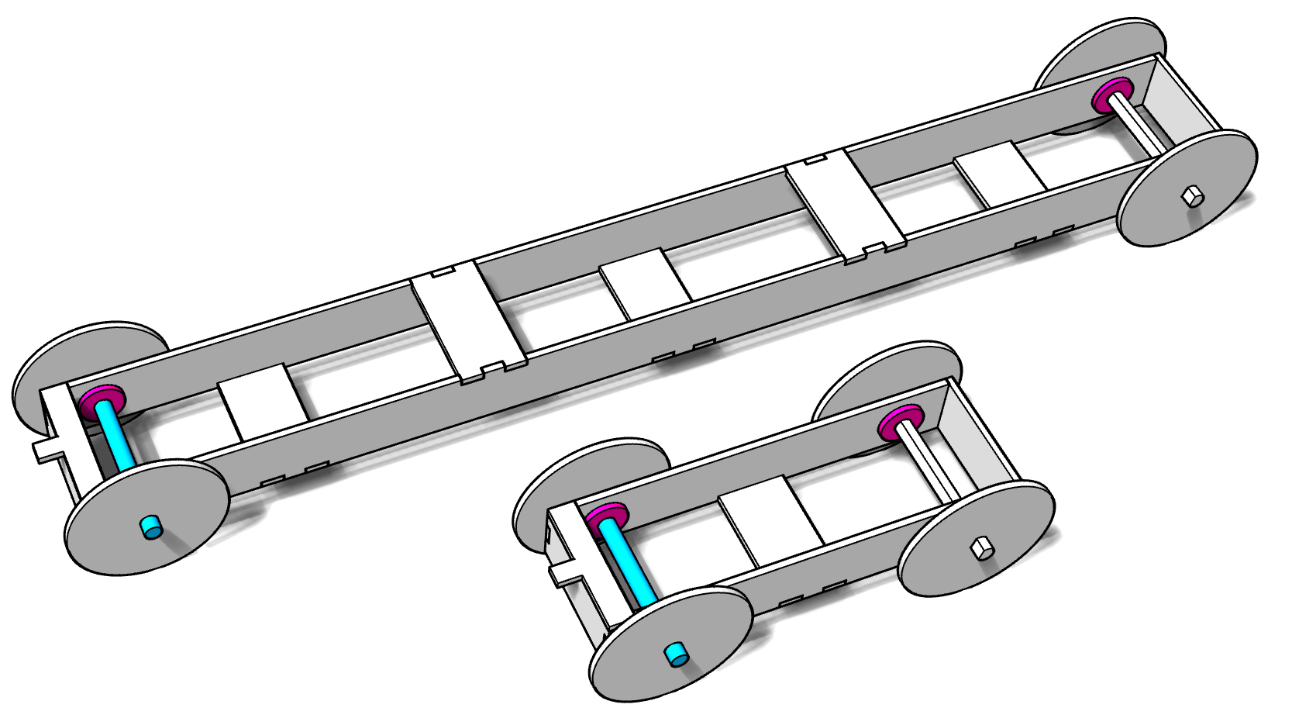

Example Laser Cutting Layout: This example features a 23.5” frame, 3” diameter wheels, wheel rim thickeners for drive wheels, and extra space for your own parts. The cross braces can be rearranged on the layout.

