Physics 200 Name: _________________________________
23-24 Rubber Band Car Analysis and Predictions

1. Find your car’s drive wheels’ maximum force of static friction.
- Fully load your car to the approximate weight you expect it to have when you race it.
- Lock the rear wheels, so they don’t rotate (tape should work).
- Measure the force it takes to just begin to drag your car forward. You can do this with a spring scale, a force sensor, or a system of weights and string slung over pulleys – or some other method.

Maximum force of static friction = ___________ N

2. Determine the radius of your drive axle empirically. The radius of the axle is, nominally, 5/32” (0.00396875m), but is that exactly right? Can you use it to calculate the correct acceleration distance if you know the string length and drive wheel radii? Maybe not. Using the same string that you plan to use for your rubber band motor, wrap a length of that string around the axle by turning the axle and counting the rotations. Carefully measure the length of string that is wrapped around the axle. Use this information to calculate the axle radius. How does it compare to 0.00396875m? In your subsequent calculations, you may use either the nominal radius or the one you find here. It’s up to you.

Number of rotations = _________rotations Length of String Wrapped = _________ m

Drive Axle radius (measured empirically) = _________ m

3. Calculate the maximum string tension that can be applied by your rubber bands – without causing your drive wheels to slip. To do this, you it makes sense to assume that the maximum backward force that the edges of drive your wheels can exert on the road is the maximum static friction force that you found in #1.

Drive wheel radius = __________ m Drive axle radius = ___________ m

Maximum string tension without slipping = _________ N

4. Design and measure a “motor” of string and rubber bands that will give your car the maximum amount of energy without causing the wheels to slip. The rubber bands must stretch linearly, and only string may wrap around the axle.

Measure your rubber bands’ tension when fully stretched. This should not exceed your maximum tension without slipping (from the previous section).

Maximum Rubber Band Tension = __________N

Measure your motor’s stretch distance. How far do the rubber bands stretch as you wind up your car (wrapping string around the axle). Another way to describe this distance is the length of string that wraps around your car’s axle.

Rubber Band Stretch Distance (wrapped string length) = _________m

5. Estimate the distance that your car will travel while it accelerates (assuming that the drive wheel’s don’t slip). From the length of string that unwinds (and the axle radius), you can determine the number of rotations. From there you can find the distance traveled by the edges of the wheels (i.e. the linear distance traveled).

Length of string that will unwrap as the car accelerates = _________m

Drive axle radius = _________ m

Angular displacement (Θ) of drive wheels and axle during acceleration = ________ radians

Drive wheel radius = _________ m

Linear distance traveled by car during acceleration = ________ m

6. Estimate your car’s energy input (i.e. the work you do as you wind it).

Option 1: pretend that your motor is an ideal spring and find its spring constant, k. Use F_{spring} = kx, where x is the stretch distance. In this case, you know the spring force when your motor is at full stretch, and you know your stretch distance x (both are in the previous question. Find your motor’s k, and then use PE_{spring} = ½ kx² to calculate the energy that is put into the spring as it is stretched a distance x.

k = __________ N/m PE_{spring} = Energy Input = __________J

Option 2: Create a graph of force vs stretch distance for the winding of your string (and the simultaneous stretching of the rubber bands). Then find the area under the curve to get the work done in winding the string. **If you fit a linear trendline to the graph, and it seems to have the same area beneath it as your force curve, then you can simply find the area under that linear trendline – or use option 1, above.

Work done on rubber bands = Energy Input = __________J

7. Estimate your motor’s energy output. In the previous section, you estimated the energy that goes into winding your car. But how much energy is actually provided by your rubber band motor as the rubber bands return to rest position? Probably less, because nothing is 100% efficient. Here is one method of finding your bands’ energy output.

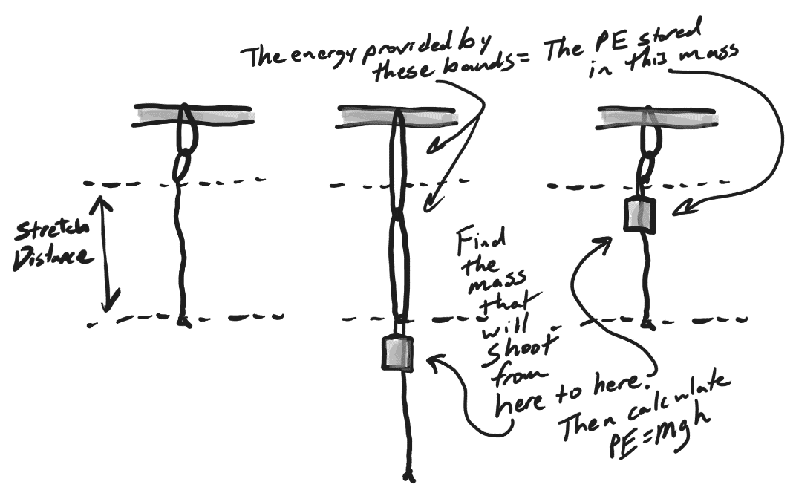
- Hang your rubber band motor from a fixed point, with the string pointing down.
- Stretch the motor downward to the extent that you will stretch it when you wind your car.
- Add a weight to the end of the bands and prepare to shoot it upward.
- Release the weight. If it shoots up to the exact point where the motor has returned to rest position, you’re done. If it goes too high, or doesn’t go high enough, try different weights until the weight reaches a height allowing the motor to return to rest position. When you find the proper weight to make this happen, move on to step E. [Note that, if the weight shoots too high, some of the rubber band energy will have gone into lifting the rubber band and string a little bit, and we can’t easily determine how much energy that represents. If the weight doesn’t shoot high enough, some of the rubber band energy will still be stored in the rubber bands. If the rubber bands return exactly to rest position, we can be certain that all of their spring energy has been converted to the weight’s gain in PE.]
- Calculate the energy that the motor put into the weight as it pulled the weight upward. This is PE, so use PE = mgh.

“Projectile” Mass = ______kg Height gained = ________m Motor Output Energy = _________J

8. Now use your information from the previous sections (#7 and #6) to calculate your motor’s % efficiency (output/input).

Motor Efficiency = _________%

9. Find moments of inertia and friction. Find the moments of inertia of both of your wheels and axles – and find the amount of frictional torque in each wheel and axle. Collect the data below and enter them into the calculator to find moment of inertia and frictional torque. Use the falling weight and string method that we have used before. Instead of doing a bunch of calculations here, you can use the spreadsheet that you already created for finding the moment of inertia (and friction from torque) for a wheel and axle.

Front Wheel and Axle
Axle Radius (m)
Mass of falling weight (kg)
Wrapped String length (m)
Acceleration time (s)
Deceleration time (s)
Moment of Inertia (kgm^2)
Torque from Friction (Nm)

Rear Wheel and Axle
Axle Radius (m)
Mass of falling weight (kg)
Wrapped String length (m)
Acceleration time (s)
Deceleration time (s)
Moment of Inertia (kgm^2)
Torque from Friction (Nm)

10. Estimate the energy loss due to frictional torque as your car is accelerating. If this were a linear situation, work done by friction would be W = F_{friction}d. Since this is a rotational situation, W = τ_{friction}Θ. You can find the angular displacement (Θ) of your drive axle during acceleration by looking at your answers to section #5. For the front axle, you will have to determine the angular displacement based on your front wheel radii and the car’s linear acceleration distance.

Drive Axle Energy Loss During Acceleration:

Torque_{drive axle frction} = ___________ Nm Θ_{during acceleration} = ___________ radians

Drive axle energy loss = τ_{friction}Θ = ___________J

Front Axle Energy Loss During Acceleration:

Linear distance traveled by car during acceleration = ___________m

Front Wheel radius = ________ m Θ_{during acceleration} = ___________ radians

Torque_{front axle frction} = ___________ Nm

Front axle energy loss = τ_{friction}Θ = ___________J

Total Energy Loss Due to Friction During Acceleration

Sum of energy loss from Drive wheels/axle + Front wheels/axle = ________ J

To arrive at total energy loss due to friction, you can use the same number above, or you can add some if you want, based on your intuitive sense. [The axle friction that you calculated earlier here was based on data collected when the normal force on the drive axle came from the weight of the axle plus the force of a small falling mass. When the drive axle is under tension from the rubber bands, it is likely that the friction will be higher. How much higher is anyone’s guess.]

Total Adjusted Energy Loss due to friction during acceleration = ___________ J

11. Calculate your car’s maximum velocity. When your car reaches its maximum velocity, all of the energy provided by your rubber band motor (minus the energy lost to friction) should be turned into KE. Remember that there will be three parts to this KE: KE_{translational} (which applies to the entire car’s mass), KE_{rot} for the front wheels and axle, and KE_{rot} for the rear wheels and axle.

First, measure the total mass of your car, including the motor. Total car Mass = ___________kg

Total energy provided by motor (motor output from #7) = _________ J

Total energy lost to friction during acceleration (from #10) = ________ J

Total KE of car at end of acceleration = ________ J

Drive wheel/axle moment of Inertia (from #9) = ________ kgm²

Front wheel/axle moment of Inertia (from #9) = ________ kgm²

Drive wheel radius = ________m

Front wheel radius = ________ m

Maximum Car Velocity = ________m/s

