**Unit 8 Packet (Physics 200): Rotational Motion Name: ___________**

**orque Notes**

**I. orque**

A. The rotational equivalent of force is _____________. Its symbol is _______.

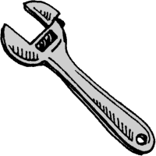

**F**

**r**

B. Torque = lever arm (r) x perpendicular force (F).

C. When  = 90o,

When  = 0o,

Torque is a maximum when  = ___________.

**II. Rotational Equilibrium**

A. In rotational equilibrium, 

In other words, the clockwise torques = the counterclockwise torques

B. Examples of rotational equilibrium:

2.0 m

100 N

2.0 m

?

1.

2.0 m

100 N

4.0 m

?

2.

?

4.0 m

600 N

800 N

3.

4. Find the force needed to hold the 5.0-meter beam that weighs 500 N level.

**F**

5. Find the force needed to hold the same beam level with the addition of a hanging weight.

100 N

2.0 m

**F**

**Torque Practice**

**I. Find the force, F, needed to keep the bar level.** The bar has a weight of 100. N. The location of the center of mass is designated by the downward arrow and the W.

**F**

**W=100. N**

**2.00 m**

**2.00 m**

A)

**F**

**W=100. N**

**1.00 m**

**3.00 m**

B)

**F**

**W=100. N**

**1.00 m**

**3.00 m**

C)

**II. Find the location of the fulcrum so that the bar balances**. In case A), assume the bar has negligible mass. In cases B) and C), the location of the center of mass is again designated by the downward arrow and the W.

**6.00 m**

**450.0 N**

**300.0 N**

A)

**W=100. N**

**5.00 m**

**200.0 N**

**400.0 N**

**5.00 m**

B)

**W=100. N**

**3.00 m**

**400.0 N**

**300.0 N**

**2.00 m**

**4.00 m**

**1.00 m**

**200.0 N**

C)

**III. Find the force, F, needed to balance the bar.** In cases A) and C), assume the bars have negligible mass. In case B), the location of the center of mass is again designated by the downward arrow and the W.

**F**

**300. N**

**1.00 m**

**3.00 m**

A)

**W=50.0 N**

**300.0 N**

**F**

**3.00 m**

**1.00 m**

**3.00 m**

**1.00 m**

B)

**150.0 N**

**F**

**250.0 N**

**100.0 N**

**0.500 m**

**0.300 m**

**0.100 m**

**0.100 m**

C)

**Solutions**:

I. A. 50.0 N B. 25.0 N C. 75.0 N

II. A. 2.40 m from left edge B. 1.43 m right of center C. 1.20 m left of center

III. A. 100 N B. 213 N C. 250 N

**Notes – 10.1 Angular Acceleration**

1. What is the definition of angular speed ? What are the units of ?

2. How are velocity and angular speed related?

3. What is the definition of angular acceleration ? What are the units of ?

4. Suppose a teenager puts her bicycle on its back and starts the rear wheel spinning from rest to a final angular velocity of 250 rpm in 5.00 s.

A. Calculate the angular acceleration in rad/s2. Show your work.

B. If she now slams on the brakes, causing an angular acceleration of –87.3 rad/s2, how long does it take the wheel to stop? Show your work.

5. How are tangential acceleration and angular acceleration related?

6. Distinguish between tangential acceleration (at) and centripetal acceleration (ac)?

7. A powerful motorcycle can accelerate from 0 to 30.0 m/s (about 108 km/h) in 4.20 s. What is the angular acceleration of its 0.320-m-radius wheels? Show your work.

**Practice – 10.1 Angular Acceleration**

1. At its peak, a tornado is 60.0 m in diameter and carries 500 km/h winds. What is its angular velocity in revolutions per second?

2. An ultracentrifuge accelerates from rest to 100,000 rpm in 2.00 min.

A. What is its angular acceleration in rad/s2?

B. What is the tangential acceleration of a point 9.50 cm from the axis of rotation?

C. What is the radial acceleration in m/s2 and multiples of g of this point at full rpm?

3. A drum rotates around its central axis at an angular velocity of 12.60 rad/s. If the drum then slows at a constant rate of 4.20 rad/s2,

A. How much time does it take to come to a stop?

[Note: f = 0 + t ]

B. Through what angle does it rotate before coming to a stop?

[Note: f – 0 = 0t + ½ t2 ]

4. Starting from rest, a disk rotates about its central axis with constant angular acceleration. In 5.0 s, it rotates 25 rad. During that time, what is the magnitude of the angular acceleration? [Note: f – 0 = 0t + ½ t2 ]

**Answers**:

1. 0.737 rev/s 2A. 87.3 rad/s2 2B. 8.29 m/s2 2C. 1.04 x 107 m/s2, 1.06 x 106 g

3A. 3.00 s 3B. 18.9 rad 4. 2.0 rad/

**Notes – 10.2 Kinematics of Rotation**

1. Fill in the table below for the translational and rotation kinematic equations.

|  |  |
| --- | --- |
| Translational (linear) | Rotational |
| ∆x = v∆t (or v=∆x/∆t) |  |
| v = v0 + at |  |
| ∆x = v0t + ½at2 |  |
| v2 = v02 + 2a(∆x) |  |

2. A deep-sea fisherman hooks a big fish that swims away from the boat pulling the fishing line from his fishing reel. The whole system is initially at rest and the fishing line unwinds from the reel at a radius of 4.50 cm from its axis of rotation. The reel is given an angular acceleration of 110 rad/s2 for 2.00 s.

A. What is the final angular velocity of the reel? Show your work.

B. At what speed is fishing line leaving the reel after 2.00 s elapses? Show your work.

C. How many revolutions does the reel make? Show your work.

D. How many meters of fishing line come off the reel in this time? Show your work.

**Practice – 10.2 Kinematics of Rotation**

1. A spinning fishing reel has an initial angular velocity is 0 = 220 rad/s. If the fisherman applies a brake to the spinning reel, achieving an angular acceleration of –300 rad/s2, how long does it take the reel to come to a stop?

2. Large freight trains accelerate very slowly. Suppose one such train accelerates from rest, giving its 0.350-m-radius wheels an angular acceleration of 0.250 rad/s2.

A. After the wheels have made 200 revolutions (assume no slippage), how far has the train moved down the track?

B. After the wheels have made 200 revolutions (assume no slippage), what are the final angular velocity of the wheels and the linear velocity of the train?

Answers:

1. 0.733 s 2. A. 440 m B. 25.1 rad/s, 8.77 m/s

**Notes – 10.3 Dynamics of Rotational Motion: Rotational Inertia**

1. A door opens more slowly if you push it closer to its hinges. The door will also open more slowly if it is more massive. From a torque and angular acceleration standpoint, the ______________ the applied force and the ______________ it is applied from the pivot point (the rotational axis), the greater the angular acceleration. The angular acceleration is ______________ proportional to mass. These relationships are analogous to the familiar relationships of force, mass, and acceleration.

2. Starting with Newton’s 2nd Law, derive an expression for torque t in terms of mass m, lever arm r and angular acceleration  (and introduce I – “Rotational Inertia” or “moment of inertia”)

3. Compare Newton’s second law for linear motion and rotational motion.

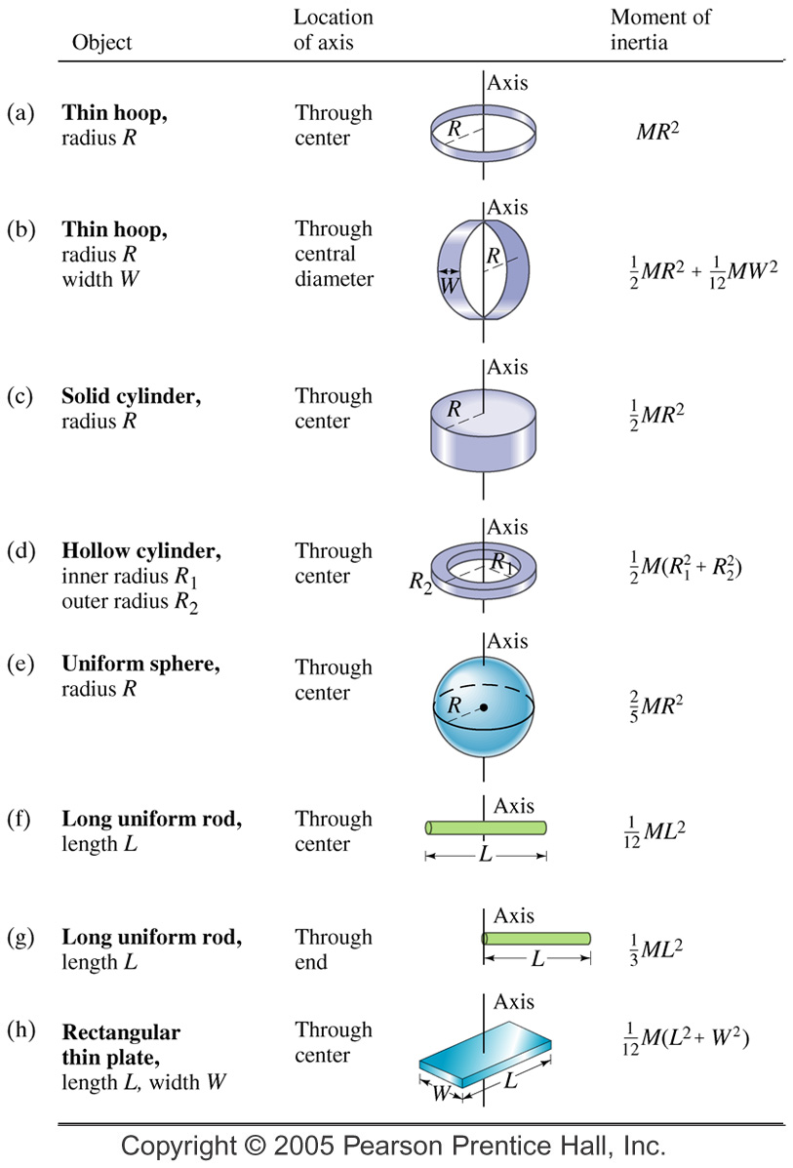

4. The two definitions of torque:

5. Rotational Inertia (I) of Various Objects

A. A single point mass:

B. Multiple point masses:

C. Other shapes – see chart

**Practice 10.3: Rotational Dynamics**

3. Calculate the rotational inertia of a solid sphere of mass M = 5.0 kg and a radius of R = 0.25 m.

4. Calculate the rotational inertia of a solid cylinder of mass M = 2.0 kg and a radius of R = 0.075 m about its central axis.

5. Suppose you exert a force of 180 N tangential to a 0.280-m-radius 75.0-kg grindstone (a solid disk).

A. What torque is exerted?

B. What is the angular acceleration assuming negligible opposing friction?

C. What is the angular acceleration if there is an opposing frictional force of 20.0 N exerted 1.50 cm from the axis?

**Answers**:

1. 0.733 s 2. A. 440 m B. 25.1 rad/s, 8.77 m/s 3. 0.13 kg m2 4. 5.6 x 10-3 kg m2

5. A. 50.4 N.m B. 17.1 rad/s2 C. 17.0 rad/s2

**Notes – 10.4 Rotational Kinetic Energy**

1. Starting with the linear (or tangential) kinetic energy formula, derive a formula for the rotational kinetic energy of a single mass m, with a velocity v, revolving around an axis at a radius r. The formula should be in terms of I and ω.

2. Calculate the final speed of a solid cylinder that rolls down a 2.00-m-high incline. The cylinder starts from rest, has a mass of 0.750 kg, and has a radius of 4.00 cm.

4. Calculate the final speed of a hoop of the same radius (4cm) that is allowed to roll down an incline of the same height (2m)

5. Compare the speeds of thin hoops and solid cylinders, in general, after rolling down ramps (assuming the objects’ radii and the ramp heights are identical, and that there is no friction).

**Practice – 10.4 Rotational Kinetic Energy**

1. What is the final velocity of a 1.00 kg hoop starting from rest that rolls without slipping down a hill 5.00 meters high?

2. What is the final velocity of a 1.0 kg solid disk/cylinder starting from rest that rolls without slipping down a hill 5.00 meters high?

3. Calculate the rotational kinetic energy of Earth on its axis. Assume the Earth is a uniform solid sphere of mass M = 5.97 x 1024 kg and a radius R = 6371 km.

4. What is the rotational kinetic energy of Earth in its orbit around the Sun? M = 5.97 x 1024 kg and R = 150 million kilometers.

5. A ball with an initial velocity of 8.00 m/s rolls up a hill without slipping. Treating the ball as a spherical shell, calculate the vertical height it reaches.

**Answers**:

1. 7.00 m/s 2. 8.08 m/s 3. 2.56 x 1029 J 4. 2.66 x 1033 J 5. 5.44 m

**Notes – 10.5 Angular Momentum and Its Conservation**

1. Write the equation for linear momentum.

2. Write the equation for angular momentum.

3. State the Law of Conservation of Angular Momentum in words.

4. Write the equation for the Conservation of Momentum.

6. Suppose an ice skater is spinning at 0.800 rev/ s with her arms extended. She has a moment of inertia of 2.34 kg⋅m2 with her arms extended and a moment of inertia equal to 0.363 kg⋅m2 with her arms close to her body. (These moments of inertia are based on reasonable assumptions about a 60.0-kg skater.)

A. What is her initial angular velocity, in rad/s?

B. What is her initial angular momentum?

C. What is her final angular velocity?

B. What is her rotational kinetic energy before and after she does this? Why does her KER change?

**Practice – 10.5 Angular Momentum and Its Conservation**

1. A playground merry-go-round has a mass of 120 kg and a radius of 1.80 m and it is rotating with an angular velocity of 0.500 rev/s. What is its angular velocity after an initially motionless 22.0-kg child gets onto it by grabbing its outer edge? This might be easier to visualize if you picture the merry-go-round snagging the child and yanking him/her into motion. [You may assume that the merry-go-round is a uniform disc with I=1/2 mr2 and that the child is a point source with I=mr2.]

2. Ice Skater

A. Calculate the angular momentum of an ice skater spinning at 6.00 rev/s given his moment of inertia is 0.400 kg⋅m2.

B. He reduces his rate of spin (his angular velocity) by extending his arms and increasing his moment of inertia. Find the value of his moment of inertia if his angular velocity decreases to 1.25 rev/s.

C. Suppose instead he keeps his arms in and allows friction of the ice to slow him from 6.00 rev/s to 3.00 rev/s. What average torque was exerted if this takes 15.0 s?

3. What is the angular momentum of Earth rotating on its axis? MEarth = 5.97 x 1024 kg and REarth = 6371 km. Assume the Earth is a solid uniform sphere (I=2/5 mr2)

4. What is the angular momentum of the Moon in its orbit around Earth? The orbital radius of the Moon is 384,399 km, the Moon’s mass is 7.35 x 1022 kg and its orbital period is 27.321 days. A) What value should you use for *I* ? b) What is the angular momentum?

**Answers**:

1. 2.30 rad/s 2. A. 15.1 kg m2/s B. 1.92 kg m2 C. -0.503 N m

3. 7.05 x 1033 kg m2/s 4. 2.89 x 1034 kg m2/s

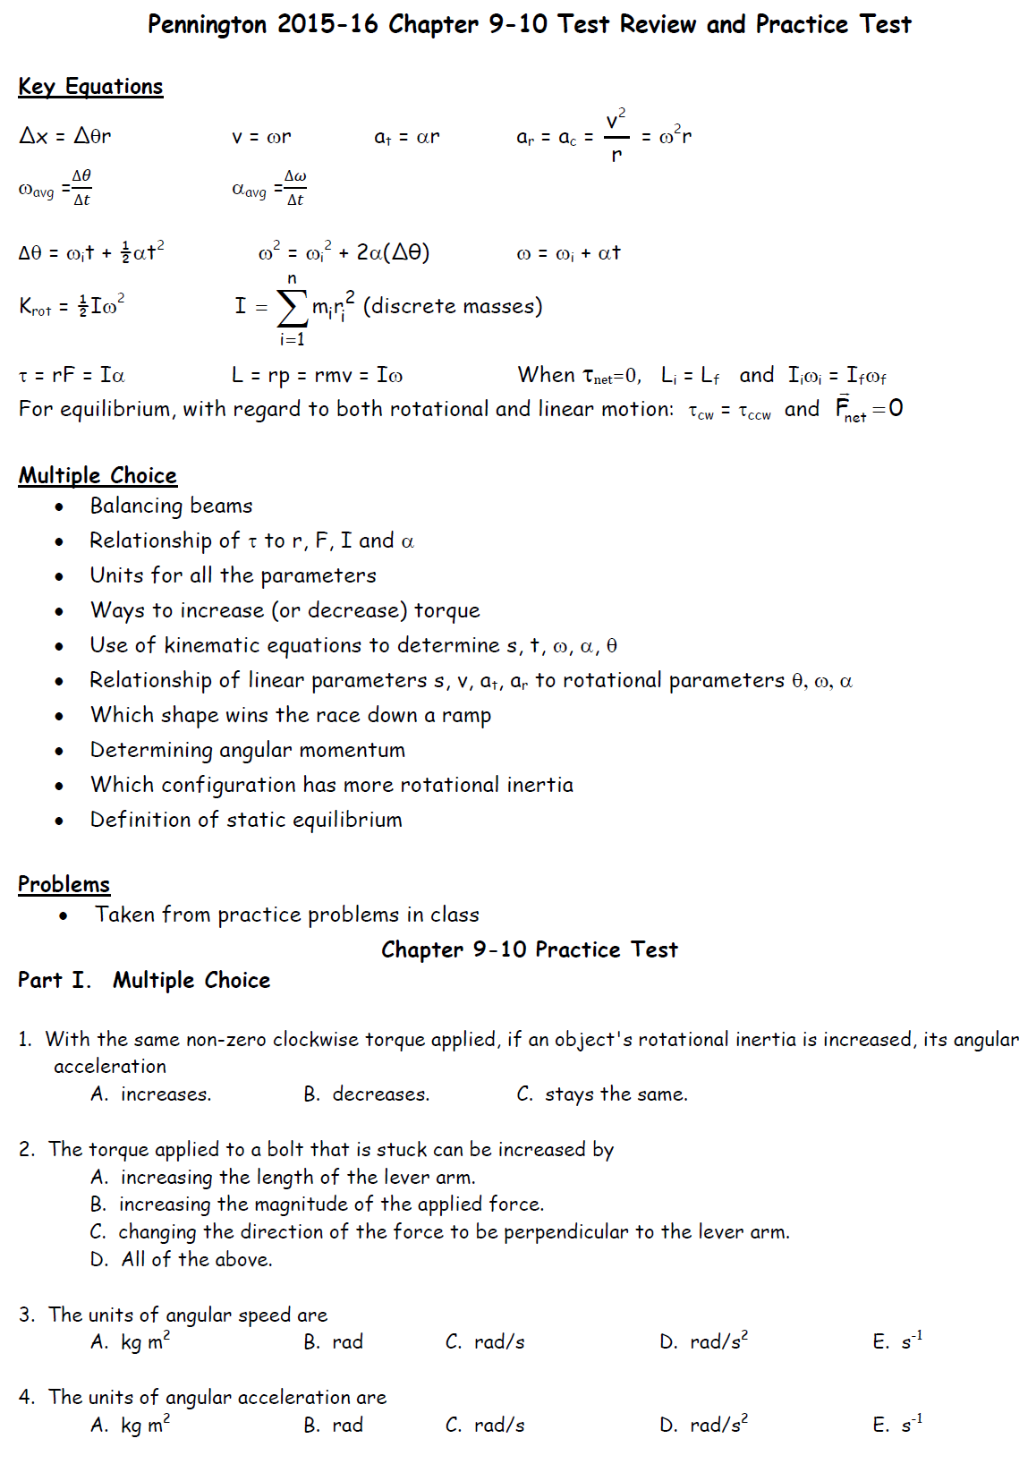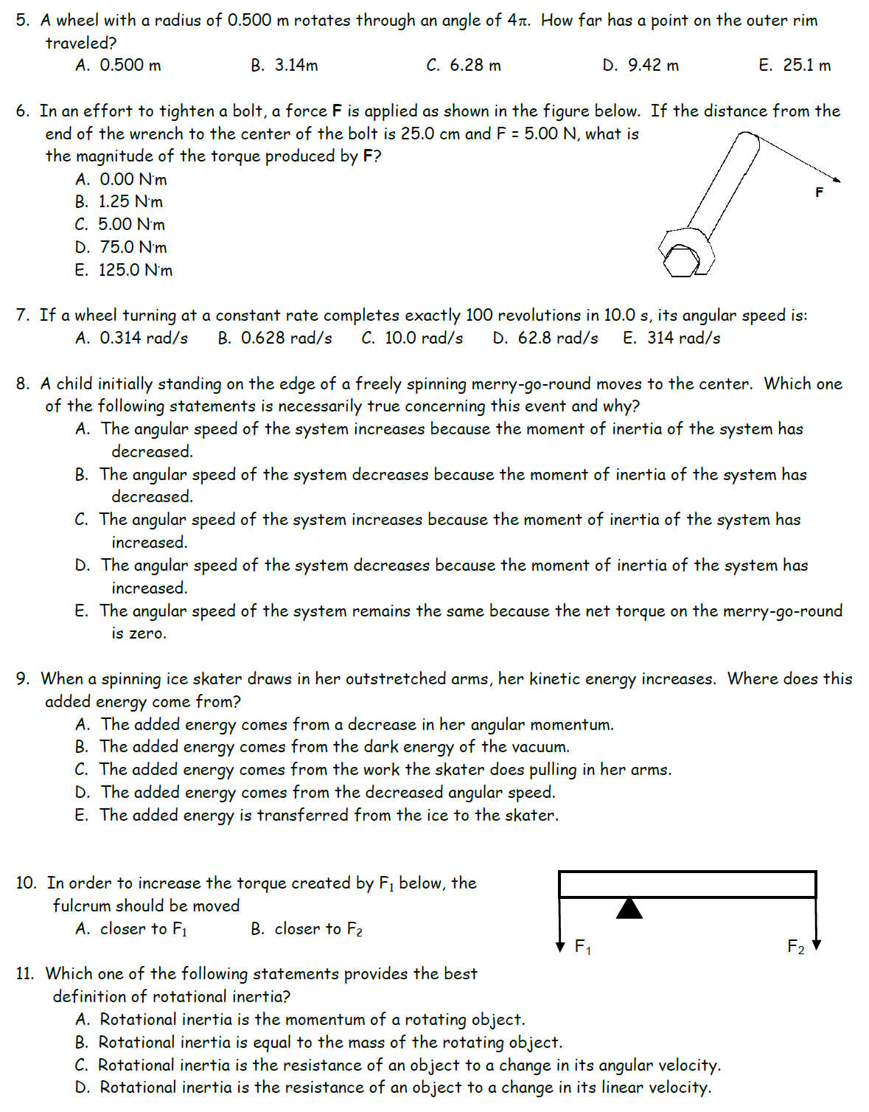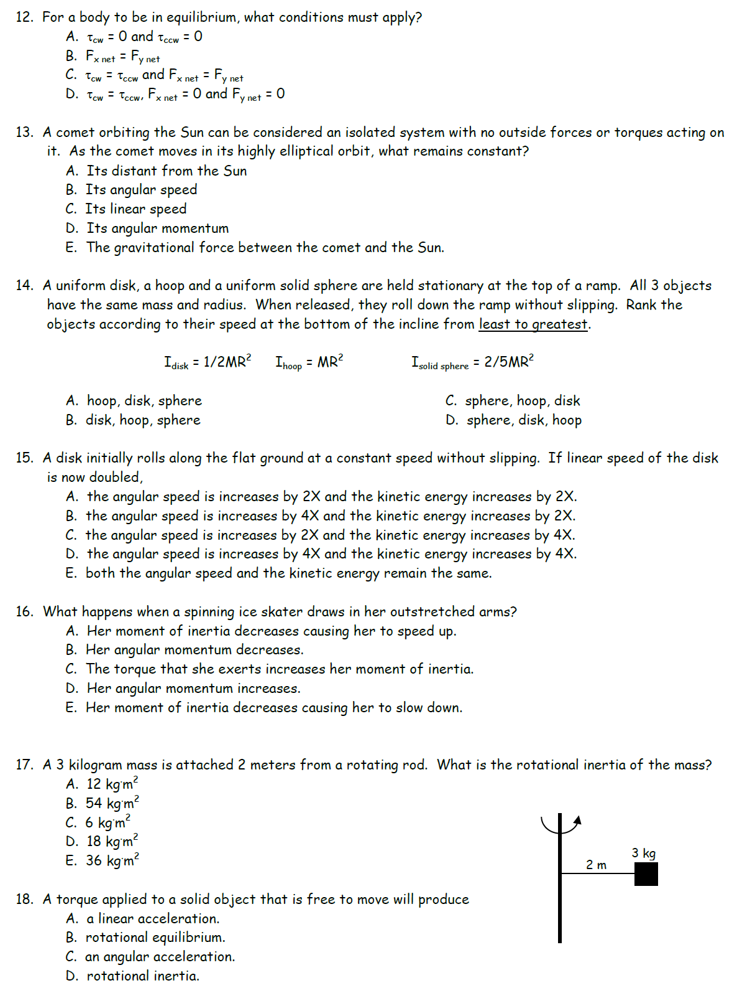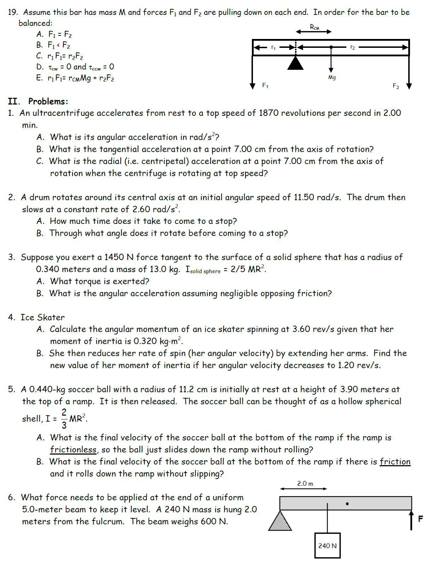

**Rotational Motion Practice Test #2**

**Part I. Multiple Choice**

1. With the same non-zero clockwise torque applied, if an object’s angular acceleration is increasing, its moment of inertia must be

A. increasing. B. decreasing. C. staying the same.

2. A rubber band car is powered by a rubber band pulling tangent to the axle. Increasing the wheel diameter

A. increases the torque B. decreases the torque C. has no effect on the torque

3. The units of rotational inertia are

A. kg m2 B. rad C. rad/s D. rad/s2 E. kg m2s-1

4. The units of angular momentum are

A. kg m2 B. rad C. rad/s D. rad/s2 E. kg m2s-1

5. A wheel with a radius of 0.500 m rolls for a distance of 6π meters. Through what angle has the a point on the wheel rotated?

A. 3.14 radians B. 6 radians C. 18.8 radians D. 37.7 radians

6. In an effort to tighten a bolt to a torque of 2.5 N.m, a force **F** is applied as shown in the figure below. If the distance from the end of the wrench to the center of the bolt is 25.0 cm, what force must be applied at the end of the wrench?

A. 1N



B. 2.5N

C. 5.00 N

D. 10N

E. 25N

7. If a wheel turning at a constant rate completes exactly 20 revolutions in 10.0 s, its angular speed is:

A. 0.314 rad/s B. 0.628 rad/s C. 10.0 rad/s D. 6.28 rad/s E. 31.4 rad/s

8. A child initially standing at the center freely spinning merry-go-round moves to the edge. Which one of the following statements is necessarily true concerning this event and why?

A. The angular speed of the system increases because the moment of inertia of the system has decreased.

B. The angular speed of the system decreases because the moment of inertia of the system has decreased.

C. The angular speed of the system increases because the moment of inertia of the system has increased.

D. The angular speed of the system decreases because the moment of inertia of the system has increased.

E. The angular speed of the system remains the same because the net torque on the merry-go-round is zero.

9. In order to increase the torque created by F2 below, the fulcrum should be moved

F2

F1

A. closer to F1 B. closer to F2

10. A comet orbiting the Sun can be considered an isolated system with no outside forces or torques acting on it. As the comet moves closer to the sun in its highly elliptical orbit, what happens to its angular momentum?

a. It increases b. It decreases c. It stays the same

11. As a comet moves closer to the sun in its highly elliptical orbit, what happens to its rotational inertia?

a. It increases b. It decreases c. It stays the same

12. As a comet’s position in its orbital path changes, its moment of inertia doubles due to the change in position. What happens to its kinetic energy as its moment of inertia doubles?

a. multiplied by 0.5x b. No change c. multiplied by 2x d. multiplied by 4x

13. Which of the following determine(s) the speed of a rolling object as it reaches the bottom of a smooth hill? Select all that apply. [Assume that all objects will actually roll without slipping.]

a. Object radius b. Object mass c. Object Shape (distribution of mass)

14. A disk initially rolls along the flat ground at a constant speed without slipping. If the disk’s radius is now doubled without changing its translational speed or its mass,

A. the angular speed decreases by 2X and the kinetic energy decreases.

B. the angular speed decreases by 4X and the kinetic energy decreases.

C. the angular speed decreases by 2X and the kinetic energy remains the same.

D. the angular speed decreases by 4X and the kinetic energy remains the same.

15. What happens when a gymnast flipping in a frictionless space opens up from a tucked position?

A. His moment of inertia decreases causing him to speed up.

B. His angular momentum decreases.

C. The torque that he exerts increases his moment of inertia.

D. His angular momentum increases.

E. His moment of inertia increases causing him to slow down.

16. A 3 kilogram rotating mass has a rotational radius of 1m and a moment of inertia of 3kg.m2. What shape could it be?

A. Thin hoop

B. Sphere

C. Disk

17. If a mechanic applies a force (F) at an acute angle θ, relative to the length of a wrench, torque generated equals

A. rFsinθ B. rFcosθ c. rFtan θ d. rF

**Part II. Problems:**

1. A car accelerates from rest to 3m/s in a time of 1.5 second. The car’s wheels have radii of 0.04m.

a. How fast do the wheels accelerate, in rad/s2?

b. Through how many radians do the wheels rotate during this 1.5s?

c. What is the angular velocity of the wheels at the end of the 1.5s, in rpm?

2. A car’s wheels are rotating at a rate of 3 revolutions per second. If the wheels slow down at a rate of 3rad/s2…

a. How much time does it take the car to come to a stop?

b. How many revolutions do the wheels make before coming to a stop?

3. In an attempt to spin a basketball (initially at rest), a child places a ball on the tip of his finger and applies a force of 3N tangent to its surface. The basketball has a mass of 0.65kg and a radius of 0.12m. [Ihollow sphere = 2/3 mr2]

a. How much torque is exerted on the basketball by the child?

b. Assuming zero friction, what is the angular acceleration of the basketball?

c. If the child were able to maintain this acceleration for one minute, what angular velocity would the basketball have, in revolutions per second?

4. A woman coasts on unicycle, traveling horizontally off the edge of a cliff. From a bystander’s perspective, her velocity as she leaves the cliff is 6m/s to the right. The unicycle wheel has a mass of 1.5kg and a radius of 23cm. For purposes of calculating moment of inertia, the wheel may be considered a thin hoop (I=mr2). The woman and the unicycle remain vertical until, a few moments after leaving the cliff, she stops the wheel’s rotation (relative to the rest of the unicycle). As she stops the wheel, she and her unicycle begin to rotate together, achieving a final rate of 10rpm.

a. What is the wheel’s angular velocity at the moment she leaves the cliff?

b. What is the wheel’s angular momentum at the moment the woman leaves the cliff?

c. From the bystander’s perspective, in which direction does the unicyclist begin to rotate after stopping the wheel?

d. What is the overall moment of inertia of the unicyclist/unicycle?

5. A visitor to Pizza Putt wants to roll a Skee-ball with enough speed so that it will have a velocity of 3m/s when it reaches the top of its ramp. The ball has a radius of 4cm and a mass of 160g. It is a solid sphere, so I=2/5 mr2. The height of the ramp is 30cm. What speed (translational speed) must the ski ball have when it reaches the bottom of the ramp, in order to have a velocity of 3m/s at the top of the ramp?

6. A 200N force and a 300N force are applied to the beam on the right in the locations indicated. Where should the fulcrum be placed in order to balance the 500N beam?

