Physics 200 Name: ___________________________
Rubber Band Car Contest
(Rotational Motion)

Goal: Design a rubber band-powered car that reaches the highest maximum velocity, and predict its performance with a mathematical model. The car should be fast (at top speed) and predictable.

Steps:
- Solve problems. Investigate rubber band car concepts.
- In CAD, choose pre-designed components and add your own parts and/or modifications (e.g. frames between 8” and 23.5”; wheels between 3” and 8” in diameter).
- Lay out your parts for laser cutting.
- Assemble your car and your rubber band/string motor.
- Collect data to create a specification table for your car.
- Create and turn-in graphs predicting your car’s speed vs time and speed vs position.
- Test your car and fine-tune your winding procedure.
- Contest tentative schedule – perform in order of predicted speed, slowest to fastest.

Important Design Considerations:
- Wheel diameters
- Rubber band and string configuration
- Rubber band stretch distance
- Friction with the “road” (floor tiles)

Scoring:
- Score = Top speed (1-(1-(acceleration distance fractional error + predicted top speed fractional error)))
- Example: Top speed =5m/s. Predicted top speed = 5.5m/s. Acceleration distance = 6m. Predicted Acceleration Distance = 5m. Speed fractional error = 0.1. Acceleration distance fractional error = 0.167.
Score = 5m/s (1-(0.1+0.167) = 5m/s (1-0.267) = 5m/s (0.733) = 3.665m/s

Rules:
- The vehicle must be fully supported by at least three wheels that roll, although momentary wheelies are acceptable.
- The car’s propulsive force must come from the rotation of at least one of its wheels, and the force of friction between this wheel and the road.
- Car torque must come from string wrapped around at least one axle.
- Force must come from one linear “spring” made of rubber bands (stretched in a straight line -- no wrapping or bending)
- The maximum allowed rubber band tension/drive string tension is 40N This year there is no rule regarding maximum drive string tension – but there is a practical limit for you to discover.
- Rubber bands must be attached in a way that allows measurement of their force (at all moments during winding) with a spring scale or digital force meter.
- Allowed materials (for class contest purposes): 1/8” plywood (no more than one 11.5”x23.5” sheet), hot glue, two 5/16” steel axles, 4 skateboard bearings, rubber bands, string, and anything else that costs less than $1.00.
- If you would rather focus on setting a new rubber band car world record, any materials are allowed, but you be disqualified from the class contest.
- Additional rules may be added at any time to close unintended loopholes and preserve the essence of the contest. If you think you’ve done some “outside the box” thinking and found an exploitable loophole, check with the teacher to see if it’s allowed.

Example Stock Cars: Max frame length 23.5”; Min frame length 8”.

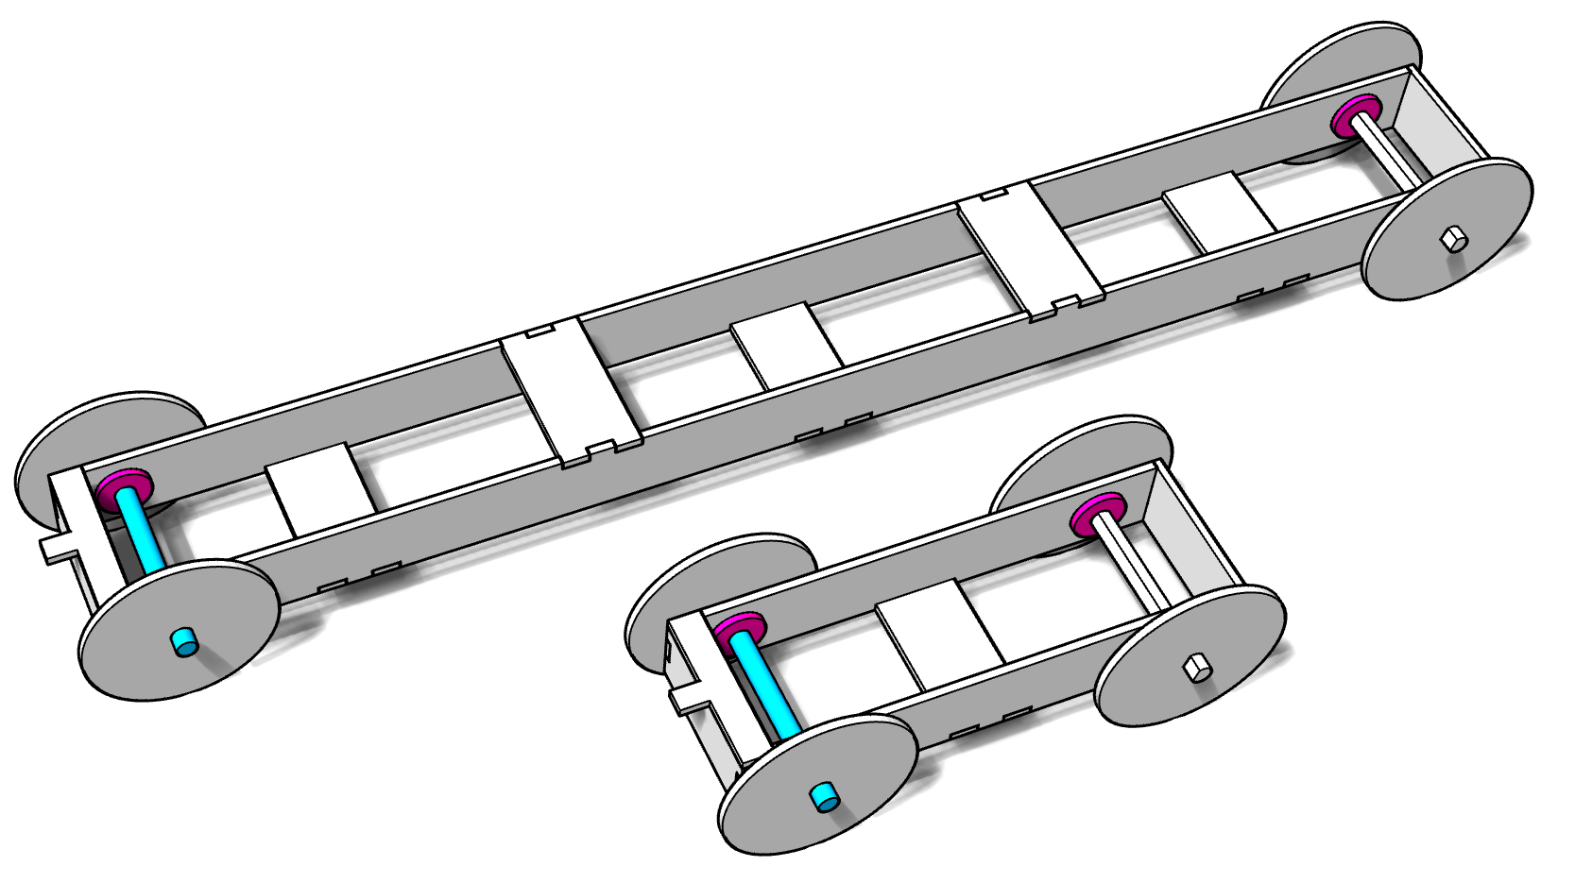

Example Laser Cutting Layout: This example features a 23.5” frame, 3” diameter wheels, wheel rim thickeners for drive wheels, and extra space for your own parts. The cross braces can be rearranged on the layout.

