Physics 200 Name: _____________________________
Rotational Motion: Rubber Band Car Problems

1 inch = 2.54cm

1. The string of a rubber band car pulls with a force of 49 Newtons. This string has negligible thickness, and it is wrapped around a 5/16” axle. The axle is fused to wheels that are 4” in diameter.
a. What is the axle radius, in meters?

b. How much torque does the string exert on the wheel and axle?

c. What is the wheel radius, in meters?

d. Assuming that there is enough friction between the wheels and the road, how much force does the edge of the wheel exert on the floor?

e. Suppose the normal force exerted on the drive wheels by the floor is 0.8N, and µ_{s} = 0.4…
i. what is the maximum force of static friction between the wheels and the floor?

ii. what minimum diameter must the drive wheels have in order to avoid slipping?

2. A rubber band car has a mass of 0.15kg and a wheel base (distance between the centers of the wheels) of 8 inches. If the center of mass is 3 inches from the center of the front wheels, what normal force is exerted by…
a. the floor, against the back wheels

b. the floor, against the front wheels

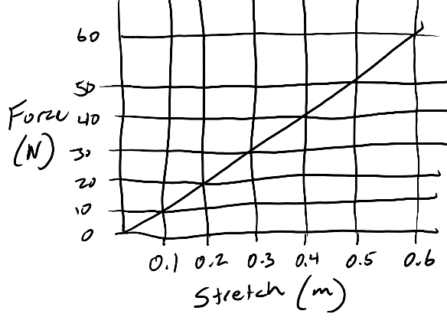
3. Suppose one rubber band has the force curve depicted here. The stretch distance describes how far the rubber band is stretched beyond its equilibrium point. Now suppose you create each of the configurations below, and you stretch each of them until they exert 30N of force. Determine the stretch distance (x, in meters), and the work that you would have to do (in Joules) in all three cases.

a. One rubber band, all alone.

b. Two rubber bands aligned with one another.

c. Two rubber bands linked together into a chain.

d. One rubber band cut to form a single strip.

4. A rubber band car is powered by 6 inches of string that is wrapped around a 5/16” drive axle. If the drive wheels are 4” in diameter, how far will the car travel as the string unwinds?

5. Suppose 1.9J of work is done in the process of winding a rubber band car. If 70% of that energy gets converted to KE, how fast will the car be moving when it reaches top speed? Mass = 200g. Front wheel/axle moments of inertia = 8x10⁻⁶kgm². Rear wheel/axle moment of inertia =5x10⁻⁵ kgm². The front wheels are 0.03m in radius, and the rear wheels are 0.05m in radius.

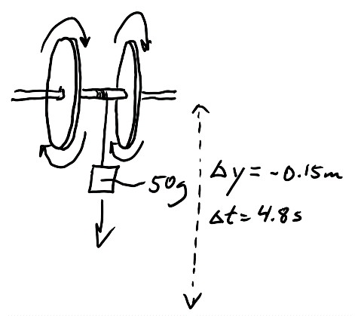
6. 15cm of thread is wrapped around the motionless drive axle (r = 0.00397m) of a rubber band car. A 50g weight is attached to the end of the thread. When the system is released, the weight falls, rotating the axle and wheels at an accelerating rate. The weight falls for 4.8 seconds, and at the end of this time interval the wheel and axle begins to decelerate. After 25 seconds the wheel and axle comes to rest. The mass of the wheel and axle is 80g.
a. What is the linear acceleration of the falling weight? [This is also the tangential acceleration of the edge of the axle.]

b. What is the angular acceleration of the axle?

c. What is the tension in the string while the weight is falling?

d. What torque is exerted on the axle by the string tension?

e. What is the maximum angular velocity of the axle (at the point when the weight is released -- just before the axle begins decelerating)?

f. What is the angular acceleration of the axle during its deceleration period.

g. Use a system of equations to find the wheel and axle moment of inertia (I) and the Torque exerted by friction. During the acceleration period, both string tension and friction contribute to the net Torque. During the deceleration period, friction is the sole source of torque.
i. Write a first equation for net torque during the acceleration period. Use T_{net} = Iα. Remember that, during the acceleration period, T_{net} = T_{friction} + T_{tension}
ii. Write a second equation for net torque during the deceleration period. During the deceleration period, T_{net} = T_{friction}

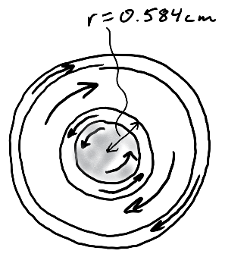
h. The bearings have an inner ring and an outer ring, and the two rings move separately. The inner ring moves with the wheels and axle. What force of friction did the outer bearing ring exert on the inner bearing ring (and therefore also on the wheel and axle) during the deceleration period? As the diagram on the right shows, the inner bearing ring has an outer radius of 0.584cm. (Use the torque formula)

i. What normal force was the bottom of the inner bearings exerting on the outer bearings below? [weight of wheel and axle]

j. What was the value of µ_{k} between the inner and outer bearing rings?

7. A rubber band car turns to the left. The curvature of its path can be described as following edge of a circle with a radius of 7m. If the car is to be released in a 3m wide hallway, where, and at what angle, should it be released in order to travel the farthest possible distance before crashing into a wall. Draw a diagram to show where the car should be released, how it should be aimed, and the path that it will follow before crashing. Precise numbers, angles, distances, etc. are not important

_______________________________________________________________________________________________

Lab Measurements: Complete on a separate sheet of paper

- Make graphs of force vs stretch for rubber bands.
  - Get a two rubber bands. Stretch them repeatedly until they loosen up and turn whitish.
  - Create individual graphs of force vs x (stretch distance) for each of the following. Use weights between 0 and 9.8N (1kg).
    - One band
    - One linked band
    - One cut band
- Calculate wheel and axle moment of inertia and frictional torque. Follow the steps in problem number 6 (a-g), above.
- Measure static friction between floor tile and wheel. Lock the car wheels, then use pulleys and thread to measure amount of force required to drag the car on a horizontal surface.

