Unit 12 Handout (Optics)
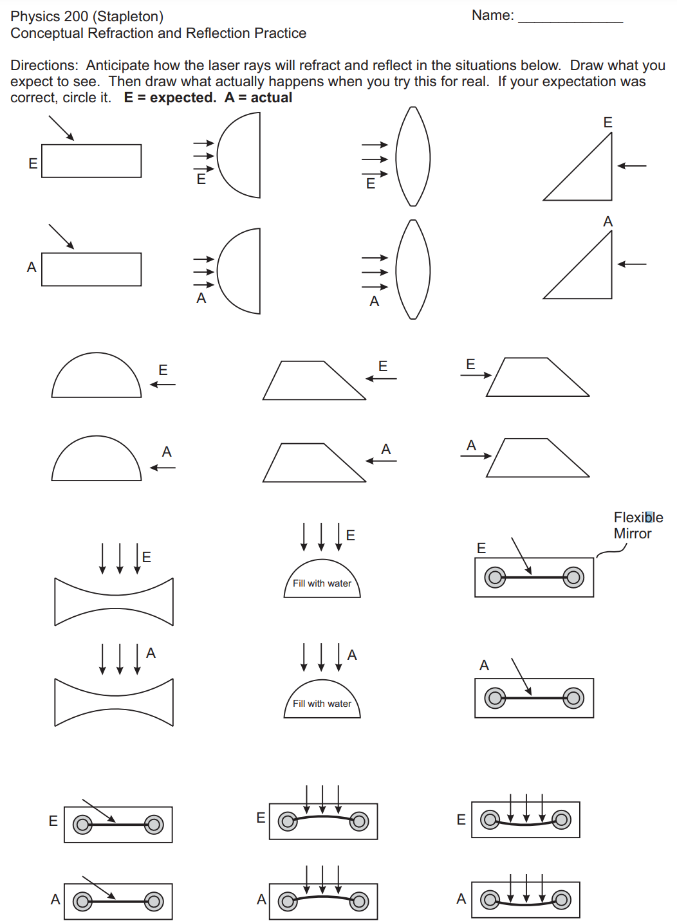
Physics 200 Name: _______________________
Notes: 25.3-25.4 Refraction and Total Internal Reflection

Notes - 25.3-25.4 Refraction and Total Internal Reflection

1. The changing of a light ray’s direction (loosely called bending) when it passes through variations in matter is called ______________________.

2. In Einstein’s theory of relativity, the speed of light c was found not to depend on the _________________of the source or the observer.

3. The speed of light is so important that its value in a ____________ is one of the most fundamental constants in nature. However, the speed of light does vary in a precise manner with the ______________ it passes through.

4. The first real evidence that light traveled at a ______________ speed came from the Danish astronomer Ole Roemer in the late 17th century. Roemer had noted that the average orbital period of one of Jupiter’s moons, as measured from Earth, varied depending on whether Earth was ________________ or _____________________ Jupiter as they orbited the Sun. He correctly concluded that the apparent change in period was due to the change in distance between Earth and Jupiter and the _____________ it took _____________ to travel this distance.

5. c =

6. The speed of light through matter is ____________than it is in a vacuum, because light interacts with the ____________ in a material. The speed of light depends strongly on the __________________________, since its interaction with different atoms, crystal lattices, and other substructures varies. The speed of light through a material is equal to:

where n = ____________________________, Since the speed of light is always ____________ than c in matter and equals c only in a vacuum, the index of refraction is always _________________ than or equal to one.

7. The change in direction of a light ray depends on how the speed of light __________________ when it crosses from one medium to another. No change in the speed of light means no bending.
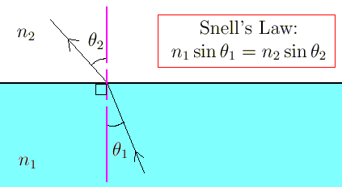
8. Snell’s Law:

8.5 Conceptually, you can understand the turning of a refracting ray if you think of the ray as a car traveling from a fast road surface to a slow one (or vice versa).

9. Total Internal Reflection
A. When the second medium has an index of refraction ___________ than the first, you can get total internal reflection where all of the light is reflected back into the medium.
B. θ_{C}
C. Examples:
i.

ii.

iii.
Practice - 25.3-25.4 Refraction and Total Internal Reflection
1. What is the speed of light in water?

3, What is the speed of light in crown glass?

5. In what substance in Table 25.1 is the speed of light 2.290 x 10⁸ m/s?

7. A scuba diver training in a pool looks at his instructor. What angle does the ray from the instructor’s face make with the perpendicular to the water at the point where the ray enters? The angle between the ray in the water and the perpendicular to the water is 25.0º.

9. Suppose you have an unknown clear substance immersed in water, and you wish to identify it by finding its index of refraction. You arrange to have a beam of light enter it at an angle of 45.0º, and you observe the angle of refraction to be 40.3º. What is the index of refraction of the substance and its likely identity?

13. What is the critical angle for light going from diamond to air?

15. Suppose you are using total internal reflection to make an efficient corner reflector. If there is air outside and the incident angle is 45.0º (so that the beam is making a right angle turn), what must be the minimum index of refraction of the material from which the reflector is made?

17. A ray of light, emitted beneath the surface of an unknown liquid with air above it, undergoes total internal reflection. If the diagram shows a light ray reflecting at the critical angle, what is the index of refraction for the liquid, and its likely identification?

Answers:
1. 2.25 x 10⁸ m/s 3. 1.97 x 10⁸ m/s 5. 1.31, ice 7. 34.3º
9. 1.46, fused quartz 13. 24.4º 15. 1.41 17. 1.50, benzene
Physics 200 (Stapleton) Name: _____________________________
Lenses, Images, and Ray Diagrams

Convex and Concave lenses can be used to produce images, both real and virtual. These images may be magnified, reduced, or inverted, and in the case of real images, they may be projected.

Image: The focused appearance of some real object, in a precise location that appears to be the same to all observers of the image (but not everyone will be in a position to see it).

Real image: An image that can be projected onto a surface; an image formed by converging light rays; usually an inverted image

Virtual image: An image that cannot be projected onto a surface; an image formed by diverging light rays; usually an upright image

The convex (converging) lenses we will be using and discussing in this class are designed in a manner that causes rays entering a lens on a path parallel to the lens’ primary axis to be refracted so that they converge at the lens focal point, which is located one focal length (f) from the lens’ center, along its primary axis. [Note that this is a simplification; rays actually refract once as they enter the lens and again as they exit the lens.] 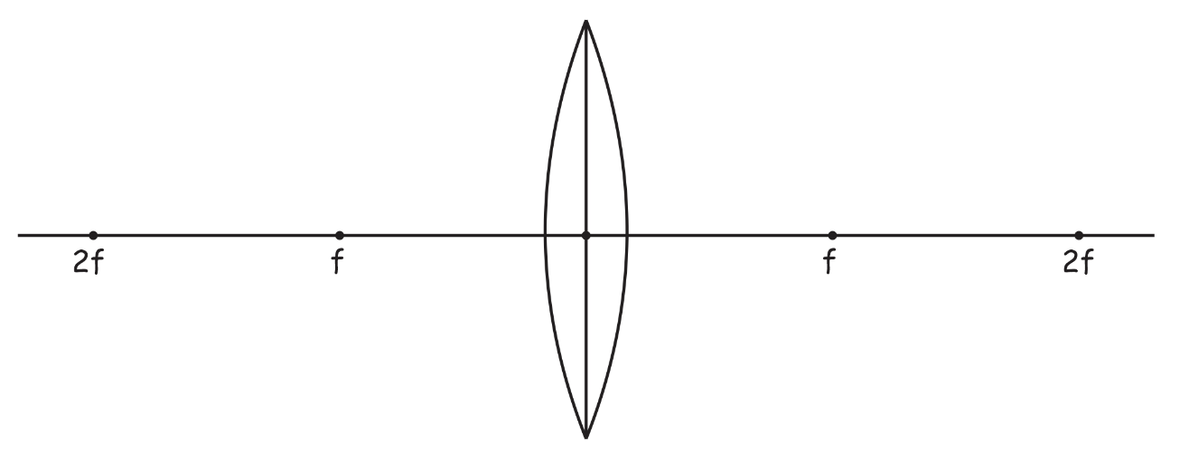

The concave (diverging) lenses we will be using and discussing in this class are designed in a manner that causes rays entering a lens on a path parallel to the lens’ primary axis to be refracted so that they diverge on paths appearing to emanate from a focal point located one focal length (f) from the lens’ center, along its primary axis, on the opposite side of the lens from which the refracted rays exit. [Again, this is a simplification; rays refract twice during their passage through the lens.]
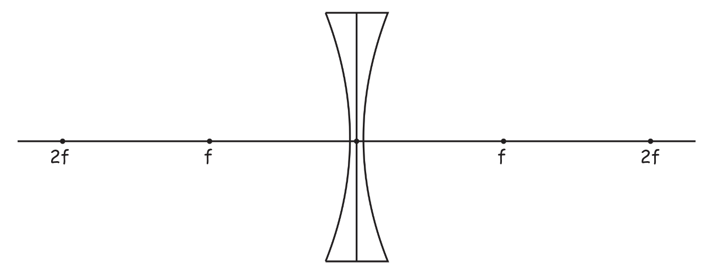

Three rules of refraction for convex (converging) lenses:

- Any incident ray traveling parallel to the principal axis of a converging lens will refract through the lens and travel through the focal point on the opposite side of the lens.
- Any incident ray traveling through the focal point on the way to the lens will refract through the lens and travel parallel to the principal axis.
- An incident ray that passes through the center of the lens will in effect continue in the same direction that it had when it entered the lens.

We will be using these three rules to draw ray diagrams which can be used to graphically answer the following questions. Given an object of height h_{o}, placed on the principal axis at a distance of d_{o} …
- Where is the image? What is its distance(d_{i}) from the lens?
- Is the image real or virtual?
- What is the height(h_{i}) of the image?
- What is the magnifying power (M) of the lens? 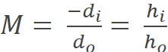

1. Draw the image of an object at a position between d_{o} = 2f and d_{o} = 3f, to the left of the lens. Is the image virtual or real? M ≈ _______

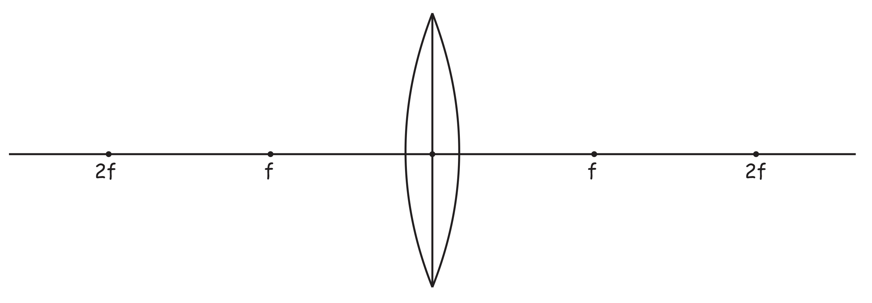

2. Draw the image of an object at a position at d_{o} = 2f, to the left of the lens. Is the image virtual or real?
M ≈ _______
3. Draw the image of an object at a position between d_{o} = f and d_{o} = 2f, to the left of the lens. Is the image virtual or real? M ≈ _______

4. Draw the image of an object at a position at d_{o} = f to the left of the lens. Is the image virtual or real?
M ≈ _______

5. Draw the image of an object at a position between d_{o} = f and the lens, to the left of the lens. Is the image virtual or real? M ≈ _______
Three rules of refraction for concave (diverging) lenses:

- Any incident ray traveling parallel to the principal axis of a diverging lens will refract through the lens and travel in line with the focal point (i.e., in a direction such that its extension will pass through the focal point).
- Any incident ray traveling towards the focal point on the way to the lens will refract through the lens and travel parallel to the principal axis.
- An incident ray that passes through the center of the lens will in effect continue in the same direction that it had when it entered the lens.

6. Draw the image of an object at a position at d_{o} = 2f to the left of the lens. Is the image virtual or real?
M ≈ _______

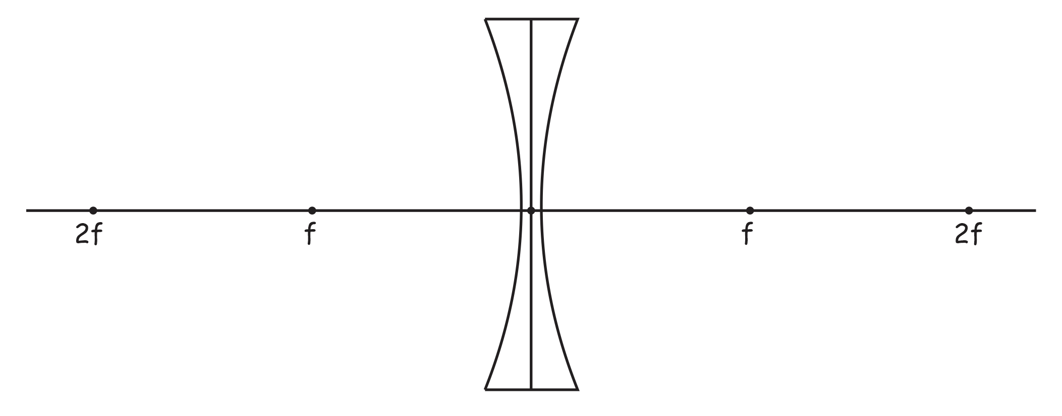

7. Draw the image of an object at a position at d_{o} = 2f to the left of the lens. Is the image virtual or real?
M ≈ _______

8. Now use lenses, paper, candles, and your eyes to view the images (real and virtual) that you simulated in this exercise.
Physics 200 (Stapleton) Name: _____________________________
Lens Equation (and magnification)

The Lens Equation: 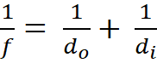 Magnification Equation: 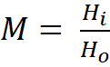 = 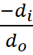

** After the first problem or two, feel free to create a spreadsheet to speed up this task.

1. (object beyond 2f) An object with a height of 1.2cm is placed on top of the principal axis of a convex lens, 7.8cm from the center of the lens. The focal length of the lens is 3cm.

- Where is the image located?

- What is the image height?

- Is the image upright or inverted?

- What is the magnification of the object in this position?

- Is the image real or virtual?

2. (object at 2f) An object with a height of 2cm is placed on top of the principal axis of a convex lens, 6cm from the center of the lens. The focal length of the lens is 3cm.

- Where is the image located?

- What is the image height?

- Is the image upright or inverted?

- What is the magnification of the object in this position?

- Is the image real or virtual?

3. (object between 1f and 2f) An object with a height of 1.5cm is placed on top of the principal axis of a convex lens, 5cm from the center of the lens. The focal length of the lens is 3cm.

- Where is the image located?

- What is the image height?

- Is the image upright or inverted?

- What is the magnification of the object in this position?

- Is the image real or virtual?

4. (object at f) An object with a height of 3cm is placed on top of the principal axis of a convex lens, 3cm from the center of the lens. The focal length of the lens is 3cm.

- Where is the image located?

- What is the image height?

- Is the image upright or inverted?

- What is the magnification of the object in this position?

- Is the image real or virtual?

5. (object between lens and f) An object with a height of 1.7cm is placed on top of the principal axis of a convex lens, 1cm from the center of the lens. The focal length of the lens is 3cm.

- Where is the image located?

- What is the image height?

- Is the image upright or inverted?

- What is the magnification of the object in this position?

- Is the image real or virtual?

Physics 200 (Stapleton) Name: ________________________________
Optics Practice Quiz
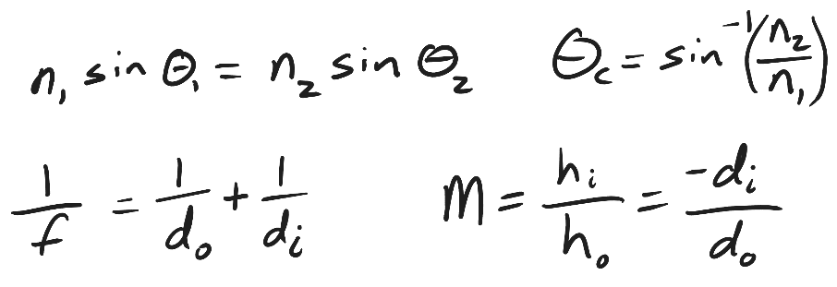
1. Substance A (n = 1.3) is separated from substance B (n = 2.5) by a flat plane. A ray of light travels from substance A to substance B, meeting the planar boundary between the substances at a 22° angle of incidence.

- Sketch a simple diagram showing the ray refracting as it travels from substance A to substance B.
- On your sketch, label the normal, the angle of incidence, and the angle of refraction. Calculate the angle of refraction and add that number to your diagram.
- On another part of your diagram (or in a new diagram) show a ray of light with an angle of incidence equal to its critical angle. Calculate and label the critical angle, 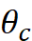. Draw what happens to the ray when it hits the boundary between the two substances.

2. A thin convex lens has a focal length of 5cm. An object 1cm tall is placed on the lens’ principal axis, at a distance of 2cm from the center of the lens.
- Is the object’s image real or virtual?
- Is the image upright or inverted?
- What is the distance of the image from the lens?
- What is the height of the image?
- What is the magnification (M) of the object in this situation?
- Optional -- Sketch or draw a ray diagram to confirm your answers.

3. The same object (1cm tall) is placed on the principal axis of a convex lens with f = 3cm, at a distance of 9 cm from the center of the lens.
- Is the object’s image real or virtual?
- Is the image upright or inverted?
- What is the distance of the image from the lens?
- What is the height of the image?
- What is the magnification (M) of the object in this situation?
- Optional – Sketch or draw a ray diagram to confirm your answers.

