Physics 200 (Stapleton) Name: _____________________________
Lenses, Images, and Ray Diagrams

Convex and Concave lenses can be used to produce images, both real and virtual. These images may be magnified, reduced, or inverted, and in the case of real images, they may be projected.

Image: The focused appearance of some real object, in a precise location that appears to be the same to all observers of the image (but not everyone will be in a position to see it).

Real image: An image that can be projected onto a surface; an image formed by converging light rays; usually an inverted image

Virtual image: An image that cannot be projected onto a surface; an image formed by diverging light rays; usually an upright image

The convex (converging) lenses we will be using and discussing in this class are designed in a manner that causes rays entering a lens on a path parallel to the lens’ primary axis to be refracted so that they converge at the lens focal point, which is located one focal length (f) from the lens’ center, along its primary axis. [Note that this is a simplification; rays actually refract once as they enter the lens and again as they exit the lens.] 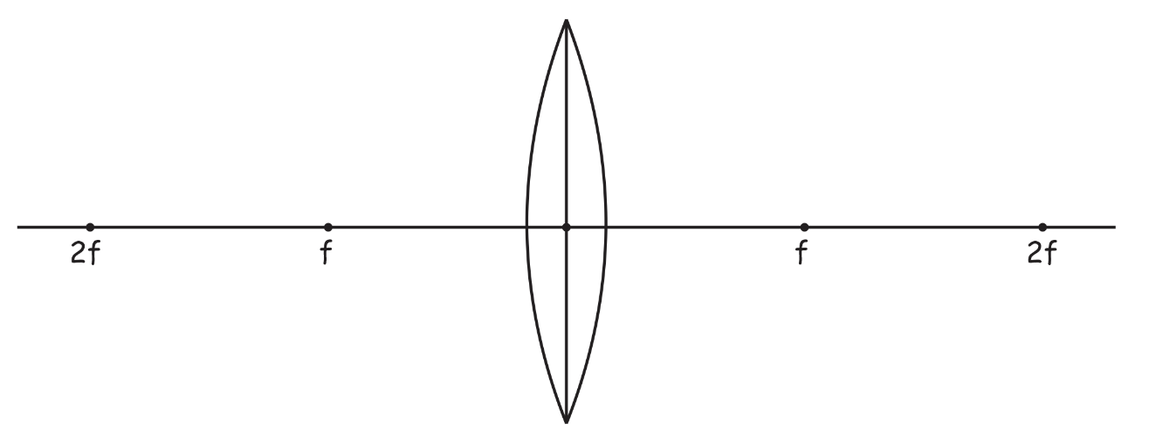

The concave (diverging) lenses we will be using and discussing in this class are designed in a manner that causes rays entering a lens on a path parallel to the lens’ primary axis to be refracted so that they diverge on paths appearing to emanate from a focal point located one focal length (f) from the lens’ center, along its primary axis, on the opposite side of the lens from which the refracted rays exit. [Again, this is a simplification; rays refract twice during their passage through the lens.]
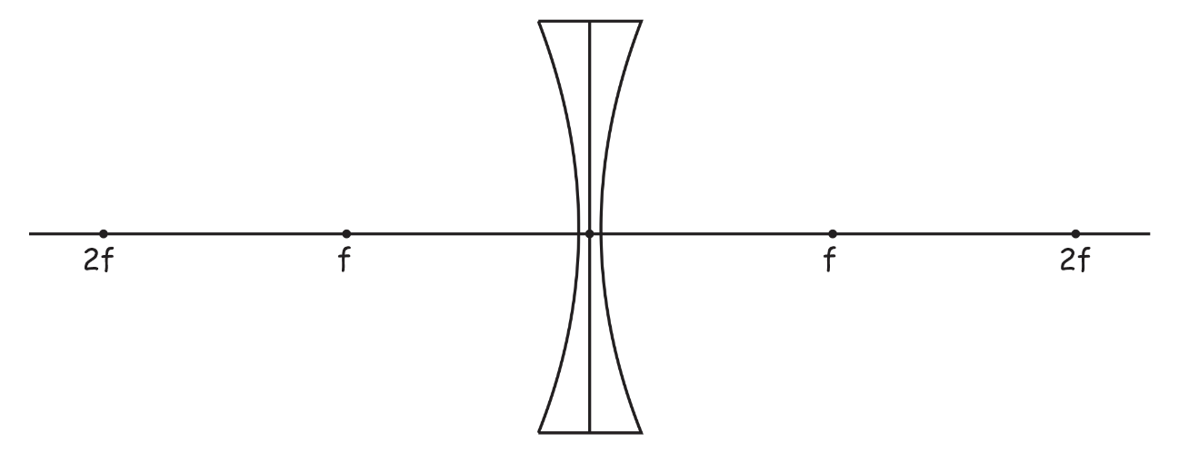

Three rules of refraction for convex (converging) lenses:

- Any incident ray traveling parallel to the principal axis of a converging lens will refract through the lens and travel through the focal point on the opposite side of the lens.
- Any incident ray traveling through the focal point on the way to the lens will refract through the lens and travel parallel to the principal axis.
- An incident ray that passes through the center of the lens will in effect continue in the same direction that it had when it entered the lens.

We will be using these three rules to draw ray diagrams which can be used to graphically answer the following questions…

- Where is the image?
- Is the image real or virtual?
- What is the

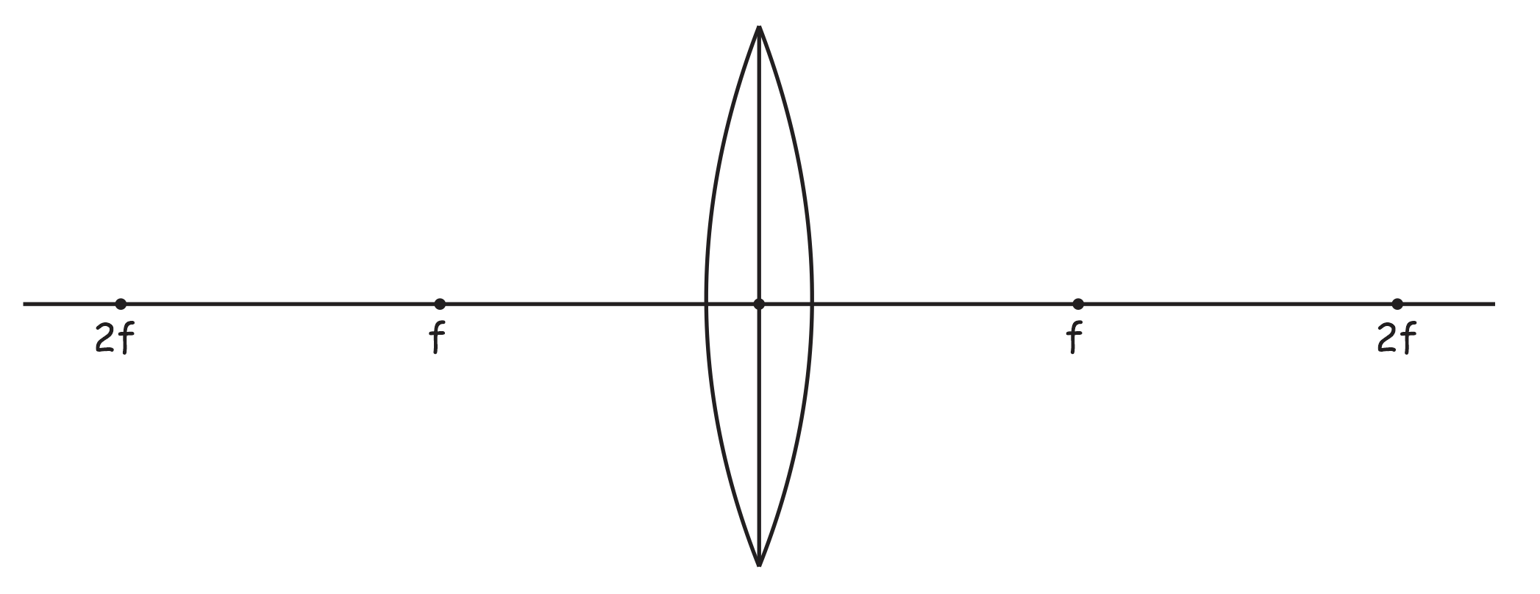

Three rules of refraction for concave (diverging) lenses:

- Any incident ray traveling parallel to the principal axis of a diverging lens will refract through the lens and travel in line with the focal point (i.e., in a direction such that its extension will pass through the focal point).
- Any incident ray traveling towards the focal point on the way to the lens will refract through the lens and travel parallel to the principal axis.
- An incident ray that passes through the center of the lens will in effect continue in the same direction that it had when it entered the lens.

