Physics 200 (Stapleton) Name: ________________________________
Optics Practice Quiz
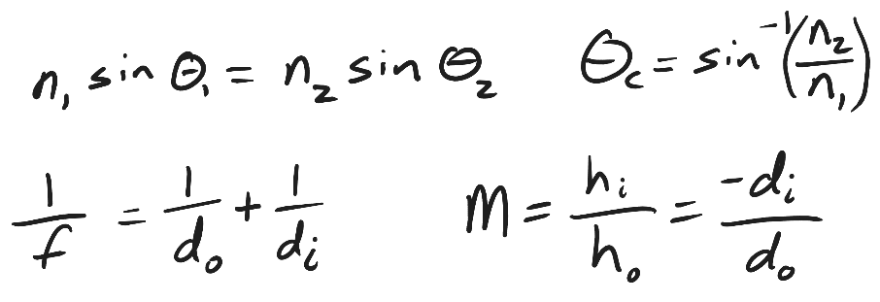
1. Substance A (n = 1.3) is separated from substance B (n = 2.5) by a flat plane. A ray of light travels from substance A to substance B, meeting the planar boundary between the substances at a 22° angle of incidence.

- Sketch a simple diagram showing the ray refracting as it travels from substance A to substance B.
- On your sketch, label the normal, the angle of incidence, and the angle of refraction. Calculate the angle of refraction and add that number to your diagram.
- On another part of your diagram (or in a new diagram) show a ray of light with an angle of incidence equal to its critical angle. Calculate and label the critical angle, $θ_{c}$. Draw what happens to the ray when it hits the boundary between the two substances.

2. A thin convex lens has a focal length of 5cm. An object 1cm tall is placed on the lens’ principal axis, at a distance of 2cm from the center of the lens.
- Is the object’s image real or virtual?
- Is the image upright or inverted?
- What is the distance of the image from the lens?
- What is the height of the image?
- What is the magnification (M) of the object in this situation?
- Optional -- Sketch or draw a ray diagram to confirm your answers.

3. The same object (1cm tall) is placed on the principal axis of a convex lens with f = 3cm, at a distance of 9 cm from the center of the lens.
- Is the object’s image real or virtual?
- Is the image upright or inverted?
- What is the distance of the image from the lens?
- What is the height of the image?
- What is the magnification (M) of the object in this situation?
- Optional – Sketch or draw a ray diagram to confirm your answers.

