Physics 200 (Stapleton) Name: ______________________________
Practice Quiz --Optics

Index of Refraction Table
Vacuum | Air | Water | Glycerin | Lead Sulfide
1.000000 | 1.0003 | 1.33 | 1.47 | 3.91

Multiple Choice: 1 point each

1. The speed of light will be the slowest in

A. Lead sulfide B. Glycerin C. Water D. air E. a vacuum

2. When the incident angle θ_{i} = θ_{critical}, which of the following is not true?

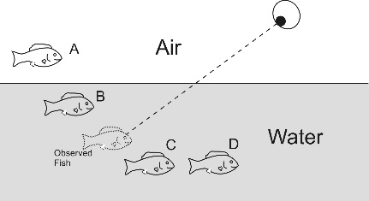
A. sin θ_{r} = 1 B. n_{i} > n_{r} C. θ_{r} = 90º D. sin θ_{i} = 1

3. The diagram on the right shows an eyeball observing a fish. The “observed” fish shows the position where the fish appears to be to the observer. Which fish is the actual fish?

A. Fish A B. Fish B C. Fish C D. Fish D

4. In which situation can total internal reflection not occur? When light travels from…

A. water into gylcerin B. lead sulfide into glycerin

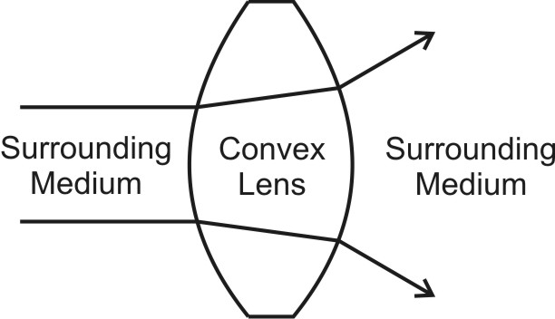
C. glycerin into water D. water into air

5. In which of the following situations could a convex lens act as a diverging lens, as shown on the right?
A. If the lens’ n is greater than the n of the surrounding medium
B. If the lens’ n is less than the n of the surrounding medium
C. Never. This cannot happen.

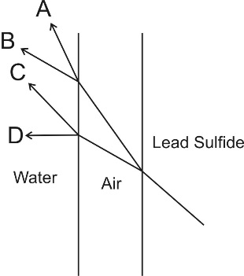

6. A ray of light passes from lead sulfide into air and then into water, at the angles shown in the diagram. Which letter represents the final path followed by the light ray? Assume all incident angles are less than the critical angle.

A. Path A B. Path B C. Path C D. Path D

Problems: 2 points each

1. Find the speed of light in water.

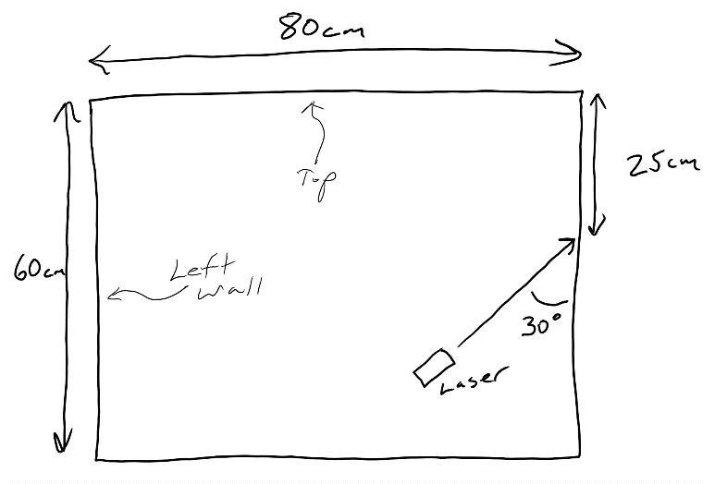

2. What is the incident angle for a light beam passing from air into water if the refracted angle is 20.0º?

3. Find the critical angle for a ray of light leaving glycerin and entering air.

4. A laser is fired as shown in mirror-lined rectangular box. How far from the top of the box will the mirror hit the box’s left wall?

