Physics 200 Name: __________________________________
Practice Test – Newton’s Laws in 2-D
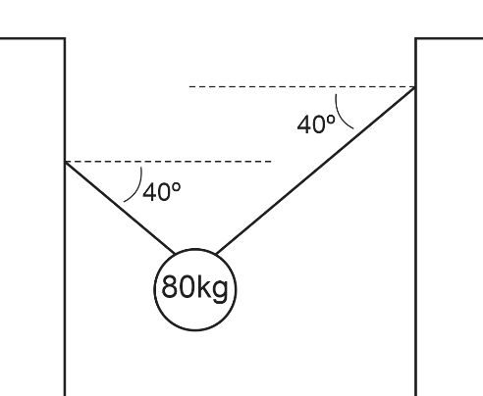

For each problem, enter the missing information into the table.

1. Two segments of rope are supporting an object. Segments are angled at the same angle, relative to horizontal.

Description | Magnitude | Units | Direction
Both Angles | 40 | degrees | relative to horizontal
Mass of object | 80 | kg | NA
Weight of hanging object
Vertical component of tension in the left string
Tension of left string
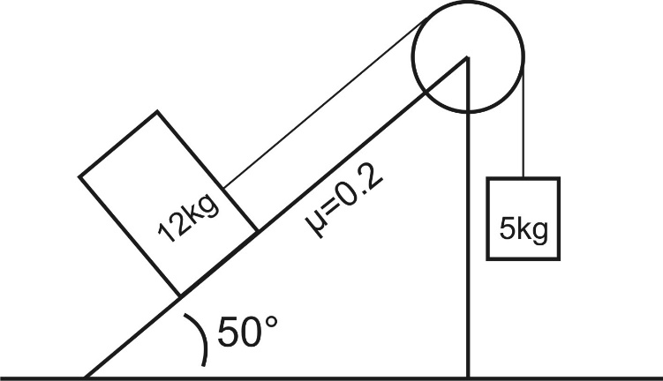

2. A sliding mass on an incline is connected via a string and pulley to a hanging mass. µ_{k} is given.

Description | Magnitude | Units | Direction
Angle of incline to horizontal (degrees) | 50 | degrees | Above rightward
Sliding mass (kg) | 12 | kg | NA
Hanging mass (kg) | 5 | Kg | NA
Coefficient of friction | 0.2 | NA | NA
Weight of sliding mass (N)
Perpendicular Component of sliding object weight (N)
Parallel Component of sliding object weight (N)
Weight of hanging object (N)
Normal Force acting on sliding object (N)
Friction (N)
Net Force (N)
Acceleration (N)
String Tension (N)
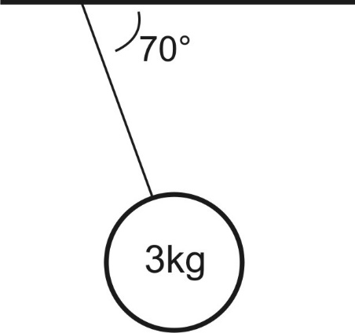
3. An object is hanging by a rope from the ceiling of a train car. The train car is enclosed, so there is no drag force acting on the object. The rope makes a constant angle with the horizontal ceiling.

Description | Magnitude | Units | Direction
Mass (kg) | 3 | kg | NA
Angle between rope and horizontal ceiling (degrees) | 70 | degrees | 70 degrees below rightward
Weight of hanging object (N)
Vertical component of tension (N)
Tension (N)
Horizontal Component of tension (N)
Acceleration of Hanging Object (N)

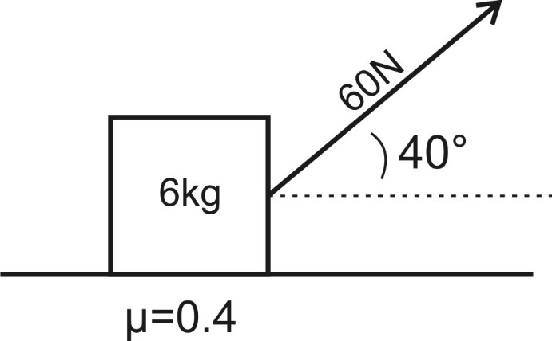
4. A sliding box is being pulled by a rope. The rope extends to the right of the mass at an upward angle, relative to horizontal. The box slides horizontally to the right.

Description | Magnitude | Units | Direction
Box Mass | 6 | kg | NA
Angle of rope | 40 | degrees | Above rightward
Coefficient of Kinetic Friction | 0.4 | NA | NA
Force applied by rope | 60 | N | 40 degrees above rightward
Box Weight
Y component of Rope Pulling Force
X component of Rope Pulling Force
Normal Force of surface against box
Friction
Net Force acting on Box
Box Acceleration

