Physics 200 Name: __________________________________
Newton’s Laws in 2 Dimensions
Bodies on Inclines

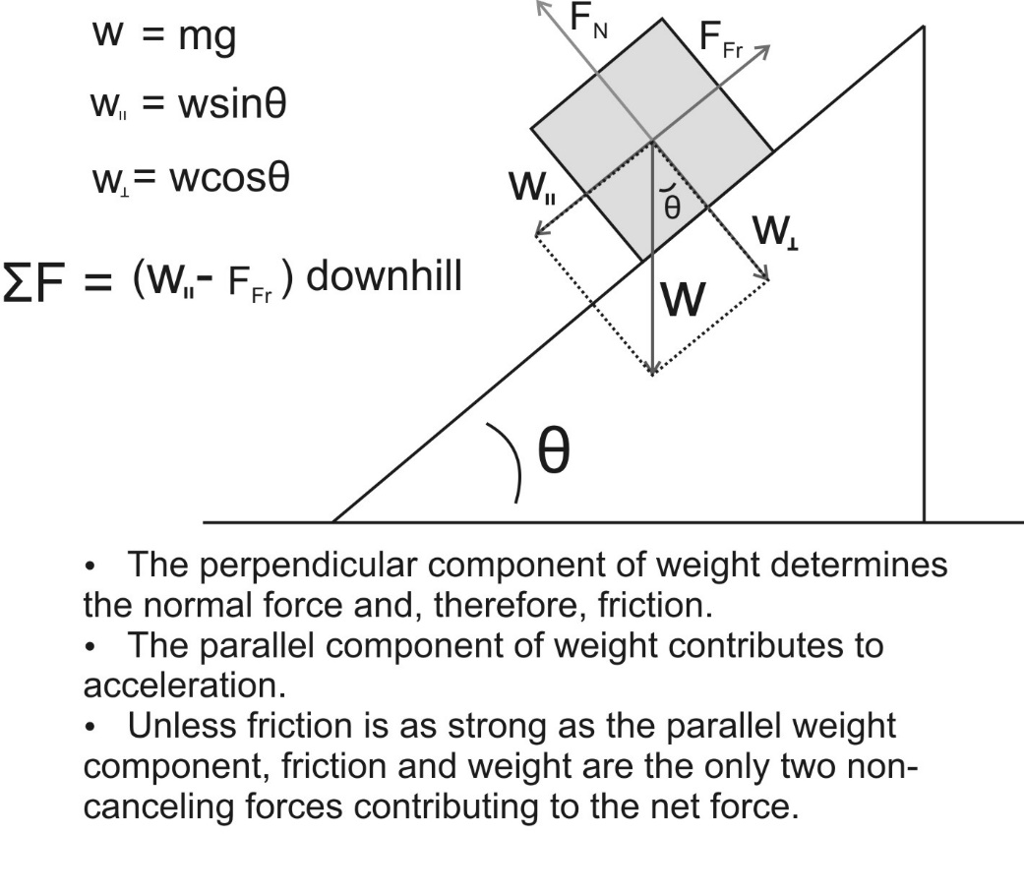
Practice Problem: Fill in the remaining cells in the table below.

Item | Direction (When applicable) | Magnitude
coefficient of friction | NA | 0.4
θ (degrees) | NA | 30
Mass of object (kg) | NA | 2
Weight of object (N)
Perpendicular Weight Component (N)
Parallel Weight Component (N)
Normal force (N)
Force of Friction ( N)
Net force on object (N)
Acceleration (m/s²)

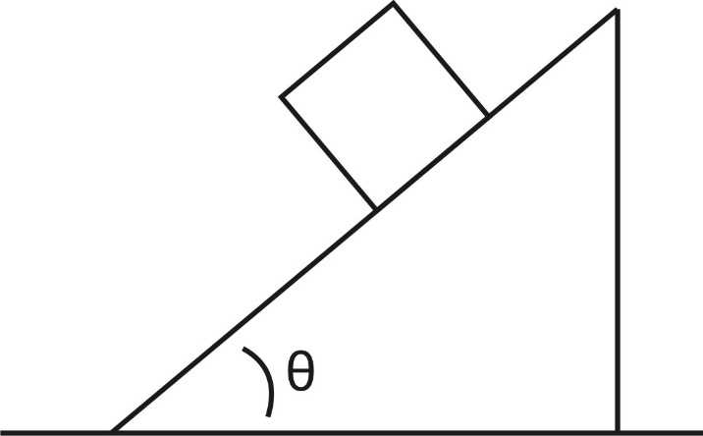
1a. The figure to the right shows a block on an incline. Draw and label the forces acting on the block. Resolve weight into perpendicular and parallel components, relative to the surface.

1b. Fill in the table below for the block on the ramp.

Item | Direction (When applicable) | Magnitude
coefficient of friction | NA | .6
θ (degrees) | NA | 60
Mass of object (kg) | NA | 2
Weight of object (N)
Perpendicular Weight Component (N)
Parallel Weight Component (N)
Normal force (N)
Force of Friction ( N)
Net force on object (N)
Acceleration (m/s²)

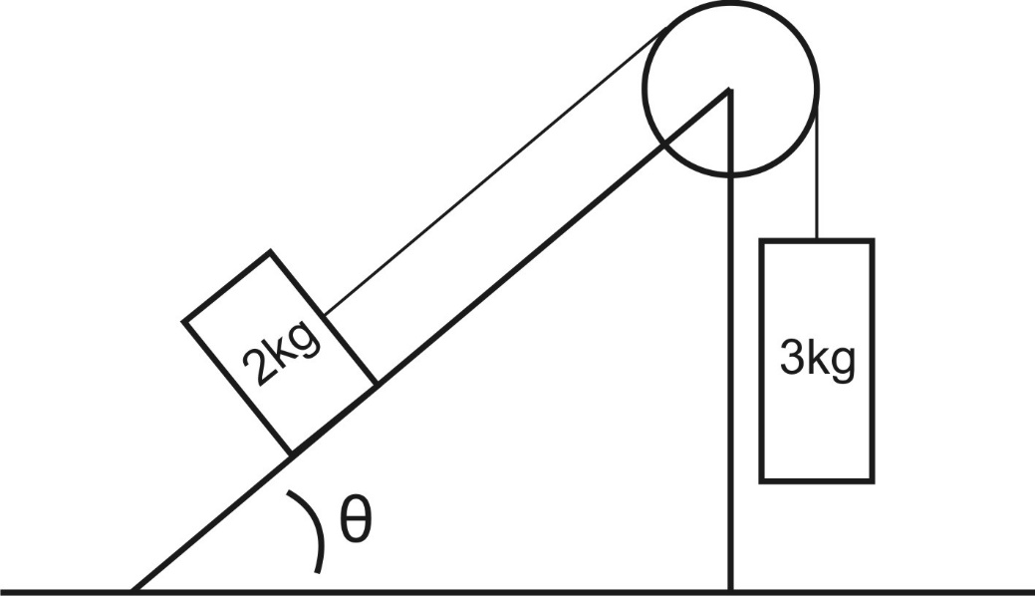
2. Fill out the table for the 2kg block. Then find the masses’ accelerations and the tension in the string.

a = _____________

Tension = _____________

.

Item | Direction (When applicable) | Magnitude
coefficient of friction | NA | 0.5
θ (degrees) | NA | 70
Mass of object (kg) | NA | 2
Weight of object (N)
Perpendicular Weight Component (N)
Parallel Weight Component (N)
Normal force (N)
Force of Friction ( N)

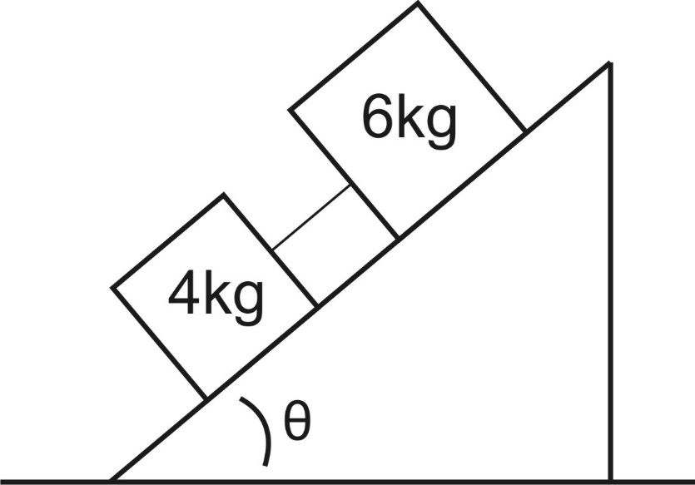
3. In the diagram, the 6kg block has a µ_{k} of 0.5, but the 4kg block is frictionless. Fill in the tables. Then find the accelerations of the blocks and the tension in the string.

a = _____________

Tension = _____________

Item | Direction (When applicable) | Magnitude
coefficient of friction | NA | 0
θ (degrees) | NA | 50
Mass of object (kg) | NA | 4
Weight of object (N)
Perpendicular Weight Component (N)
Parallel Weight Component (N)
Normal force (N)
Force of Friction ( N)
Item | Direction (When applicable) | Magnitude
coefficient of friction | NA | 0.4
θ (degrees) | NA | 50
Mass of object (kg) | NA | 6
Weight of object (N)
Perpendicular Weight Component (N)
Parallel Weight Component (N)
Normal force (N)
Force of Friction ( N)

