Physics 200 Name: __________________________________
Newton’s Laws in 2 Dimensions
Bodies on Inclines

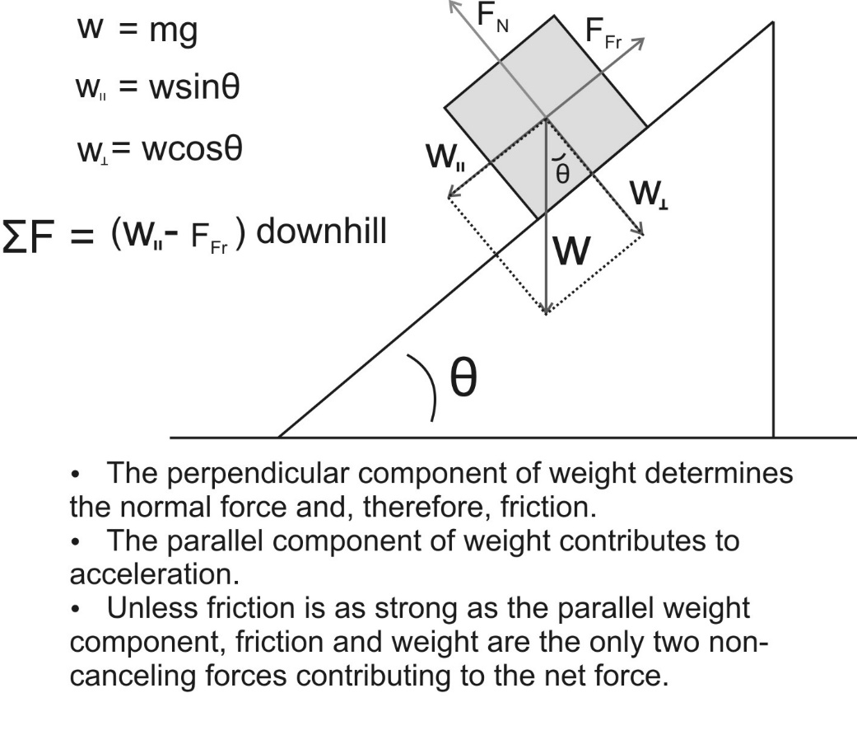
Practice Problem: Fill in the remaining cells in the table below.

Item | Direction (When applicable) | Magnitude
coefficient of friction | NA | 0.4
θ (degrees) | NA | 30
Mass of object (kg) | NA | 2
Weight of object (N)
Perpendicular Weight Component (N)
Parallel Weight Component (N)
Normal force (N)
Force of Friction ( N)
Net force on object (N)
Acceleration (m/s²)

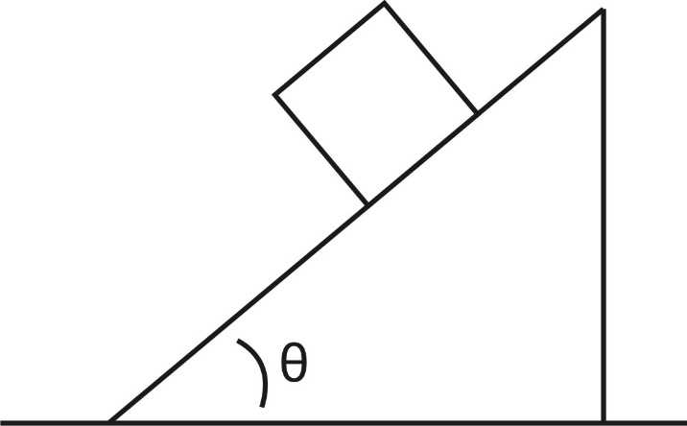
1a. The figure to the right shows a block on an incline. Draw and label the forces acting on the block. Resolve weight into perpendicular and parallel components, relative to the surface.

1b. Fill in the table below for the block on the ramp The block is the “item.”

Item | Direction (When applicable) | Magnitude
coefficient of friction | NA | .6
θ (degrees) | NA | 60
Mass of object (kg) | NA | 2
Weight of object (N)
Perpendicular Weight Component (N)
Parallel Weight Component (N)
Normal force (N)
Force of Friction ( N)
Net force on object (N)
Acceleration (m/s²)

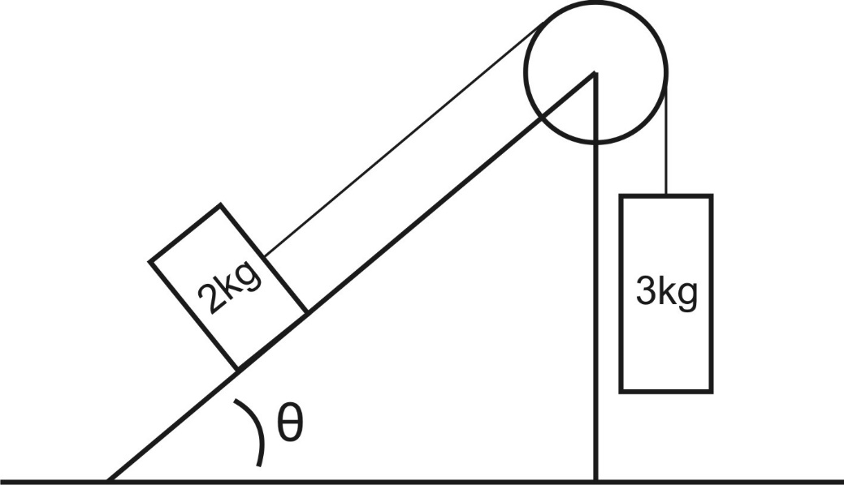
2. Fill out the table for the 2kg block. Then find the masses’ accelerations and the tension in the string.

a = _____________

Tension = _____________

.

Item (2kg block) | Direction (When applicable) | Magnitude
coefficient of friction | NA | 0.5
θ (degrees) | NA | 70
Mass of object (kg) | NA | 2
Weight of object (N)
Perpendicular Weight Component (N)
Parallel Weight Component (N)
Normal force (N)
Force of Friction ( N)

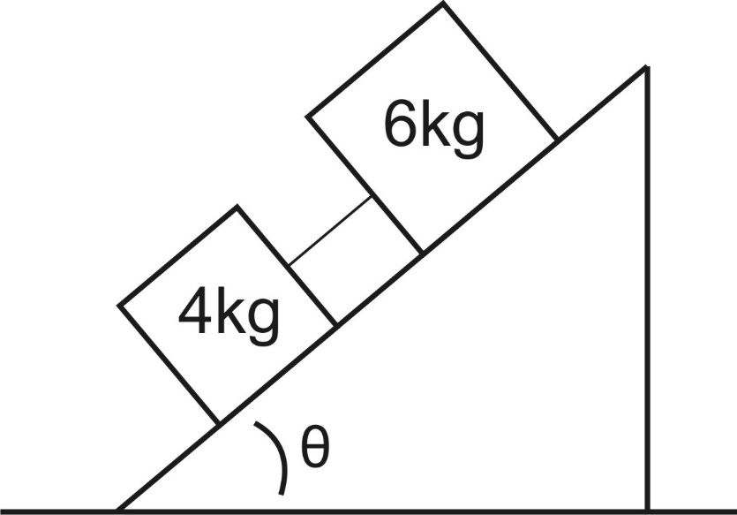
3. In the diagram, the 6kg block has a µ_{k} of 0.5, but the 4kg block is frictionless. Fill in the tables. Then find the accelerations of the blocks and the tension in the string.

a = _____________

Tension = _____________

Item (4kg block) | Direction (When applicable) | Magnitude
coefficient of friction | NA | 0
θ (degrees) | NA | 50
Mass of object (kg) | NA | 4
Weight of object (N)
Perpendicular Weight Component (N)
Parallel Weight Component (N)
Normal force (N)
Force of Friction ( N)
Item (6kg block) | Direction (When applicable) | Magnitude
coefficient of friction | NA | 0.4
θ (degrees) | NA | 50
Mass of object (kg) | NA | 6
Weight of object (N)
Perpendicular Weight Component (N)
Parallel Weight Component (N)
Normal force (N)
Force of Friction ( N)

Physics 200 Name: _________________________
Masses Hanging and Dragged at Angles – Newton’s Laws in 2 Dimensions
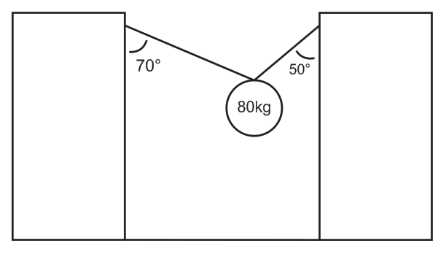
1. The 80kg mass is in static equilibrium. Find the tensions in the two segments of rope.

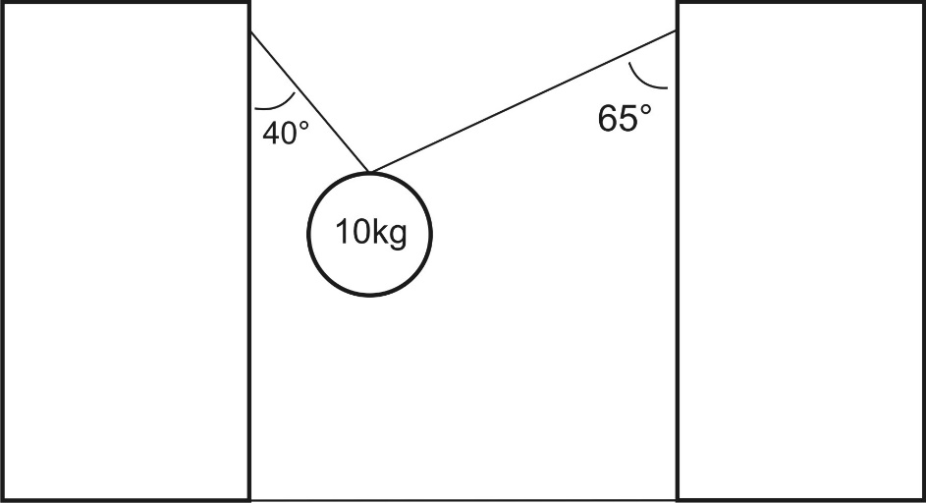
2. The 10kg mass is in static equilibrium. Find the tensions in the two segments of rope.
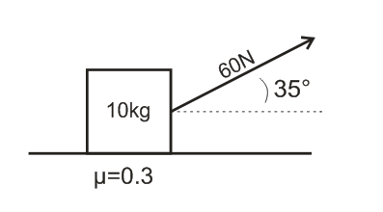
3. A 10kg mass is being accelerated horizontally by the tension in a rope that is attached to the mass as shown. Find the acceleration of the 10 kg mass.

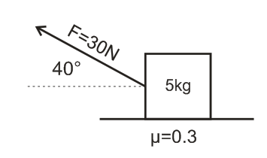
4. A 5kg mass is being accelerated horizontally by the tension in a rope that is attached to the mass as shown. Find the acceleration of the 8kg mass.

Physics 200 Name: __________________________________
Last Year's Test Retake – Newton’s Laws in 2-D
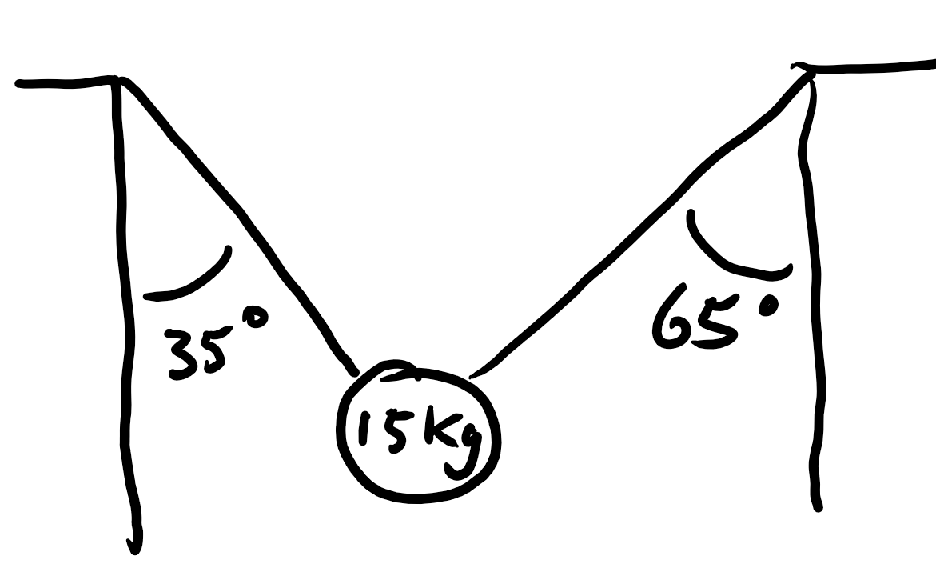

For each problem, enter the correct answers into the table. Note that only the yellow (shaded, if black and white) cells will be graded (except on #1, where you may receive partial credit for the blank cells.)

1. Two segments of rope are supporting an object. Segments are angled at the same angle, relative to horizontal. Find the object’s weight and the tensions in the two ropes (yellow cells). You may receive partial credit for correctly entering the blue terms -- but you will not lose points if they are wrong.

Description | Magnitude | Units | Direction
Rope 1 Angle (relative to vertical) | 35 | degrees | Right of downward
Rope 2 Angle (relative to vertical) | 65 | degrees | Left of downward
Hanging Mass | 15 | kg | NA
T_{1x} (in terms of T₁ -- tension in Rope 1) |  | T₁ | Leftward
T_{1y} (in terms of T₁) |  | T₁ | Upward
T_{2x} (in terms of T₂) |  | T₂ | Rightward
T_{2y} (in terms of T₂) |  | T₂ | Upward
T₁ (in terms of T₂) |  | T₂ | Along String
Weight of the hanging mass |  | N | Downward
T₂ (tension in Rope 2) |  | N | Along String
T₁ (tension in Rope 1) |  | N | Along string

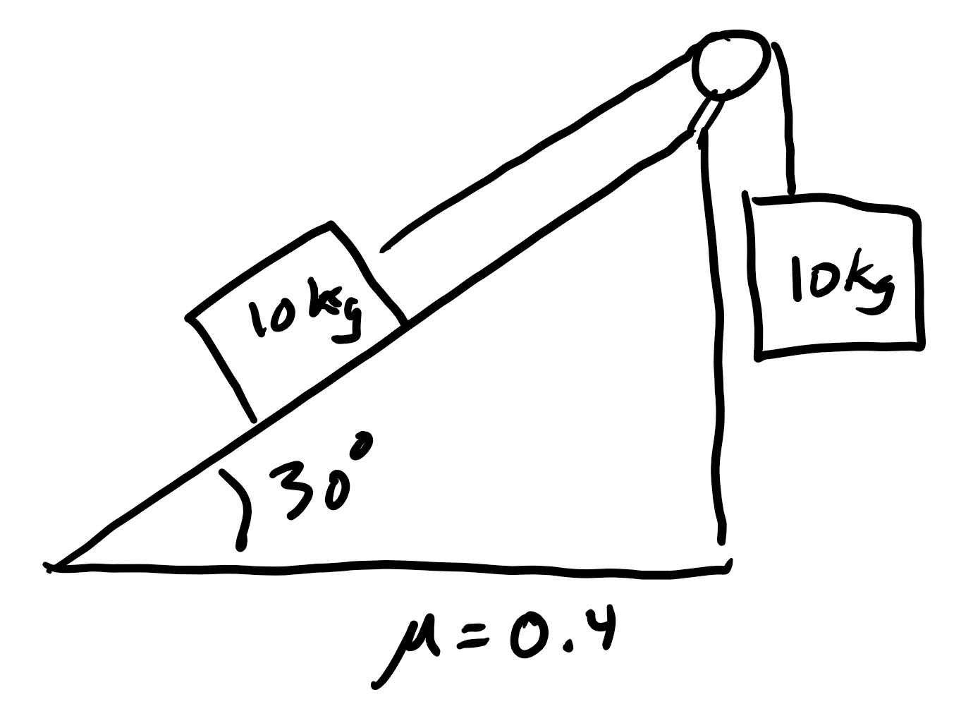
2. A sliding mass on an incline is connected via a string and pulley to a hanging mass. µ_{k} is given.

Description | Magnitude | Units | Direction
Angle of incline to horizontal | 30.00 | degrees | Above rightward
Sliding mass | 10.00 | kg | NA
Hanging mass | 10.00 | kg | NA
Coefficient of friction | 0.40 | NA | NA
Weight of sliding mass
Perpendicular Component of sliding object weight
Parallel Component of sliding object weight
Weight of hanging object
Normal Force acting on sliding object
Friction
Net Force
Acceleration
String Tension

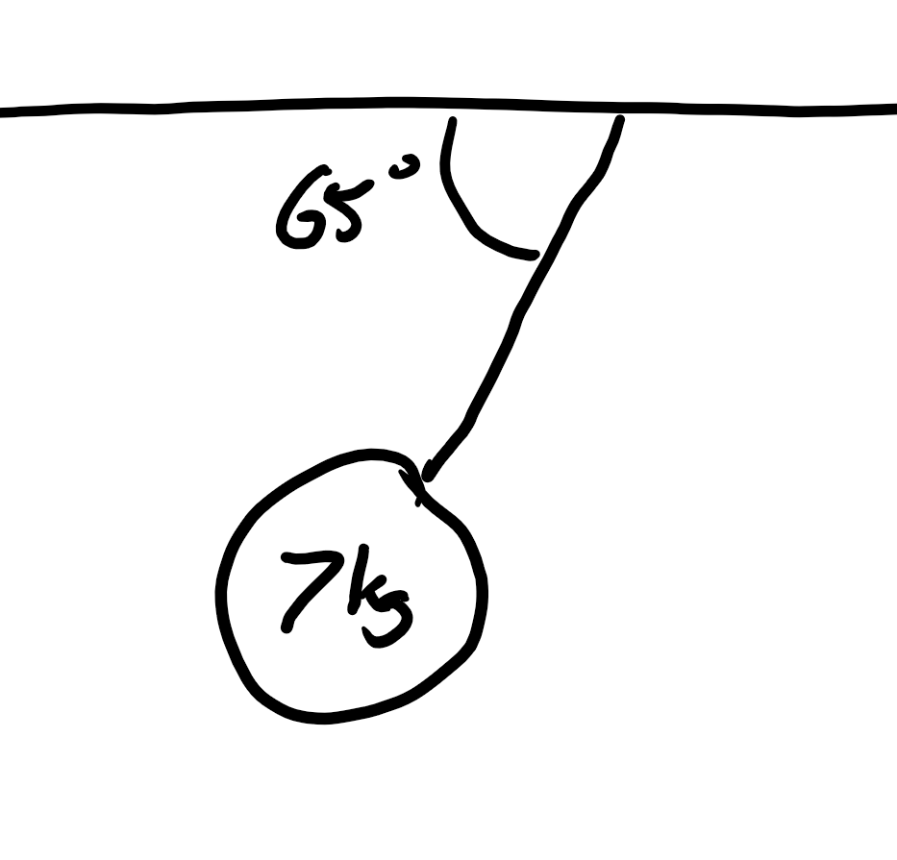
3. An object is hanging by a rope from the ceiling of a train car. The rope makes a constant angle with the horizontal ceiling.

Description | Magnitude | Units | Direction
Mass | 7 | kg | NA
Angle between rope and horizontal ceiling | 65 | degrees | below leftward
Weight of hanging object
Vertical component of tension
Tension
Horizontal Component of tension
Acceleration of Hanging Object

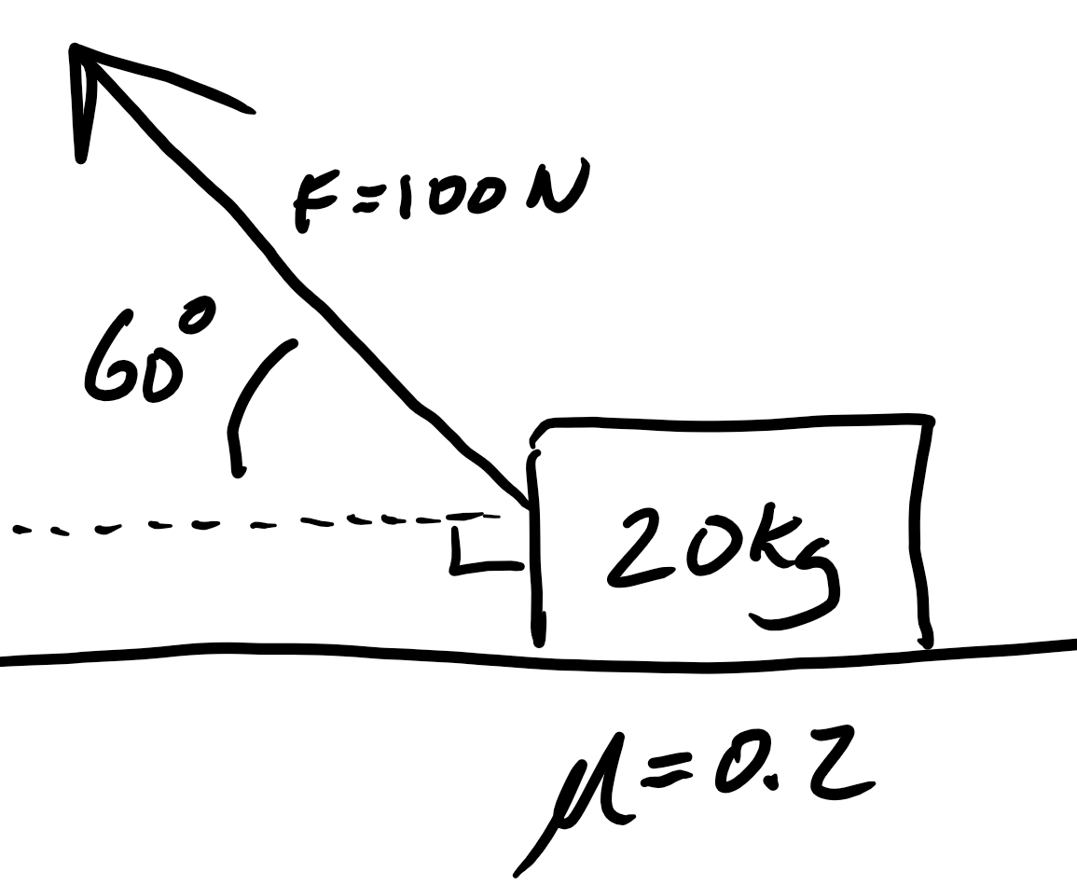
4. A sliding box is being pulled by a rope. The rope extends to the right of the mass at an upward angle, relative to horizontal. The box slides to the right.

Description | Magnitude | Units | Direction
Box Mass | 20 | kg | NA
Angle of rope | 60 | degrees | Above leftward
Coefficient of Kinetic Friction | 0.2 | NA | NA
Force applied by rope | 100 | N | 60 degrees above leftward
Box Weight
Y component of Rope Pulling Force
X component of Rope Pulling Force
Normal Force of surface against box
Friction
Net Force acting on Box
Box Acceleration

Practice Test #2 – Newton’s Laws in 2-D
