Newton Sled Activity Names: _____________________________________________________
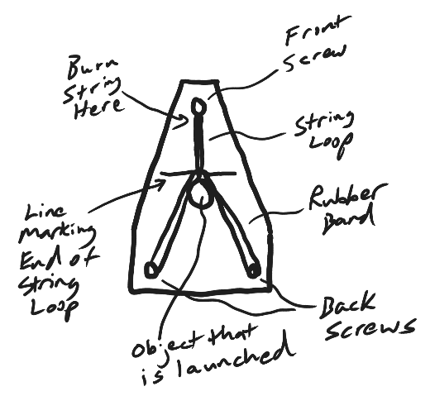
Directions:
Launch all of the items below by burning loops of string to release the stretched rubber bands. Use the same number of rubber bands every time. Make a reference mark so that you can stretch the rubber bands the same distance every time. In general, make sure that every launch happens in the same way. The only manipulated variable should be the object that is launched. Fill out the data table as you go. Then answer the questions. When you complete the launch of the Earth, collect the additional data below.

Object Launched | Sled travel distance (m) -- **ACTUALLY MEASURE THIS!** | Launched Object travel distance (or subjective description of its speed)
200g mass
500g mass
Ping pong ball
Entire Earth

- When the ping pong ball is launched, what gets pushed with a greater force, the sled or the ping-pong ball? Explain your reasoning.

- When the entire Earth is launched, what gets pushed with a greater force, the sled or the Earth? Explain how you can tell.

- Out of all of the items that you launched, which one experienced the most force? ___________________

Which one experienced the least force? __________________

How can you tell?

If everything is the same except for the masses, why are the forces different?

- F_{net}=ma helps explain the relationship between objects’ masses and their accelerations, and one major goal of this activity is to see that relationship. Describe an example from this activity and explain how it demonstrates that relationship.

- Newton’s 1st Law uses the term “unbalanced.” It says that “objects in motion remain in motion, in a straight line and at a constant speed, and objects at rest stay at rest, unless acted upon by an unbalanced (net) force.”
    - Considering the entire time interval spanning before, during, and after an object’s launch, when are the forces on the object balanced, and when are they unbalanced?

    - For each of these times, explain how you can tell.

- Use the knowledge that the Earth’s mass is 5.972x10²⁴kg, along with data from your Earth launch to perform the calculations below. Note that this represents a tricky sequence of problems. You should probably work on a separate sheet of paper.
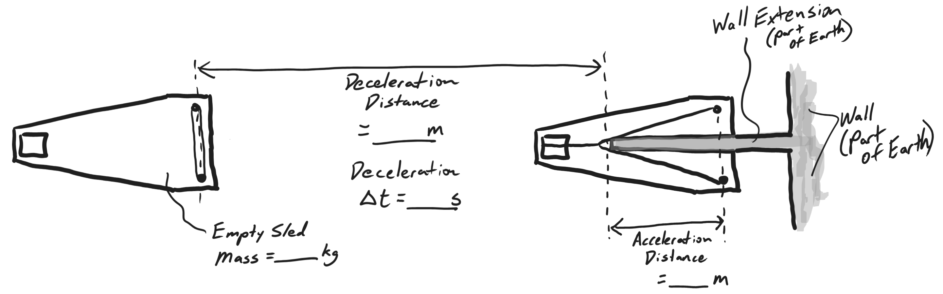

  - Calculate the acceleration of the sled during the Earth launch deceleration period.

a_{deceleration} = __________

  - Calculate the force of friction exerted on the sled by the floor. Assume that the force of friction is constant, and that it is equal during the acceleration and deceleration periods.

F_{friction} = _________

  - Calculate the accelerations of the sled and the Earth during the Earth launch acceleration period.

a_{acceleration of sled} = _________ a_{acceleration of Earth} = __________________

  - Calculate the distance moved by the Earth during the Earth launch acceleration period.

Δx_{Earth} = _________

