Physics 200 (Stapleton) Name: _________________________
Newton’s Laws in 1 Dimension
Notes: 1st and 2nd Laws

Net force (F_{net}):
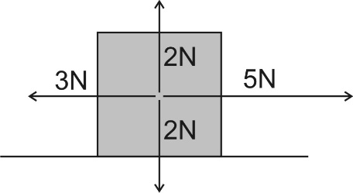

What is the net force that is acting on the box to the right?

Normal Force:

Newton’s 1st Law:

- Usual version: Objects in motion remain in motion in a straight line and at a constant speed, and objects at rest stay at rest, unless they are acted upon by an outside (or unbalanced) force.

- Simpler version:

If there is no net force acting on an object (i.e. any applied forces are balanced), what might that object be doing? What are the options?

What are the options for what an object might be doing if there is a net force acting on an object?

Newton's 1st Law is called the "Law of Inertia." Inertia is:

What kinds of objects have the most inertia?

The basic metric unit of force is the ______________. 1 ______ ≈ 0.224 pounds.

Newton's 2nd Law:

Mass:

The unit we will use for Mass = ________________________, which is abbreviated _________

On Earth, a 1kg mass weighs about 9.8 Newtons or about 2.2 pounds.

Weight:

Primary strategy for solving problems in this unit:

1.

2.

3.

Calculating forces using Newton's 2nd law:

1. A 91N net force is applied to an object. If the object accelerates at a rate of 8m/s², what is the object’s mass?

2. A 1,200kg car is being acted upon by two forces. The car’s motor is providing a 1,000N rightward force, and friction is providing a 300N leftward force. What is the car’s acceleration?

3. A bowling ball is sitting motionless on the ground. The ground is applying a 49N upward force to the bowling ball. What is the bowling ball’s mass?

Practice with Forces in 1 Dimension
(up & down, left & right)

Conceptual Questions
1. If the acceleration of an object is zero, does this mean that no forces acting on it? Explain.

2. In the absence of air resistance, all objects fall at the same rate. The force of gravity on a 2-kg rock is twice as great as that on a 1-kg rock. Why then doesn’t the heavier rock fall faster?

3. When an object falls freely under the influence of gravity there is a net force mg exerted on it by the Earth. Yet by Newton’s third law the object exerts an equal and opposite force on the Earth. Why doesn’t the Earth move?

4. According to Newton’s third law, each team in a tug of war pulls with equal force on the other team. What, then, determines which team will win?

Problems
1. (I) What force is needed to accelerate a child on a sled at

2. (I) A net force of 265 N accelerates a bike and rider at What is the mass of the bike and rider together?

3. (I) What is the weight of a 76-kg astronaut (a) on Earth, (b) on the Moon (c) on Mars (d) in outer space traveling with constant velocity?

4. (II) What average force is required to stop an 1100-kg car in 8.0 s if the car is traveling at

5. (II) A 0.140-kg baseball traveling strikes the catcher’s mitt, which, in bringing the ball to rest, recoils backward 11.0 cm. What was the average force applied by the ball on the glove?

6. (II) How much tension must a rope withstand if it is used to accelerate a 1200-kg car vertically upward at

7. (II) An elevator (mass 4850 kg) is to be designed so that the maximum acceleration is 0.0680g. What are the maximum and minimum forces the motor should exert on the supporting cable?

8. (II) A 75-kg petty thief wants to escape from a third-story jail window. Unfortunately, a makeshift rope made of sheets tied together can support a mass of only 58 kg. How might the thief use this “rope” to escape? Give a quantitative answer.

9. (II) A person stands on a bathroom scale in a motionless elevator. When the elevator begins to move, the scale briefly reads only 0.75 of the person’s regular weight. Calculate the acceleration of the elevator, and find the direction of acceleration.

10. (I) If the coefficient of kinetic friction between a 35-kg crate and the floor is 0.30, what horizontal force is required to move the crate at a steady speed across the floor? What horizontal force is required if is zero?

11. (I) A force of 48.0 N is required to start a 5.0-kg box moving across a horizontal concrete floor. (a) What is the coefficient of static friction between the box and the floor? (b) If the 48.0-N force continues, the box accelerates at What is the coefficient of kinetic friction?

12. (I) Suppose that you are standing on a train accelerating at 0.20g. What minimum coefficient of static friction must exist between your feet and the floor if you are not to slide?

13. (II) Drag-race tires in contact with an asphalt surface have a very high coefficient of static friction. Assuming a constant acceleration and no slipping of tires, estimate the coefficient of static friction needed for a drag racer to cover 1.0 km in 12 s, starting from rest.

14. (II) A box is given a push so that it slides across the floor. How far will it go, given that the coefficient of kinetic friction is 0.20 and the push imparts an initial speed of

Notes - 4.4 Newton’s Third Law of Motion: Symmetry in Forces

1. State Newton’s 3rd Law of Motion.

2. Forces always occur in pairs, and one body cannot exert a force on another without ____________________. This is sometimes referred to as action-_____________.

3. Consider the swimmer pushing off from the side of a pool in Figure 4.9. She pushes against the pool wall with her feet and accelerates in the direction opposite to that of her push. The wall has exerted an equal and opposite force back on the swimmer. Why does the swimmer accelerate? Don’t these two forces cancel each other out?

4. Describe some other examples of Newton’s 3rd Law.

Walking:

Car:

Helicopter:

5. Rockets
A. What is the common misconception regarding rocket propulsion? What is the reality?

B. What observation disproves this misconception?

Notes – 5.1 Friction

1. What is friction?

2. When there is relative motion between objects in contact, the friction is called _____________ friction. Its symbol is ______.

3. When there is no motion between objects in contact, the friction is called _____________ friction. Its symbol is ______.

4. The harder two objects are pushed together, the _________________ the friction becomes.

5. Write the equation for the magnitude of static friction.

6. Write the equation for the magnitude of kinetic friction.

7. Looking at Table 5.1, which coefficient of friction is greater, static or kinetic?

8. From Table 5.1, give the three highest examples of the coefficient of static friction.

9. From Table 5.1, give the three lowest examples of the coefficient of kinetic friction.

10. A skier is sliding along a horizontal field of snow If the overall of mass of the skier plus her skis is 62kg, and if she is experiencing a 30N force of friction, what is the coefficient of friction between the skis and the snow? Is this static or kinetic friction?

Notes, Ch. 4.5: Normal, Tension, and Other Examples of Forces

1. What is tension?

2. In our physics problems, almost all of the ropes, chains, wires, cables, or strings will be massless. In massless objects such as these the force of tension at every point is
_____________. We know this because of Newton’s __________ law.

Analyzing Multibody Systems (and writing net force equations for those systems)

3. What is a “system, in Physics?

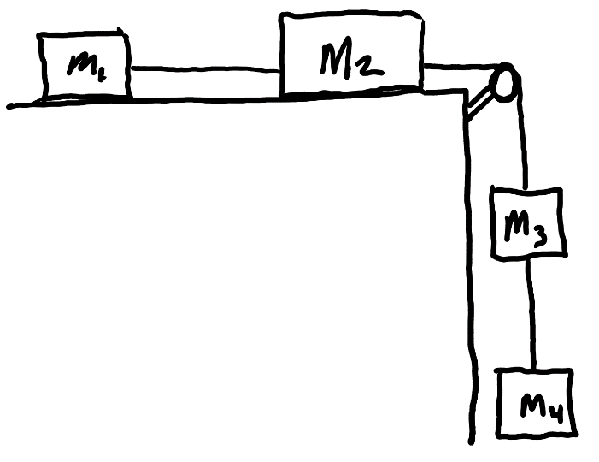
4. The diagram on the right represents blocks of matter that are connected by a massless string. The pulley and the air are frictionless, but there is friction between the surface and the blocks.
- Draw several (or possibly all) of the individual systems that you can find in the diagram.
- For each system, write equations for net force in terms of:
  - The sum of individual forces
  - Newton’s 2nd Law

Continue…
Multibody Drill A

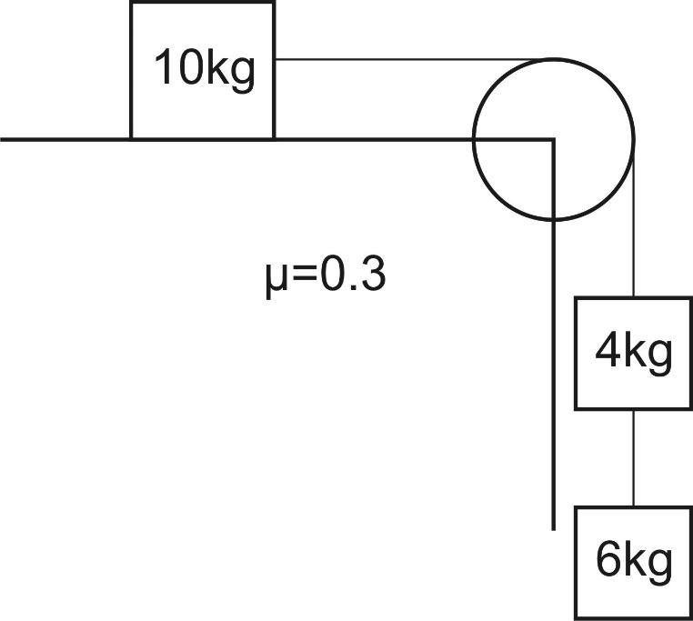
Practice) Find the accelerations and tensions of the ropes on the right.

1) Find the acceleration and the tension in the rope between the 2 masses. Assume μ = 0.

5 kg
15 kg

F =100

2) Repeat if μ = 0.2.

3) Find the acceleration and the tension in the rope between the 2 masses.
1 kg
3 kg
F =30 N

4) Find the force required to accelerate the 2 masses at a rate of +2.5 m/s².

5) Find the acceleration and the tension in the 2 ropes if the surface is frictionless.
3.5 kg
3.0 kg
2.0 kg

6) Repeat if the coefficient of kinetic friction is 0.10

Ch. 5.1 Notes: Drag and Terminal Velocity

1. Drag force:

2. Drag force equation:

3. Draw diagrams showing all of the forces acting on a skydiver in 3 different situations: negative acceleration, zero acceleration, and positive acceleration,

4. When a falling skydiver’s net force and acceleration are zero, she or he is said to

be at ______________________.

5. Use the drag formula an equation for the terminal velocity of a skydiver.

6. The table below describes the experience of a skydiver who steps out of a stationary helicopter. Create a reasonable acceleration graph portraying this sequence of events. Note the skydiver’s velocities at various points.

Sequence | Event
1 | Skydiver steps off of helicopter
2 | Skydiver reaches a terminal velocity of -40m/s
3 | Skydiver pulls chute cord. Parachute deploys.
4 | Skydiver reaches a new terminal velocity of -4m/s
5 | Skydiver feet touch down
6 | Skydiver comes to rest

***Important note – Since F_{net} = ma, acceleration is proportional to F_{net.} So, this is essentially a graph of net force vs time.**
Conceptual Practice with Drag:
1. Consider a golf ball that is being dropped by an astronaut who is standing on the Moon. Gravity causes the ball the fall to the Moon’s surface. Describe the action and reaction forces that are involved as the ball is falling toward the moon’s surface.

Action:

Reaction:

2. You’re floating freely in outer space, and you have two seemingly identical boxes – box A and box B. Although the boxes look the same, one has much more mass than the other. Describe a test you could conduct in order to figure out which box has more mass, and explain how the results of the test would be different for the two boxes.

3. A small child and a team of Austrian weightlifters are fighting over a sturdy (though massless) scarf. The child is pulling on one end, and the weightlifters are pulling on the other end. Neither side will let go. As you might expect, the child is being taken for quite a ride. Which end of the scarf has the most tension? Explain why.

4. A 100 kg human is standing on a barge in the absence of air resistance. The barge is accelerating to our right at a rate of 2m/s² and the person is accelerating along with it. Draw all of the individual forces that are acting on the human. Use arrows to show the direction of each force. Label each arrow with an appropriate name of the force, the correct magnitude of the force, and the correct units.

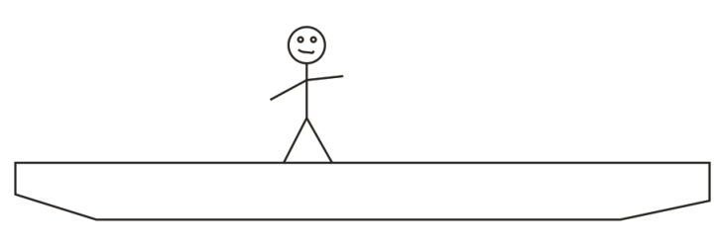

5. A 10kg watermelon is dropped out of an airplane without a parachute. Use the timetable to fill out the empty cells in the second data table below. Don’t forget correct signs and units. The mass and weight columns will not be graded, but you might find them to be helpful.

5. A 10kg watermelon is dropped out of an airplane without a parachute. Use the timetable to fill out the empty cells in the second data table below. Don’t forget correct signs and units. The mass and weight columns will not be graded, but you might find them to be helpful.

Time | Event
0s | Watermelon is dropped out of plane
20s | Watermelon reaches terminal velocity of -100m/s
500s | Watermelon hits the Earth

Time | Watermelon Mass [not graded] | Watermelon Weight [not graded] | Force of Drag on melon | Net Force acting on melon | Melon Acceleration | Melon Velocity
0s
15s |  |  | 90N |  |  | -80 m/s
80s

Physics 200 (Stapleton) Name: __________________________
Newton’s Laws in 1-D 20-21 Practice Problems

For each of these problems, draw a diagram showing all of the forces acting on the bold object. Label each force with its value and name. If this does not answer the question, continue to solve the stated problem.

1. A 20kg rock is hanging from a rope. If the tension in the rope is 120N, what is the acceleration of the rock?

2. [requires two separate diagrams – one for motionless elevator; one for accelerating elevator]
A child stands on a bathroom scale in a motionless elevator, and the scale reads 200N. What will the scale read if the elevator accelerates upward at 1.3m/s² (assuming that the child continues standing on the scale)?

3. A rocket accelerates directly upward at a constant rate. It starts from rest and ascends the first 20m in 3 seconds. An astronaut is standing in the rocket and accelerating along with it. If the rocket pushes against the astronaut with a force of 855N during this time period, what is the astronaut’s mass?

4. A 70kg scout is standing in a canoe, while the canoe travels leftward at a rate of 4m/s. A paddler brings the canoe (and, therefore, the scout) to a stop over a distance of 15m. What force is applied to the scout during this time period?

5. What horizontal force does Bev need to apply to a 6kg block in order to accelerate the block at a rate of -3m/s², if µ_{k} = 0.35?

6. If Bev must apply a 15N horizontal force to a 6kg block in order to move the block at a constant speed of 6m/s, what is µ_{k}?

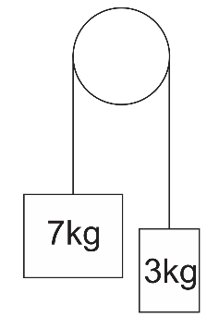
7. Some runners are racing on an extremely slippery floor (µ_{s} = 0.015). Starting from rest, what is the shortest amount of time in which one of the runners can run a distance of 10m?

8. For the diagram on the right, find the tension in the string and the acceleration of each mass.

9. For the diagram below, find the accelerations of the masse and the tension in each string. Note that µ_{k} = 0.2

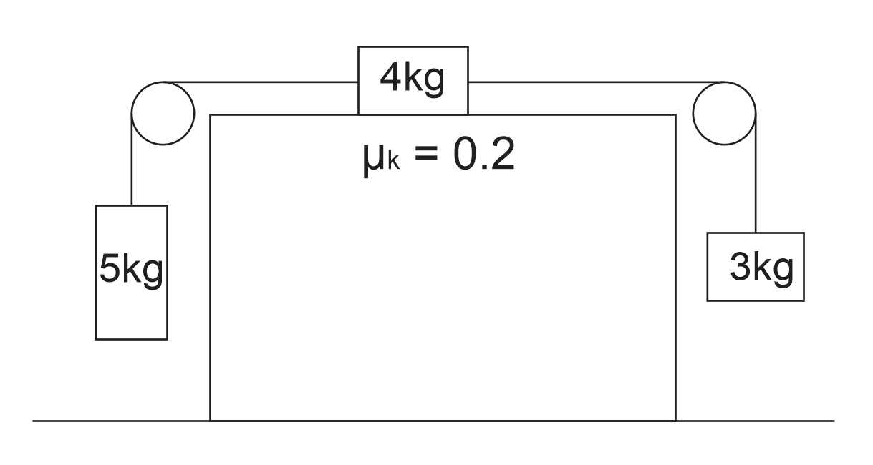

More Newton’s Laws in 1-D Practice
Formulas:

$$∆x=x-x_{0}$$

$$v_{x Ave.}=\frac{∆x}{∆t}$$

$$a=\frac{∆v}{∆t}$$

$$∆x=\frac{1}{2}\left(v_{x0 }+v_{x}\right)t$$

$$v_{x}=v_{x0 }+at$$

$$∆x=v_{x0 }t+ \frac{1}{2}at^{2}$$

$${v_{x}}^{2}= {v_{0x}}^{2}+2a(∆x)$$

$${∑F=F}_{NET}=ma$$

$$w=mg$$

$$F_{f}=µF_{N}$$

$$g=9.8\frac{m}{s^{2}}$$

1. A 1kg car is traveling to our right on a level surface. There is no engine, and no one is pushing the car, so the car is slowing down. The rate of deceleration is constant. Every second, the car’s velocity is 1m/s slower than the second before. Draw a free-body diagram showing the car itself and all of the significant forces that are acting on the car. Represent each force as an arrow labeled with an appropriate name of the force, the correct magnitude of the force, and the correct units.

2. Before the car above began to slow down, a child was pushing it rightward with a force of 3 N. Create another diagram showing all of the individual forces (and the net force) acting on the car while the child was pushing.

3. Starting from rest, a driver accelerates a car leftward at the car’s maximum possible rate. When the driver reaches 50mph, he sees a deer and hits the brakes, slowing to 30mph. He then continues with maximum acceleration until he reaches the car’s top speed, which he maintains for 20 seconds before hitting a tree and coming to an abrupt stop. Sketch a graph of net force vs time. The “system” that you are analyzing here could be either the car, the driver, or both.
4. The first table, below, is a timeline detailing a parachuter’s descent from an airplane. The second table is an incomplete analysis of mass, forces, and acceleration relating to the parachuter’s fall. Use the timeline and your knowledge of physics to complete the second table. Pay close attention to the times in the second table. Most of them do not coincide with the times in the first table, but you can still use the first table to complete the analysis for those times. Before you go too far, it would be prudent to first identify the times in the second table at which the parachuter has reached terminal velocity.

Time | Event
0s | Parachuter steps out of plane
10s | Parachuter reaches a first terminal velocity of -55m/s
90s | Parachuter pulls chute cord. Chute deploys.
98s | Parachuter reaches a second terminal velocity of -3m/s
500s | Parachuter lands

Time | Parachuter Mass | Parachuter Weight | Force of Drag | Net Force | Acceleration | Velocity
0s | 100kg
5s |  |  | 500N Upward |  |  | -35 m/s
80s
97s |  |  | 1200N Upward |  |  | -5m/s
300s

Problems:

1. What is the mass of an astronaut who weighs 600 pounds on the surface of Jupiter, where g_{jupiter} = 24.8m/s²?

2. A 60kg box is being pushed horizontally across a floor. The box is accelerating at a rate of 2m/s², and the coefficient of sliding friction of the box on this surface is µ_{k} = 0.4.

a. What normal force is the floor applying to the box?

b. What friction force is acting on the box?

c. What force is the student applying to the box?

3. A 60kg skydiver is falling from an airplane, accelerating upward at a rate of 7m/s². What is the force of air resistance that is acting on the skydiver at this time?

4. A Finn jumps off of a cliff while holding on to a rope that is tied to a bunch of helium balloons. As the Finn descends, the tension in the rope 500N. The mass of the Finn is 80kg. Ignoring air resistance, how long will it take the Finn to reach the valley floor, 300m below?

5. Charlene is standing on a bathroom scale in a motionless elevator, and the scale reads 600N. The elevator begins to descend, traveling upward with an acceleration of 3m/s² downward.

a. What is Charlene’s mass?

b. What does the scale read, in Newtons, as it accelerates upward?

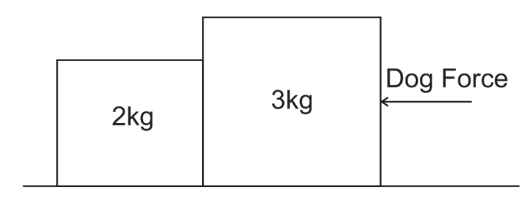
6. Two blocks are sitting on a surface with a µ_{s} = 0.4. A dog nudges the two blocks leftward by pushing the rightmost block with its nose. If the blocks are moving leftward at a constant velocity, what is the contact force between the two blocks?

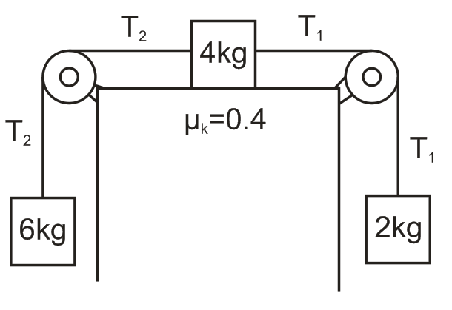

7. The diagram below shows three masses connected by two segments of massless rope. The pulleys are massless and frictionless. The coefficient of kinetic friction of the upper mass on the surface is µ_{k} = 0.4.

a. Find the acceleration of the objects.

b. What is tension T₁?

c. What is tension T₂?

Practice Test (2019-2020 test) -- Newton’s Laws (1-D)

1. An object of mass m is hanging by a string from the ceiling of an elevator. The elevator is accelerating downward. What is the tension in the string?
a. less than mg b. exactly mg c. greater than mg
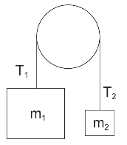
2. The diagram on the right features a massless, frictionless rope and pulley. If m₁ is much greater than m₂, what is the relationship between T₁ and T₂?
a. T₁ = T₂ b. T₁ > T₂ b. T₁ < T₂ d. Impossible to tell

3. Two sumo wrestlers are floating motionless in outer space. Suddenly, Sumo A pushes Sumo B. According to Newton’s Laws, which of the following must be equal for the two sumos during this push?
a. acceleration b. mass x acceleration c. displacement d. speed

4. What property(ies) change(s) significantly when an object is transported from Earth into space?
a. The object’s mass but not its weight b. The object’s weight, but not its mass
c. The object’s mass and its weight d. Neither the object’s mass nor its weight

5. A hockey player is accelerating across an ice rink. Which of the following best describes the force that is pushing her forward?
a. The forward swing of her arms b. The force of her leg extending
c. The ice pushing against the blade of her skate d. Her foot pushing against the sole of her skate
e. Her skate pushing against the ice.

6. A larger object and a smaller object, both falling from the sky, are each experiencing the same force of drag. Which of the following statements cannot be true about these objects?
a. The larger object is heavier than the small one.
b. The smaller object is falling faster than the large one.
c. The larger object is more aerodynamic than the smaller object (lower C_{d})
d. They are falling at terminal velocity.
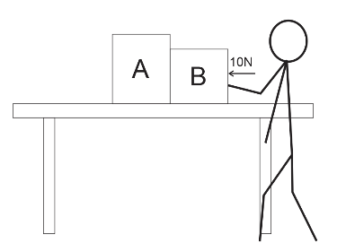
e. None. These statements can all be true.

7. Fred is pushing some boxes horizontally across the surface of a table by applying a constant force of 10N to the rightmost box (as shown). If the surface of the table is frictionless, how does Fred’s applied force compare to the contact force between boxes A and B?
a. Fred Force = Contact Force b. Fred Force > Contact Force
c. Fred Force < Contact Force d. Impossible to tell

8. A stone of mass m is thrown directly upward into air. It goes up; it comes down. If the magnitude of its drag force at any given moment is represented by F_{d}, what net force is the stone experiencing when it is on its way down? Assume that the upward direction is positive.
a. -F_{d}-mg b. -F_{d}+mg c. F_{d}+mg d. F_{d}-mg e. -mg

9. A stone of mass m is thrown directly upward into air. It goes up; it comes down. The magnitude of its drag force at any given moment is represented by F_{d}. Where in its flight is its acceleration equal to -9.8m/s²?
a. On the way up b. On the way down c. At the top
d. Nowhere e. Everywhere.

Short Answer:

1. A 50kg student is standing up in the aisle of a bus as the bus travels rightward toward a stoplight. The bus is currently slowing down. The bus and the student are accelerating at a rate of -3m/s². The bus’ current velocity is 10m/s. The student does not slip or fall, and he remains in contact only with the floor of the bus. On the diagram, draw all of the individual forces that are acting on the student. Use arrows to show the direction of each force. Label each arrow with an appropriate name of the force, the correct magnitude of the force, and the correct units.

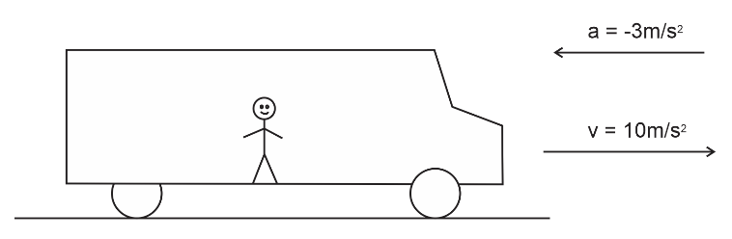

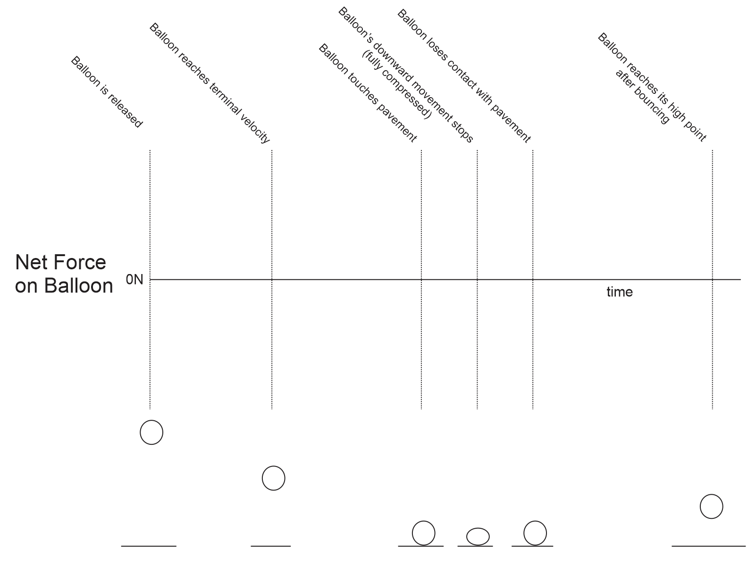
2. A child inflates a typical rubber balloon and drops it from a roof. The balloon reaches terminal velocity as it falls and eventually hits the pavement below. When the balloon hits the pavement, it compresses, bounces back upward, and reaches some new maximum height before falling back to the pavement. Show the changes in the net force acting on the balloon during its journey. Assume that up = positive. The graph times are not organized to scale. Force magnitudes do not have to be exactly to scale. The pictures below the graph are meant to help you understand what is happening to the balloon at each moment

3. A 10kg brick is dropped from a helicopter. The brick falls until it reaches terminal velocity, falls some more, and then it hits the ground. The table below provides incomplete descriptions of three moments during the brick’s descent (labeled A-C). They are intentionally scrambled so that they are not in order! Use the second column to correctly order the moments in time. Also enter the correct drag force and net force for each of the moments.

Moments in the descent | Order (1=occurs first, 3 = occurs last) | Brick Weight [Not Graded] | Force of Drag on brick | Net Force acting on brick | Brick Acceleration
A |  |  | 98N
B |  |  | 0N
C |  |  | 49N

4. Describe the action and reaction forces that explain how a walking person accelerates forward.

Action:

Reaction:

Problems:

1. A student weighs 600N on Earth.

a. What is his mass?

b. On a different planet, the acceleration of gravity is 0.7g. What weight would the student have on that planet?

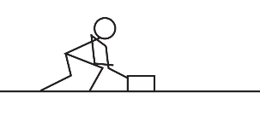
2. Pam pushes a block of wood so that it accelerates at a rate of 3.2m/s².

a. If the block of wood has a mass of 3kg, what net force must be acting on the wood block?

b. If Pam’s 3kg block of wood has a coefficient of kinetic friction (µ_{k}) of 0.4, what friction force is acting on the block while Pam is pushing it?

c. Given the same block mass and friction as above, what force must Pam be applying in order to make the block accelerate at this rate (3.2m/s²)?

d. How fast would the block of wood accelerate if Pam applied this same force (from part c), but there were no friction (µ_{k}=0)?

3. A 60kg student is standing on a bathroom scale in an elevator, and the scale currently reads 500N. Describe the acceleration of the elevator? (provide magnitude and direction)

4. Matilda and Vern are hoisting tools up to a roof so that they can begin a roofing project. One of their saws has a weight of 90N, and Matilda wants to be able to lift it from the ground to the roof (a height of 7m) in exactly 7 seconds.

a. How fast must the saw accelerate in order to ascend a height of 7m in 7seconds, starting from rest?

b. How strong does the rope need to be in order to lift the 90N saw at this rate? Give its minimum breaking strength, in Newtons.

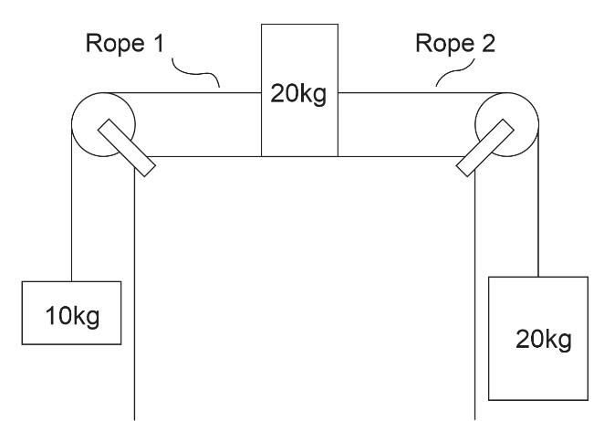
5. The diagram on the right shows three masses connected by frictionless, massless strings passing over frictionless pulleys. The coefficient of friction between the sliding mass and the surface is µ_{k} = 0.3, and the masses and strings are in motion.

a. Find the acceleration of the entire system of masses and ropes.

b. Find the tension in Rope 1

c. Find tension in Rope 2.

