Physics 200 (Stapleton) Name: ___________________

Notes, Ch. 4.5: Normal, Tension, and Other Examples of Forces

1. What is tension?

2. In our physics problems, almost all of the ropes, chains, wires, cables, or strings will be massless. In massless objects such as these the force of tension at every point is
_____________. We know this because of Newton’s __________ law.

Analyzing Multibody Systems (and writing net force equations for those systems)

3. What is a “system, in Physics?

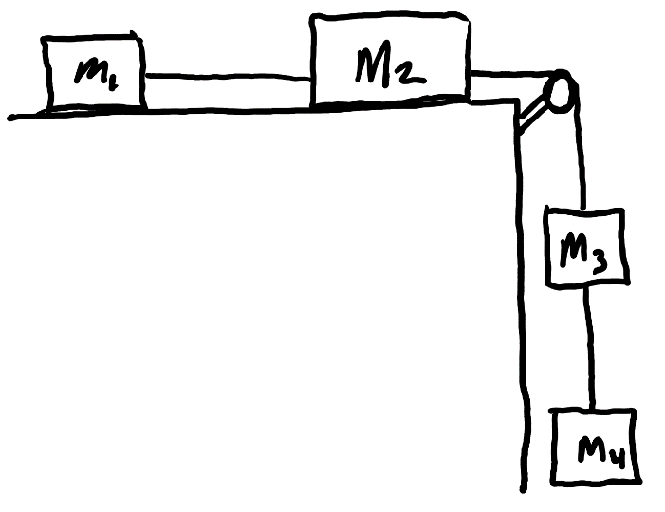
4. The diagram on the right represents blocks of matter that are connected by a massless string. The pulley and the air are frictionless, but there is friction between the surface and the blocks.
- Draw several (or possibly all) of the individual systems that you can find in the diagram.
- For each system, write equations for net force in terms of:
  - The sum of individual forces
  - Newton’s 2nd Law

Continue…
Multibody Drill A

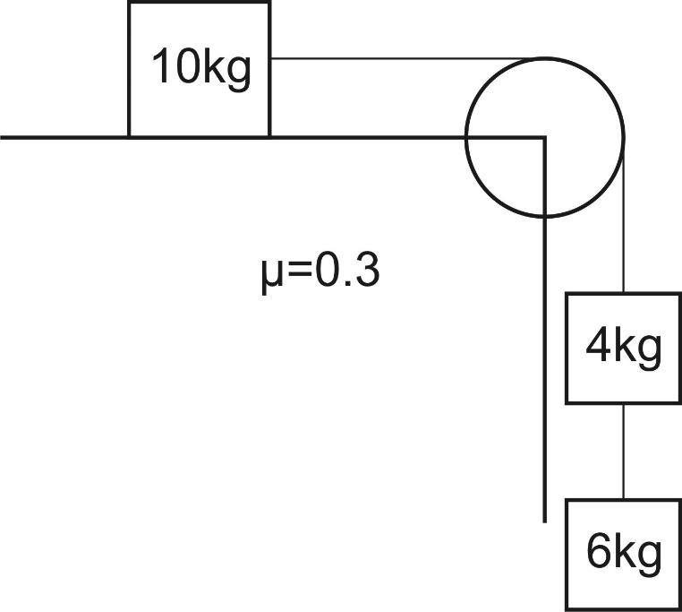
Practice) Find the accelerations and tensions of the ropes on the right.

1) Find the acceleration and the tension in the rope between the 2 masses. Assume μ = 0.

5 kg
15 kg

F =100

2) Repeat if μ = 0.2.

3) Find the acceleration and the tension in the rope between the 2 masses.
1 kg
3 kg
F =30 N

4) Find the force required to accelerate the 2 masses at a rate of +2.5 m/s².

5) Find the acceleration and the tension in the 2 ropes if the surface is frictionless.
3.5 kg
3.0 kg
2.0 kg

6) Repeat if the coefficient of kinetic friction is 0.10

