Physics 200 (Stapleton) Name: ____________________
Ch. 5.1: Drag and Terminal Velocity

1. Drag force:

2. Drag force equation:

3. Draw diagrams showing all of the forces acting on a skydiver in 3 different situations: negative acceleration, zero acceleration, and positive acceleration,

4. When a falling skydiver’s net force and acceleration are zero, she or he is said to

be at ______________________.

5. Use the drag formula an equation for the terminal velocity of a skydiver.

6. The table below describes the experience of a skydiver who steps out of a stationary helicopter. Create a reasonable acceleration graph portraying this sequence of events. Note the skydiver’s velocities at various points.

Sequence | Event
1 | Skydiver steps off of helicopter
2 | Skydiver reaches a terminal velocity of -40m/s
3 | Skydiver pulls chute cord. Parachute deploys.
4 | Skydiver reaches a new terminal velocity of -4m/s
5 | Skydiver feet touch down
6 | Skydiver comes to rest

***Important note – Since F_{net} = ma, acceleration is proportional to F_{net.} So, this is essentially a graph of net force vs time.**
Conceptual Practice with Drag:
1. Consider a golf ball that is being dropped by an astronaut who is standing on the Moon. Gravity causes the ball the fall to the Moon’s surface. Describe the action and reaction forces that are involved as the ball is falling toward the moon’s surface.

Action:

Reaction:

2. You’re floating freely in outer space, and you have two seemingly identical boxes – box A and box B. Although the boxes look the same, one has much more mass than the other. Describe a test you could conduct in order to figure out which box has more mass, and explain how the results of the test would be different for the two boxes.

3. A small child and a team of Austrian weightlifters are fighting over a sturdy (though massless) scarf. The child is pulling on one end, and the weightlifters are pulling on the other end. Neither side will let go. As you might expect, the child is being taken for quite a ride. Which end of the scarf has the most tension? Explain why.

4. A 100 kg human is standing on a barge in the absence of air resistance. The barge is accelerating to our right at a rate of 2m/s² and the person is accelerating along with it. Draw all of the individual forces that are acting on the human. Use arrows to show the direction of each force. Label each arrow with an appropriate name of the force, the correct magnitude of the force, and the correct units.

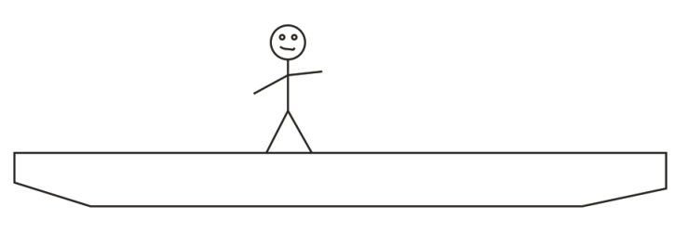

5. A 10kg watermelon is dropped out of an airplane without a parachute. Use the timetable to fill out the empty cells in the second data table below. Don’t forget correct signs and units. The mass and weight columns will not be graded, but you might find them to be helpful.

Time | Event
0s | Watermelon is dropped out of plane
20s | Watermelon reaches terminal velocity of -100m/s
500s | Watermelon hits the Earth

Time | Watermelon Mass [not graded] | Watermelon Weight [not graded] | Force of Drag on melon | Net Force acting on melon | Melon Acceleration | Melon Velocity
0s
15s |  |  | 90N |  |  | -80 m/s
80s

