Name: ___________________________

Notes - 4.4 Newton’s Third Law of Motion: Symmetry in Forces

1. State Newton’s 3rd Law of Motion.

2. Forces always occur in pairs, and one body cannot exert a force on another without ____________________. This is sometimes referred to as action-_____________.

3. Consider the swimmer pushing off from the side of a pool in Figure 4.9. She pushes against the pool wall with her feet and accelerates in the direction opposite to that of her push. The wall has exerted an equal and opposite force back on the swimmer. Why does the swimmer accelerate? Don’t these two forces cancel each other out?

4. Describe some other examples of Newton’s 3rd Law.

Walking:

Car:

Helicopter:

Rocket:

5. Rockets
A. What is the common misconception regarding rocket propulsion?

B. What observation disproves this misconception?

Notes, Ch. 4.5: Normal, Tension, and Other Examples of Forces – Part 2

6. What is tension?

7. The force of tension at every point in a single rope, chain, wire, cable, or string is
_____________

Two masses are suspended by cables of negligible mass, as shown below on the right. The acceleration of the cables and the masses is a.

8. Consider the “system” to be both of the blocks and the cable between them.

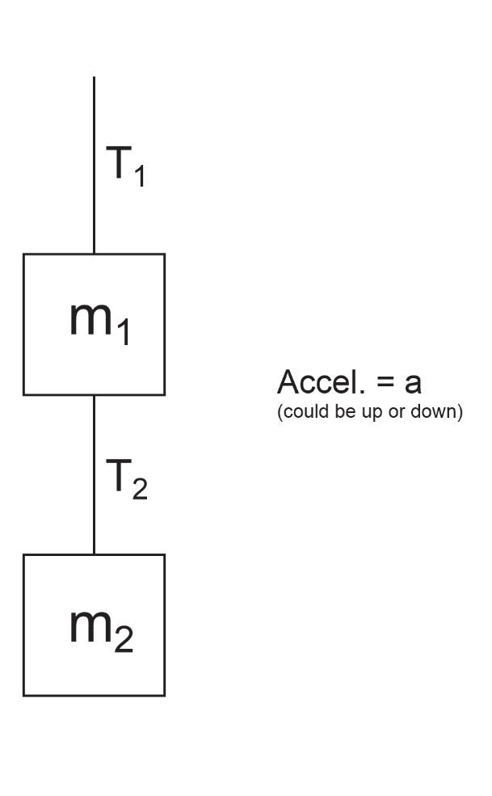
A. Write an equation for Net force as the vector sum of the forces acting on the two blocks.

B. Use Newton’s 2nd Law to write an equation for the net force acting on the two blocks.

C. Use your two equations to derive a formula for T₁.

9. Consider the “system” to be just the bottom block (m₂).

A. Write an equation for Net force as the vector sum of the forces acting on the two blocks.

B. Use Newton’s 2nd Law to write an equation for the net force acting on the two blocks.

C. Use your two equations to derive a formula for T₁.
Ch. 5.1: Drag and Terminal Velocity

Drag force (friction when moving through a fluid) =

10. Draw a Free Body Diagram (diagram showing forces) showing all of the forces acting on a skydiver.

11. When a falling skydiver’s net force and acceleration are zero, she or he is said to be at ______________________.

12. Write an equation for the terminal velocity of a skydiver.

13. Under what circumstances is a skydiver’s acceleration…

…positive?

…negative?

…zero?

14. The table below describes the experience of a skydiver who steps out of a stationary helicopter. Create a reasonable acceleration graph portraying this sequence of events. Note the skydiver’s velocities at various points.

Sequence | Event
1 | Skydiver steps off of helicopter
2 | Skydiver reaches a terminal velocity of -40m/s
3 | Skydiver pulls chute cord. Parachute deploys.
4 | Skydiver reaches a new terminal velocity of -4m/s
5 | Skydiver feet touch down
6 | Skydiver comes to rest

