Physics 200 Name: _______________________
Newton’s Laws (1-D) (Test from 2018-2019)

Multiple Choice:
1. A 20-ton truck collides with a 1500-lb car and causes a lot of damage to the car. A lot of damage is done on the car. In truth…
a. the force on the truck is greater than the force on the car.
b. the force on the truck is equal to the force on the car.
c. the force on the truck is smaller than the force on the car.
d. the truck did not slow down during the collision.

2. The acceleration due to gravity is lower on the Moon than on Earth. Which of the following is true about the mass and weight of an astronaut on the Moon's surface, compared to Earth?
a. Mass is less, weight is same. b. Mass is same, weight is less.
c. Both mass and weight are less. d. Both mass and weight are the same.

3. A stone is thrown straight up. At the top of its path, the net force acting on it is
a. greater than its weight. b. greater than zero, but less than its weight.
c. instantaneously equal to zero. d. equal to its weight.

4. A 20-N weight and a 5.0-N weight are dropped simultaneously from the same height. Ignore air resistance. Compare their accelerations.
a. The 20 N weight accelerates faster because it is heavier.
b. The 20 N weight accelerates faster because it has more inertia.
c. The 5.0 N weight accelerates faster because it has a smaller mass.
d. They both accelerate at the same rate because they have the same weight to mass ratio.

5. If the sum of all forces on an object is zero (i.e. F_{Net} = 0), then the object
A. must have a velocity v = 0. B. must have an acceleration a = 0.
C. must remain in the same position. D. must be accelerating with a = g.

6. A 1,000 kg car and a 1 gram feather fall to the Earth at their respective terminal velocities. Which object has the greatest acceleration at terminal velocity?
a. the feather b. the car c. Neither, both have 0 acceleration.
d. It cannot be determined because there is not enough information given.

7. A 1,000 kg car and a 1 gram feather fall to the earth at their respective terminal velocities. Which object has the largest force of air resistance acting on it?
a. the feather b. the car c. Neither, both have the same amount of air resistance acting on them.
d. It cannot be determined because there is not enough information given.

8. An object of mass m is hanging by a string from the ceiling of an elevator. The elevator is moving up at constant velocity. What is the tension in the string?
a. less than mg b. exactly mg c. greater than mg

9. A sailboat is using an unstretchable rope to tow a small rowboat. The rowboat has a mass of 100kg and the sailboat has a mass of 1,000kg. The sailboat is accelerating forward at a rate of 1m/s², causing the rowboat to accelerate along with it. Which of the following is true?

a. The rope exerts a stronger force on the rowboat than it does on the sailboat.
b. The rope exerts a stronger force on the sailboat than it does on the rowboat.
c. The rope exerts equal forces on the two boats.
d. The rope does not exert a force on either boat.

Short Answer:

1. A 100 kg human is standing on a barge in the absence of air resistance. The barge is accelerating to our right at a rate of 2m/s² and the person is accelerating along with it. Draw all of the individual forces that are acting on the human. Use arrows to show the direction of each force. Label each arrow with an appropriate name of the force, the correct magnitude of the force, and the correct units.

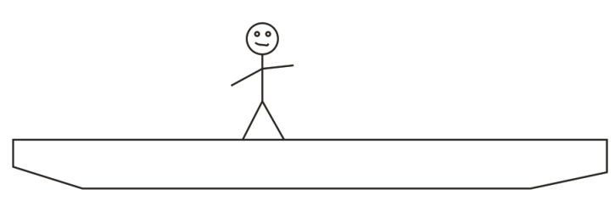

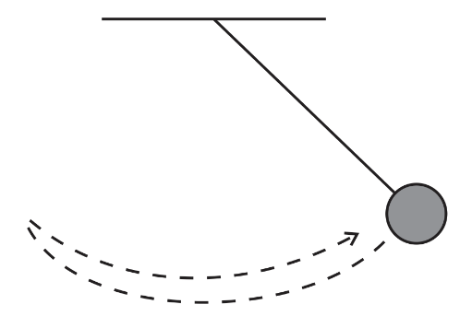
2. This pendulum consists of a heavy sphere and a string of negligible mass. The pendulum is suspended from a ceiling in a vacuum at the surface of the Earth. Sketch a graph of the X dimension net force acting on the pendulum vs time as the pendulum swings over and back once. You do not have to label the axes with specific magnitudes.

Net Force (X-dimension) vs. Time

3. A 10kg watermelon is dropped out of an airplane without a parachute. Use the timetable to fill out the empty cells in the second data table below. Don’t forget correct signs and units. The mass and weight columns will not be graded, but you might find them to be helpful.

Time | Event
0s | Watermelon is dropped out of plane
20s | Watermelon reaches terminal velocity of -100m/s
500s | Watermelon hits the Earth

Time | Watermelon Mass [not graded] | Watermelon Weight [not graded] | Force of Drag on melon | Net Force acting on melon | Melon Acceleration | Melon Velocity
0s
15s |  |  | 90N |  |  | -80 m/s
80s

4. a. Consider a golf ball that is being dropped by an astronaut who is standing on the Moon. Gravity causes the ball the fall to the Moon’s surface. Describe the action and reaction forces that are involved as the ball is falling toward the moon’s surface.

Action:

Reaction:

Problems:

1. A student weighs 700N on Earth.

a. What is his mass?

b. How much does he weigh on Mars, where the acceleration due to gravity is -0.38g_{Earth}?

2. A sled has a mass of 40kg.

a. In a frictionless environment, how much force is required to accelerate the sled horizontally at a rate of 2m/s²?

b. If the coefficient of friction between the sled and the ground is µ_{k} =0.2, calculate the force of friction while the sled is sliding horizontally to the right?

c. If the sled’s µ_{k} =0.2, what applied force is required to accelerate the sled, horizontally, at a rate of 2m/s²?

d. If µ_{k} =0.2, what applied force is required to move the sled, horizontally, at a constant velocity?

3. A 0.012kg bullet collided with an old stump. As the bullet penetrated into the stump and came to rest, the average impact force was 30,000N. The bullet penetrated a distance of 0.12m before coming to rest.

a. Calculate the bullet’s acceleration during its impact.

b. How fast was the bullet moving just before it hit the stump?

4. A student weighing 700N is standing on a bathroom scale in an elevator, and the scale currently reads 400N. What are the magnitude and direction of the elevator’s current acceleration?

5. A woman fishing on a public pier just caught a nice spottail bass. The fish is now at rest (motionless), and the woman is about to lift the fish a vertical distance of 8m, from the water’s surface to the top of the pier railing. In her eager state, she wants to lift the fish as fast as possible. If the bass’ mass is is 5kg, and the breaking strength of the fishing line is 100N, how fast can she can lift the fish 8 meters?

a. What is fastest possible acceleration that she can impart to the fish (without breaking the line)?

b. At that acceleration, how long will it take her to lift the fish 8 meters?

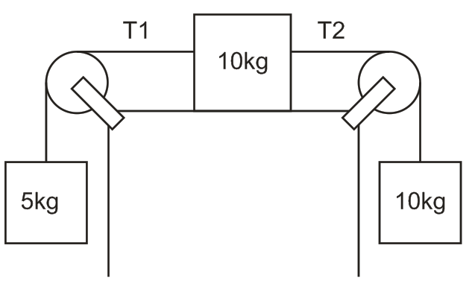
6. The diagram on the right shows three masses connected by frictionless strings passing over frictionless pulleys. The surface below the 10kg mass, however, has a µ_{k} = 0.3.

a. Find the acceleration of the 10kg mass.

b. Find tension T₁

c. Find tension T_{2.}

